Alzheimer's Disease Detection Using Deep Learning

Mayank Pratap Singh1,Aryashrestha Sagar2, Maitri Sharma3, Devanjali Relan4, Kiran Khattar5

1,2,,3,4,5 BML Munjal University [mayankpratap.singh.22cse@bmu.edu.in1](mailto:mayankpratap.singh.22cse@bmu.edu.in1) , [aryashrestha.sagar.22cse@bmu.edu.in](mailto:aryashrestha.sagar.22cse@bmu.edu.in)2, [maitri.sharma.22cse@bmu.edu.in3](mailto:maitri.sharma.22cse@bmu.edu.in3), [devanjali.relan@bmu.edu.in4](mailto:devanjali.relan@bmu.edu.in4), [kiran.khatter@bmu.edu.in5](mailto:kiran.khatter@bmu.edu.in5)

**Abstract.** Alzheimer's Disease (AD) is a neurodegenerative disorder that leads to cognitive decline, making early detection crucial for effective treatment. This project explores deep learning techniques, particularly Convolutional Neural Networks (CNNs), for detecting Alzheimer's Disease from brain imaging data. Two datasets were utilized to develop and evaluate two distinct models: a transfer learning approach using the pre-trained VGG16 network and a custom CNN ar- chitecture tailored for multi-class classification of AD stages. The datasets un- derwent rigorous pre-processing to address class imbalance, with data augmen- tation techniques applied to enhance model performance.

The models were trained and validated using stratified train-test splits, and their performance was assessed using metrics such as accuracy, precision, recall, and F1-score. Proposed Model 1, employing VGG16, achieved 98% accuracy for Moderate Dementia (ModerateD) vs. No Dementia (ND) classification and 98% for the multi-class classification of ModerateD, Very Mild Dementia (VeryMildD), Mild Dementia (MildD), and ND. Proposed Model 2, also based on VGG16, attained 98% accuracy for both AD vs. NC (Cognitively Normal) and AD/EMCI (Early Mild Cognitive Impairment)/LMCI (Late Mild Cognitive Impairment)/NC classifications.

The custom CNN models demonstrated even higher performance. Proposed Model 3 achieved 99% accuracy for both AD vs. NC and AD/EMCI/LMCI/NC classifications on the ADNI dataset, while Proposed Model 4 achieved 97% ac- curacy for ModerateD vs. ND and 98% for the multi-class classification of Mod- erateD, VeryMildD, MildD, and ND. These results underscore the potential of deep learning in reliable AD diagnosis, with the custom CNN providing compet- itive results compared to the transfer learning approach. The study highlights the importance of dataset quality and model design for achieving robust detection and paves the way for future research aimed at expanding datasets and exploring alternative architectures to further improve detection accuracy.

**Keywords:** CNNs, VGG16, Transfer Learning, Alzheimer’s Classification, Multiclass Classification, Neuroimaging Data, Feature Extraction, Deep Learn- ing, ADNI Dataset

# Introduction

Alzheimer's Alzheimer's Disease (AD) is a progressive neurodegenerative disorder and the leading cause of dementia, affecting millions of individuals globally each year. It is characterized by memory loss, cognitive decline, and behavioral changes, eventually culminating in the inability to perform daily tasks. As the aging population continues to grow, the prevalence of AD is expected to increase dramatically, posing significant challenges to healthcare systems and caregivers alike [1]. Early diagnosis of AD is cru- cial, as it provides an opportunity to implement therapeutic interventions that may slow disease progression, improve patient quality of life, and alleviate the societal burden. Conventional diagnostic techniques often rely on subjective assessments, including cognitive tests and manual analysis of neuroimaging data, which are time-intensive and prone to variability [3].

Neuroimaging is pivotal in diagnosing and monitoring AD, with MRI and PET im- aging being widely used to detect structural and functional brain changes. While these imaging modalities provide valuable insights, interpreting the data requires significant expertise and is prone to human error [5]. To overcome these challenges, deep learning techniques, particularly Convolutional Neural Networks (CNNs), have emerged as powerful tools for medical image analysis. CNNs have demonstrated exceptional capa- bilities in automatically extracting hierarchical patterns from complex imaging data, offering state-of-the-art performance in AD classification tasks [7].

Recent studies have utilized CNNs for multiclass classification of AD, achieving notable accuracy levels across different classification tasks. For instance, a 3D-CNN model applied to neuroimaging data achieved 93.18% accuracy in three-class classifi- cation (Cognitively Normal, Mild Cognitive Impairment, and AD) by focusing on the hippocampal region—a key biomarker of AD progression [8]. Similarly, the use of transfer learning, particularly with pre-trained networks such as VGG16, has shown promise in tackling multiclass AD classification, achieving accuracies as high as 96.7% for four-class classification problems involving stages such as AD, Early Mild Cogni- tive Impairment (EMCI), Late Mild Cognitive Impairment (LMCI), and Cognitively Normal (CN) [9] [10].

Despite these advancements, the development of robust models for AD classification faces challenges, including class imbalance and limited dataset sizes. Data augmenta- tion techniques, such as rotation, flipping, and intensity scaling, have been employed to artificially expand training datasets, mitigating these issues and improving model generalizability [3]. Furthermore, advanced preprocessing methods, including segmen- tation and contrast enhancement, are utilized to focus on regions of interest, such as the hippocampus and ventricles, enhancing model performance in detecting subtle disease biomarkers [6].

This study leverages the strengths of deep learning to tackle the complex problem of multiclass AD classification. Two models were developed: a transfer learning model using the VGG16 pre-trained network and a custom CNN architecture, trained and eval- uated on two distinct datasets. The performance of these models was assessed using rigorous metrics such as accuracy, precision, recall, and F1-score. With preprocessing techniques such as histogram equalization, CLAHE, and K-means clustering integrated

into the pipeline, this research highlights the potential of deep learning in addressing key challenges in AD diagnosis. The findings underscore the importance of carefully designed models and robust data preparation in developing scalable, AI-driven tools for early and accurate AD detection [2] [7].

# Objectives and Motivation

The motivation for this research stems from the increasing global prevalence of Alz- heimer's Disease (AD), a neurodegenerative disorder responsible for severe cognitive decline, memory loss, and behavioral changes. Early detection of AD is critical to ena- bling timely therapeutic interventions and improving patient outcomes. However, tra- ditional diagnostic approaches, such as manual analysis of neuroimaging data and clin- ical assessments, are subjective, time-consuming, and often inconsistent. This under- scores the need for automated, reliable, and scalable diagnostic tools to aid clinicians in identifying AD and its stages with higher accuracy and efficiency [1].

This study aims to leverage the capabilities of deep learning, particularly Convolu- tional Neural Networks (CNNs), to classify Alzheimer's Disease into its stages: NonDe- mented, VeryMildDemented, MildDemented, and ModerateDemented. Two distinct models were developed to address this objective: a transfer learning approach using the pre-trained VGG16 architecture [4] and a custom-built CNN model [5]. These models are designed to extract and analyze intricate patterns from brain MRI scans, showcasing the ability of CNNs to handle the complexities of medical imaging data [6].

To ensure robust performance, advanced preprocessing techniques were employed, including segmentation, edge detection, histogram equalization, and K-means cluster- ing [8]. These methods enhanced the visual and structural features of the brain scans, allowing the models to focus on subtle but critical differences between stages of AD. Additionally, data augmentation techniques such as rotation, flipping, and zooming were applied to mitigate class imbalance [9], ensuring that the models are well-trained and generalize effectively to unseen data [10].

A significant focus of this research is on evaluating the performance of the developed models across two datasets, enabling a comprehensive assessment of their robustness and generalizability [1]. Performance metrics such as accuracy, precision, recall, and F1-score were computed to measure the efficacy of the models for both multiclass and binary classification tasks [4]. By exploring these avenues, this study aims to contribute to the development of AI-driven tools that can facilitate early and reliable diagnosis of Alzheimer’s Disease in clinical settings [3].

Through these objectives, the research aspires to highlight the potential of deep learning in revolutionizing the field of neurodegenerative disease diagnosis, providing a foundation for future work to enhance these models with larger datasets, alternative architectures, and expanded feature sets [10].

# Related Work

Recent research on Alzheimer's Disease (AD) classification using deep learning has made significant strides, exploring a variety of methodologies to enhance accuracy and address common challenges such as handling imbalanced datasets, feature extraction, and multiclass classification. A key study in [1] proposed the use of a 3D-CNN for both binary and multiclass classification of AD using PET and MRI neuroimaging data. This approach demonstrated the effectiveness of augmentation techniques, particularly ran- dom zoom and Gaussian blur, which resulted in an accuracy of 86.63% for AD/NC binary classification and 59.73% for AD/NC/MCI multiclass classification, indicating the importance of data manipulation in improving performance. Other research in [7] focused on the use of fully connected neural networks (DNNs) for binary classification, specifically distinguishing between AD and cognitively normal (CN) individuals. One such model, applied to T1-weighted MRI images, achieved 87.50% accuracy for AD vs. CN classification, 83.33% for AD vs. MCI, and 79.17% for MCI vs. CN, demon- strating the potential of DNNs in AD classification tasks.

Another study in [10] incorporated multi-view CNNs, using axial, coronal, and sag- ittal views of MRI scans for AD classification, achieving an average accuracy of 90.62% for AD/NC binary classification. The integration of Long Short-Term Memory (LSTM) networks with CNNs improved the accuracy by approximately 2%, emphasiz- ing the advantages of combining spatial and temporal features. This hybrid approach illustrated how capturing both spatial and sequential dependencies could improve diag- nostic performance. Similarly, research in [3] explored the effectiveness of transfer learning for AD classification using pre-trained CNN architectures. The study reported a classification accuracy of 96.7% for a four-class AD problem (AD, EMCI, LMCI, CN), showcasing the robustness of transfer learning in reducing computational over- head while maintaining high performance.

Additionally, deep learning has been applied to functional neuroimaging modalities such as resting-state fMRI. One study in [8] used a modified 3D-CNN model to classify fMRI data into four categories (AD, EMCI, LMCI, CN), achieving an accuracy of 93%. This research highlighted the potential of fMRI combined with deep learning for early- stage AD detection and improved diagnostic capabilities. Similarly, research in [9] ap- plying 3D-CNN architectures for structural MRI classification found that residual and plain CNN models provided comparable results to traditional methods. The study demonstrated that the model achieved accuracies of 80% for AD vs. NC and 63% for AD vs. EMCI, reflecting the challenges of classifying different stages of Alzheimer's Disease.

Finally, some studies have focused on graph-based models for AD classification, using techniques such as Graph Convolutional Neural Networks (GCNNs) to classify subjects based on Diffusion Tensor Imaging (DTI)-derived connectivity graphs. One such study in [6] achieved an impressive 89% accuracy for AD/EMCI/LMCI/NC mul- ticlass classification, illustrating the potential of GCNNs to perform well even with smaller sample sizes. The performance gap between different methods was found to increase as the disease progressed, with GCNNs performing better as the severity of Alzheimer's disease increased. Collectively, these studies emphasize the diversity of

approaches—ranging from traditional CNNs to hybrid and graph-based models—and highlight the ongoing advancements in the use of deep learning for AD classification. Building on these methods, our work aims to refine multiclass classification using CNNs and transfer learning techniques, achieving improved generalization and perfor- mance across multiple datasets and modalities.

# Dataset Description

This project evaluates the performance of a deep learning model on two distinct da- tasets focused on Alzheimer's disease classification. The datasets used are the ADNI Dataset and the Alzheimer's Disease Multiclass Dataset, both of which contain MRI images categorized based on different stages or types of Alzheimer's disease. Each da- taset has specific characteristics that influence the model's ability to detect and classify Alzheimer's disease stages.

## ADNI Dataset

The Alzheimer's Disease Neuroimaging Initiative (ADNI) dataset consists of brain imaging data, including MRI scans, from subjects with varying stages of Alzheimer's disease. It contains multiple diagnostic categories: CN (Cognitively Normal), EMCI (Early Mild Cognitive Impairment), LMCI (Late Mild Cognitive Impairment), and AD (Alzheimer’s Disease). This dataset is widely used for research on early detection, pro- gression, and prognosis of Alzheimer's.

* + - Number of Images: 39,929 images across four categories.
    - Classes: CN (6464 images), EMCI (9600 images), LMCI (8960 images), AD (8960 images).
    - Image Format: MRI scans in various formats, preprocessed to be suitable for training deep learning models.
    - Image Size: Standardized to 224x224 pixels for input into the model.

## Alzheimer's Disease Multiclass Dataset

The Alzheimer's Disease Multiclass Dataset focuses on MRI scans categorized based on the severity of dementia. It consists of images from patients at different stages of Alzheimer's disease, including non-demented subjects, those with very mild, mild, and moderate dementia.

* + - Number of Images: 44,000 images across four classes.
    - Classes:
      * NonDemented (12,800 images)
      * VeryMildDemented (11,200 images)
      * MildDemented (10,000 images)
      * ModerateDemented (10,000 images)
    - Image Format: MRI scans as JPG files, pre-processed (skull-stripped, cleaned of non-brain tissue).
    - Image Size: Suitable for input to deep learning models with standard pre-pro- cessing.

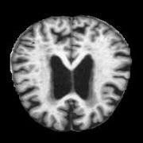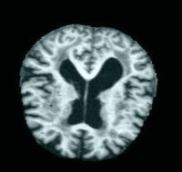

**Fig. 1**. MRI Scan of Skull

# Methodology

In this study, we compare the performance of two deep learning models— Convolutional Neural Network (CNN) and VGG16—on the task of Alzheimer's disease classification using two different MRI image datasets. The goal is to evaluate and compare the effectiveness of these models in detecting varying stages of Alzheimer's disease: Non-Demented, Very Mild Demented, Mild Demented, and Moderate Demented. Below is a detailed explanation of the methodology used for both models.

## Image Preprocessing

Preprocessing is a critical step to standardize and enhance the image data for optimal performance by deep learning models. The following procedures are applied:

* + - Resizing: Images are resized to a uniform dimension (224x224 pixels) to meet the input size requirements of both the CNN and VGG16 architectures.
    - Normalization: The pixel values of the images are scaled to a uniform range, reducing computational overhead and improving model convergence.
    - Data Augmentation: Data augmentation techniques, such as rotation, flipping, zooming, and shifting, are applied to the training dataset. This increases diver- sity, simulates real-world variations, and reduces the risk of overfitting.

In our image preprocessing pipeline, we applied segmentation, edge detection, and gradient-based techniques to enhance our understanding of the brain scans. Segmenta- tion was performed using binary thresholding, which separates regions of interest, such as white fluid areas or ventricles, from the background. This simplifies the image by isolating key structures, enabling focused analysis. Canny edge detection was used to highlight edges and contours in the image, making subtle boundaries more prominent, such as those between brain matter and fluid regions. Additionally, Laplacian edge de- tection was employed to detect all edges based on intensity gradients, while Sobel edge

detection provided directional information (horizontal and vertical gradients), allowing for a better understanding of structural patterns within the images.

These techniques were chosen to enhance the visual and structural features of the brain scans, aiding in the identification of subtle details like abnormalities or fluid regions. By preprocessing the images in this way, we aimed to extract meaningful information that could be valuable for both manual analysis and as input features for machine learn- ing models. This combination of techniques ensures that both global and local structural patterns are captured, improving the interpretability and effectiveness of our approach.

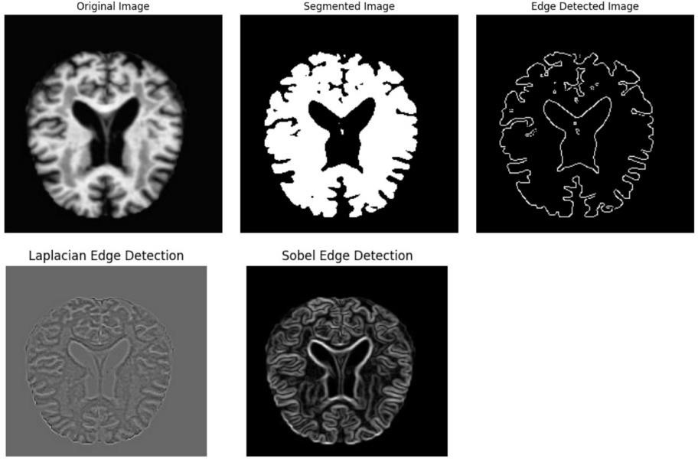

**Fig. 2**. Preprocessing steps: segmentation, edge detection, and gradient analysis for en-

hanced brain scan features.

Building on our preprocessing pipeline, we further employed techniques like histo- gram equalization, CLAHE, and K-means segmentation to enhance image quality and extract critical features. Histogram equalization was used to globally enhance contrast, improving the visibility of structures by redistributing intensity values evenly. This was complemented by CLAHE (Contrast Limited Adaptive Histogram Equalization), which adaptively improved local contrast while preventing noise amplification, particularly in regions with subtle intensity variations such as gray and white matter boundaries.

Additionally, K-means clustering segmentation was applied to group pixels into dis- tinct intensity-based clusters, allowing us to identify and isolate regions of interest, such as white fluid areas. By highlighting the brightest cluster, we specifically detected po- tential fluid-filled regions, which are critical for diagnosing and understanding struc- tural changes in brain scans. These techniques provided a deeper insight into the im- ages, enabling us to enhance and focus on meaningful features essential for manual interpretation and machine learning workflows

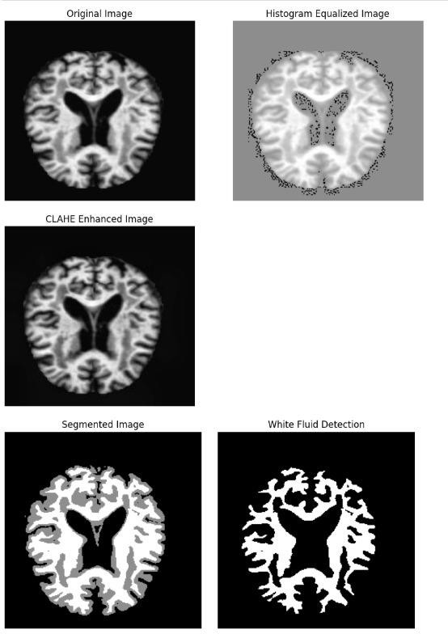

**Fig. 3**. Advanced preprocessing with histogram equalization, CLAHE, and K-means seg- mentation for enhanced contrast and region detection in brain scans.

## Model Architectures

Two different models are employed in this study: a custom Convolutional Neural Network (CNN) and the pre-trained VGG16 model.

## Custom CNN Architecture

The CNN model is designed with the following key components:

1. Convolutional Layers: Multiple layers of 2D convolutions with increasing fil- ter sizes (32, 64, 128, 256) to capture features from the input images. Each convolutional layer uses the ReLU activation function to introduce non-line- arity.
2. Batch Normalization: Applied after each convolutional layer to normalize ac- tivations, which accelerates training and helps prevent overfitting.
3. Max Pooling: Pooling layers (with a pool size of (2, 2)) reduce the spatial dimensions of the feature maps and retain the most important information.
4. Dropout: Dropout layers with rates of 0.25 or 0.5 are used to prevent overfit- ting by randomly setting a fraction of the input units to 0 during training.
5. Fully Connected Layers: After flattening the feature maps, dense layers are used to classify the images into one of four classes. ReLU activation functions are used in these layers.
6. Output Layer: The final layer uses softmax activation to output the probability distribution over the four classes.

The model is trained using the Adam optimizer, with categorical crossentropy as the loss function and accuracy as the evaluation metric.

## VGG16 Architecture

The VGG16 model is used as a pre-trained feature extractor with the following compo- nents:

1. Pre-trained VGG16: We use the VGG16 model without the top fully con- nected layers (include_top=False), pre-trained on the ImageNet dataset. This allows us to leverage the learned features from the ImageNet dataset for better generalization.
2. Pooling: VGG16 uses average pooling instead of max pooling, which reduces the spatial dimensions of the feature maps.
3. Fully Connected Layers: After flattening the output from VGG16, two dense layers (2048 and 1024 units) with ReLU activation are added. Batch normali- zation is applied after each dense layer to normalize activations.
4. Output Layer: The final layer uses softmax activation for multi-class classifi- cation, outputting probabilities for each of the four classes.
5. Freezing Pre-trained Layers: The convolutional layers of the pre-trained VGG16 model are frozen (trainable=False), so only the fully connected layers are trained on the new dataset. This allows for faster training and prevents overfitting when the dataset is small.

The VGG16 model is also compiled using the Adam optimizer, categorical crossen- tropy as the loss function, and accuracy as the evaluation metric.

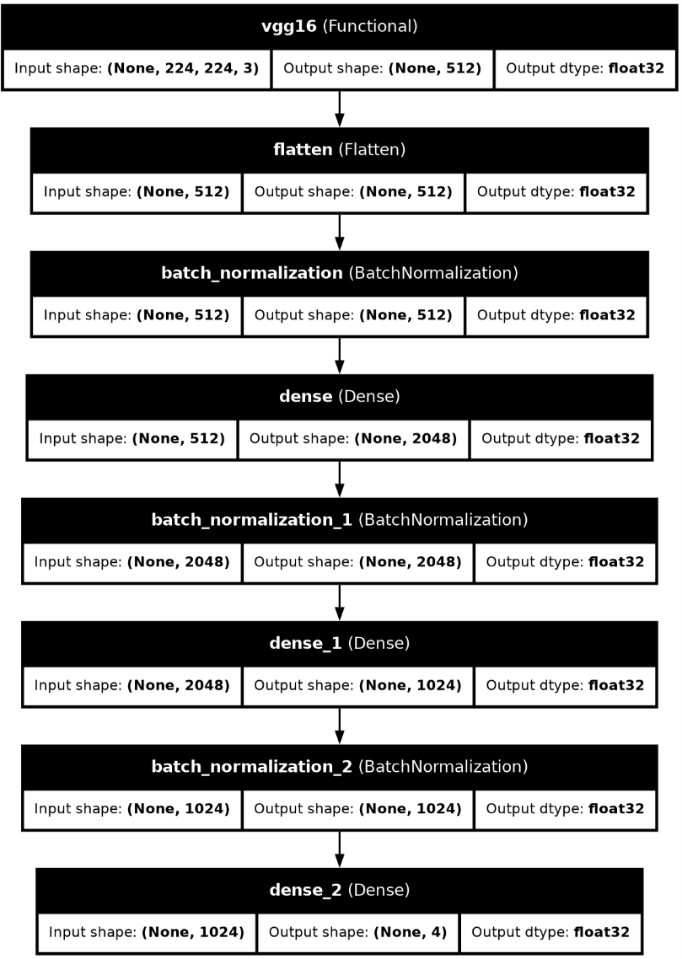

**Fig. 4.** VGG16 Model Architecture

## Training

Data Generators: The training and validation sets are fed into the models using Im- ageDataGenerator. These generators handle data augmentation and ensure that the data is appropriately fed into the models in batches.

Callbacks:

* + - EarlyStopping is used to stop training if the validation accuracy does not im- prove for 10 consecutive epochs, ensuring the model does not overfit.
    - ModelCheckpoint is used to save the best model during training based on val- idation performance.

## Evaluation

After training, the performance of both models is assessed using the validation da- taset. The primary evaluation metric is accuracy, which measures the proportion of cor- rectly classified images. To gain deeper insights into the classification performance, a confusion matrix is analyzed, providing a detailed breakdown of true positives, false positives, true negatives, and false negatives across all classes. Additionally, training and validation loss and accuracy curves are plotted to visualize the learning behavior of the models over time. These curves help identify potential issues such as overfitting or underfitting, ensuring the models are performing optimally and generalizing well to unseen data.

# Results and Discussions

## Performance of VGG16 VGG16 on ADNI Dataset

The VGG16 model demonstrated remarkable performance on the ADNI dataset. During training, the model achieved a training accuracy of 0.98 with a training loss of 0.03, indicating that the network effectively learned the patterns within the train- ing data. The validation accuracy of 0.97 and validation loss of 0.08 suggest that the model generalizes well without overfitting. Furthermore, on the test set, the model achieved an excellent test accuracy of 0.98, highlighting its robustness in predicting unseen data. These results validate the suitability of VGG16 for binary classification tasks in the Alzheimer's Disease domain, specifically when leveraging high-quality datasets such as ADNI.

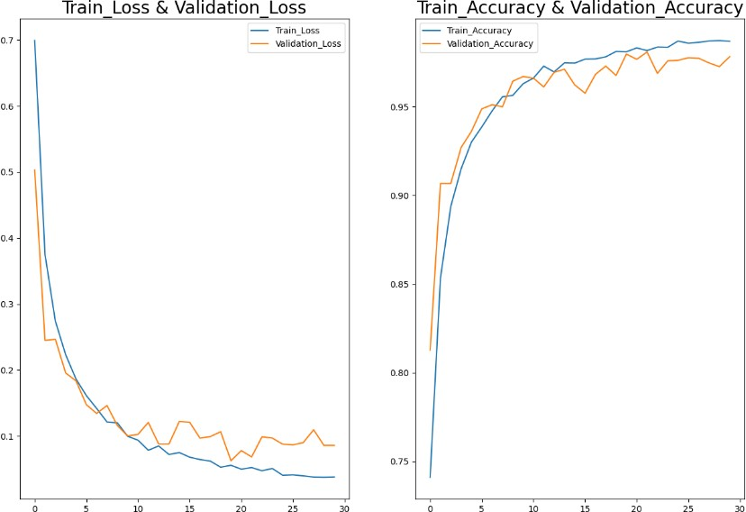

**Fig. 5**. Graphs depicting model evaluation parameters

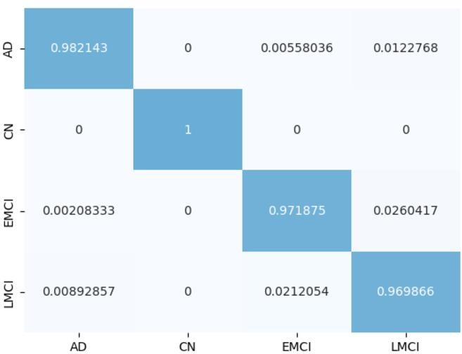

**Fig. 6.** Confusion Matrix of Actual Values and Predicted Values

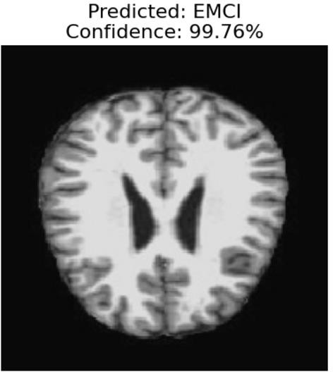

**Fig. 7.** EMCI image accurately predicted by model with a confidence level of 99.76%

## VGG16 on Alzheimer’s Multiclass Dataset

When applied to the multiclass Alzheimer’s dataset, VGG16 outperformed its performance on the ADNI dataset. It achieved a training accuracy of 0.99 and a training loss of 0.01, indicating extremely efficient feature learning. The validation accuracy of 0.98 and a consistent validation loss of 0.08 highlight that the model is

well-tuned and avoids overfitting despite the complexity of multiclass classification. Notably, the test accuracy of 0.98 reaffirms the model's capability to handle diverse classes effectively. This outcome underscores the potential of VGG16 in tackling multiclass classification problems, emphasizing its ability to learn subtle distinctions between categories.

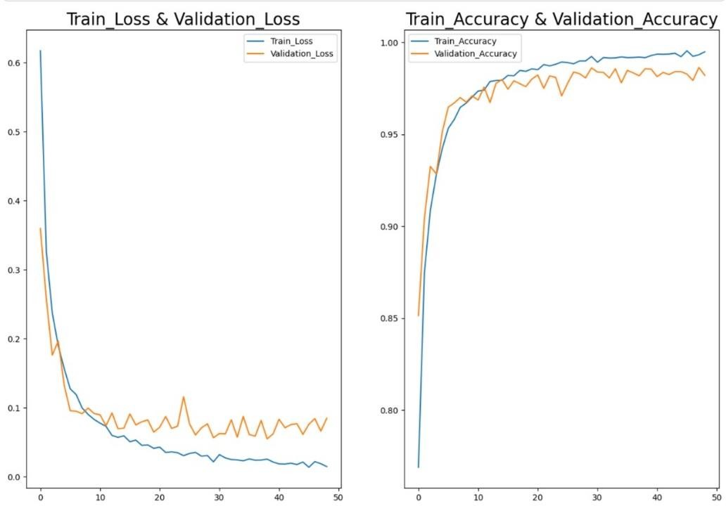

**Fig. 8**. Graphs depicting model evaluation parameters

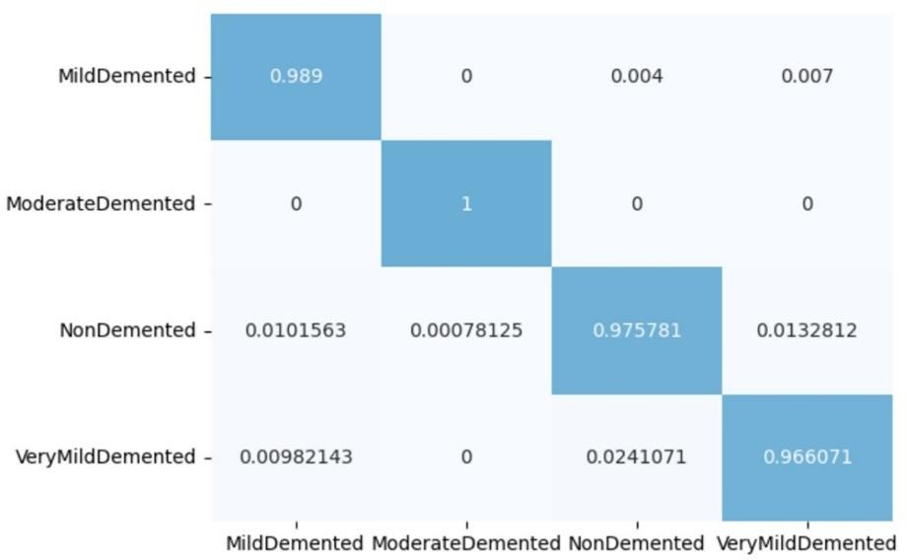

**Fig. 9.** Confusion Matrix of Actual Values and Predicted Values

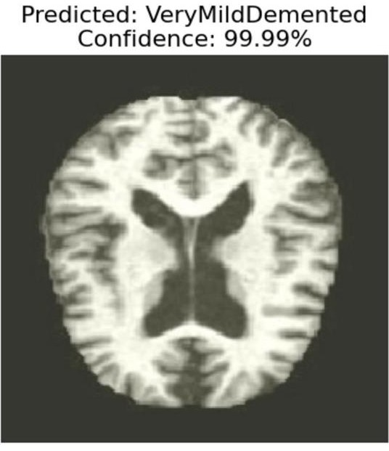

**Fig. 10.** VeryMildDemented image accurately predicted by model with a confidence level of

99.99%

## Comparison of Results

The results suggest that VGG16 performs exceptionally well on both datasets, with marginally better training accuracy and lower loss on the multiclass Alz- heimer’s dataset. This could be attributed to the model's ability to leverage a more diverse set of features present in multiclass data. However, the validation and test metrics are comparable, confirming the model’s consistency and reliability across binary and multiclass tasks. The small gap between training and validation accura- cies across both datasets highlights the effectiveness of the training process and hy- perparameter tuning, ensuring minimal overfitting.

## Performance of CNN CNN on ADNI Dataset

The CNN model exhibited exceptional performance on the ADNI dataset. It achieved a training accuracy of 0.99 with a training loss of 0.05, demonstrating ef- fective learning from the training data. The validation accuracy of 0.98 and valida- tion loss of 0.05 highlight the model's excellent generalization capabilities, with no significant signs of overfitting. On the test set, the model achieved an impressive test accuracy of 0.99, confirming its robustness and reliability in predicting unseen data. These results indicate that the CNN architecture is highly suitable for binary

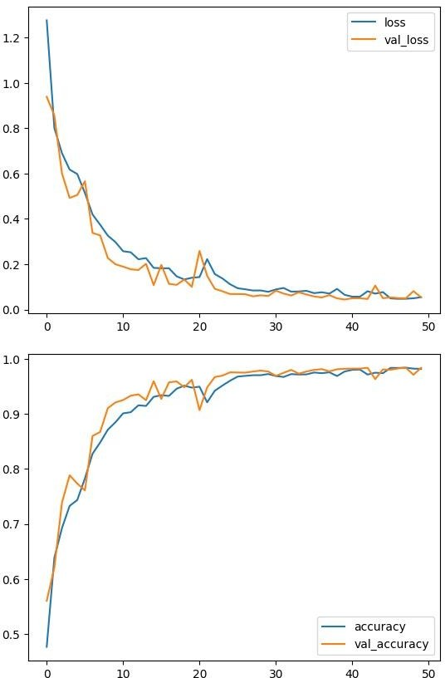classification tasks in Alzheimer's Disease diagnosis, leveraging its simplicity and efficient feature extraction mechanisms.

**Fig. 11**. Graphs depicting model evaluation parameters

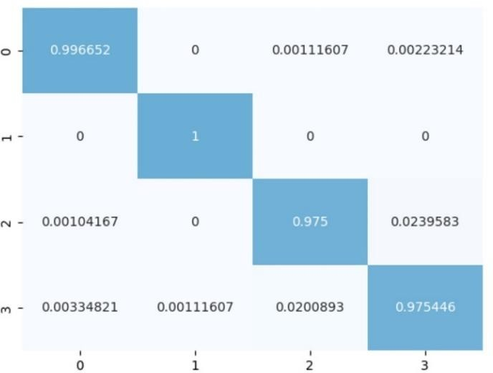

**Fig. 12.** Confusion Matrix of Actual Values and Predicted Values where 0: 'AD', 1: 'CN', 2:

'EMCI', 3: 'LMCI'

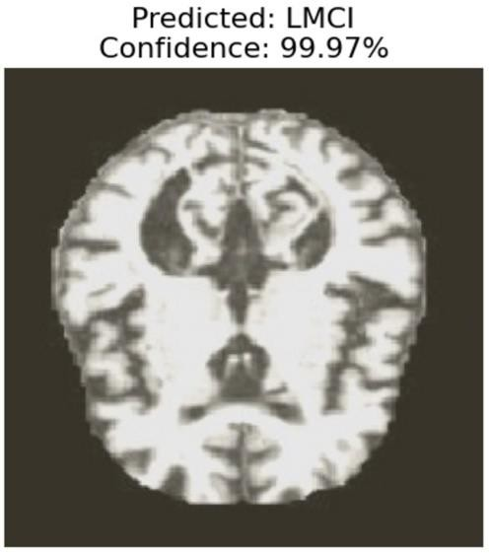

**Fig. 13.** LMCI image accurately predicted by model with a confidence level of 99.99%

## CNN on Alzheimer’s Multiclass Dataset

On the multiclass Alzheimer's dataset, the CNN model maintained strong perfor- mance, achieving a training accuracy of 0.98 and a training loss of 0.06, reflecting its efficiency in learning from the training data despite the increased complexity of multiclass classification. The validation accuracy of 0.98 and a slightly higher vali- dation loss of 0.07 suggest that the model is well-regularized and capable of gener- alizing effectively. The test accuracy of 0.98 further underscores the model's robust- ness in handling diverse classes, showcasing its versatility in learning nuanced dis- tinctions among different categories.

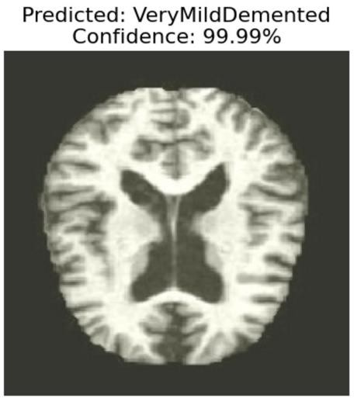

**Fig. 14.** VeryMildDemented image accurately predicted by model with a confidence level of

99.99%

## Comparison of Results

The CNN model performed consistently across both datasets, with near-perfect accuracies and minimal losses in training, validation, and testing phases. While the model achieved slightly higher training accuracy and lower loss on the ADNI da- taset, this is expected due to the simpler nature of binary classification. For the mul- ticlass Alzheimer's dataset, the model effectively handled the increased classification complexity, delivering competitive performance comparable to that on the ADNI dataset.

**Table 1.** Comparison of methodologies, datasets, modalities, classification types, and accuracy metrics for Alzheimer's Disease classification across various studies, along with the perfor- mance of our proposed models.

|  |  |  |  |  |  |
| --- | --- | --- | --- | --- | --- |
| **Paper** | **Method** | **Dataset** | **Modality** | **Classification Type** | **All Accuracies (%)** |
| [1] | 3D-CNN | ADNI | MRI | AD/NC | 96.88 (AD/NC) |
| [2] | CNN | ADNI | MRI | Multi-class (AD/EMCI/LMCI/NC) | 97.00 (AD/EMCI/LMCI/NC) |
| [3] | MRI + PET  Fusion CNN | ADNI | MRI + PET | AD/NC | 97.00 (AD/NC) |
| [4] | 3D-CNN with Augmentation | PET | PET | Multi-class (AD/NC/MCI) | 59.73 (AD/NC/MCI),  68.50 (AD/MCI),  86.63 (AD/NC) |
| [5] | Dense Neural Network | T1-weighted MRI | MRI | AD/NC, AD/MCI, MCI/NC | 87.50 (AD/NC),  83.33 (AD/MCI),  79.17 (MCI/NC) |
| [6] | CNN + LSTM | ADNI | MRI | AD/NC | 90.62 (AD/NC) |
| [7] | Deep Neural Network | ADNI | MRI | AD/NC, MCI/NC, AD/MCI | 85.19 (AD/NC),  76.93 (MCI/NC),  72.73 (AD/MCI) |
| [8] | Modified 3D-  CNN | ADNI | fMRI | Multi-class  (AD/EMCI/LMCI/NC) | 93.00  (AD/EMCI/LMCI/NC) |
| [9] | Residual and Plain CNN | ADNI | MRI | Various (AD/NC, AD/EMCI, etc.) | 80.00 (AD/NC),  63.00 (AD/EMCI),  59.00 (AD/LMCI),  61.00 (LMCI/NC),  52.00 (LMCI/EMCI),  56.00 (EMCI/NC) |
| [10] | GCNN | ADNI | DTI | Multi-class  (AD/EMCI/LMCI/NC) | 89.00  (AD/EMCI/LMCI/NC) |
| Proposed Model 1 | VGG16 | AD Mul- ticlass | MRI | Multi-class (Moder- ateD/VeryMildD/MildD/N D) | 98.00(ModerateD/ND),  98.00 (Moder- ateD/VeryMildD/Mild D/ND) |

|  |  |  |  |  |  |
| --- | --- | --- | --- | --- | --- |
| Proposed Model 2 | VGG16 | ADNI | MRI | Multi-class (AD/EMCI/LMCI/NC) | 0.98(AD/NC),  0.98(AD/EMCI/LMCI/ NC) |
| Proposed Model 3 | Custom CNN | ADNI | MRI | Multi-class (AD/EMCI/LMCI/NC) | 0.99(AD/NC),  0.99(AD/EMCI/LMCI/ NC) |
| Proposed Model 4 | Custom CNN | AD Mul- ticlass | MRI | Multi-class (Moder- ateD/VeryMildD/MildD/N D) | 97.00(ModerateD/ND),  98.00 (Moder- ateD/VeryMildD/Mild  D/ND) |

# Conclusion and Future Scope

The In this study, the performance of VGG16 and CNN architectures for Alz- heimer’s Disease classification was evaluated on both the ADNI dataset (binary classi- fication) and the Alzheimer’s Multiclass dataset. Both models achieved impressive re- sults across training, validation, and test phases. VGG16 demonstrated high accuracy, with a test accuracy of 0.98 on both datasets, and CNN also exhibited strong perfor- mance, reaching test accuracies of 0.99 for ADNI and 0.98 for the multiclass dataset. These results validate the suitability of both models for Alzheimer’s Disease classifi- cation, showing that deep learning techniques, such as CNNs and VGG16, can effec- tively learn complex patterns from neuroimaging data and generalize well to unseen data.

The promising outcomes of this study suggest that future research could focus on expanding the dataset and optimizing the models further. Incorporating additional data sources, such as genetic or clinical information, could enhance model accuracy and reliability. Moreover, implementing transfer learning and techniques like dropout or data augmentation could improve the models’ generalization capabilities. Finally, ad- dressing the interpretability of these models would be crucial for their integration into clinical settings, where understanding model decisions is essential for trust and practi- cal application. Future work in these areas could significantly advance the field of Alz- heimer’s Disease diagnosis and contribute to more effective early detection methods.

# References

1. Ebrahimi, A., Luo, S., & Initiative, F. T. a. D. N. (2021). Convolutional neural networks for Alzheimer’s disease detection on MRI images. *Journal of Medical Imaging*, *8*(02). https://doi.org/10.1117/1.jmi.8.2.024503
2. Helaly, H. A., Badawy, M., & Haikal, A. Y. (2021). Deep learning approach for early de- tection of Alzheimer’s disease. *Cognitive Computation*, *14*(5), 1711–1727. https://doi.org/10.1007/s12559-021-09946-2
3. Punjabi, A., Martersteck, A., Wang, Y., Parrish, T. B., & Katsaggelos, A. K. (2019). Neu- roimaging modality fusion in Alzheimer’s classification using convolutional neural net- works. *PLoS ONE*, *14*(12), e0225759. https://doi.org/10.1371/journal.pone.0225759
4. Tufail, A. B., Ullah, K., Khan, R. A., Shakir, M., Khan, M. A., Ullah, I., Ma, Y., & Ali, M.

S. (2022). On improved 3D-CNN-Based binary and multiclass classification of Alzheimer’s disease using neuroimaging modalities and data augmentation methods. *Journal of Healthcare Engineering*, *2022*, 1–14. https://doi.org/10.1155/2022/1302170

1. Prajapati, R., & Kwon, G. (2022). A binary classifier using fully connected neural network for Alzheimer’s disease classification. *Journal of Multimedia Information System*, *9*(1), 21– 32. https://doi.org/10.33851/jmis.2022.9.1.21
2. Transfer learning for Alzheimer’s disease detection on MRI images. (n.d.). IEEE Confer- ence Publication | IEEE Xplore. https://ieeexplore.ieee.org/abstract/document/8784845/fig- ures#figures
3. *An efficient deep neural network binary classifier for Alzheimer’s disease classification*. (n.d.). IEEE Conference Publication | IEEE Xplore. https://ieeexplore.ieee.org/abstract/doc- ument/9415212
4. Parmar, H., Nutter, B., Long, R., Antani, S., & Mitra, S. (2020). Spatiotemporal feature extraction and classification of Alzheimer’s disease using deep learning 3D-CNN for fMRI data. *Journal of Medical Imaging*, *7*(05). https://doi.org/10.1117/1.jmi.7.5.056001
5. Korolev, S., Safiullin, A., Belyaev, M., & Dodonova, Y. (2017, January 23). *Residual and plain convolutional neural networks for 3D brain MRI classification*. arXiv.org. https://arxiv.org/abs/1701.06643
6. *Graph Convolutional neural networks for Alzheimer’s disease classification*. (n.d.). IEEE Conference Publication | IEEE Xplore. https://ieeexplore.ieee.org/document/8759531