**Name : Mihir Thakkar**

**Class : TY A**

**Roll no : 59**

**SRN : 201901267**

**Business Intelligence Ass-5**

**Filtering Data :-**

1. **Basic filtering :-**
2. From the Dataset given, **Last Year Sales**. Click on the visualization tab, and click on

Tree-map.

1. Select “Last Year Sales” from Sales, “Category”: from Item and “Chain” from Store.
2. In the filters section click on the dropdown for the “Category” and “Chain” attribute. Select the filter type as “Basic Filter” and select the first five from “Category” in the list of options and “Fashions Direct from “Chain” in the list of options.

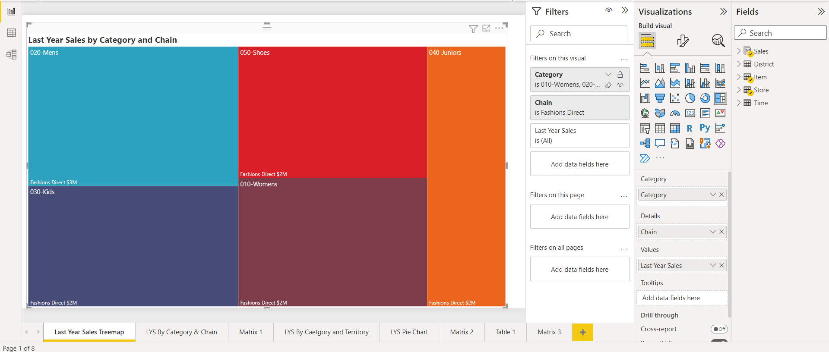

1. **Advanced Filtering :-**
2. From the Dataset given, **Last Year Sales**. Click on the visualization tab, and click on Pie-Chart.
3. Select “Last Year Sales” from Sales, “Category”: from Item and “Chain” from Store.
4. In the filters section click on the dropdown for the “Category” and “Chain” attribute. Select the filter type as “Top N” and filter the items based on the value of “Last Year Sales” (N=5).

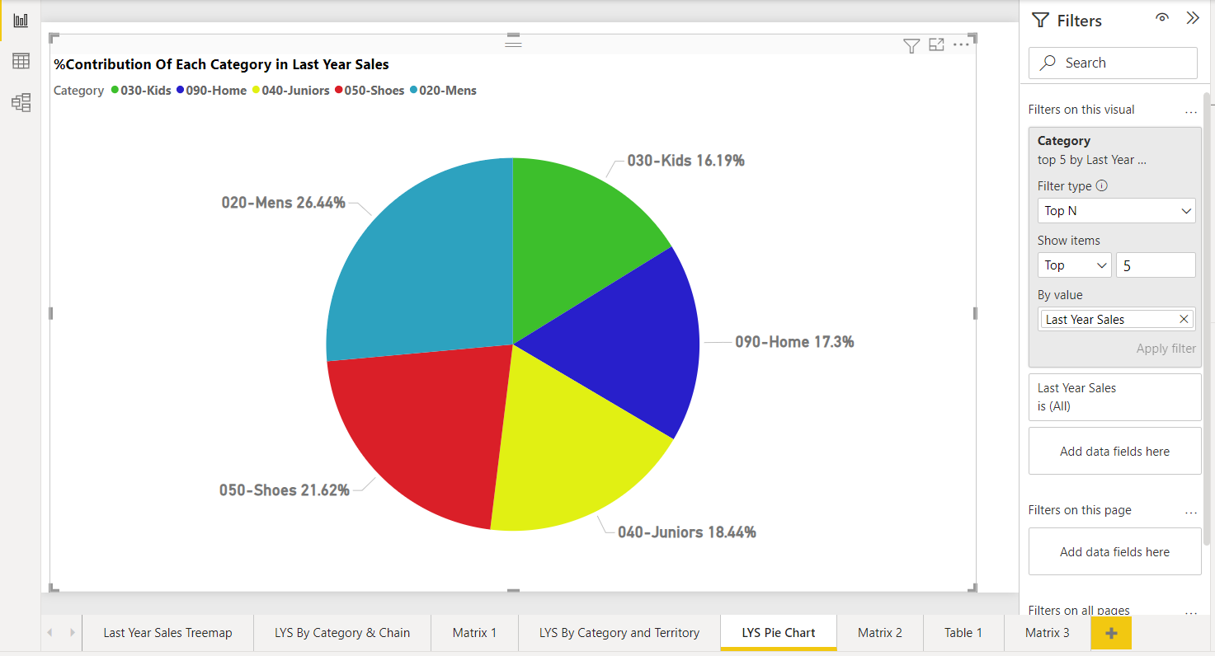

**Sorting:-**

**Graphs and Charts :-**

1. From the Dataset given, **Last Year Sales**. Click on the visualization tab, and click on Clustered Column Chart.
2. Select “Last Year Sales” from Sales, “Category”: from Item and “Chain” from Store.
3. Click on the three dots on the top of the graph. Select ”Sort Axis”->”Sort ascending” -> ”Category”.
4. The Bar chart shown below displays the LSY by category and chain in ascending order alphabetically on x-axis.

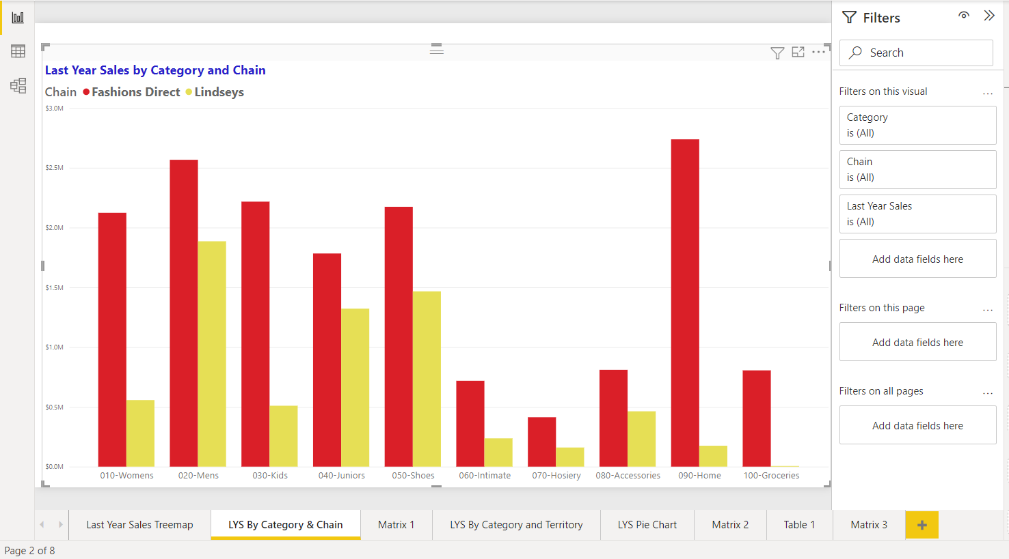

**Calculate :-**

**Calculate :-**

1. Go to model in Power BI
2. Write CALCULATE and a formula of your choice.
3. I have written a formula that calculates the percentage of a Selling Area of the category in different territories and their respective cities. The formula is as follows :

**%SellingArea = [SellingAreaSize]/100000**

1. The screenshot of CALCULATE function is given below

