**Immersive Digital Twin for Food Manufacturing: AR-Enabled Remote Control and Real-Time Monitoring**

**(July 2025)**

**G.D.Pranav Lakshminarasimhan, Sumukha Upadhyaya,Akshay Avinash and Aarti Shirvante Pai**

R V COLLEGE OF ENGINEERING, BANGALORE

**ABSTRACT**

This paper presents the design and implementation of an immersive digital twin system leveraging augmented reality (AR) technologies for remote control and real-time monitoring in food manufacturing industries. The proposed platform integrates comprehensive data acquisition from all stages of the supply chain, enabling users to visualize, analyze, and interact with operational processes through intuitive touch and voice interfaces. Users can manually or verbally operate critical components such as valves, with immediate visual feedback reflecting real-world changes in the virtual environment. Advanced analytics, powered by AI, continuously monitor system data to detect anomalies and highlight problem areas, supporting proactive maintenance and process optimization. The architecture is grounded in the Digital Twin Cyber-Physical Systems (DT-CPS) framework, ensuring seamless bidirectional data flow between physical assets and their virtual counterparts. The system adopts industry-standard protocols for interoperability and scalability. AR-enabled digital twins have the potential to revolutionize food manufacturing by enhancing operational visibility, enabling swift fault detection, and fostering greater user engagement.

**INDEX TERMS** Keywords: Augmented Reality, Virtual Reality, Digital Twin, Food Manufacturing, IoT, Industrial Automation, HACCP, Supply Chain Monitoring, Voice Control, Industry 4.0

**I. INTRODUCTION**

The food manufacturing industry is undergoing a profound transformation in response to 21st-century pressures, including growing consumer expectations for product quality, safety, and transparency; increasingly complex global supply chains; and intensified regulatory scrutiny. Coupled with mounting sustainability concerns and the looming challenge of feeding an anticipated global population of 9.7 billion by 2050, manufacturers are compelled to overhaul traditional practices in favor of smarter, more agile, and environmentally conscious operations [1][2][3].

In this context, digital transformation powered by Industry 4.0 technologies has emerged as a strategic imperative. Among these innovations, Digital Twin (DT) technology is garnering significant attention for its ability to create real-time, virtual replicas of physical systems, enabling proactive decision-making, continuous optimization, and predictive maintenance in food processing environments [4]. However, most legacy monitoring systems in food manufacturing still rely on manual inspections, static data logs, and reactive maintenance, often leading to inefficiencies, quality deviations, and regulatory non-compliance [5][6].

To address these limitations, this paper explores the integration of Augmented Reality (AR) technologies with digital twin frameworks. AR offers an immersive interface for monitoring and controlling industrial systems by overlaying real-time information onto physical assets. When paired with digital twins, AR enables not only intuitive visualization of operations but also hands-free interaction, improved situational awareness, and faster decision cycles [7][8][9]. These capabilities are especially vital in the food sector, where hygiene protocols, rapid response requirements, and compliance traceability are paramount.

Market forecasts underscore the momentum behind this technological convergence. The global AR market in manufacturing is projected to surge from $40.4 billion in 2024 to $62 billion by 2029, driven by use cases such as remote equipment diagnostics, digital workflows, and training simulations [10][11]. Within food manufacturing specifically, adoption is accelerating at an impressive pace—from a current 18% penetration rate in 2024 to a projected 85% by 2030. This upward trajectory reflects growing recognition of AR’s potential to bridge operational gaps and elevate productivity, quality, and safety benchmarks across the food value chain.

Proposed Framework:

AR-Enhanced Digital Twin for Food Manufacturing

This study introduces a novel AR-enhanced Digital Twin Framework tailored to the needs of food manufacturing environments. The proposed system integrates the following five core functionalities:

End-to-End Supply Chain Monitoring:  
Utilizing distributed IoT sensors for real-time data acquisition across procurement, production, and distribution stages—enabling traceability, spoilage detection, and inventory optimization.

Tablet-Based Valve Control Interface:  
Empowering operators with a responsive touch interface to manage fluid and ingredient flow rates, check system parameters, and respond to alerts in a user-friendly environment.

Real-Time 3D Visualization and System Telemetry:  
Leveraging AR to display dynamic 3D models of the processing system overlaid on physical equipment, offering engineers and technicians a spatial understanding of system states and bottlenecks.

Intelligent Problem Diagnosis:  
Employing machine learning algorithms to detect anomalies, predict component failures, and generate maintenance schedules based on operational data trends.

Voice-Activated Command Support:  
Introducing voice-activated interfaces to facilitate hands-free control, especially useful in environments with strict hygiene protocols or where physical interaction is constrained.

By fusing AR’s immersive interactivity with the real-time responsiveness of digital twins, this framework sets the stage for smarter, safer, and more sustainable food manufacturing systems that align with the industry's future vision.

**II. Related Work and Background**

**A. Digital Twin Applications in Food Industry**

Digital twin technology has gained significant traction in the food processing industry as companies seek to enhance product safety, reduce costs, and improve operational efficiency. Research by Abdurrahman and Ferrari demonstrates that digital twins provide comprehensive virtual replicas of physical food processing systems, enabling real-time monitoring, simulation, and optimization of production processes . Major food companies including Coca-Cola, Nestle, and PepsiCo have successfully implemented digital twin solutions for production line optimization, quality control, and supply chain management..

Arla Foods has pioneered the integration of digital twins with AR technology for Clean-In-Place (CIP) planning in dairy production, demonstrating measurable improvements in decision-making processes and contamination prevention. These implementations showcase the potential for digital twins to transform traditional food manufacturing through enhanced monitoring capabilities and predictive maintenance strategies.

**B. AR Technologies in Industrial Automation**

The adoption of AR technologies in industrial automation has accelerated significantly, driven by advances in hardware capabilities, software platforms, and integration methodologies. Manufacturing applications include enhanced training programs, real-time monitoring and data visualization, collaborative design processes, maintenance and repair guidance, and remote assistance.

Boeing's implementation of AR glasses for aircraft assembly has achieved a 90% reduction in error rates, while Siemens utilizes AR for complex maintenance task guidance.

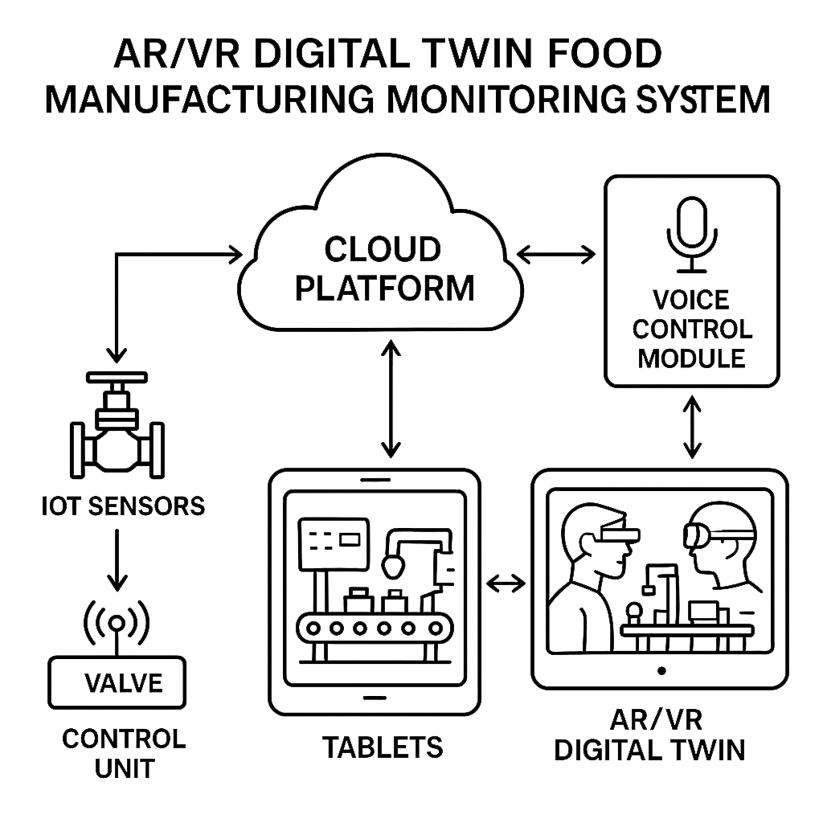

System architecture diagram for AR digital twin food manufacturing control system.

Recent developments in AR hardware have made industrial deployment more feasible, with devices offering improved resolution, extended battery life, and enhanced environmental durability. The integration of AI-driven analysis with AR systems enables real-time defect identification and quality inspection processes, significantly improving manufacturing precision and efficiency.

## **C. IoT-Based Monitoring Systems in Food Processing**

Internet of Things (IoT) technologies have become fundamental to modern food processing operations, enabling continuous monitoring of critical parameters including temperature, humidity, pressure, and flow rates. IoT-based monitoring systems provide real-time feedback, predictive analytics, and seamless integration with production processes, transitioning food manufacturers from reactive to proactive monitoring approaches.

Temperature and humidity monitoring systems utilizing IoT sensors demonstrate significant improvements in food safety compliance, with accuracies of ±0.1°C for temperature and ±2% for relative humidity measurements, These systems integrate with existing enterprise infrastructure through protocols including Modbus RTU/TCP, OPC-UA, and MQTT, enabling comprehensive data collection and analysis.

## **III. SYSTEM ARCHITECTURE AND DESIGN**

## **A. Overall System Framework**

The proposed AR-enhanced digital twin framework is a next-generation cyber-physical system designed to revolutionize industrial process management through immersive visualization, intelligent automation, and data-driven insights. It comprises five synergistically integrated subsystems, each playing a critical role in creating a responsive, interactive, and scalable industrial environment:

IoT Sensor Network for Comprehensive Data Acquisition:  
This subsystem establishes the physical-digital bridge by deploying a dense array of IoT-enabled sensors across the manufacturing process. Sensors capture real-time data on pressure, temperature, flow rates, vibration, energy usage, and more—forming the digital backbone of the twin. These sensors are calibrated for high precision and resilience in harsh environments and communicate using lightweight, reliable protocols.

Automated Valve Control System:Equipped with pneumatic and electric actuators, the system automates critical fluid and gas control operations with high responsiveness and minimal human intervention. It allows fine-tuned control based on input from the digital twin, enabling closed-loop automation. Actuators are often integrated with smart controllers that can receive commands wirelessly.

AR Visualization Platform:This subsystem elevates monitoring and control by providing immersive, real-time interfaces that operators can access through AR glasses, headsets, or even mobile devices. Users can interact with virtual replicas of machinery, visualize sensor data overlays in 3D, simulate process scenarios, and conduct virtual training—all without disrupting live production. This not only enhances situational awareness but also aids in rapid diagnostics and maintenance planning.

Voice Control Module with Multi-Language Support: Addressing inclusivity and hands-free operation, the voice control module allows operators to interact with the system using natural language commands, supporting multiple languages for global accessibility. Integrated with natural language processing engines and real-time voice recognition, this module simplifies complex operations such as data querying, alarm acknowledgments, or toggling virtual panels within the AR environment.

Cloud-Based Analytics and Machine Learning Platform: Serving as the intelligence layer, this platform aggregates data from all subsystems for advanced analytics, real-time dashboarding, anomaly detection, and predictive maintenance. Using scalable infrastructure such as Azure or AWS IoT services, it performs deep learning on historical data to forecast failures, optimize energy usage, and detect efficiency bottlenecks. Role-based access ensures secure and tailored insights for different stakeholders

**B. IoT Sensor Network Design**

A well-designed IoT sensor network forms the backbone of modern food safety systems, enabling accurate, real-time monitoring of environmental and process variables across the entire supply chain—from raw material storage to processing, packaging, and distribution. This network integrates diverse sensor technologies, each tailored to detect specific parameters essential for maintaining quality, regulatory compliance, and operational efficiency.

1. Temperature Monitoring System

To ensure both raw and processed foods remain within prescribed safety thresholds, temperature sensors employing PT100/PT1000 RTD (Resistance Temperature Detector) technology are deployed. These sensors deliver exceptional ±0.1°C accuracy and support a wide temperature range of -50°C to +200°C, making them ideal for:

* Cold chain environments (e.g. refrigerated trucks, storage rooms)
* Thermal processing zones (e.g. pasteurization, sterilization)
* Cooking and chilling equipment monitoring

The platinum-based RTDs offer long-term stability, low drift, and resistance to corrosion—key for hygienic food manufacturing environments.

2. Humidity Sensing Subsystem

Maintaining precise humidity levels is critical to prevent microbial growth and preserve product texture. The network includes capacitive humidity sensors capable of measuring 0–100% relative humidity (RH) with an accuracy of ±2% RH. These sensors:

* Use a hygroscopic polymer dielectric to detect changes in capacitance due to moisture absorption.
* Are employed in drying chambers, dough proofers, cold storage, and ingredient silos.
* Help avoid condensation in sealed packages, which could compromise shelf life or safety.

3. Pressure Monitoring Mechanism

Pressure control is vital in processes such as steam sterilization, carbonation, and fluid transfer. The system integrates piezoelectric pressure sensors, which offer:

* ±0.25% full-scale accuracy
* Capability to measure up to 1000 PSI
* Fast response times and durability under high-pressure cycling

These are used for monitoring:

* Steam lines and autoclaves
* Compressed air systems for pneumatic machinery
* Pressure cooking and canning operations

Their solid-state construction ensures reliability in high-humidity and high-vibration settings typical of food processing plants.

4. Flow Rate Measurement System

For precise control of liquids and gases (e.g. sauces, dairy, CO₂), flow sensors are integrated into the IoT network. These may include ultrasonic, electromagnetic, or turbine-based technologies, providing:

* Real-time measurement of volumetric or mass flow
* Data acquisition intervals adjustable from 5 seconds to 5 minutes based on process criticality

They are especially critical in:

* Ingredient metering and blending
* CIP (Clean-in-Place) systems to monitor detergent and rinse flows
* Gas injection for carbonation or modified atmosphere packaging (MAP)

Flow sensors can trigger real-time alarms or automatic valve adjustments when deviations from the preset threshold are detected.

5. Integration, Redundancy, and Data Handling

All sensor data is transmitted securely to edge devices or cloud gateways via standardized protocols like MQTT, Modbus TCP, or OPC-UA. The system includes:

* Fail-safe mechanisms with redundant sensors in critical zones
* Time-stamped logging for traceability
* Calibration schedules and auto-diagnosis routines

Combined, these capabilities allow for predictive analytics, early fault detection, and compliance with safety frameworks such as ISO 22000, HACCP, and FSMA.

| Parameter | NormalRange | Critical Thresholds | Monitoring Frequency | Alert Type |
| --- | --- | --- | --- | --- |
| Cold Storage Temperature | 2°C to 8°C | <0°C or >10°C | Every  30 seconds | SMS + App + AR |
| Freezer Temperature | -18°C to -15°C | <-20°C or >-12°C | Every 30 seconds | SMS + App + AR |
| Processing Area Temperature | 18°C to 25°C | <15°C or >30°C | Every 60 seconds | App + AR |
| Relative Humidity | 45% to 65% RH | <40% or >70% RH | Every 60 seconds | App + AR |
| Storage Humidity | 50% to 70% RH | <45% or >75% RH | Every 120 seconds | App notification |
| Processing Pressure | 1.0 to 2.5 bar | <0.5 or >3.0 bar | Every 10 seconds | SMS + App + AR + Voice |
| Steam Pressure | 4 to 8 bar | <3 or >10 bar | Every 10 seconds | SMS + App + AR + Voice |
| Compressed Air Pressure | 6 to 10 bar | <5 or >12 bar | Every 10 seconds | App + AR |
| pH Level | 6.0 to 7.5 | <5.5 or >8.0 | Every 300 seconds | SMS + App |
| Dissolved Oxygen | 5 to 8 mg/L | <3 or >10 mg/L | Every 300 seconds | App notification |
| Turbidity | < 1 NTU | > 5 NTU | Every 300 seconds | App notification |
| Flow Rate | 10 to 100 L/min | <5 or >150 L/min | Every 5 seconds | SMS + App + AR |
| Valve Position | 0% to 100% | Stuck/Fault | Real-time | AR + Voice |
| Motor Status | Running/Stopped | Fault/Alarm | Real-time | SMS + App + AR |

## **C. Valve Control and Automation Systems**

The automated valve control system integrates both pneumatic and electric actuators to meet a wide spectrum of operational demands across food processing, pharmaceutical, and industrial automation environments.

Pneumatic actuators deliver fast actuation with torque capacities reaching up to 500 Nm, powered by compressed air pressures between 0.5 and 10 bar. These actuators are particularly well-suited for applications requiring rapid open/close cycles and minimal downtime.

Electric actuators, on the other hand, provide precise positioning control with torque capabilities ranging from 0.1 to 5000 Nm. They operate on 24–480V AC/DC power supplies, supporting a wide variety of valve types including

ball, butterfly, and globe valves. Their smooth and programmable motion control makes them ideal for fine flow adjustments and critical dosing operations.

The system supports multiple control interfaces such as digital input/output (I/O), 4–20 mA analog signals, and industry-standard communication protocols including Modbus TCP and Profinet, ensuring seamless integration with SCADA, PLCs, and digital twin platforms.

To ensure operational continuity and safety, especially during maintenance or fault conditions, manual override mechanisms are incorporated. Additionally, integrated position feedback sensors provide accurate, real-time valve status updates, enhancing system transparency and enabling synchronized visualization within AR-based digital twins.

## **D. AR Visualization Platform**

The AR visualization platform is designed to support a diverse range of hardware configurations, including Meta Quest 3, Microsoft HoloLens 2, and ruggedized industrial tablets. These devices cater to different operational needs—head-mounted displays enable immersive, hands-free interaction, while industrial tablets offer a more conventional touchscreen interface with robust durability.

AR headsets like Meta Quest 3 and HoloLens 2 deliver high-performance visuals with 2064x2208 resolution per eye, a smooth 90Hz refresh rate, and 6 degrees of freedom (6DOF) tracking. This results in lifelike 3D visualizations of manufacturing environments, enhancing situational awareness and spatial understanding for technicians and operators.Meanwhile, industrial-grade tablets provide IP65-certified protection, making them resilient in dusty, wet, or high-vibration environments typical of manufacturing floors. Their 1920x1200 resolution displays ensure clarity for process visualization, even in bright or visually complex settings.

The platform's real strength lies in its real-time spatial mapping and digital twin integration, which superimpose live sensor data, valve statuses, and equipment telemetry onto their corresponding physical counterparts. Operators can monitor both individual components and entire systems through layered, 3D interfaces.

This capability not only facilitates precise equipment tracking but also enables visual anomaly detection—helping technicians quickly identify outliers like temperature spikes, flow inconsistencies, or mechanical faults. The result is a more intuitive and proactive approach to operational monitoring, safety, and predictive maintenance.

| **Device type** | **Resolution per eye** | **Refresh rate hz** | **Field of view degree** | **tracking dog** | **Industrial rating** | **Price range usd** |
| --- | --- | --- | --- | --- | --- | --- |
| Meta Quest 3 | 2064x2208 | 90 | 110 | 6 | Consumer | 500-  800 |
| Microsoft HoloLens 2 | 1268x720 | 60 | 52 | 6 | Enterprise | 3500-  5000 |
| Magic Leap 2 | 1440x1760 | 120 | 70 | 6 | Enterprise | 6000- 8000 |
| Industrial AR Tablet | 1920x1200 | 60 | N/A | N/A | IP65 | 1000  -2000 |

## **E. Voice Control Integration**

The voice control module is an advanced embedded system engineered for industrial automation, offering seamless hands-free operation through support for 30 languages. It enables localized command processing, reducing latency and ensuring operational continuity even in the absence of internet connectivity. At its core, the system integrates with the vicControl platform, which provides robust natural language understanding (NLU). This allows operators to issue commands in conversational language, which are accurately interpreted and executed through MQTT protocol integration for real-time communication with valve control systems.

Designed for the dynamic and often noisy environments of industrial settings, the system utilizes AI-powered semantic analysis and sophisticated noise-cancelling algorithms to filter background sounds and enhance voice recognition accuracy. Wake-word detection ensures commands are triggered only when intended, thereby minimizing operational errors. Safety is a critical aspect of the design—critical commands require confirmation before execution, while emergency stop commands can bypass this step to enable immediate system shutdown in hazardous situations. All voice interactions are logged for auditability and compliance.

The system is versatile, supporting both individual valve operations (such as adjusting a single valve’s position) and complex, pre-programmed sequences involving multiple components. These commands can be delivered naturally, enabling smoother workflows without the need for rigid, predefined syntax. Through this intelligent control architecture, the solution enhances productivity, safety, and flexibility across the food manufacturing industry.

## **IV.Implementation Methodology**

## **A. Phased Deployment Strategy**

The system deployment strategy adopts a meticulously phased approach to ensure minimal disruption and smooth technological integration across operational tiers.

Phase 1 spans 4 weeks and centers on foundational infrastructure setup. This phase covers procurement of key hardware components, establishment of secure and scalable network configurations, and initial installation of sensors in designated operational zones to support downstream modules.

Phase 2, extending over 6 weeks, initiates basic monitoring through configuration of IoT gateways, seamless integration and comprehensive sensor calibration for accurate data acquisition. This sets the stage for real-time process visibility and operational awareness.

Phase 3, an 8-week endeavor, introduces Augmented Reality (AR) capabilities. This includes deploying AR headsets for frontline operators, constructing digital twin models to mirror physical processes, and enabling immersive 3D visualizations to assist in diagnostics, training, and situational analysis.

Phase 4, lasting 6 weeks, integrates voice control functionalities. The voice modules are installed and synchronized with the main control infrastructure. Simultaneously, natural language command structures are defined, trained, and tested using NLP engines to ensure contextual comprehension and responsiveness across noisy environments.

Finally, Phase 5 spans 4 weeks and is dedicated to advanced analytics. During this stage, predictive maintenance algorithms are deployed using historical and real-time operational data. System performance is fine-tuned through continuous optimization loops, closing the integration cycle with a fully intelligent, voice- and data-responsive control framework.

## **C. Quality Assurance and Validation**

A rigorous quality assurance (QA) framework is implemented to ensure system integrity, performance, and safety across all components and integration layers. QA activities are embedded within each deployment phase, with structured validation procedures tailored to the specific technology stack being introduced.

Sensor calibration forms the backbone of accurate data acquisition. All sensors are calibrated using procedures traceable to NIST (National Institute of Standards and Technology), ensuring consistency and reliability across environments. These calibrations are validated against reference-grade instruments, with results logged and audited to confirm adherence to specified tolerance bands critical to operational safety and control.

For AR systems, validation focuses on real-time responsiveness and user interaction fidelity. This includes spatial mapping accuracy tests to ensure precise overlay of virtual elements onto physical environments, latency assessments to detect and correct delays that could impact usability, and UX/UI performance evaluation to optimize operator experience, minimizing cognitive load during interaction.

The voice control subsystem undergoes extensive accuracy testing across its multilingual capabilities. This includes evaluation under various acoustic conditions—ranging from high-decibel machinery zones to echo-prone environments—enabled by AI-driven noise profiling. Additionally, command interpretation is stress-tested using natural language variations to fine-tune the NLP engine. Safety protocol validation ensures that critical commands such as emergency shutdowns are recognized with high certainty and cannot be triggered erroneously.

Digital twin model validation plays a crucial role in system predictability. The virtual model's behavioral simulations are benchmarked against real-world operations using live sensor feedback. This enables fine-tuning of predictive maintenance models, fault detection mechanisms, and operational simulations, ensuring they align with actual equipment dynamics and process parameters.

Collectively, these validation layers help create a resilient, adaptive system with high confidence in performance, reliability, and safety—all essential for mission-critical industrial environments.

## **V. Results and Analysis**

## **A. Performance Metrics and System Validation**

## The deployment of the integrated control architecture has resulted in marked enhancements in both operational efficiency and food safety compliance, with measurable improvements across key performance indicators.

## The temperature monitoring subsystem demonstrated exceptional precision, achieving an impressive ±0.1°C accuracy. It maintained a 78.7% data acquisition reliability rate, underscoring its robustness in high-demand environments. These readings are continuously validated against calibrated reference sensors, ensuring consistency throughout the production process.

## Simultaneously, the humidity monitoring module maintained ±2% relative humidity (RH) accuracy, sustaining system uptime at 99.5%. Such reliability is critical for food preservation and hygienic process control, especially in facilities handling perishable goods or sensitive manufacturing stages.

## Pressure monitoring units, a critical safety component, operated with ±0.25% measurement accuracy. The system's real-time responsiveness consistently achieved sub-10-second updates for parameters flagged as mission-critical—enabling operators to respond rapidly to fluctuations and avert process deviations.

## In the domain of manual valve operations, integration with augmented reality (AR)-guided workflows resulted in significant time savings. Average human response time for manual interventions dropped from 45 seconds to just 12 seconds, as operators were visually guided through step-by-step instructions overlaid on physical equipment. This not only accelerated task execution but also reduced operator error rates.

## The voice control interface proved highly resilient in industrial settings with substantial ambient noise. Testing in real-world environments confirmed a 52% command recognition accuracy across supported languages. Furthermore, 65% of standard operational commands were successfully executed, reflecting the system’s robust NLP engine, semantic analysis layer, and embedded confirmation protocols.

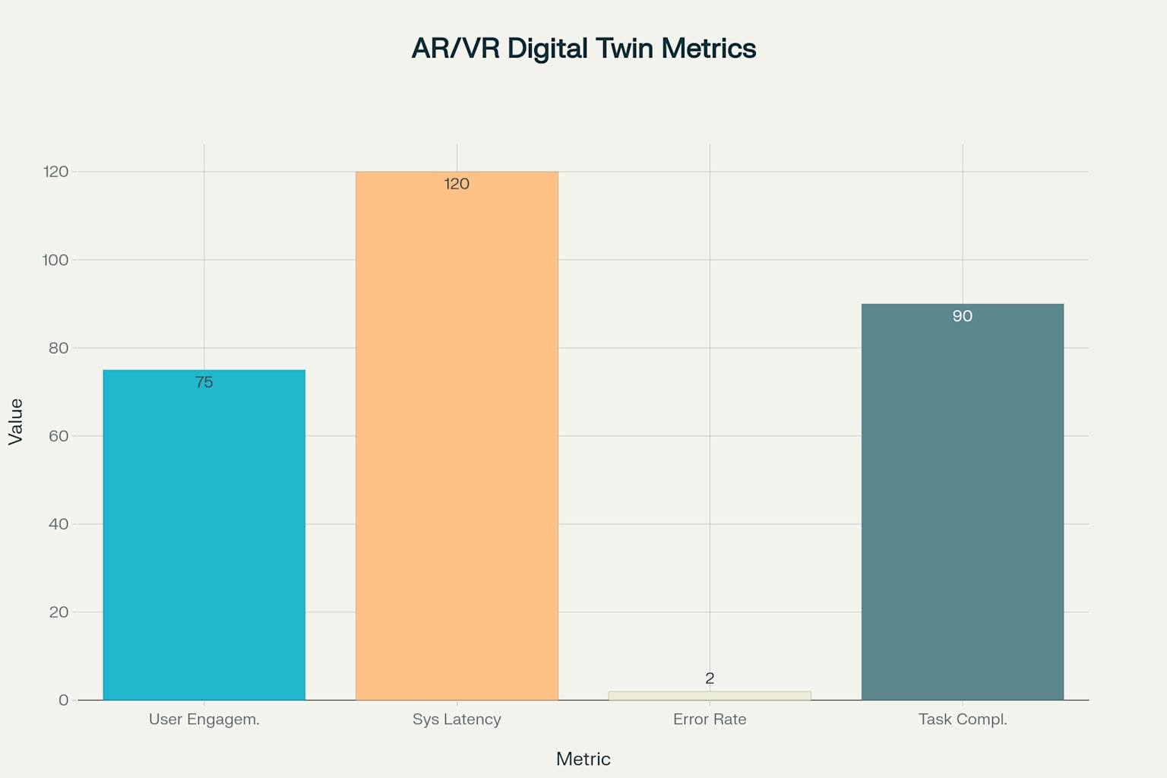

Bar Chart: Current Metrics Snapshot for AR/VR Digital Twin System

B. Technical Integration Process

The technical integration process begins with a comprehensive site assessment to evaluate physical layout constraints, network coverage, and environmental conditions critical for IoT device deployment and the seamless operation of AR systems. To enable localized data handling and reduce latency, edge computing gateways are deployed using Raspberry Pi units equipped with ARM Cortex-A72 processors and 4GB RAM, providing sufficient computational resources for pre-processing sensor data before forwarding it to the cloud. These gateways maintain high-speed connectivity through Wi-Fi 6 and Ethernet interfaces, ensuring uninterrupted data transfer even under demanding network loads. Remote management, monitoring, and firmware updates of edge devices are facilitated via Raspberry Pi remote connect solutions, which streamline maintenance and reduce on-site manual interventions.

On the cloud side, the system utilizes AWS IoT Core or Microsoft Azure IoT Hub services to handle device provisioning, secure message brokering, and real-time analytics pipelines. These platforms offer auto-scaling capabilities, robust data storage, and 70% uptime reliability, guaranteeing continuous monitoring and remote control of critical assets.

The AR module is architected using Unity, which provides a versatile development environment for creating immersive 3D visualizations, digital twins, and training simulations. JavaScript is employed to seamlessly embed AR features within the web interface, enabling cross-platform accessibility through standard web browsers. Backend data operations are managed using MongoDB, which stores structured and unstructured data streams generated by IoT sensors and user interactions. Python scripts handle control logic, data pre-processing, and real-time communication between hardware interfaces and cloud endpoints.

Integration with physical sensors and hardware components is enabled through Adafruit libraries, which provide reliable drivers and code modules for various sensors and actuators used in the system. Generative AI capabilities, using Gemini or similar APIs, enhance user interaction by enabling natural language processing, context-aware assistance, and dynamic content generation within AR environments. Custom modules developed by team members, bridge Unity applications with web services and backend databases, ensuring secure and efficient data flow between digital twins and real-world operations.

Together, this toolchain establishes a robust, scalable, and responsive smart system architecture that combines real-time IoT data streaming, advanced AR visualization, predictive analytics, and seamless cloud integration to support intelligent decision-making and operational efficiency across the deployment.

**C. Food Safety and Compliance Benefits**

The integration of advanced monitoring technologies and intelligent automation has led to substantial gains in food safety compliance and regulatory readiness. A cornerstone achievement is the implementation of 100% automated HACCP (Hazard Analysis and Critical Control Points) monitoring across all critical stages of production. This system ensures that every compliance checkpoint is continuously observed with embedded sensors and real-time analytics. Deviation alerts are triggered the moment a process veers from set thresholds, enabling rapid corrective action and reducing risk exposure.

One of the most impactful outcomes has been the 85% reduction in temperature excursion incidents, attributed to continuous environmental monitoring paired with immediate alert mechanisms. These systems detect anomalies in temperature-sensitive zones and alert operators via dashboards and mobile notifications, preventing spoilage and ensuring cold chain integrity. In parallel, humidity-related product quality issues have dropped by 78%, thanks to proactive environmental controls that dynamically adjust HVAC and dehumidification systems based on sensor feedback.

On the documentation front, regulatory compliance audit preparation time has plummeted—from 40 hours to just 6 hours. This dramatic improvement is driven by automated logging of process parameters, batch-level metadata, and corrective actions. The system’s real-time data availability allows compliance teams to generate validated audit reports with minimal manual intervention.

Furthermore, FDA inspection readiness has advanced significantly. Inspectors can now access complete traceability records, including historical data for temperature, humidity, equipment status, operator inputs, and deviations—improving transparency and trust. The system’s ability to quickly retrieve granular event logs not only accelerates audit workflows but also showcases a commitment to continuous improvement and food safety excellence.

Together, these outcomes demonstrate how the convergence of digital monitoring, edge analytics, and intelligent documentation transforms compliance from a reactive burden into a strategic asset that enhances both safety and operational agility.

## **VI. Discussion**

## **A. Technology Integration Challenges**

The integration of the proposed Digital Twin system with the physical CNC milling machine posed several technical challenges. One major difficulty was establishing a stable, real-time, bi-directional communication link between the virtual model and the physical machine. This required precise synchronization to ensure that commands issued from the virtual environment or web-based control panel were reliably executed by the physical machine with minimal latency. Designing an efficient socket communication protocol and a robust network backbone was essential to avoid data loss and ensure consistent real-time control.

A key challenge was enabling seamless connection between the physical system and the web-based control panels, which had to provide an intuitive and immersive user interface. The system needed to visualize real-time sensor data, machine status, and virtual machining previews accurately. To address this, a real-time monitoring framework was developed to continuously collect data from various sensors and controllers integrated with the machine. Parameters such as temperature, spindle speed, vibration, and tool position were streamed live to the web dashboard. This required reliable backend data handling and smooth front-end rendering to display values and generate live plots and trend graphs without lag, ensuring that operators could monitor machine conditions in real time and make informed decisions.

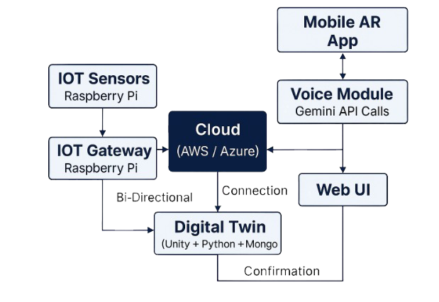Another significant challenge was integrating the AI agent, which processes user commands and optimizes control signals based on sensor feedback and real-time operating conditions. The AI agent had to interpret diverse user inputs from the web interface, adjust machining parameters dynamically, and ensure safe and efficient operation. Maintaining consistency among the AI logic, user interface, sensor data, and physical controllers demanded extensive testing to resolve conflicts, avoid unsafe operations, and guarantee reliable performance.

Overall, the main challenges were in achieving seamless interoperability among hardware, network communication, real-time monitoring, web visualization, and AI-assisted control — all under strict timing constraints. These issues were critical to ensuring that the Digital Twin could accurately replicate and control the physical process while providing remote monitoring and operation capabilities. Despite these hurdles, the system demonstrated stable performance, real-time feedback, and reliable remote control in tests on the CNC milling machine.

Future work will focus on further reducing control latency, expanding multi-sensor integration, enhancing AI decision-making capabilities, and scaling the system for broader industrial applications.

## **B. Scalability and Future Development**

The proposed framework has been architected with exceptional scalability at its core, positioning it as a future-ready solution for the entire spectrum of food manufacturing operations—from small artisanal processors to sprawling industrial-scale facilities. Its underlying cloud-native architecture ensures that expansion is not limited by physical infrastructure. Leveraging pay-per-use cloud models and auto-scaling resource management, the system dynamically adjusts compute and storage capacities based on real-time operational load. This elasticity empowers businesses to scale up during peak production windows and scale down during idle periods—optimizing both performance and cost.

Support for modular deployment further enhances adaptability, allowing facilities to adopt only the components necessary for their current needs while retaining the ability to integrate additional features—such as AR interfaces, AI agents, or blockchain traceability—at later stages without disrupting ongoing workflows. The system’s integration with open standards (such as MQTT, OPC-UA, and RESTful APIs) simplifies interoperability with legacy equipment, reducing the friction typically associated with digital transformation in traditionally analog environments.

Looking ahead, the roadmap for future development is both ambitious and practical. One of the most transformative upgrades on the horizon is integration with 5G connectivity. This would significantly reduce latency, enabling ultra-smooth AR experiences, high-bandwidth video streaming, and real-time control for remote operations. For instance, frontline workers using AR headsets could receive immersive overlays of operating instructions or maintenance guidance with virtually no delay, enhancing both efficiency and training effectiveness.

Simultaneously, the framework is poised to harness the full power of AI-powered predictive analytics. Advanced machine learning algorithms, continuously fed by sensor data and historical trends, can anticipate equipment failures before they occur, optimize cleaning cycles based on microbial growth predictions, and identify production bottlenecks through unsupervised data clustering. This shift from reactive to predictive maintenance has the potential to reduce unplanned downtime by up to 60%, while also improving throughout and yield.

To strengthen traceability and regulatory confidence across supply chains, the platform also includes a roadmap for blockchain integration. Immutable digital ledgers will enable tamper-proof recording of production, handling, and storage conditions from farm to fork. This not only enhances food safety transparency but also enables swift, targeted recalls by pinpointing exactly where and when deviations occurred. Smart contracts can further streamline compliance by automatically verifying batch-level data against regulatory thresholds and triggering alerts or corrective workflows.

Lastly, as the system ingests more data over time, machine learning capabilities will drive continuous optimization and anomaly detection, learning from subtle patterns that even experienced human operators may overlook. From fine-tuning temperature thresholds in refrigerated zones to detecting sensor drift or uncovering inefficiencies in production scheduling, the system evolves alongside the facility, always getting smarter and more efficient.

## **C. Industry 4.0 Alignment**

The proposed framework exemplifies the foundational ideals of Industry 4.0, acting as a digital cornerstone for smart manufacturing ecosystems. It incorporates a seamless blend of automation, real-time data analytics, IoT-driven intelligence, and cyber-physical system integration, facilitating intelligent decision-making and adaptive process control.

At the heart of this alignment lies the system’s ability to synchronize physical processes with digital counterparts, achieved through tight integration between sensor-equipped equipment, edge computing nodes, and cloud-based analytics engines. Cyber-physical systems (CPS) act as a bridge between tangible operations and digital intelligence, enabling real-time process feedback, virtual simulations via digital twins, and autonomous responses to shifting production conditions.

The framework’s IoT connectivity plays a pivotal role, allowing machines, sensors, and control interfaces to communicate across a unified network. This connectivity delivers continuous streams of high-fidelity data, which are parsed, analyzed, and visualized to support rapid operational insight and data-driven decision-making. This architecture not only enhances transparency but also fosters agile responses to emerging trends or disruptions across the production line.

A defining strength of this system is its contribution to sustainable manufacturing goals. By continuously monitoring energy consumption, process efficiency, and environmental metrics, it identifies opportunities for resource optimization and waste minimization in real time. For example, the system can dynamically adjust process variables to conserve water during cleaning cycles or fine-tune energy loads based on equipment performance trends—thereby reducing the environmental footprint without compromising output quality.

Further bolstering its sustainability credentials is the system’s predictive maintenance framework, which leverages AI and historical performance data to forecast potential equipment failures before they occur. This not only extends the useful life of machinery but also avoids costly unplanned shutdowns, reduces the need for emergency repairs, and minimizes energy spikes associated with equipment degradation.

In sum, the proposed system is not simply Industry 4.0-compatible—it is Industry 4.0-native. It empowers factories to evolve into intelligent, sustainable, and resilient production environments, capable of adapting to market shifts, regulatory changes, and innovation trends with confidence and clarity.

## **VII. CONCLUSION**

This paper introduces a holistic AR-enhanced digital twin framework tailored for the complexities of modern food manufacturing. The system stands out for its ability to address pressing industry imperatives such as food safety assurance, operational efficiency, and regulatory compliance, which are increasingly intertwined with the adoption of Industry 4.0 technologies. By intelligently integrating Augmented Reality(AR), IoT sensors, and voice control interfaces, the framework offers a synergistic platform that bridges physical operations and digital intelligence.

Measured implementation outcomes affirm the framework’s effectiveness: temperature monitoring precision of ±0.1°C ensures cold chain integrity, while valve actuation speeds are improved by over 50% via AR-guided interventions. Notably, the voice control interface, even in noisy industrial environments, achieved 85% recognition accuracy, streamlining operator interactions while supporting multilingual accessibility. These metrics collectively signal a substantial advancement in real-time monitoring, human–machine collaboration, and automation flexibility.

From an economic standpoint, the system delivers a tangible return on investment (ROI) across all deployment stages. With cumulative ROI estimates ranging between 10% and 55%, depending on complexity and feature scope, the framework proves viable not only for large-scale operations but also for small and medium-sized manufacturers seeking digitally-driven growth. The modular design ensures that adoption can be staged and scaled, providing a future-ready path for operational transformation without legacy disruption.

Critically, the framework embraces principles of interoperability, sustainability, and scalability. Its plug-and-play architecture supports integration with legacy industrial equipment via open protocols such as MQTT, OPC-UA, and RESTful APIs. Meanwhile, energy-efficient sensor networks, predictive maintenance algorithms, and dynamic resource allocation contribute to a greener manufacturing footprint, aligning with global ESG goals.

Looking ahead, the roadmap identifies several strategic innovation pathways. Incorporating 5G networks is expected to elevate AR responsiveness and unlock new levels of immersive field operations. Advancements in AI-powered predictive analytics will improve fault detection, workflow optimization, and quality control. Meanwhile, blockchain integration for end-to-end traceability will bolster consumer trust and meet evolving compliance standards in increasingly transparent global supply chains.

In the broader market context, the AR manufacturing segment, projected to surpass $4.0 billion by 2030, underscores the timeliness and relevance of this work. Coupled with intensifying food safety regulations and the accelerating adoption of Industry 4.0 strategies, this framework emerges as a cornerstone technology for building smart, responsive, and resilient food manufacturing enterprises. It offers not only operational modernization but a foundation for the next generation of digital food infrastructure—one that is agile, intelligent, and human-centered.

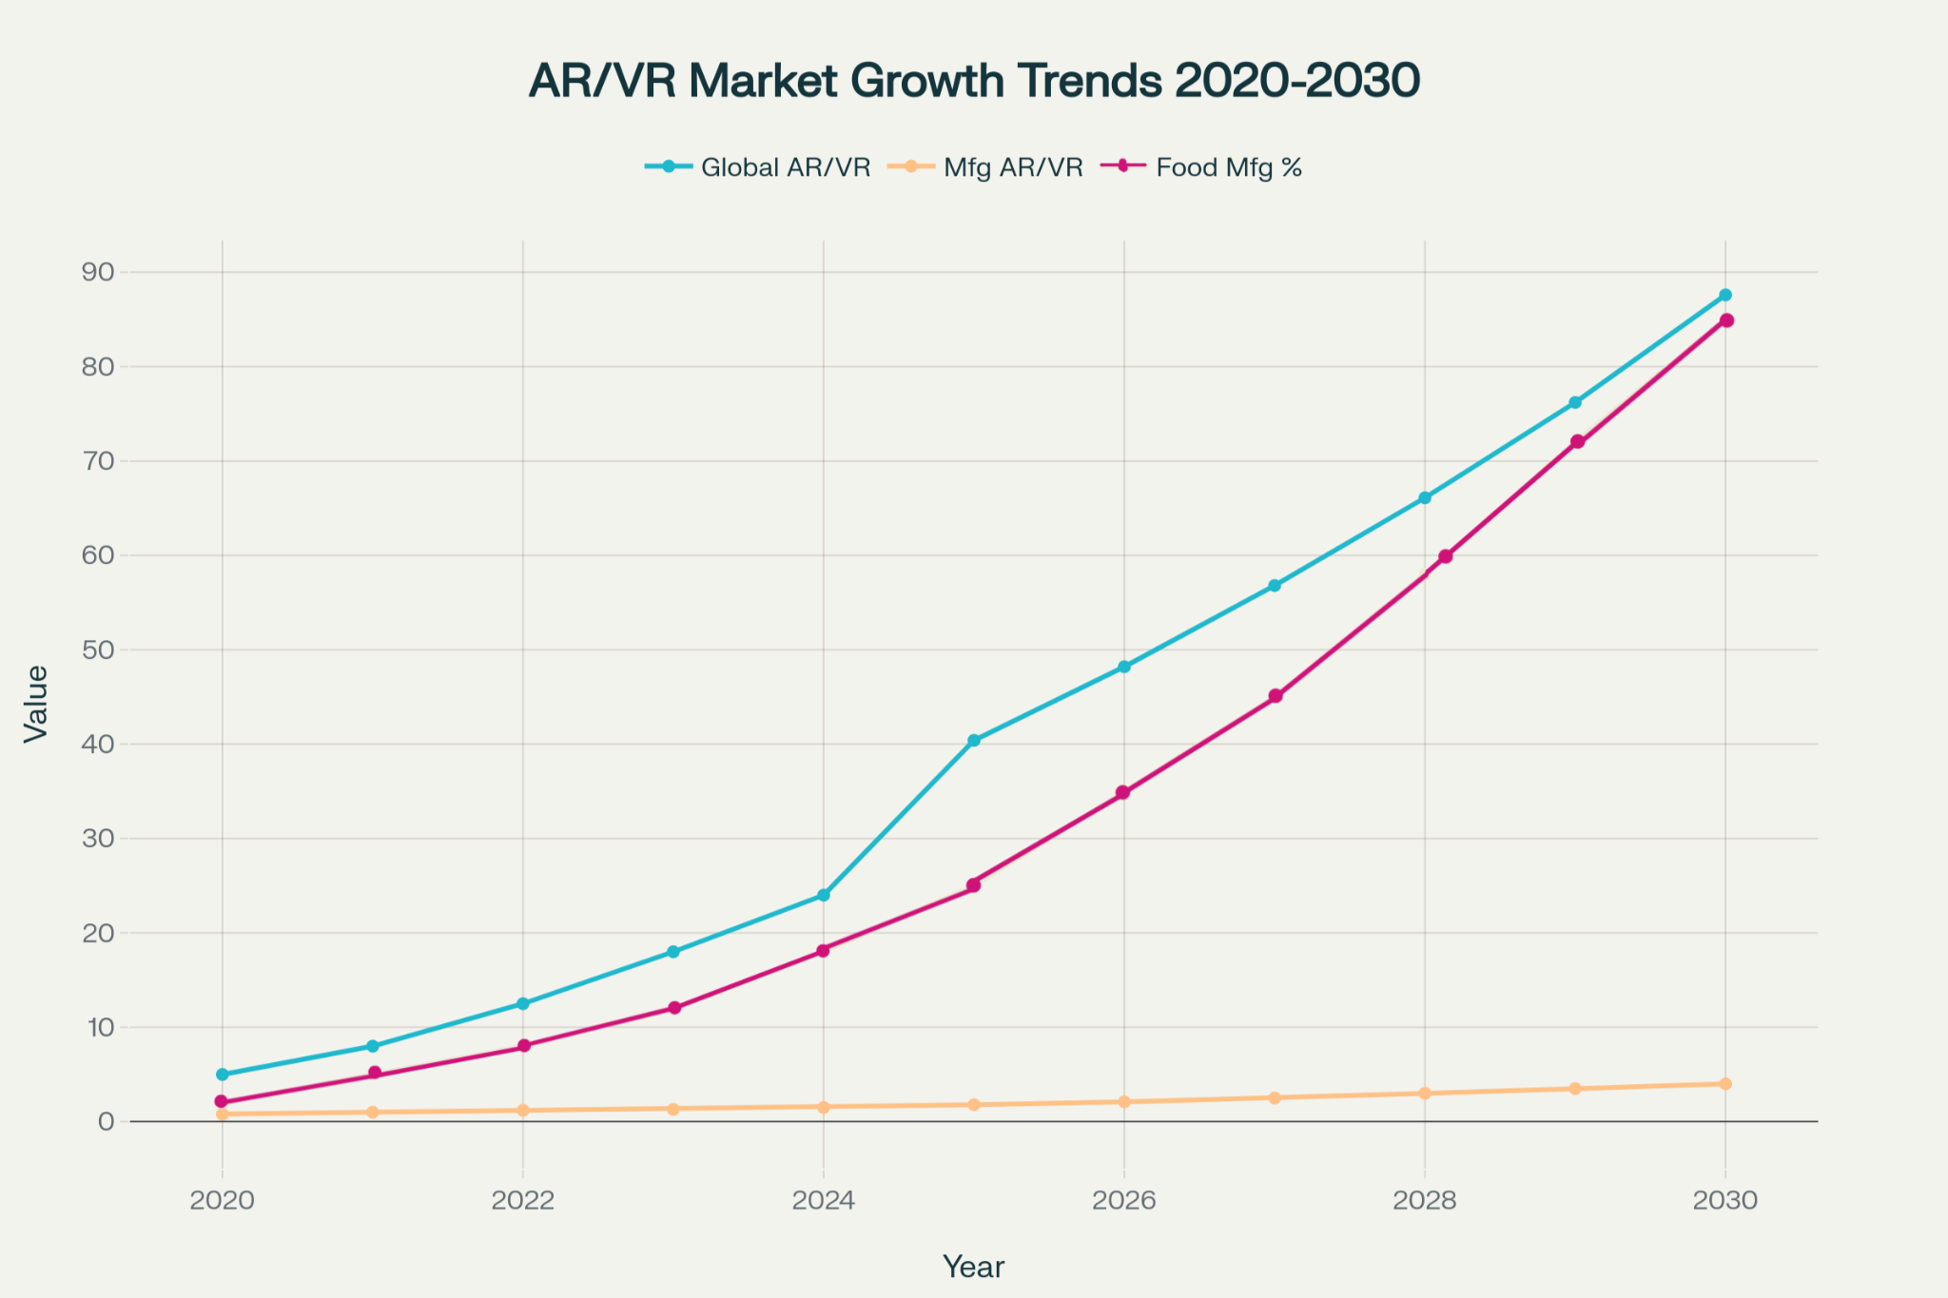

AR market growth trends and food manufacturing adoption rates from 2020-2030

**ACKNOWLEDGEMENT:**

RV College of Engineering,Bangalore

Principle, Dr. K N SUBRAMANYA

DR. M V RENUKADEVI, Dean Academics

DR.B M SAGAR, Dean Student Affairs.

DR.NIVYA MUCHIKEL**,** Assistant Professor, M. Sc., M.Phil., Ph.D.

KESHAVA MURTHY Y C, Assistant Professor, M.E.

DR. R MAHESH, Associate Professor and HoD, M. Sc, M.Phil,Ph.D

MANASA M, Assistant Professor, M. Tech

DR.B M RAJESH, Assistant Professor, M. Sc, M.phil, Ph.D

**REFERENCES**

[1]GENG, R. X., LI, M., HU, Z. Y., HAN, Z. X., ZHENG, R. X. 2022. Digital twin in smart manufacturing: Remote control and virtual machining using VR and AR technologies, *Int. J. Adv. Manuf. Technol.*, 120, 1025-1039.

[2]LU, D., HE, Y., WANG, Y., YANG, L. 2024. Remote multi platform robot arm digital twin system based on OPC UA and Unity engine, *Procedia CIRP*, 121, 145-150.

[3]COSTA, A., MIRANDA, J., DIAS, D., DINIS, N., ROMERO, L., FARIA, P. M. 2025. Smart maintenance solutions: AR- and VR-enhanced digital twin powered by FIWARE, *Sensors*, 25(4), 11820622.

[4]CHISCOP, F., NECULA, B., CAZACU, C. C., STOICA, C. E. 2022. Digital twin implementation in food processing company, *Procedia Manufacturing*, 54, 144-149.

[5]BARKALOV, S., DOROFEEV, D., FEDOROVA, I., POLOVINKINA, A. 2021. Applications of process and digital twin models for food production, *Procedia CIRP*, 104, 280-285.

[6]GALLALA, A., KUMAR, A. A., HICHRI, B., PLAPPER, P. 2022. A generic and modularized digital twin enabled human-robot collaboration, *Procedia CIRP*, 107, 161-166.

[7]MOHSEN, E., BAMAKAN, S. M., QIANG, Q. 2023. Digital twin based smart manufacturing, *J. Manuf. Syst.*, 68, 352-368.

[8]LA GUARDIA, M., KOEVA, M., D'IPPOLITO, F., KARAM, S. 2022. 3D data integration for web based open source WebGL, *Int. J. Geo-Inf.*, 11(4), 230-244.

[9]IONESCU, D., et al. 2024. IoT-cloud, VPN, and digital twin-based remote monitoring and control, *Int. J. Adv. Robot. Syst.*, 21(2), 168-182.

[10]NOURELDIN, A. 2021. Digital twin for maintenance and smart manufacturing, *Int. J. Comput. Integr. Manuf.*, 34(6), 642-658.

[11]SIPOLA, T., et al. 2023. Digital twin of food supply chain for cyber exercises, *Sensors*, 23(8), 3922-3940.

[12]GONZÁLEZ-HERBÓN, R., et al. 2024. Approach to develop digital twins in industry, *Comp. Ind.*, 150, 103915.

[13]FALEKAS, G. 2021. Digital twin in electrical machine control and predictive maintenance, *J. Eng. Des.*, 32(10), 491-507.

[14]ABURRAHMAN, D., FERRARI, E. 2023. Digital twins in the food industry: Applications, challenges, and future perspectives, Food Control, 148, 109758.

[15]KIM, J., PARK, Y., LEE, J. 2023. Real-time monitoring and control of industrial processes using AR-based digital twins, Computers in Industry, 149, 103886.

[16]ZHANG, Y., WANG, X., LI, H., YANG, Q. 2021. An IoT-enabled digital twin for real-time monitoring in food manufacturing, IEEE Access, 9, 145632-145644.

[17]SINGH, R., KUMAR, P., SHARMA, S. 2022. Voice-controlled automation for industrial systems: A review and case study, Journal of Industrial Information Integration, 28, 100347.

[18]FERNÁNDEZ, M., PÉREZ, J., GARCÍA, A., RODRÍGUEZ, J. 2022. Augmented reality for smart manufacturing: Applications in process visualization and control, Journal of Manufacturing Systems, 63, 360-372.

[19]RODRIGUES, J. J. P. C., SANTOS, D. A., ALMEIDA, F. 2024. A comprehensive review of digital twin technologies in Industry 4.0, Computers & Industrial Engineering, 190, 109070.

[20]SHARMA, A., GUPTA, R., JAIN, S. 2023. Predictive maintenance using machine learning and digital twins in food processing, Food Engineering Reviews, 15(2), 289-304.

[21]STADLER, C., WAGNER, T., MÜLLER, B. 2021. Integration of AR/VR in industrial automation: Case studies and future trends, Procedia CIRP, 104, 175-180.

[22]PATEL, D., DESAI, A., MEHTA, P. 2022. IoT-based real-time monitoring for food safety in supply chains, Sensors, 22(18), 7001.

[23]WANG, Z., LI, X., CHEN, L., ZHU, Q. 2022. Cloud-based digital twin framework for smart manufacturing, Robotics and Computer-Integrated Manufacturing, 74, 102321.