Student Name: | Aneta Mielczarek | Student Number: | S00289919 | Class Group: | B

1. Proposed 4 Page Web Site Topic
[Short description of the website goals and objectives and intended audience]
This website is for those interested in true crime and shares generic stories as well as more infamous people that these people can read about. It also adds a page to let users engage with this website.
This website is intended to educate.
goals: interactive interface, animations, forum for engagement.

2. Proposed Design
[Short description of the website logo, main navigation, colours, sources of information]
Logo: “true crime” with a knife on the bottom
main nav: Home, Killer of the week, previous kotw, Forum
Colours: black,red
Main sources: YouTube – Bailey Sarian, news networks, documentaries, research papers

3. Proposed Design of each page content
[Short description of the website content of each page, colours, text font types etc and sources]

Homepage: some light new crime stories based anywhere in the world (these would change daily but for the project some stories would be picked and put on this page and there wouldn’t be a cycle)
‘Killer of the week’ page: page based on a murderer that would be picked weekly (for this project it would be based on Robert Pickton)

‘’killer of the week’’ History: previous killers of the weeks

Forum page: page to suggest future ‘killer of the week’

4. Rough Proposed sketch of website home page -
[example in Chapter 1 & 18 can sketch by hand or use an app and include photo image]
Little bit of scrolling and you see footer.
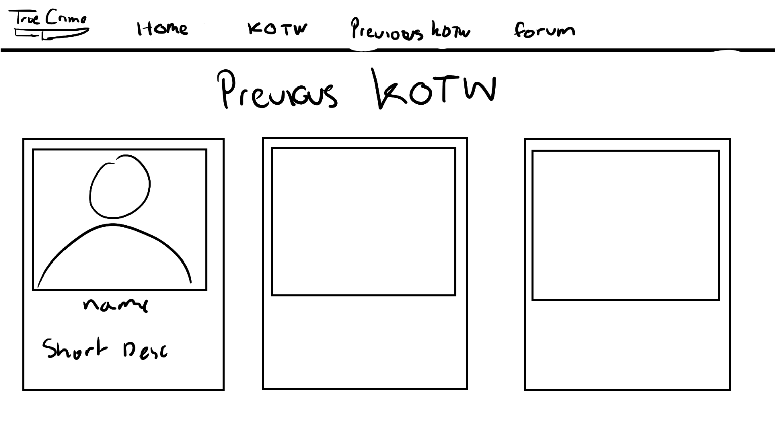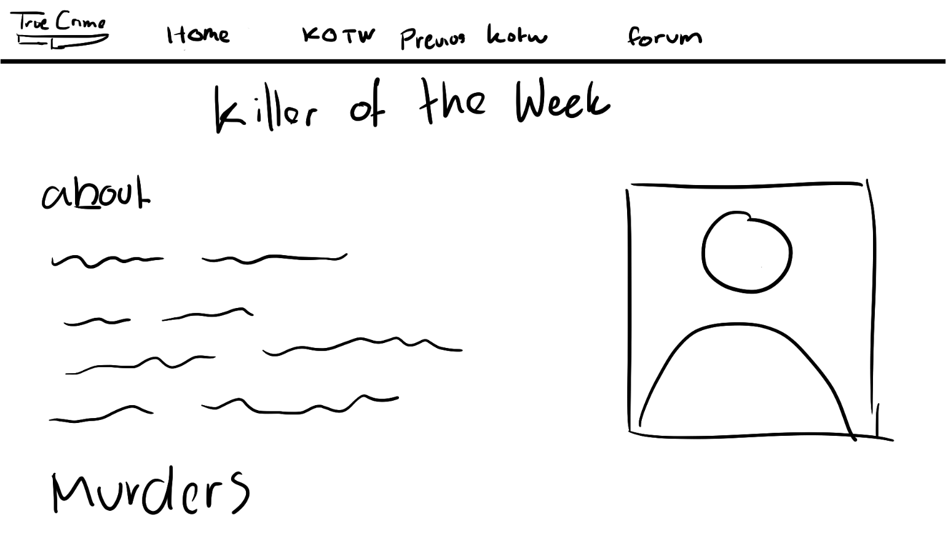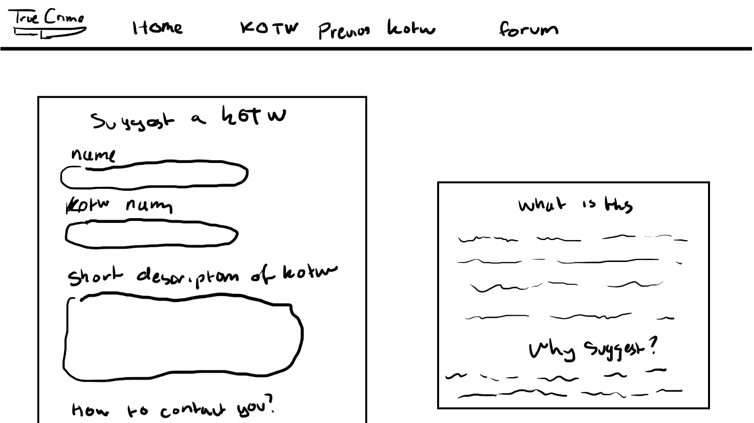

Notes: Project outline
Create a simple website on a topic of your choice. A proposed topic and design brief must be submitted on or before submission date. Once your lecturer will approve your design and marked on moodle.

Included in your Website
- Good coding practices - Code Comments, Code Indentation, White space,
- Web pages should Clear consistent design, Visually attractive clear and clean and aligned. Suitable use of colours and fonts, all text and images referenced.(Public domain images).
  - Follow four principles of graphic design, Alignment, Proximity, Repetition and Contrast
- **All text content must be clear concise and meaningful and reference link to source. Do not reference any personnel details, name etc or any reference to ATU Sligo on the web pages.
- **Place on the following text on the home page. This is a college project completed as part of an assignment.
Project will consist of the following and you will be provided with a complete check list of features which will form the marking scheme for the project
- Internal and external styling (CSS), minimum of 4 html pages, appropriate use of sematic HTML 5 on every page, background and foreground, tables of statistical data, internal and external links, lists numbered and bullet, video, a contact form, radio buttons etc , google map, footer on every page with Copyright notice.
- Also additions marks for addition features not outlined above. Project checklist and marking scheme will be available on Moodle.

Proposal submission
- Use this Word document and upload on Moodle on timewith sections 1-4 above completed

