Cafeteria Management System
BPMN Process Diagrams
Based on SRS, User Stories, and Use Case Scenarios
BPMN Notation Legend
● Start Event (white circle) — marks where a process begins
● End Event (filled dark circle) — marks where a process ends
◇ XOR Gateway (diamond) — exclusive decision point, one path taken
□ Task (rounded rectangle) — an activity or action step
→ Sequence Flow (solid arrow) — normal flow between steps
- - → Message Flow (dashed arrow) — cross-lane communication
Swim Lanes — horizontal bands representing actors/roles

1. Order-to-Payment & Kitchen Flow
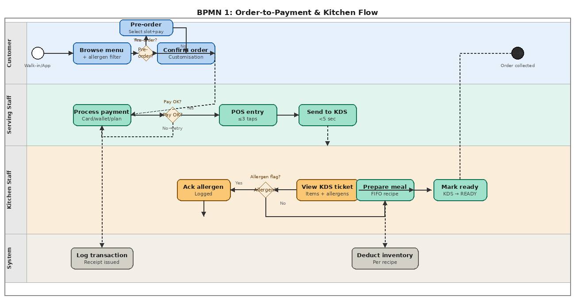
Shows the full customer order lifecycle from walk-in or pre-order, through POS entry, KDS dispatch, allergen acknowledgement, meal preparation, and payment processing. Swim lanes: Customer, Serving Staff, Kitchen Staff, System.

2. Inventory & Procurement Flow
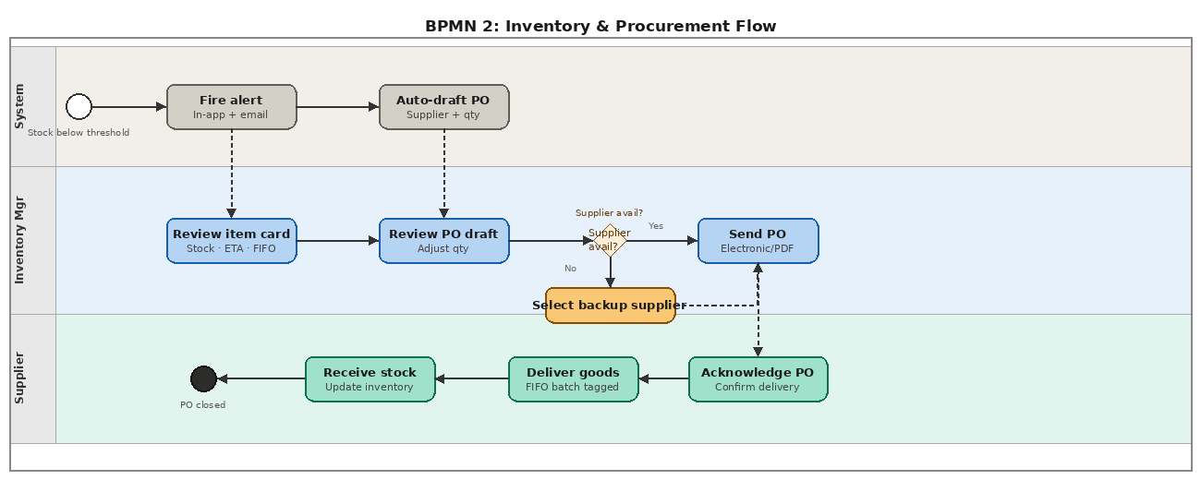
Covers the automated low-stock alert trigger, inventory manager review, purchase order drafting and adjustment, supplier availability gateway, goods delivery, and stock receipt with FIFO batch tagging. Swim lanes: System, Inventory Manager, Supplier.

3. Staff Scheduling & Payroll Flow
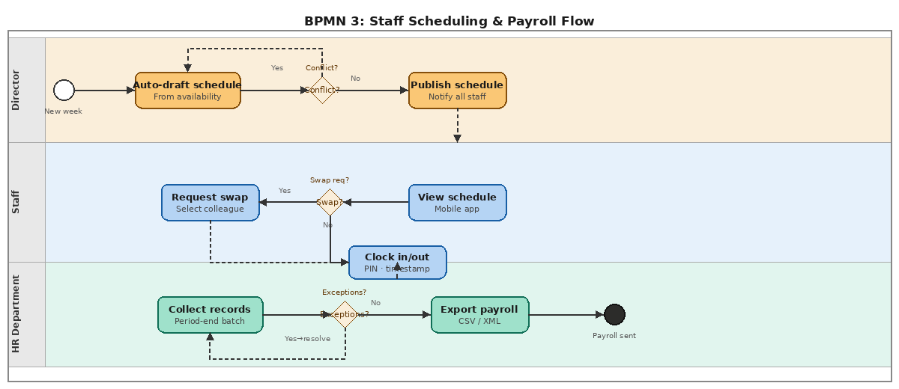
Details schedule auto-generation, conflict detection, shift swap requests, digital clock-in/out, and HR payroll export with exception resolution. Swim lanes: Director, Staff, HR Department.

4. Finance — P&L & Budget Variance
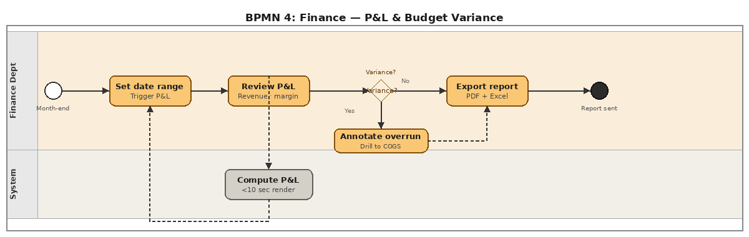
Depicts month-end P&L triggering, system computation, director review, budget variance annotation, COGS drill-down, and PDF/Excel export. Swim lanes: Finance Department, System.

5. IT Deployment & Security Incident Flow
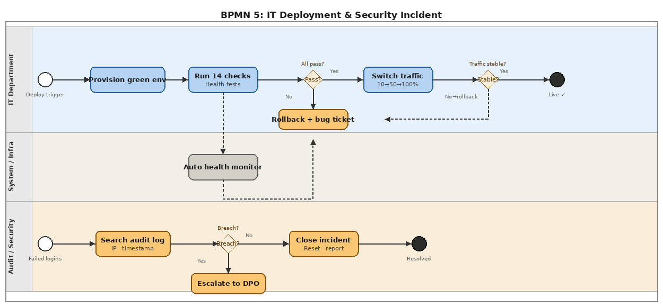
Two parallel flows — blue-green deployment (provision → health checks → traffic ramp → stability) and security incident handling (audit log search → breach assessment → DPO escalation). Swim lanes: IT Department, System/Infra, Audit/Security.

