SOFTWARE ENGINEERING
LAB 1 | Requirements Engineering & UML Use-Case Modelling
PROBLEM STATEMENT #20
Hospital Bed & ICU Allocation Dashboard

SUBMISSION BY
Name | Abhirama H Y
SRN | PES2UG24CS023
Section | A

COMBINED LAB SUBMISSION
Problem Statement • Requirements Table • UML Use-Case Diagram • Use-Case Flow Specification

Problem Statement

1. Problem Context & Overview
An emergency room bed management dashboard displaying real-time ward occupancy, prioritizing ICU transfers based on triage score, and orchestrating inter-facility ambulance transfer workflows.

2. Target Stakeholders / Actors
Triage Nurse | Hospital Administrator

3. Sample Functional Requirement
FR-001 [Priority: High]
Description: The system shall compute triage severity scores from intake vitals and dynamically order the ER bed allocation waitlist.
Sample Acceptance Criteria: Pass: Higher acuity patient automatically moves ahead of lower acuity patient; Fail: FIFO queue ignores critical emergency.

4. Sample Non-Functional Requirement
NFR-001 [Type: Performance & Security]
Description: Bed status transitions (Occupied, Cleaning, Available) must propagate to all connected ER dashboard clients in under 1 second via WebSockets.
Sample Acceptance Criteria: Pass: Benchmarking tests confirm target latency and security standards under simulated peak load.

5. Required Deliverables
Complete Requirements Table — exactly 5 Functional Requirements (FR-001 to FR-005).
2 Non-Functional Requirements (NFR-001 & NFR-002) with ID, Type, Description, Priority, Acceptance Criteria, and Rationale.
UML Use-Case Diagram — model all actors and primary use cases and include at least one «include» and one «extend» relationship.
Use-Case Flow Specification — 1-page document for one core use case with Preconditions, Postconditions, Main Success Scenario, and one Alternate Flow.

Requirements Table
Req ID | Type | Description | Priority | Acceptance Criteria | Rationale | Comments
FR-001 | Functional | The system shall compute triage severity scores from intake vitals and dynamically order the ER bed allocation waitlist. | High | Pass: When a patient's intake vitals are submitted, the system calculates a severity score and places the patient in the waitlist according to acuity. Fail: The waitlist remains FIFO when a higher-acuity patient is entered. | Core requirement for prioritizing emergency patients and allocating scarce ER beds according to triage severity. | Given in problem statement; wording retained with measurable acceptance criterion.
FR-002 | Functional | The system shall display the real-time status of beds by ward, including Occupied, Cleaning, and Available, and allow authorized staff to update a bed status. | High | Pass: After an authorized user changes a bed status, the new status is displayed for that bed and ward. Fail: The old status remains displayed or an unauthorized user can change it. | Provides the operational visibility required for real-time bed and ICU allocation. | Status values are restricted to those specified by the problem statement.
FR-003 | Functional | The system shall support ICU transfer prioritization by presenting eligible patients in triage-score order together with currently available ICU beds. | High | Pass: For two eligible patients, the patient with the higher triage severity appears first, and the dashboard shows the current available ICU beds. Fail: The lower-severity patient is ranked first or bed availability is missing. | Directly supports the stated requirement to prioritize ICU transfers based on triage score and bed availability. | Designed to make the allocation decision traceable and consistent.
FR-004 | Functional | The system shall initiate and track an inter-facility ambulance transfer workflow, including transfer request, ambulance assignment, dispatch, and completion status. | High | Pass: A transfer can progress through Request → Assigned → Dispatched → Completed and each status is visible to authorized users. Fail: A required status cannot be recorded or the transfer cannot be tracked. | Supports the stated orchestration of inter-facility ambulance transfer workflows. | Status sequence is defined for testability.
FR-005 | Functional | The system shall notify relevant authorized staff when a critical bed allocation, ICU transfer, or ambulance transfer status requires their attention. | Medium | Pass: When a configured critical event occurs, the responsible authorized user receives a dashboard notification for that event. Fail: No notification is generated for the configured event. | Reduces delays in emergency coordination by making important workflow changes visible to responsible staff. | Notification is limited to relevant workflow events rather than every dashboard change.
NFR-001 | Nonfunctional | Bed status transitions (Occupied, Cleaning, Available) must propagate to all connected ER dashboard clients in under 1 second via WebSockets. | High | Pass: Benchmarking tests confirm that a bed-status update reaches all connected dashboard clients in < 1 second under the defined simulated peak load. Fail: The measured propagation time is ≥ 1 second or the update is not delivered to a connected client. | Given in problem statement and essential for a real-time emergency dashboard. | Performance target retained from the problem statement.
NFR-002 | Nonfunctional | The system shall enforce role-based access control so that only authenticated users with the required role can perform protected triage, bed-allocation, administration, or ambulance-transfer actions. | High | Pass: In security testing, 100% of unauthorized protected-action attempts are denied, while authorized test users can access only the functions assigned to their role. Fail: Any unauthorized protected action succeeds. | Protects patient-related operational data and prevents unauthorized changes to emergency allocation and transfer workflows. | Roles modeled in this assignment include Triage Nurse and Hospital Administrator; operational ambulance coordination is also represented.

UML Use-Case Diagram

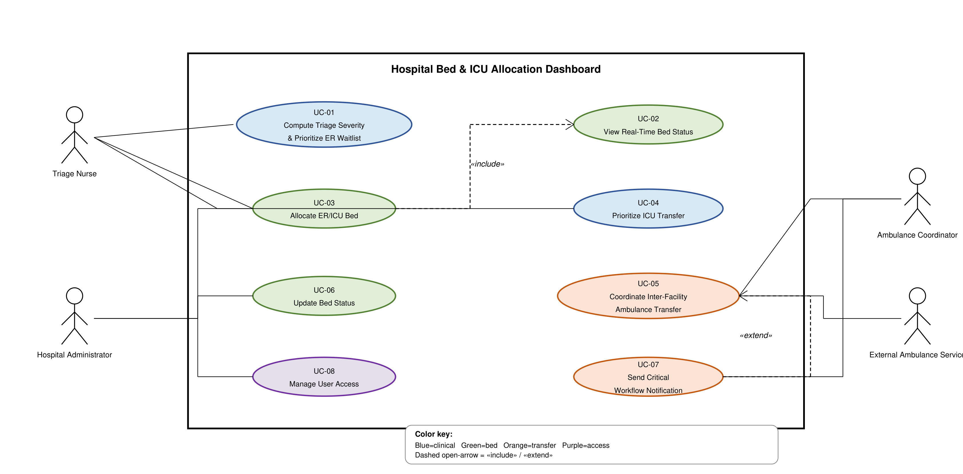

Use-Case Flow Specification
UC-04 — Prioritize ICU Transfer

Primary Actors | Triage Nurse; Hospital Administrator
Supporting Actors | Ambulance Coordinator; External Ambulance Service
Preconditions | Patient has a recorded triage severity score; ICU bed-status data is available; user is authenticated and authorized.
Postconditions | The prioritized ICU-transfer decision is recorded/displayed; if transfer is initiated, the ambulance workflow can be tracked.

Main Success Scenario
- Triage Nurse selects the ICU transfer prioritization function.
- System retrieves eligible patients and their current triage severity scores.
- System retrieves the current ICU bed availability/status.
- System orders eligible patients by triage severity, placing higher-acuity patients ahead of lower-acuity patients.
- System displays the prioritized transfer list together with available ICU beds.
- Triage Nurse selects the highest-priority eligible patient for transfer.
- System records the ICU transfer prioritization decision and updates the workflow status.
- System displays the updated transfer state to authorized users.

Alternate Flow — ICU Bed Unavailable
- System finds that no ICU bed is currently available.
- System displays the patient’s priority position and the current ICU availability as unavailable.
- System keeps the patient in the prioritized transfer list and allows authorized staff to monitor the bed-status change.
- When an ICU bed becomes available, the system updates the dashboard and the patient can be considered for transfer again according to the current priority order.

Traceability note: This flow operationalizes FR-001, FR-002, and FR-003 and uses the real-time bed-status behavior specified by NFR-001.

