SOFTWARE ENGINEERING
LAB 2
Agile Backlog Creation & Sprint Simulation in Jira
Project #20: Hospital Bed & ICU Allocation Dashboard

Name | Abhirama H Y
SRN | PES2UG24CS023
Section | A

1. Objective
To convert the functional requirements from Lab 1 into Agile Epics and User Stories using Jira, prioritize and estimate the stories using story points, simulate two Scrum sprints, and analyse sprint progress using a Burndown Chart.

2. Epics
Epic | Description | Lab 1 Traceability
EPIC 1 — ER Triage & Bed Allocation | Manage emergency-room triage prioritization and real-time hospital bed allocation by calculating patient severity, ordering the ER bed allocation waitlist, displaying bed availability, and allowing authorized staff to update bed status. | FR-001, FR-002, NFR-001, NFR-002
EPIC 2 — ICU Transfer Prioritization | Support ICU transfer decisions by prioritizing eligible patients according to triage severity, displaying current ICU bed availability, recording transfer decisions, and handling situations where an ICU bed is unavailable. | FR-003, NFR-002
EPIC 3 — Inter-Facility Ambulance Transfers | Manage inter-facility ambulance transfers from transfer request through ambulance assignment, dispatch, and completion while allowing authorized users to track the current transfer status. | FR-004, NFR-002
EPIC 4 — Critical Event Notifications | Notify relevant authorized staff when critical bed allocation, ICU transfer, or ambulance transfer events require attention so that emergency workflows can be handled without unnecessary delay. | FR-005, NFR-002

3. User Stories, Priorities and Story Points
# | Epic | User Story Summary | User Story | Priority | Points
1 | ER Triage & Bed Allocation | Calculate Patient Triage Severity | As a Triage Nurse, I want the system to calculate a patient's triage severity score from their intake vitals, so that emergency patients can be prioritized according to acuity. | High | 5
2 | ER Triage & Bed Allocation | Prioritize ER Bed Allocation Waitlist | As a Triage Nurse, I want the ER bed allocation waitlist to be dynamically ordered according to triage severity, so that higher-acuity patients are placed ahead of lower-acuity patients. | High | 5
3 | ER Triage & Bed Allocation | View Real-Time Bed Status | As a Triage Nurse, I want to view the real-time status of beds by ward, so that I can identify available, occupied, and cleaning beds when making allocation decisions. | High | 3
4 | ER Triage & Bed Allocation | Update Bed Status | As an authorized hospital staff member, I want to update a bed's status between Occupied, Cleaning, and Available, so that the dashboard accurately reflects current bed availability. | High | 3
5 | ICU Transfer Prioritization | View Prioritized ICU Transfer List | As a Triage Nurse, I want to view eligible patients ordered by triage severity, so that I can identify which patient should receive ICU transfer priority. | High | 5
6 | ICU Transfer Prioritization | View Available ICU Beds | As a Triage Nurse, I want to view currently available ICU beds alongside the prioritized transfer list, so that I can determine whether a suitable ICU transfer can be made. | High | 3
7 | ICU Transfer Prioritization | Record ICU Transfer Decision | As a Triage Nurse, I want to select an eligible patient for ICU transfer and record the prioritization decision, so that the transfer decision is traceable and visible to authorized staff. | High | 3
8 | ICU Transfer Prioritization | Handle ICU Bed Unavailability | As a Triage Nurse, I want the system to show when no ICU bed is available while retaining the patient's priority position, so that I can monitor availability and reconsider the transfer when a bed becomes available. | High | 3
9 | Inter-Facility Ambulance Transfers | Create Ambulance Transfer Request | As an Ambulance Coordinator, I want to create interfacility ambulance transfer request, so required patient transfer can enter the ambulance workflow. | High | 3
10 | Inter-Facility Ambulance Transfers | Assign Ambulance to Transfer | As an Ambulance Coordinator, I want to assign an ambulance to a transfer request, so that the requested inter-facility transfer can be prepared for dispatch. | High | 3
11 | Inter-Facility Ambulance Transfers | Track Ambulance Transfer Status | As an Ambulance Coordinator, I want to track an ambulance transfer through Request, Assigned, Dispatched, and Completed statuses, so that authorized staff can monitor the progress of the transfer. | High | 5
12 | Critical Event Notifications | Notify Staff of Critical Events | As an authorized hospital staff member, I want to receive dashboard notifications when a critical bed allocation, ICU transfer, or ambulance transfer event requires attention, so that I can respond to important workflow changes promptly. | Medium | 3

4. Lab 1 Traceability
Lab 1 Item | Jira Coverage | Notes
FR-001 | Stories 1–2 | Triage severity calculation and ER waitlist prioritization.
FR-002 | Stories 3–4 | Real-time bed display and authorized bed-status updates.
FR-003 | Stories 5–8 | ICU prioritization, ICU availability, decision recording and unavailable-bed flow.
FR-004 | Stories 9–11 | Request, ambulance assignment, and Request → Assigned → Dispatched → Completed tracking.
FR-005 | Story 12 | Critical event notifications.
NFR-001 | Stories 3–4 and related bed-status functionality | Real-time bed-status propagation requirement.
NFR-002 | Protected operations across relevant stories | Role-based access control.

5. Jira Backlog — Screenshot
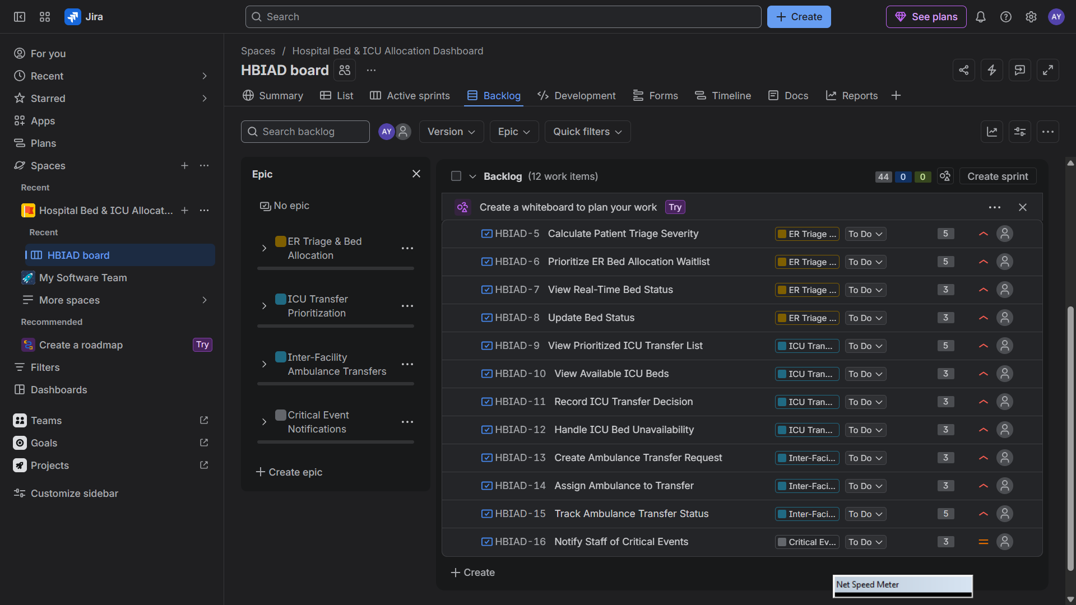
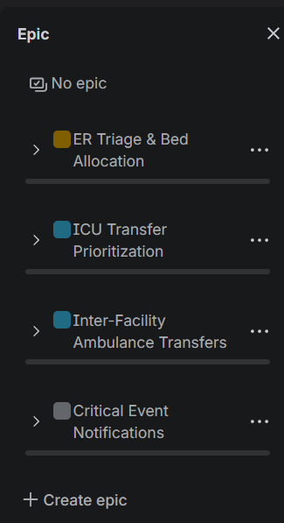

6. Story Point Assignments — Screenshot
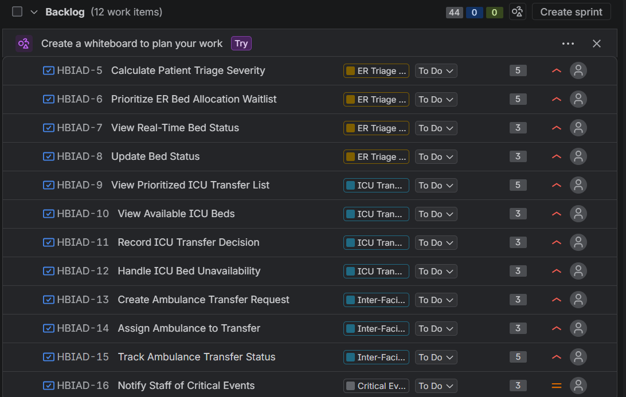

7. Sprint Planning
Sprint 1
Goal: Implement core ER triage, real-time bed visibility, and initial ICU transfer prioritization capabilities.
Duration: 1 week
Planned Story Points: 24
Sprint 1 Story | Story Points
Calculate Patient Triage Severity | 5
Prioritize ER Bed Allocation Waitlist | 5
View Real-Time Bed Status | 3
Update Bed Status | 3
View Prioritized ICU Transfer List | 5
View Available ICU Beds | 3

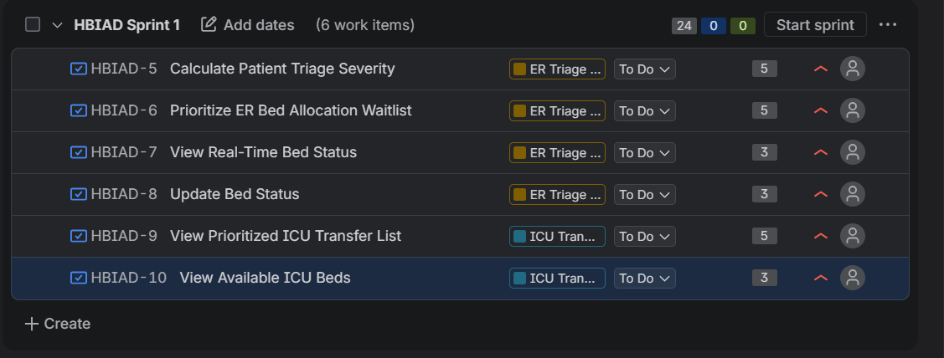
Sprint 2
Goal: Complete ICU transfer workflow, inter-facility ambulance transfer tracking, and critical event notifications.
Duration: 1 week
Planned Story Points: 20
Sprint 2 Story | Story Points
Record ICU Transfer Decision | 3
Handle ICU Bed Unavailability | 3
Create Ambulance Transfer Request | 3
Assign Ambulance to Transfer | 3
Track Ambulance Transfer Status | 5
Notify Staff of Critical Events | 3
Total backlog: 44 Story Points across 12 User Stories.

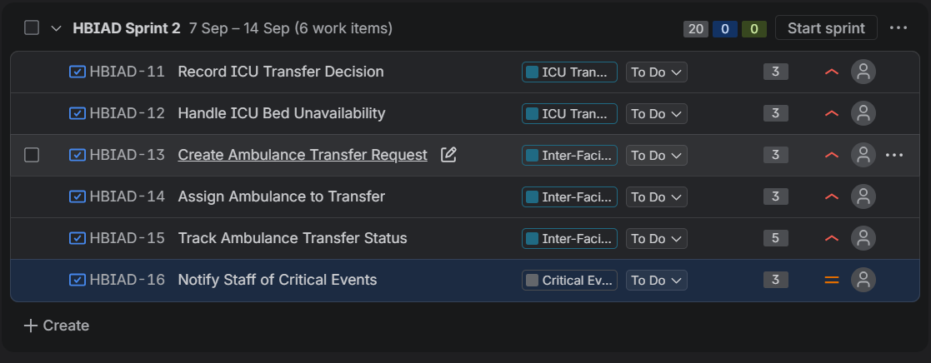

8. Sprint Board / Active Sprint — Screenshot
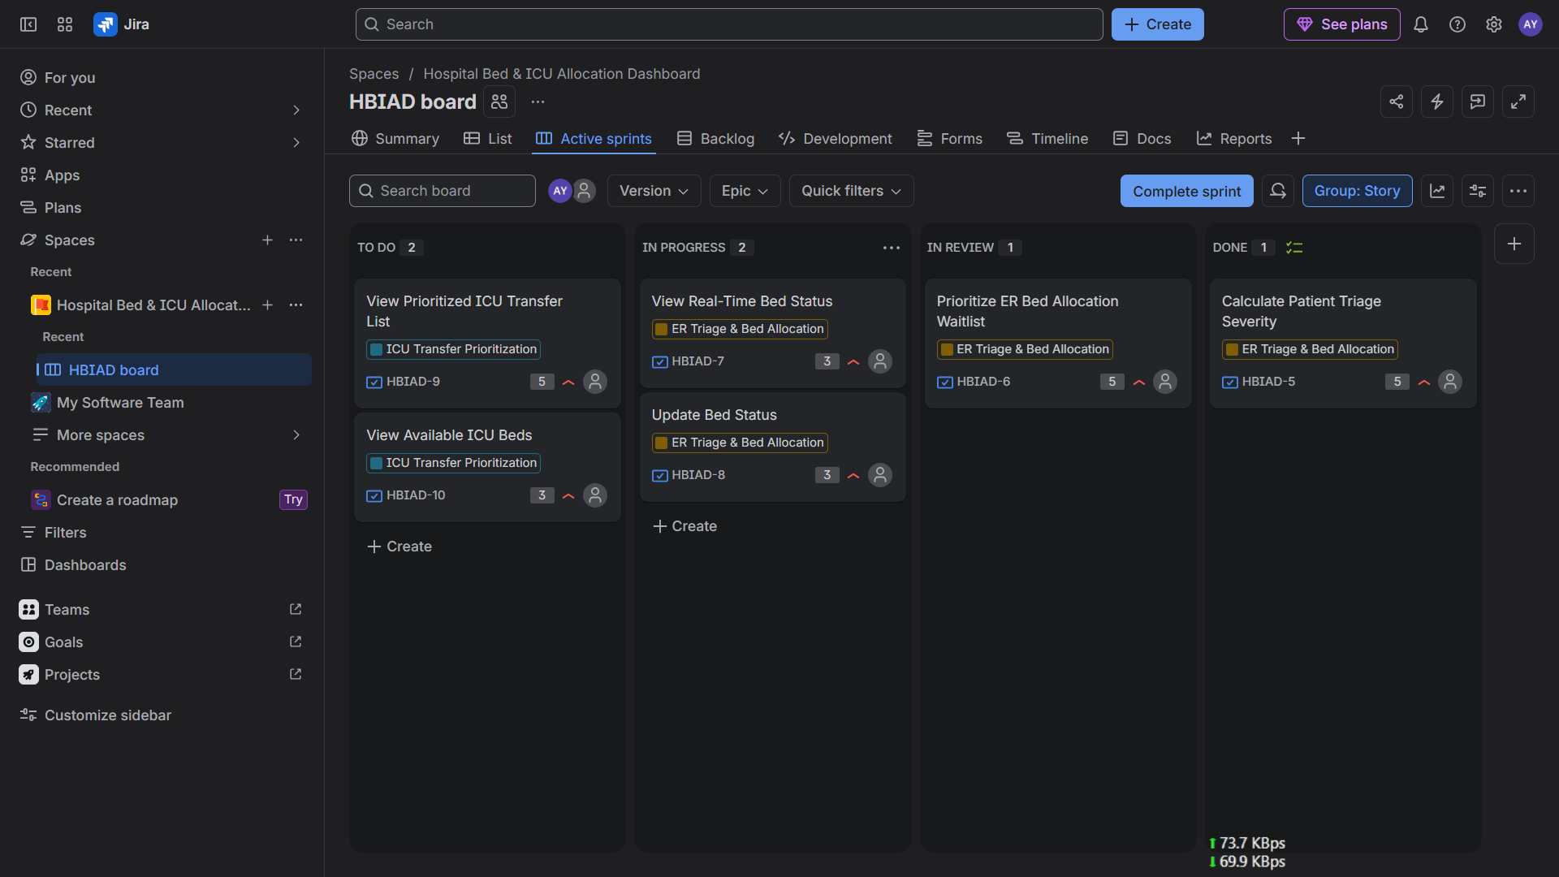
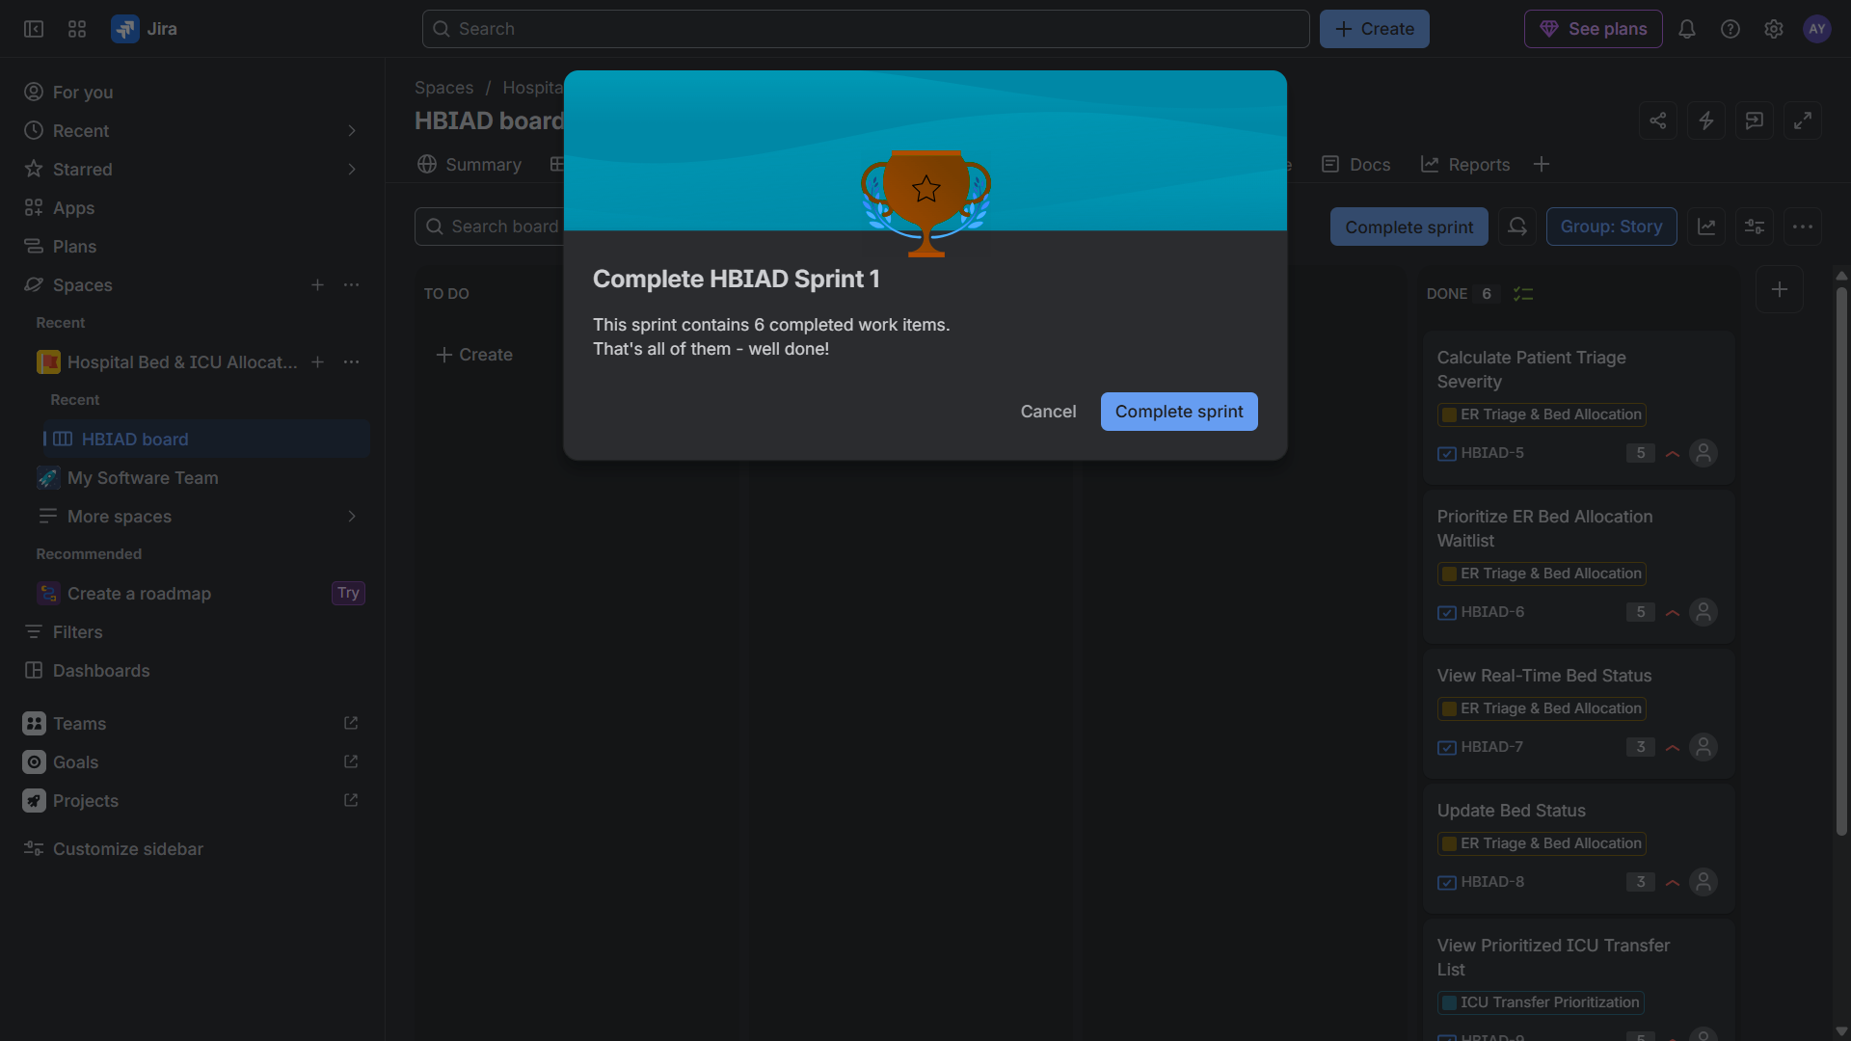
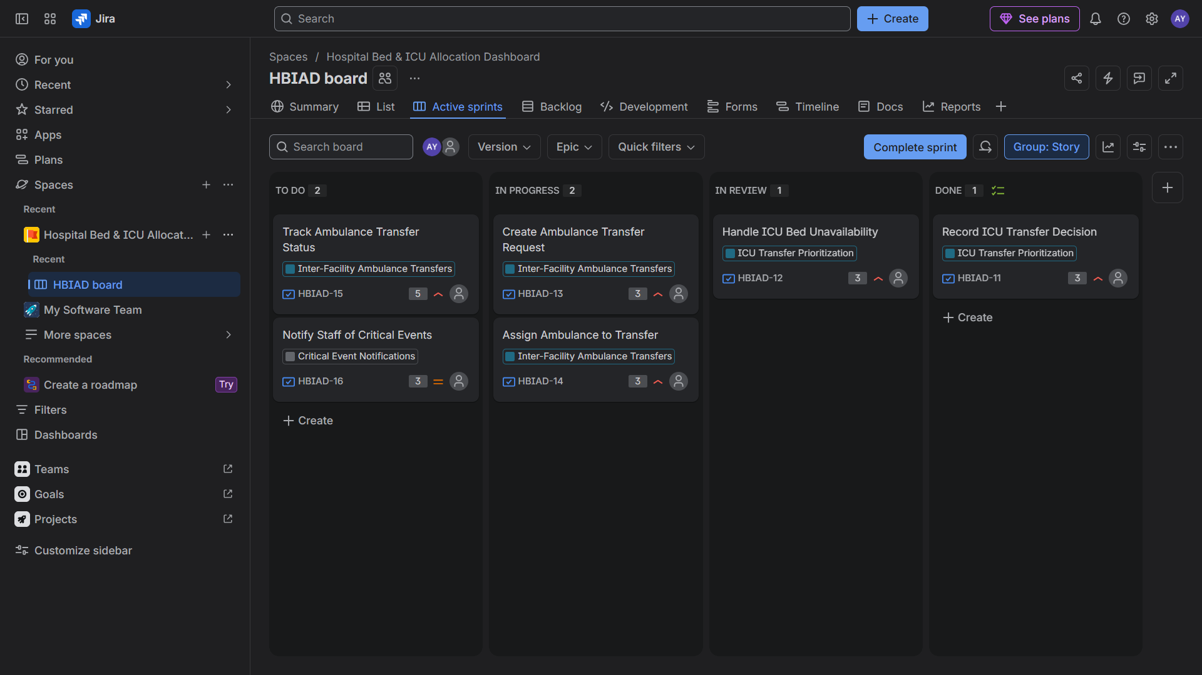
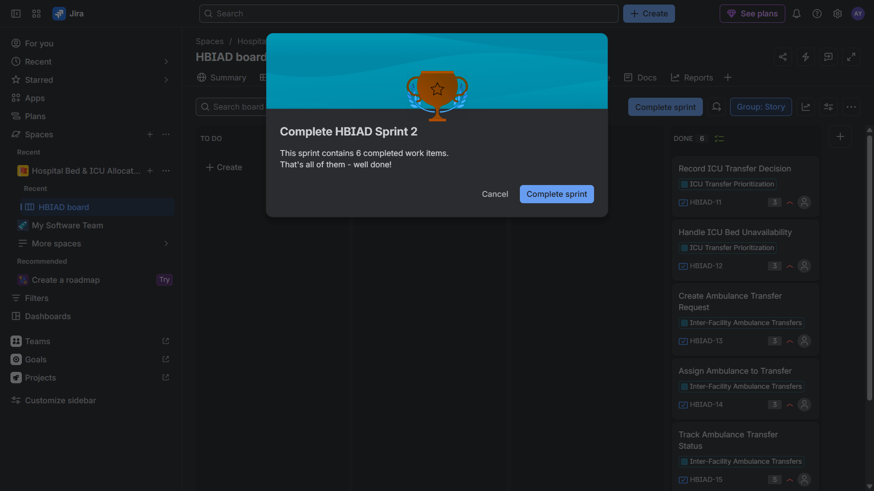

9. Burndown Chart — Screenshot
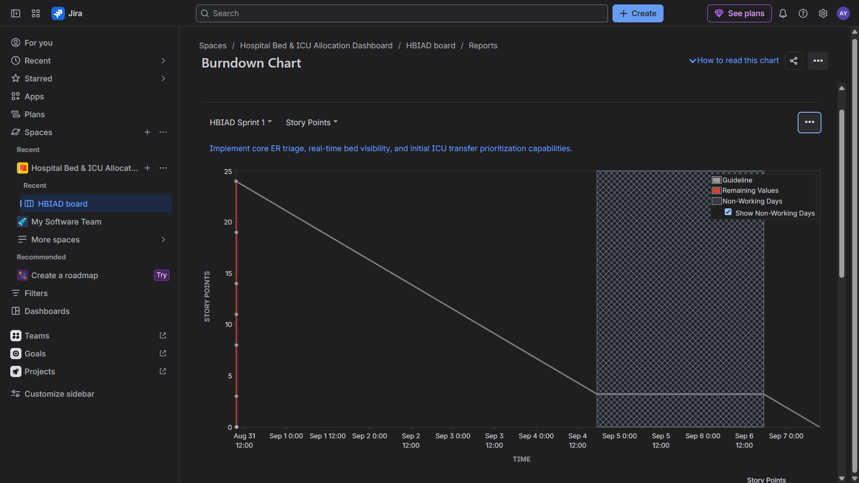
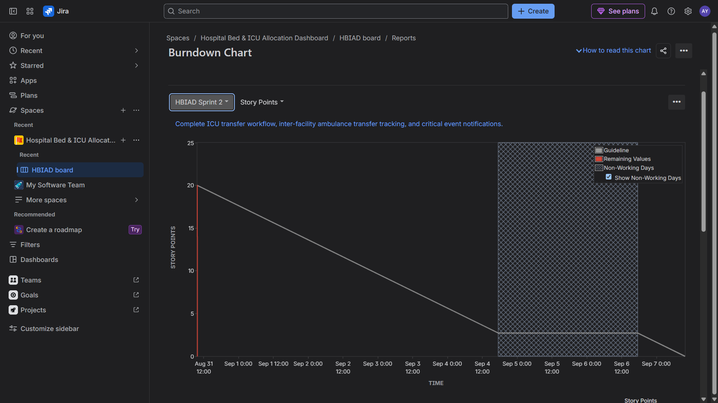

10. Reflection
Did your estimations reflect the actual effort?
The story-point estimates generally reflected the relative effort of the user stories. The 5-point stories involved more complex decision-making or workflow coordination, such as calculating triage severity, prioritizing patients, and tracking ambulance transfers. The 3-point stories represented more focused functionality such as displaying information, updating statuses, recording decisions, and sending notifications. Since the sprint was simulated, the estimates cannot be compared with real development hours, but the relative sizing provided a reasonable basis for sprint planning.
Was your backlog well-prioritized?
Yes. The backlog was prioritized according to the operational importance of the functionality. Core emergency functions such as triage severity calculation, ER bed allocation, real-time bed status, ICU transfer prioritization, and ambulance transfer management were assigned High priority because they directly support emergency coordination. Critical-event notifications were assigned Medium priority because they improve responsiveness but support the core workflows rather than replacing them.
How did your simulated sprint align with your plan?
The simulated sprint followed the planned backlog structure. Sprint 1 focused on the foundational ER triage, bed-status, and initial ICU prioritization capabilities, while Sprint 2 completed the remaining ICU transfer, ambulance transfer, and notification functionality. The stories were moved from To Do to In Progress and then Done to simulate development progress. The sprint structure therefore followed the planned functional progression from core bed and triage operations toward transfer and notification workflows.
What insights did the burndown chart give about your team's capacity?
The burndown chart provided a visual representation of the remaining story-point workload throughout the sprint. It helped show whether work was being completed at an appropriate rate compared with the expected guideline. Completing stories progressively should produce a downward trend in remaining work. The exercise also demonstrated that a team should use historical completion rates and estimation accuracy when deciding how much work to commit to a future sprint.

11. Conclusion
The lab demonstrated how the functional requirements from the Hospital Bed & ICU Allocation Dashboard were transformed into an Agile backlog consisting of Epics and User Stories. The stories were prioritized and estimated using Fibonacci-based story points and organized across two simulated Scrum sprints. The sprint board demonstrated the progression of work from To Do to In Progress to Done, while the Burndown Chart provided insight into remaining work and sprint capacity.

THE END

