SOFTWARE ENGINEERING — LAB 6
Code and Branch Coverage Analysis — Food Delivery
Student: Abhirama H Y | SRN: PES2UG24CS023 | Section: A

1. Aim and objectives
The aim of this lab is to measure and improve the test coverage of the assigned Food Delivery Python application. The work compares statement (line) coverage with branch coverage and uses targeted tests to exercise normal cases, validation failures, coupon rules, distance bands, weather surcharge, and delivery-time decisions.

2. Assigned application
Repository: https://github.com/SETAPESU26/L6_L7_20_food_delivery
Submission repository: https://github.com/A6h1ramahy/PES2UG24CS023_SE-Lab/tree/main/LAB6
The application has three functions: delivery_charge(distance_km, order_value, is_raining), apply_coupon(order_value, code, is_first_order), and estimated_time(distance_km, is_peak_hour, restaurant_busy). The original application logic is preserved in food_delivery.py.

3. Test strategy and coverage criteria

3.1 Code / line coverage stage
Line coverage checks whether executable statements in the application were executed at least once. The first test file deliberately exercises every executable statement, including each return statement, exception path, fee calculation, coupon deduction, and delivery-time adjustment.

3.2 Branch coverage stage
Branch coverage checks whether each decision outcome has been exercised. Tests therefore cover both sides of the delivery-range check, the free-order check and distance tiers, raining and non-raining cases, coupon absent/invalid/valid cases, first-order eligibility, the minimum order threshold, peak/non-peak time, busy/not-busy restaurant, and the nested busy-plus-peak decision.
Coverage is a test adequacy measure, not proof that the application is defect-free. The tests use the expected behavior defined by the assigned source code.

4. Screenshots

4.1 Code coverage stage
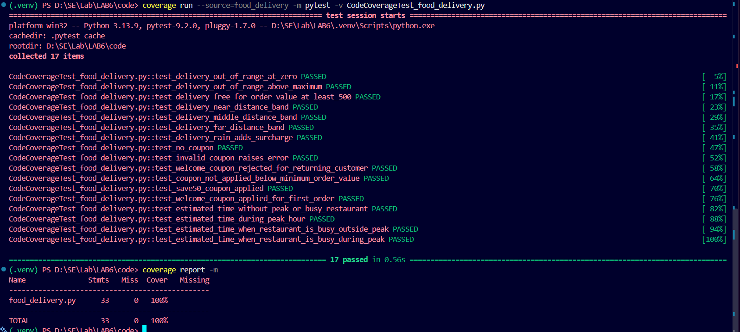

4.2 Branch coverage stage
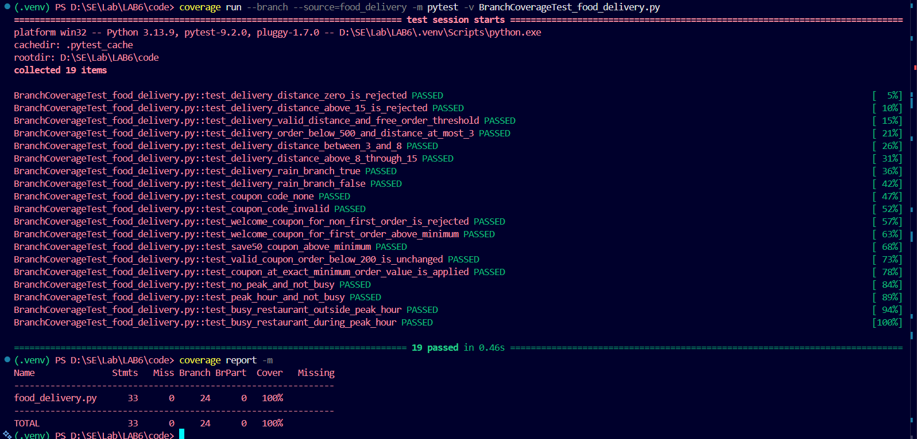

6. Test case coverage matrix

Function | Decision / condition | Expected behavior covered
delivery_charge | distance <= 0 / distance > 15 | Invalid range raises ValueError
delivery_charge | order_value >= 500 | Free delivery charge
delivery_charge | distance <= 3 | Near-distance fee
delivery_charge | 3 < distance <= 8 | Middle-distance fee
delivery_charge | distance > 8 and <= 15 | Far-distance fee
delivery_charge | is_raining True / False | Rain surcharge and no surcharge
apply_coupon | code is None | Original order value returned
apply_coupon | unknown coupon | Invalid coupon ValueError
apply_coupon | WELCOME and not first order | Eligibility ValueError
apply_coupon | order value < 200 | Coupon not applied
apply_coupon | order value >= 200 and valid coupon | SAVE50 / WELCOME discount applied
estimated_time | peak hour True / False | Peak adjustment and no peak adjustment
estimated_time | restaurant_busy True / False | Busy adjustment and no busy adjustment
estimated_time | busy and peak nested condition | Additional nested 5-minute adjustment

THE END

