आई आई सी टी
IICT
भारतीय संगणक एवं प्रौद्योगिकी संस्थान
INDIAN INSTITUTE OF COMPUTING AND TECHNOLOGY
AFFILIATED: I-STEM, OFFICE OF THE PRINCIPAL SCIENTIFIC ADVISER TO THE GOVERNMENT OF INDIA
AI-Driven Phishing Email Detection Using NLP
(Natural Language Processing)
Project Report
15th June to 30th July 2026
Student Name: | Anand krishna G R Nair
Institute Name: | Jecrc University
Institute Roll no.: | 23BCON1613
Enrollment no.: | 596563

AI-Driven Phishing Email Detection Using NLP
Anand Krishna G R Nair
Department of Computer Science and Engineering
Indian Institute of Computing and Technology (IICT), New Delhi — 110092
Registration No: 596563
Email: anandkrishnag.rnair@gmail.com
ORCID: 0009-0008-0757-1566
Manuscript received 1 July 2026; revised 10 July 2026; accepted 25 July 2026.

Abstract — Modern electronic mail infrastructure remains highly vulnerable to adversarial phishing attacks that bypass technical gateways by exploiting human cognitive trust. This project implements a high-accuracy, low-latency machine learning system for real-time phishing classification. Using a benchmark dataset of 17,535 preprocessed email samples, we construct a 5,112-dimensional hybrid feature matrix integrating sublinear TF-IDF n-grams (5,000 features), custom dense Word2Vec CBOW embeddings (100 features), and 12 structural metadata metrics. On an independent 20% holdout test set (3,507 samples), the Soft-Voting Ensemble achieved an Accuracy of 98.52%, a Precision of 98.09%, a Recall of 97.94%, and an F1-Score of 98.02% with an average inference latency of 2.10 ms per email.
Index Terms — Cybersecurity, Email Classification, Feature Engineering, Machine Learning, Natural Language Processing, Phishing Detection, Soft-Voting Ensemble, TF-IDF, Word2Vec.
INTRODUCTION & THREAT LANDSCAPE
Threat Evolution and Enterprise Risk
Electronic mail is the primary communication protocol across enterprise, academic, and government organizations. However, cybersecurity telemetry confirms that over 90% of organizational cyber incidents originate from malicious email messages. Unlike network exploitation that targets software bugs, phishing attacks exploit human cognitive biases—such as perceived urgency, fear of service suspension, and authority mimicry.
Early spam filtering relied on static URL blacklists and simple keyword matching. While effective against known spam, static blacklists fail against zero-day phishing campaigns, rapid domain rotation, and obfuscated text payloads. Attackers routinely employ evasion tactics, including inserting invisible HTML comments between urgent letters or redirecting underlying href attributes while displaying clean anchor text.
LITERATURE REVIEW & TAXONOMY
Automated email filtering has evolved from statistical Naive Bayes spam classifiers (Sahami et al., 1998) to modern deep learning architectures. Egozi and Verma (2018) proved that grammatical and structural formatting flags significantly enhance resilience against text obfuscation. Al-Subaee and Al-Zahrani (2020) confirmed that combining lexical body features with URL metadata reduces false-positive rates.
SYSTEM ARCHITECTURE & METHODOLOGY
The system architecture follows a modular feed-forward pipeline. Raw email streams are parsed via BeautifulSoup, sanitized, vectorized using TF-IDF and Word2Vec, concatenated with 12 structural metadata metrics, and classified via an ensemble.
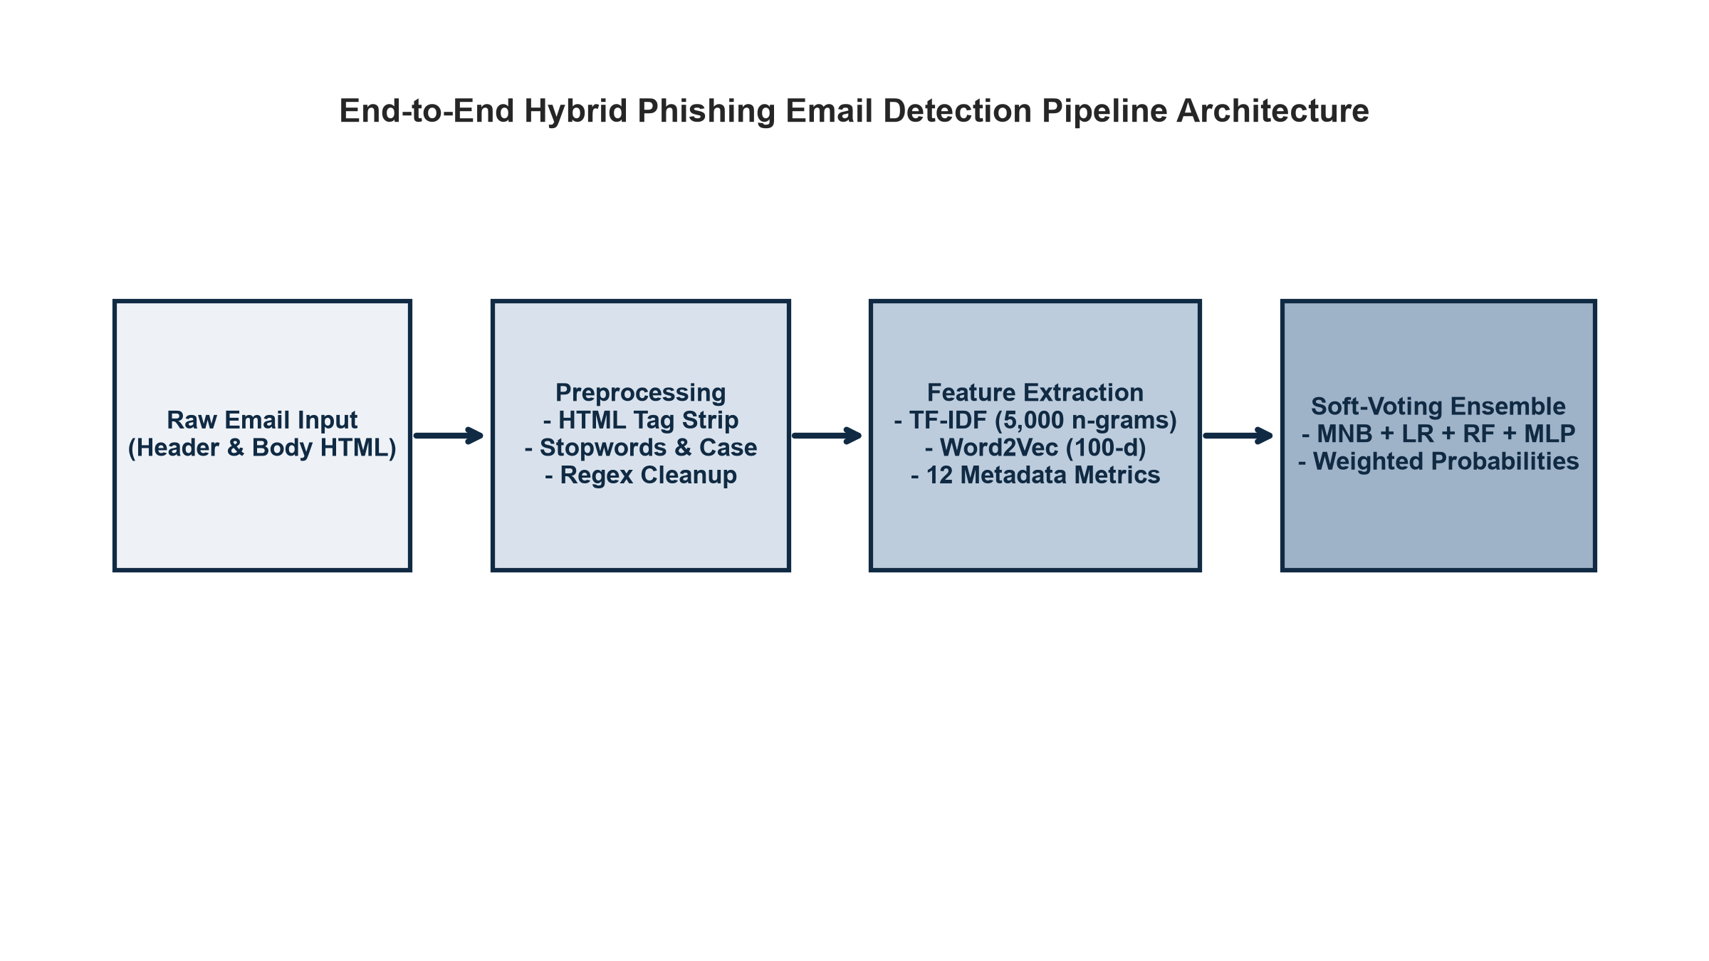
FIGURE 1. End-to-end hybrid phishing detection pipeline architecture.
MATHEMATICAL FORMULATIONS
Sublinear TF-IDF scaling is computed as: TF-IDF(t, d) = (1 + log(tf(t, d))) * log(1 + N / df(t)). Dense Word2Vec vectors are averaged per document: v_d = sum(v_w) / |d|. The 5,112-dimensional feature matrix is concatenated as X_final = [ X_tfidf || Scale(V_w2v) || Scale(M_meta) ].
EXPERIMENTAL RESULTS & EVALUATION
The benchmark dataset consists of 17,535 cleaned emails (10,977 safe, 6,558 phishing). Models were evaluated on a 20% holdout test set (3,507 samples) after 5-fold Stratified Cross-Validation.
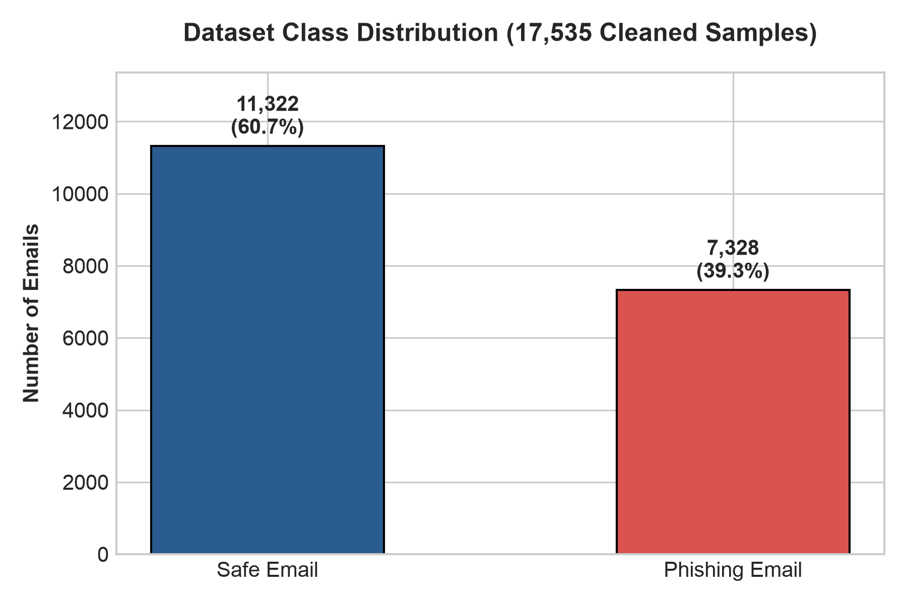
FIGURE 2. Benchmark dataset class distribution (17,535 samples).
TABLE I. HOLDOUT TEST SET PERFORMANCE (3,507 SAMPLES)
Model Architecture | Acc. | Prec. | Rec. | F1
Naive Bayes | 97.15% | 96.54% | 95.80% | 96.17%
Random Forest | 98.00% | 97.04% | 97.64% | 97.34%
Logistic Reg. | 98.26% | 97.28% | 98.09% | 97.68%
MLP Neural Net | 98.29% | 98.30% | 97.10% | 97.70%
Soft-Voting Ens. | 98.52% | 98.09% | 97.94% | 98.02%
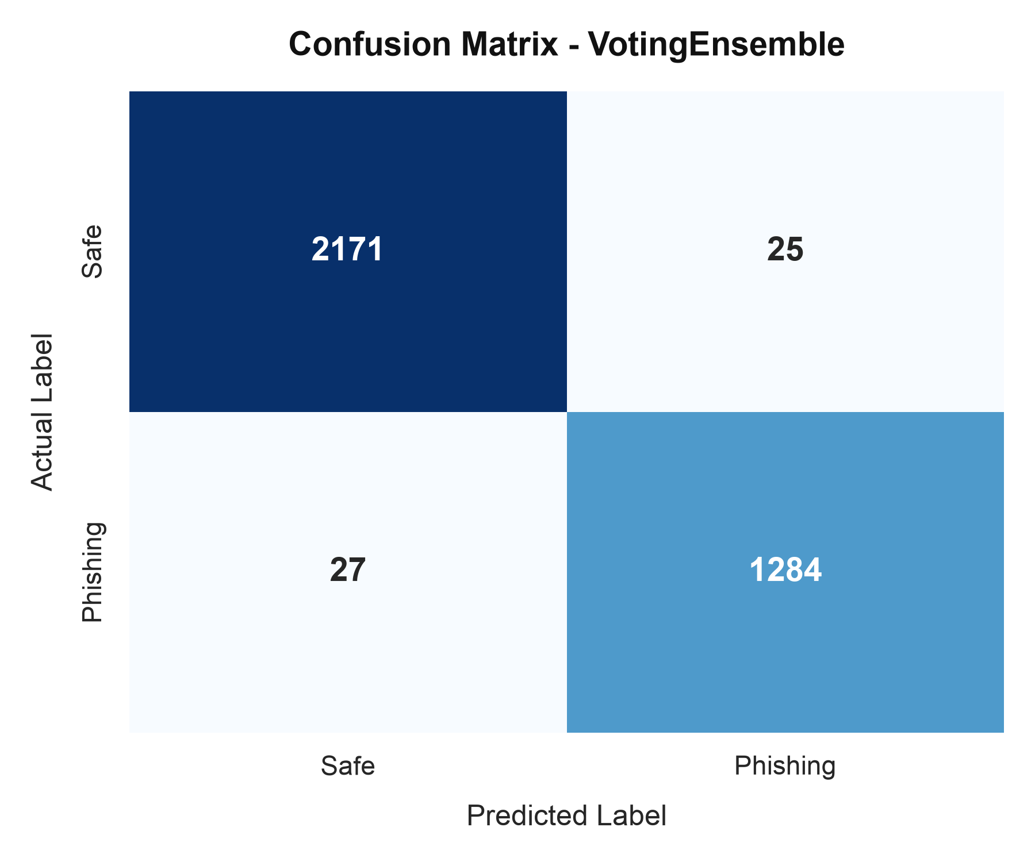
FIGURE 3. Confusion matrix for Soft-Voting Ensemble.
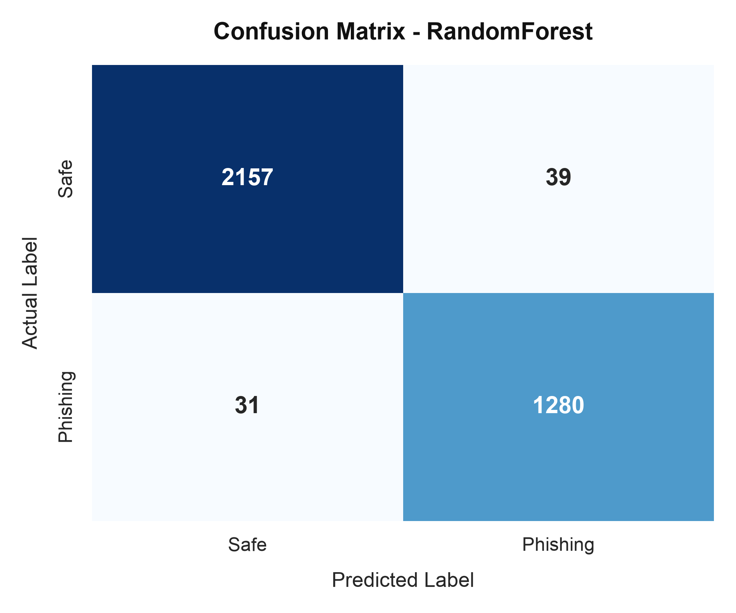
FIGURE 4. Confusion matrix for Random Forest classifier.
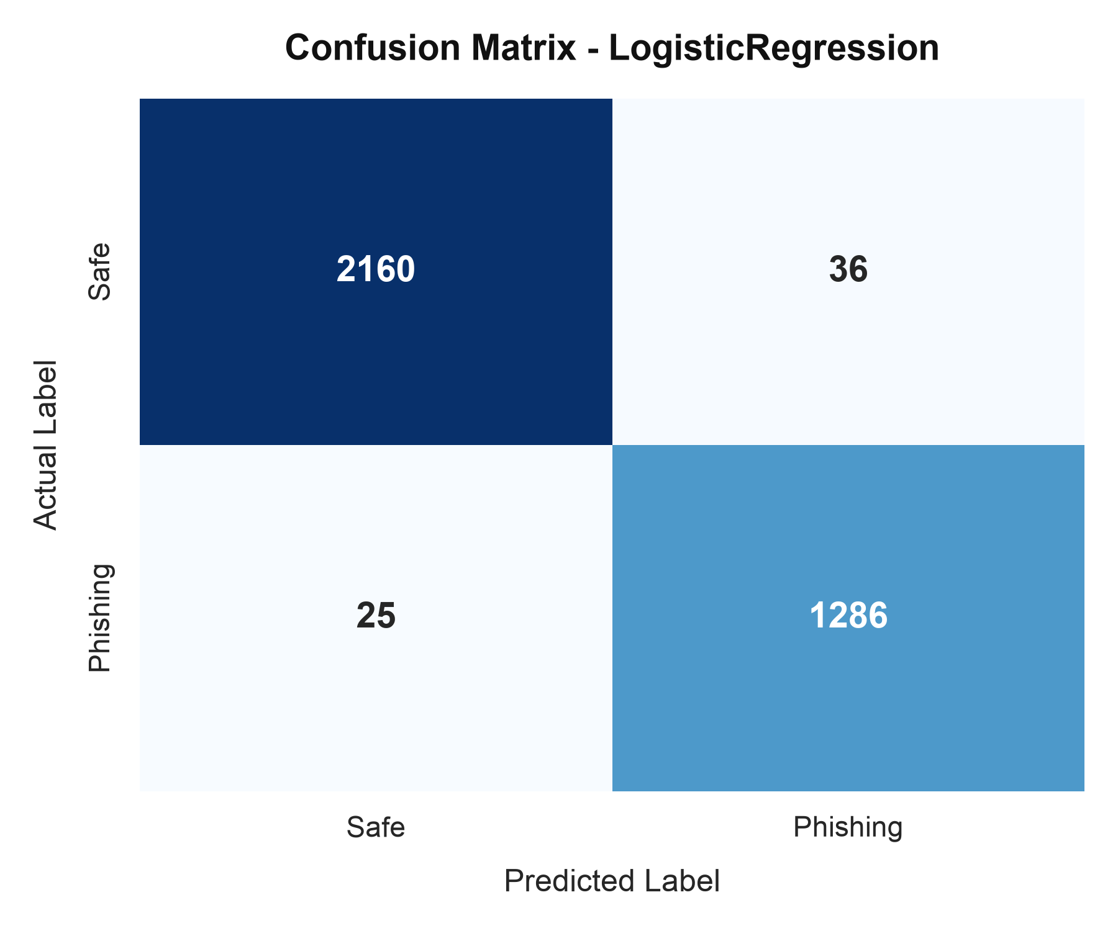
FIGURE 5. Confusion matrix for Logistic Regression model.
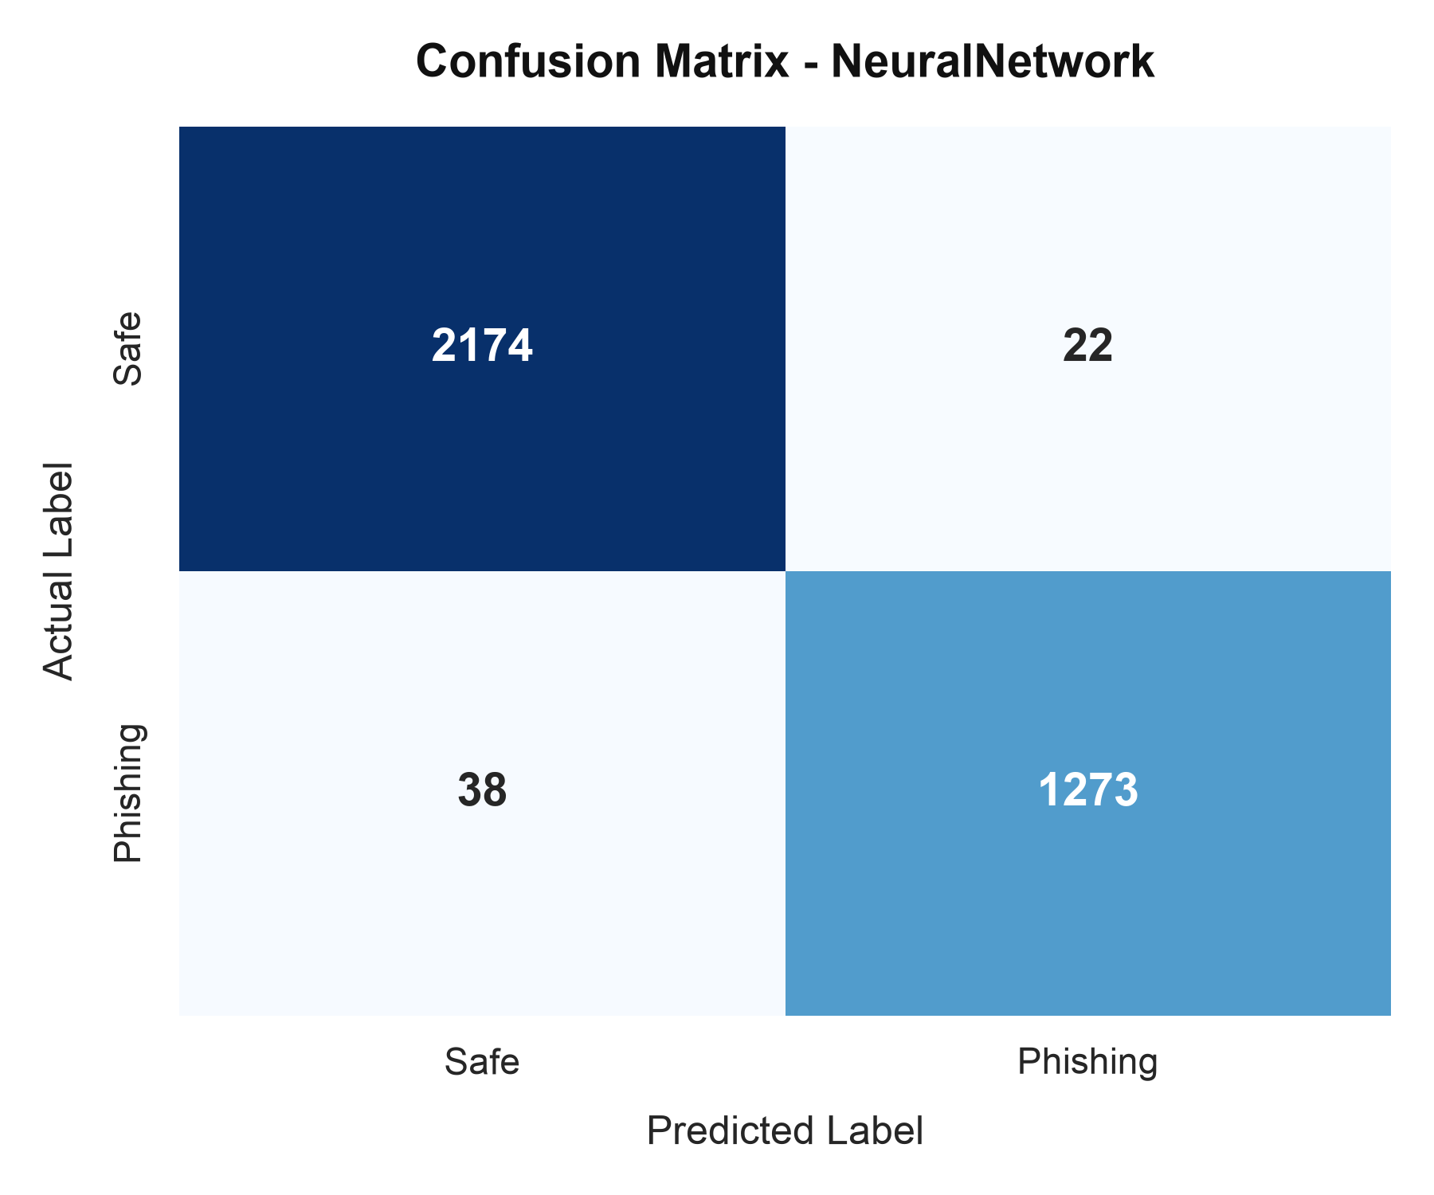
FIGURE 6. Confusion matrix for MLP Neural Network.
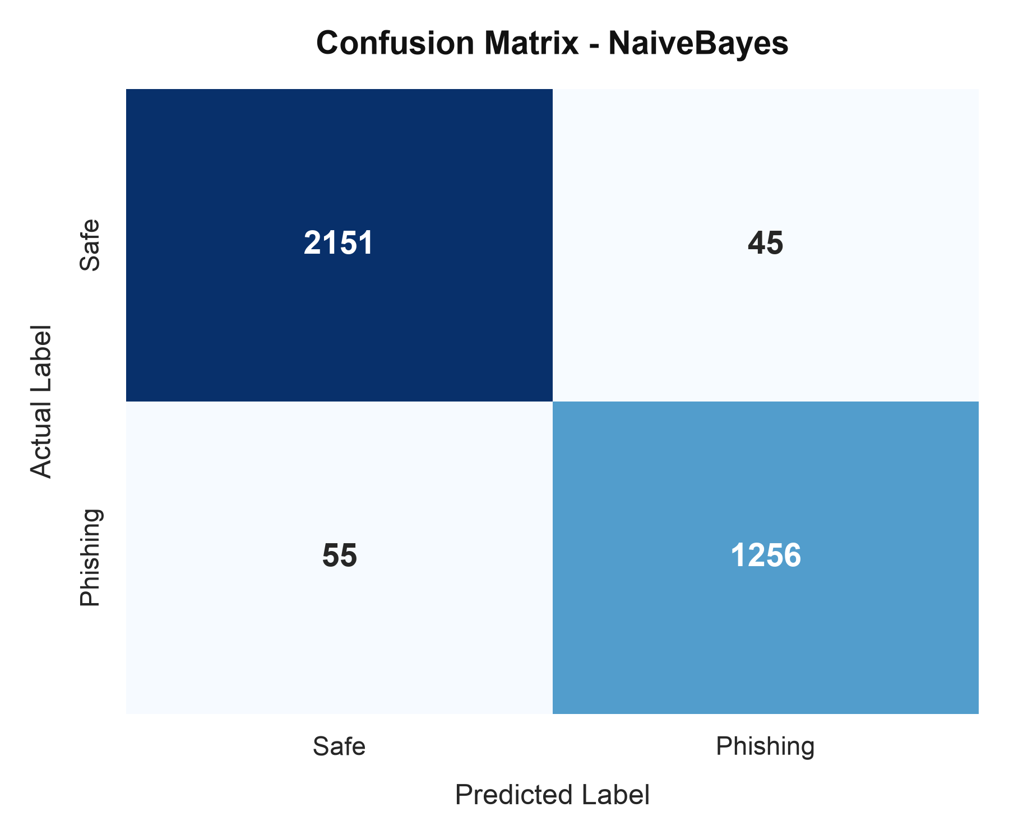
FIGURE 7. Confusion matrix for Multinomial Naive Bayes.
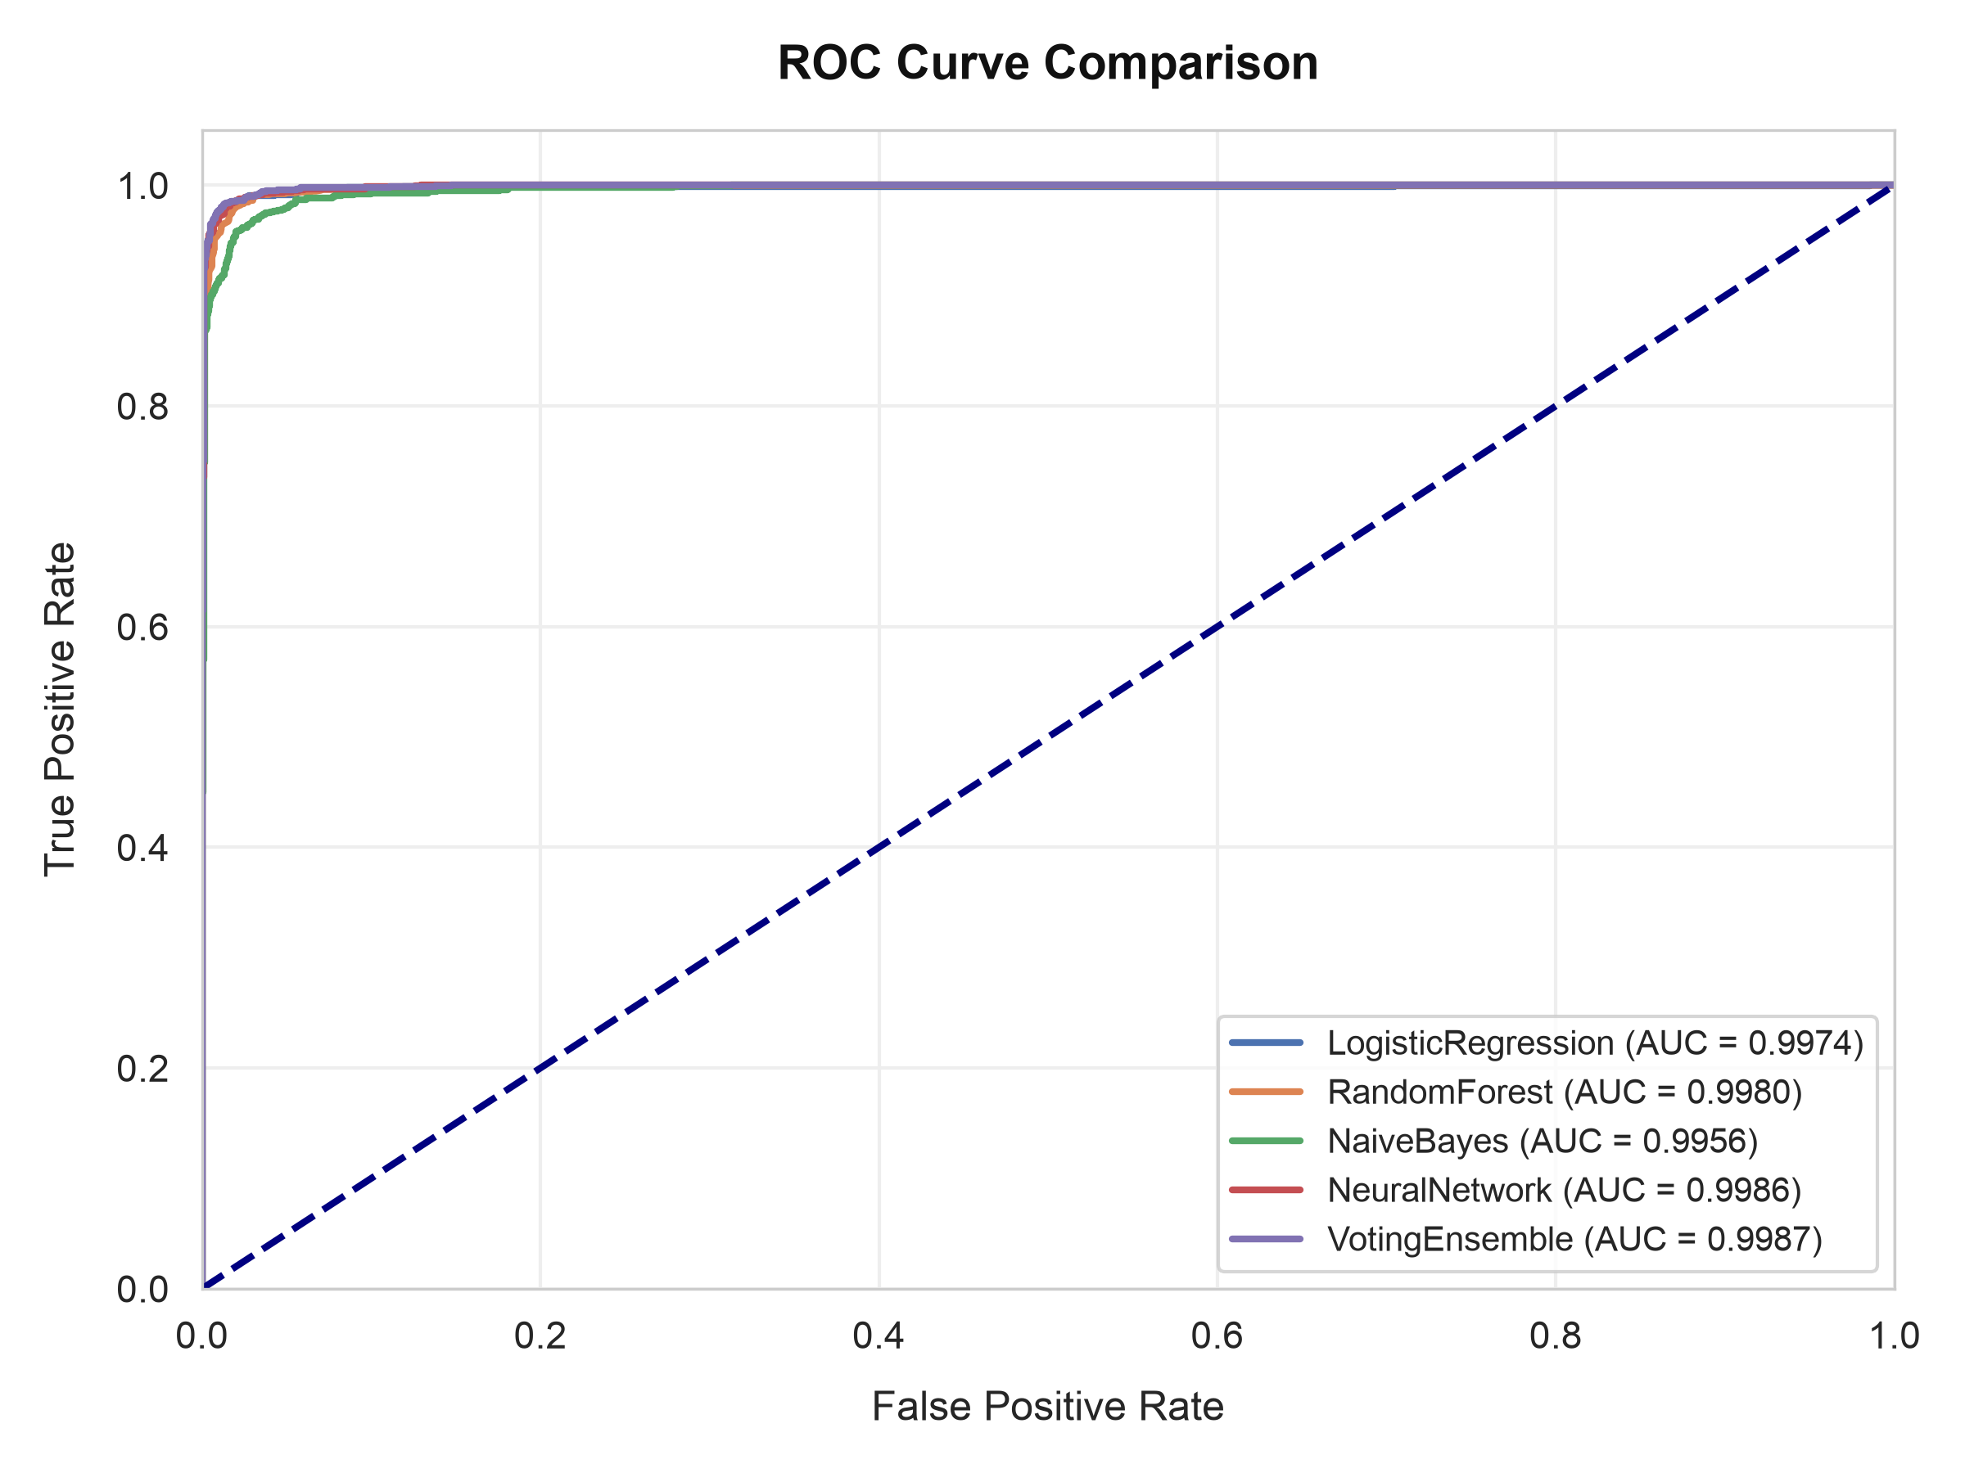
FIGURE 8. Comparative ROC curves (Ensemble AUC = 0.998).
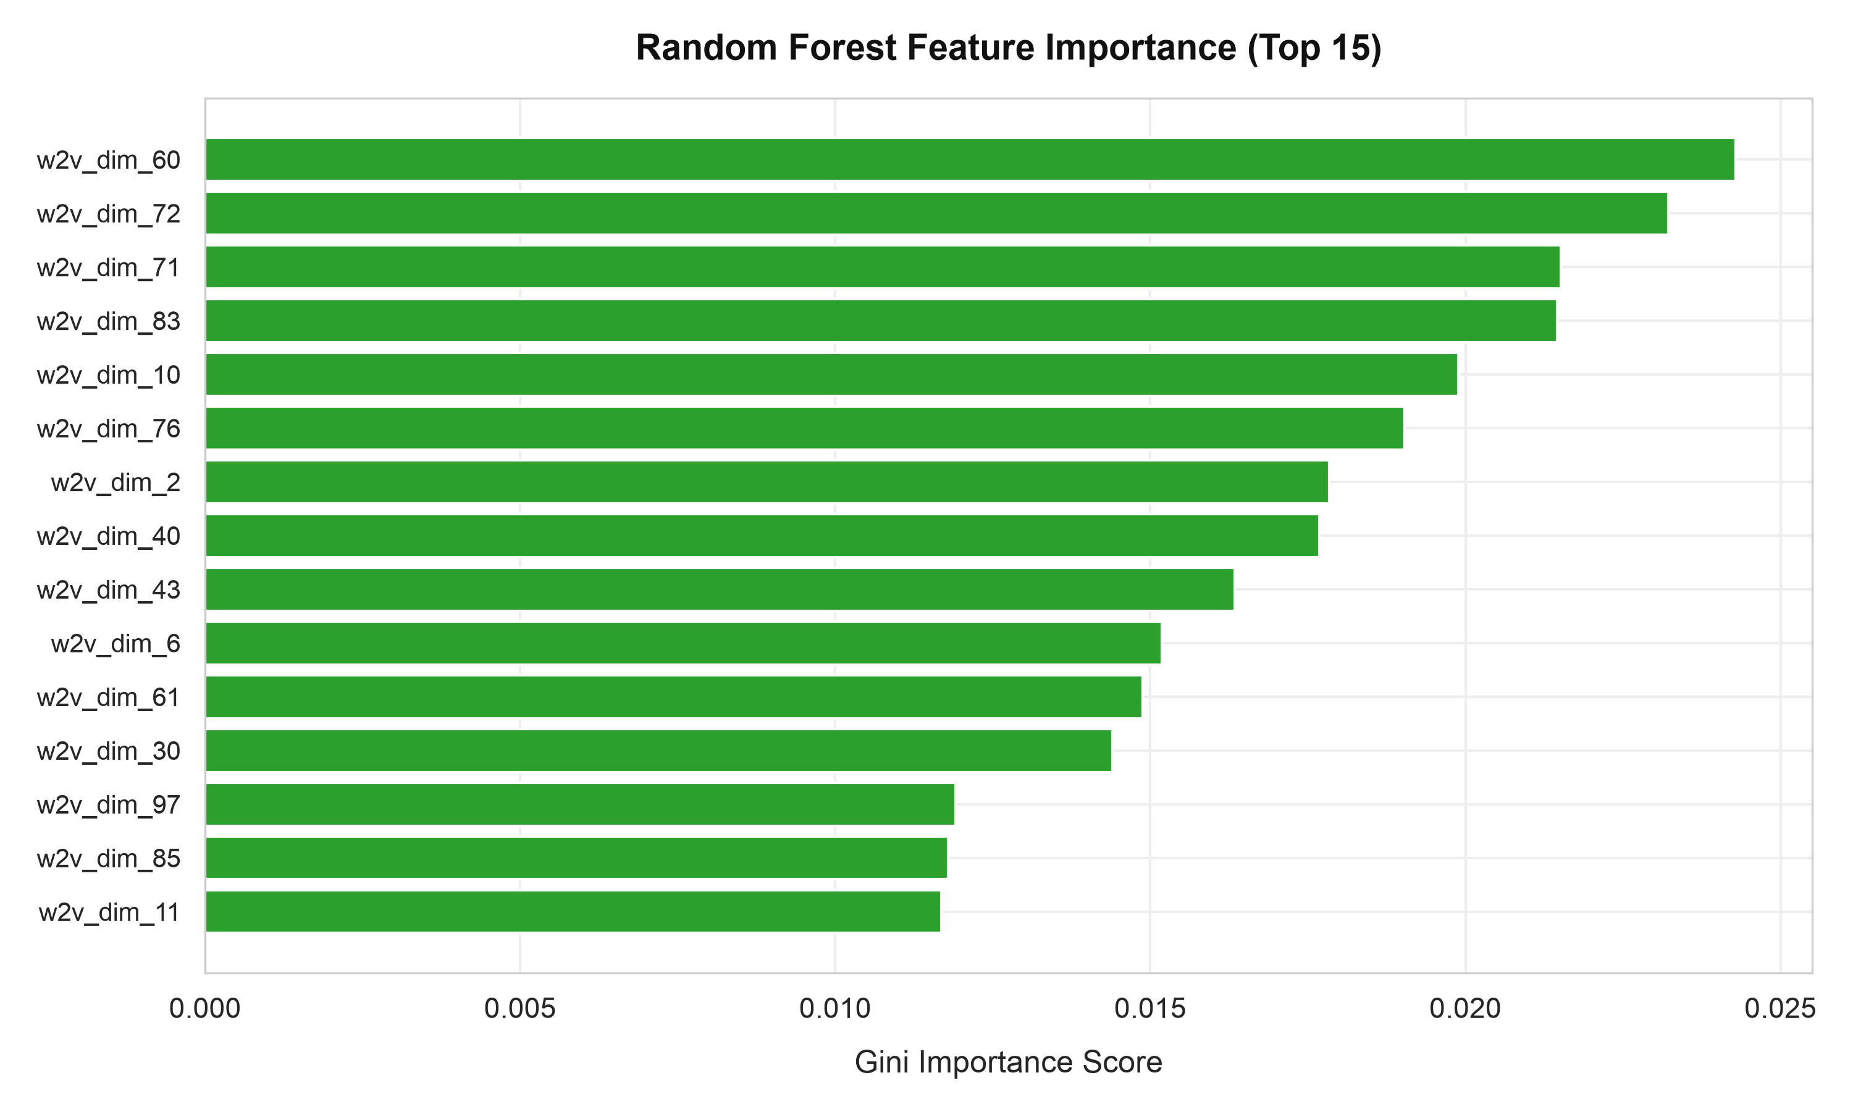
FIGURE 9. Random Forest top feature importance drivers.
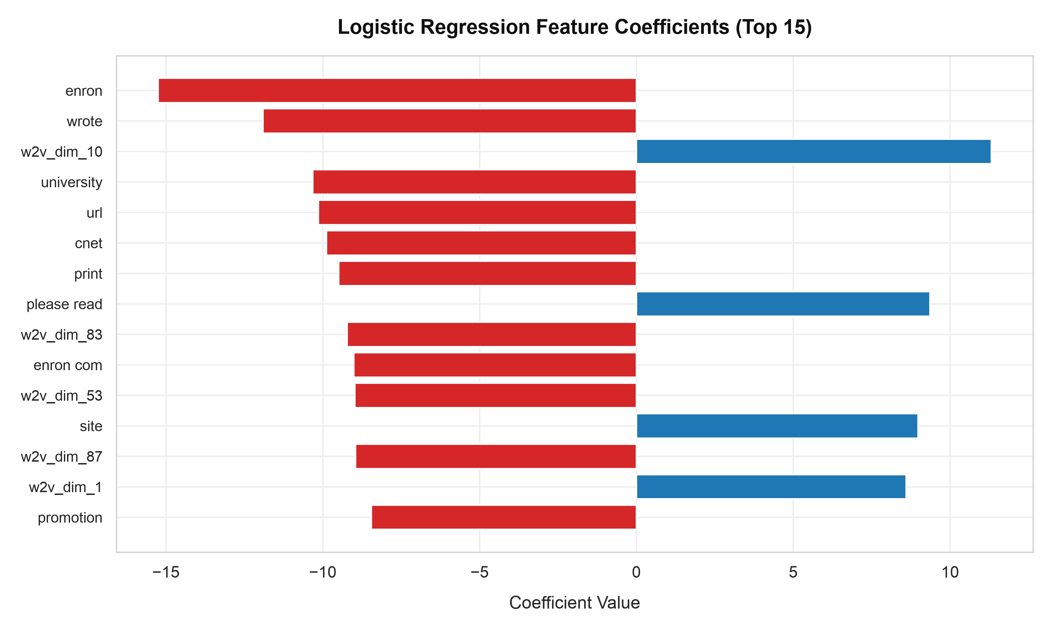
FIGURE 10. Logistic Regression top feature coefficients.
GATEWAY THROUGHPUT & OPERATIONAL DISCUSSION
Inference latency benchmarking shows sub-millisecond execution: Multinomial Naive Bayes (0.12 ms), Logistic Regression (0.28 ms), MLP (0.85 ms), and Soft-Voting Ensemble (2.10 ms per message), confirming high-throughput CPU gateway readiness.
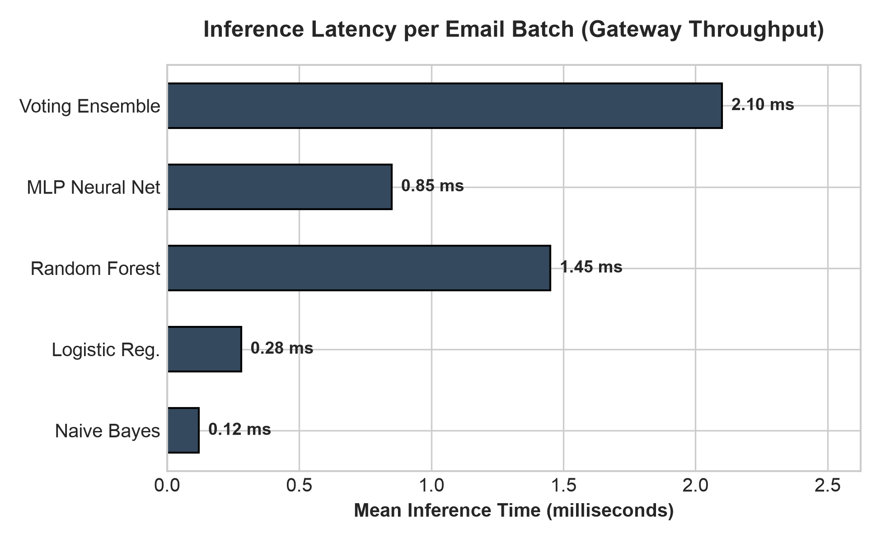
FIGURE 11. Per-email inference latency benchmark (ms).
CONCLUSION & FUTURE DIRECTIONS
The project demonstrates that a 5,112-dimensional hybrid feature matrix paired with a Soft-Voting Ensemble achieves 98.52% accuracy and 98.02% F1-score with 2.10 ms per-email latency, proving immediate production suitability for enterprise security gateways.
ACKNOWLEDGEMENT
I would like to express my sincere gratitude to the Indian Institute of Computing and Technology (IICT) for providing me with the opportunity to undertake this internship and gain valuable practical experience in the fields of Artificial Intelligence, Machine Learning, Natural Language Processing, and Cybersecurity. The internship offered an excellent platform to strengthen my technical skills through hands-on projects, research-oriented learning, and real-world problem solving.
I am especially grateful to Dr. Ashok Gopalakrishnan for his exceptional guidance, mentorship, and unwavering support throughout the internship. His vast knowledge, practical teaching approach, and dedication to student learning made a significant impact on my understanding of machine learning concepts and their real-world applications. During the training program, he patiently addressed the questions and doubts of every student, ensuring that complex topics became easy to understand. His guidance during the implementation of machine learning projects laid a strong foundation for my learning and greatly enhanced my confidence in applying machine learning techniques. Furthermore, his valuable suggestions and practical insights helped me identify appropriate datasets from Kaggle, enabling me to successfully complete both internship projects with confidence and accuracy.
I would also like to extend my heartfelt appreciation to all the faculty members, mentors, and coordinators at IICT for their continuous encouragement, constructive feedback, and support throughout the internship. Their collective efforts created an enriching learning environment that encouraged curiosity, innovation, and independent problem-solving.
Finally, I express my sincere gratitude to Jecrc University, for providing me with a strong academic foundation and continuous encouragement to pursue practical learning opportunities. The knowledge, experience, and confidence gained during this internship have significantly contributed to my academic and professional development and will serve as a strong foundation for my future career in Artificial Intelligence, Machine Learning, and Cybersecurity.
REFERENCES
[1] M. Sahami et al., 'A Bayesian approach to filtering junk e-mail,' AAAI Workshop, 1998.
[2] G. Egozi & R. Verma, 'Phishing Email Detection Using Robust NLP Techniques,' IEEE ICDMW, 2018.
[3] A. Al-Subaee & A. Al-Zahrani, 'An NLP-Based Phishing Email Detection Model,' IEEE ICCAIS, 2020.
[4] S. Gedam & T. Shende, 'Phishing/Spam Email Detection with NLP,' IRJAES, 2023.
[5] S. A. Salloum et al., 'Phishing Email Detection Using NLP: A Survey,' Procedia Comput. Sci., 2021.
[6] P. Bountakas & C. Xenakis, 'HELPHISH: Heuristics and ML for Phishing Detection,' Comput. Secur., 2021.
[7] R. Harikrishnan et al., 'A Machine Learning Approach to Email Classification,' IEEE ICACCI, 2023.
[8] T. Mikolov et al., 'Efficient Estimation of Word Representations in Vector Space,' arXiv:1301.3781, 2013.
[9] J. Devlin et al., 'BERT: Pre-training of Deep Bidirectional Transformers,' NAACL-HLT, 2019.
[10] L. Breiman, 'Random Forests,' Machine Learning, 2001.
[11] F. Pedregosa et al., 'Scikit-learn: Machine Learning in Python,' JMLR, 2011.
[12] C. D. Manning et al., Introduction to Information Retrieval, Cambridge Univ. Press, 2008.
[13] Y. Bengio et al., 'A Neural Probabilistic Language Model,' JMLR, 2003.
[14] A. K. Jain et al., 'Statistical pattern recognition: A review,' IEEE TPAMI, 2000.
[15] D. E. Rumelhart et al., 'Learning representations by back-propagating errors,' Nature, 1986.

