Machine Intelligence: CSCI417
Phase 1 Documentation

Habibatallah Mahdi 231000176
Sama Abdelsadek 231000571
Mohamed Allam 231000572
Shaza Hossam 231001228
Ahmed Shaban 231001388

- Introduction & Problem Statement

Context: Sports analytics is a key concept in revolutionizing every kind of sport right now and basketball is no exception. For basketball, player’s performance, health metrics and a lot of other factors affect their ability to free throw which is very important in NBA.
Problem: We want to predict whether a specific NBA player will make a free throw based on their season-long performance metrics, physical attributes, and playing style.
Objectives: To build a classification model that evaluates a player's profile and predicts their free-throw success.
Significance: This model can be used by coaches for late-game decision-making
(e.g., deciding who should take technical free throws or knowing which opposing players to intentionally foul, famously known as the "Hack-a-Shaq" strategy).

- Dataset Details
Source: We scraped our dataset from the website https://www.basketball-reference.com
Data Description:
    - RK (Rank): Player's rank in the table based on overall listing.
    - Columns: player (player name)
    - Age (player’s age)
    - Team (Team’s name)
    - Pos (Position)
    - G (Games): Number of games the player appeared in
    - GS (Games started): Number of games the player started.
    - MP (Minutes played): Average minutes played per game.
    - FG (Field Goals Made): Average number of made shots per game (excluding free throws).
    - FGA (Field Goals Attempted): Average number of shot attempts per game.
    - FG% (Field Goal Percentage): Shooting efficiency calculated as FG / FGA.
    - 3P (3-Point Made): Average number of three-point shots made per game.
    - 3PA (3-Point Attempted): Average number of three-point attempts.
    - 3P% (3-Point Percentage): Three-point shooting efficiency.
    - 2P (2-Point Made): Average number of two-point shots made per game.
    - 2PA (2-Point Attempted): Average number of two-point attempts.
    - 2P% (2-Point Percentage): Two-point shooting efficiency.
    - eFG% (Effective Field Goal Percentage): Adjusted field goal percentage that accounts for the added value of three-point shots.
Formula: (FG + 0.5 × 3P) / FGA
Since three-point shots are worth more points than two-point shots, they are given extra weight in this metric.
    - FT (Free Throws Made): Average number of free throws made per game.
    - FTA (Free Throws Attempted): Average number of free throw attempts.
    - FT% (Free Throw Percentage): Free throw success rate.
    - ORB (Offensive Rebounds): Average rebounds collected on the offensive end.
It happens when a player retrieves the ball after a missed shot by their own team, giving the team another scoring opportunity.
    - DRB (Defensive Rebounds): Average rebounds collected on the defensive end.
It happens when a player retrieves the ball after a missed shot by the opposing team, ending their possession.
    - TRB (Total Rebounds): Total rebounds per game (ORB + DRB).
It represents the player's overall rebounding performance.
    - AST (Assists): Average number of assists per game.
    - STL (Steals): Average number of steals per game.
    - BLK (Blocks): Average number of blocked shots per game.
    - TOV (Turnovers): Average number of times a player loses possession of the ball.
This can happen due to bad passes, ball handling mistakes, or violations (e.g., traveling).
    - PF (Personal Fouls): Average number of fouls committed by a player against opponents. These can result in free throws or penalties, and too many fouls may lead to fouling out.
    - PTS (Points)
    - Awards
    - Season: Season year (added manually during data collection).

Timeframe: We scraped data from [1975-2026]
No of Rows: 26292
No of Columns: 32
Note: All statistics are per-game averages, not totals for the season.
- Data preprocessing
    - Some columns had missing values due to attempts, so we just dropped the nulls. On the contrary, the Awards column had too many missing values (23,740) so we dropped the column itself.
    - There were no duplicate rows.
    - We also dropped the Player and RK columns (not useful)
    - We derived a new feature GoodFT that has binary values either 0 or 1 based on the FT%.

X: ["Pos", "G", "GS", "MP", "FG%", "3P%", "2P%", "eFG%", "TRB", "AST", "STL", "BLK", "TOV", "PF”]
Y: GoodFT

- Literature Review
Kaggle/GitHub Precedents: Many open-source sports analytics projects attempt to predict game outcomes or MVP winners. For example, Kaggle models frequently use historical NBA data to predict team wins, but predicting individual granular events like free-throw success is less common and more specialized.
Academic/Industry Research: Research in sports science shows a strong correlation between a player's three-point shooting ability and their free-throw percentage, as both rely on similar biomechanics. Studies also explore how player position affects shooting mechanics.
The "Gap": While standard tutorials might use simple, clean datasets (like predicting house prices), our project tackles real-world, scraped sports data. We are bridging the gap between general season statistics and specific shooting outcomes.

- Visuals
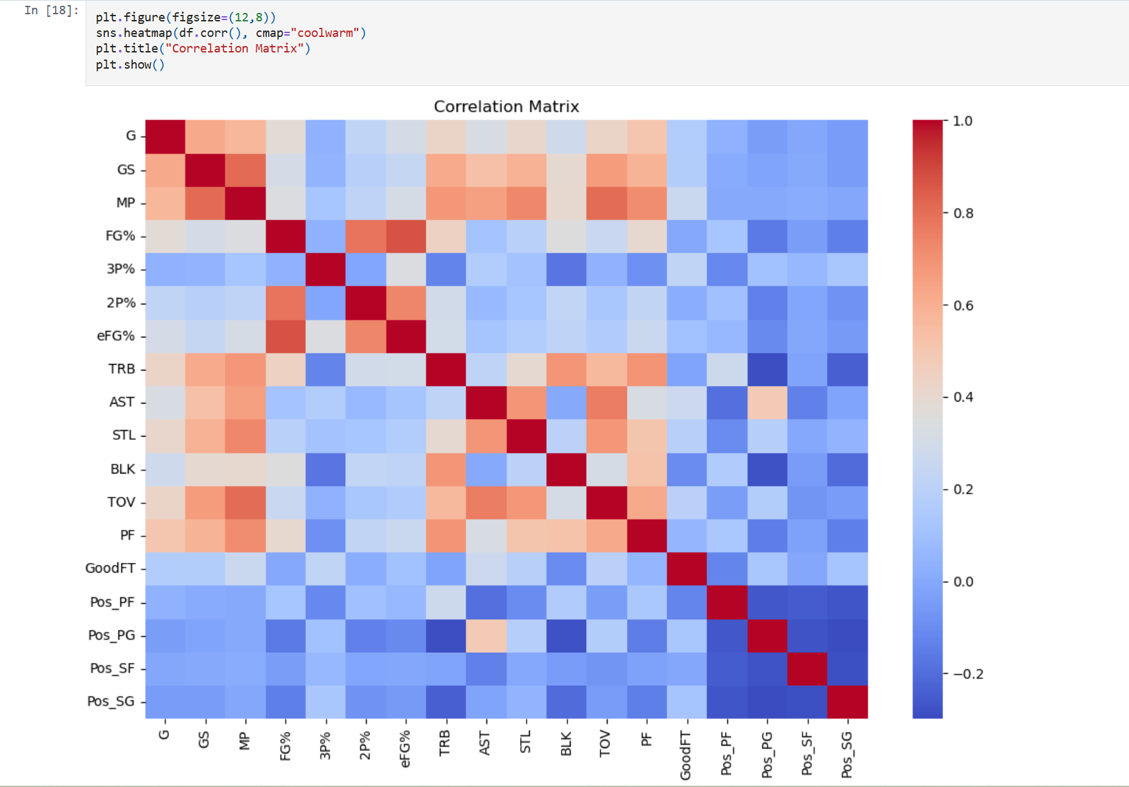

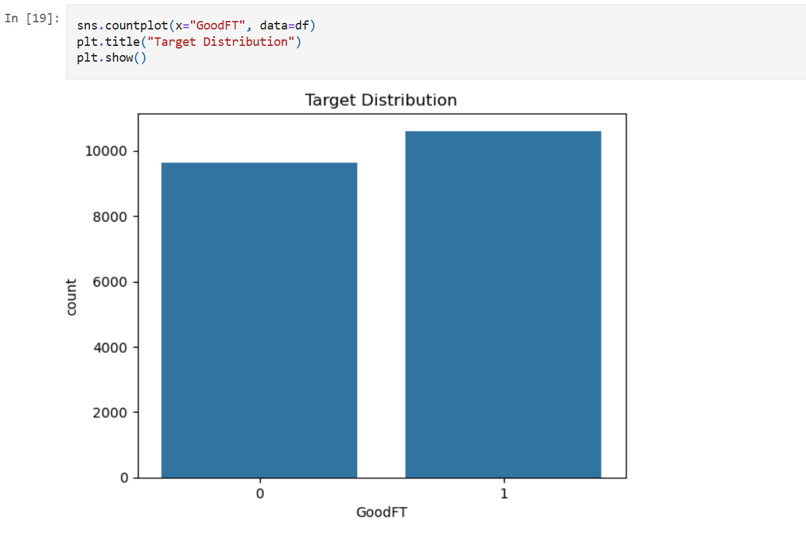

- Future plan
Model Selection:
Logistic Regression: We used this as our strong baseline because its regularization perfectly handles the highly overlapping stats in our dataset (like having both FG% and e FG%) without overfitting.

Random Forest: We chose this because it naturally captures complex 'If-Then' interactions in basketball stats—like how being a Guard versus a Center changes the impact of a player's total rebounds.

Gradient Boosting (XGBoost/LightGBM): We included this because it's the gold standard for tabular data; it aggressively learns from its own mistakes to squeeze out the highest possible accuracy on our 20,000 rows.

Support Vector Classifier (SVC): We used SVC because it excels at finding strict boundaries for crowded 'edge cases,' which is exactly what we need for players hovering right on our strict 75% cutoff.

K-Nearest Neighbors (KNN): We chose KNN because it perfectly mimics the real-life sports scouting method of 'player comparables' by predicting a player's success based on the guys most statistically similar to them.

Which will use the data as is: Random Forest and XGBoost. Tree-based models don't care about scale. They just look for splitting points.

Which will need scaling and further preprocessing: Logistic Regression, SVC, and KNN. These models use distance and geometry. If you don't scale the data, the "Minutes Played" column (e.g., 36) will overpower the "3P%" column (e.g., 0.33) just because 36 is a bigger number.

