Movies ontologies

CSE488- Ontologies and the Semantic Web

Team 15 members:

* Ahmed Gamil Fathy 19P4664
* Ahmed Osama Noaman 19P7926
* Mohamed Ehab Mansour 19P5241

Table of Contents

The Tree Hierarchy 3

Object and Data Properties: 5

Populating the Ontology: 6

Querying the Ontology: 7

More SPARQL Queries: 17

Manipulating The Ontology in Python 21

Ontology1 21

Code 21

output: 22

Ontology2 22

Code 22

Output 24

Ontology3 24

Code 24

Output 25

Ontology4 25

Code 25

Output 27

Ontology5 27

Code 27

Output 29

Ontology6 29

Code 29

Output 31

Application 32

Code 32

Output 36

RDF GRAPH USING PYTHON 37

DFD 38

# The Tree Hierarchy

Classes: Person, Movie, and Genre.

Subclasses: Actor, Director, Writer

OntoGraf:

# Object and Data Properties:

Object properties represent relationships between individuals or instances of classes in an ontology. These relationships typically involve other individuals or instances as their values. Data properties, on the other hand, represent attributes of individuals or instances in an ontology. These attributes typically have literal values, such as strings, numbers, or dates.

# Populating the Ontology:

Individuals, or Examples, are added through the Individual tab in Protégé by using the classes, subclasses, and data and object properties.

# Querying the Ontology:

SPARQL query is used for these examples:

1. List the instances of the class Actor

PREFIX owl: <http://www.w3.org/2002/07/owl#>

PREFIX rdf: <http://www.w3.org/1999/02/22-rdf-syntax-ns#>

PREFIX rdfs: <http://www.w3.org/2000/01/rdf-schema#>

PREFIX nms: <http://www.semanticweb.org/team15/ontologies/2024/4/M1-ontology-2/>

PREFIX nmsP: <http://www.semanticweb.org/team15/ontologies/2024/4/M1-ontology-2#>

SELECT DISTINCT **?actor**

WHERE {

?movie nms:hasActor **?actor**.

}

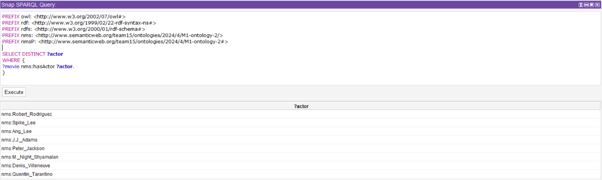

1. List the instances of the class writer

PREFIX owl: <http://www.w3.org/2002/07/owl#>

PREFIX rdf: <http://www.w3.org/1999/02/22-rdf-syntax-ns#>

PREFIX rdfs: <http://www.w3.org/2000/01/rdf-schema#>

PREFIX nms: <http://www.semanticweb.org/team15/ontologies/2024/4/M1-ontology-2/>

PREFIX nmsP: <http://www.semanticweb.org/team15/ontologies/2024/4/M1-ontology-2#>

SELECT DISTINCT **?writer**

WHERE {

**?writer** rdf:type nms:Person.

?movie nms:hasWriter **?writer**.

}

1. List the instances of the class director

PREFIX owl: <http://www.w3.org/2002/07/owl#>

PREFIX rdf: <http://www.w3.org/1999/02/22-rdf-syntax-ns#>

PREFIX rdfs: <http://www.w3.org/2000/01/rdf-schema#>

PREFIX nms: <http://www.semanticweb.org/team15/ontologies/2024/4/M1-ontology-2/>

PREFIX nmsP: <http://www.semanticweb.org/team15/ontologies/2024/4/M1-ontology-2#>

SELECT DISTINCT **?director**

WHERE {

**?director** rdf:type nms:Person.

?movie nms:hasDirector **?director**.

}

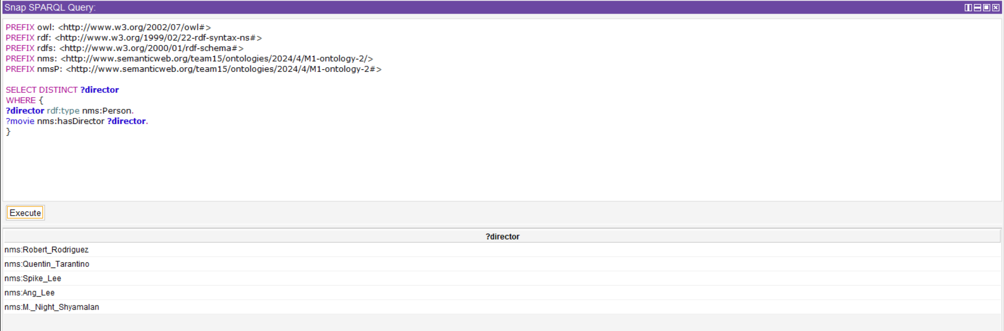

1. List the name of all Thriller movies. For each one, display its director.

PREFIX owl: <http://www.w3.org/2002/07/owl#>

PREFIX rdf: <http://www.w3.org/1999/02/22-rdf-syntax-ns#>

PREFIX rdfs: <http://www.w3.org/2000/01/rdf-schema#>

PREFIX nms: <http://www.semanticweb.org/team15/ontologies/2024/4/M1-ontology-2/>

PREFIX nmsP: <http://www.semanticweb.org/team15/ontologies/2024/4/M1-ontology-2#>

SELECT **?movie** **?director**

WHERE {

**?movie** rdf:type nms:Movie.

**?movie** nms:hasGenre nmsP:Thriller.

**?movie** nms:hasDirector **?director**.

}

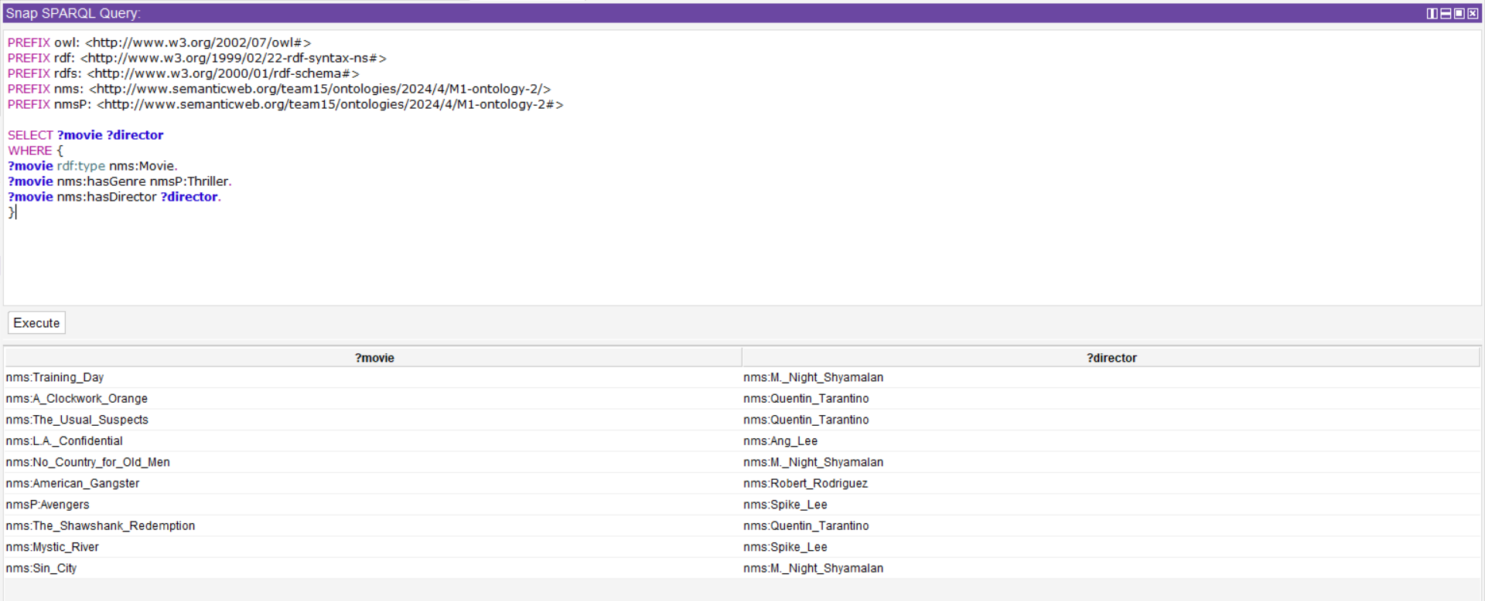

1. List the name of all Crime Thriller movies.

PREFIX owl: <http://www.w3.org/2002/07/owl#>

PREFIX rdf: <http://www.w3.org/1999/02/22-rdf-syntax-ns#>

PREFIX rdfs: <http://www.w3.org/2000/01/rdf-schema#>

PREFIX nms: <http://www.semanticweb.org/team15/ontologies/2024/4/M1-ontology-2/>

PREFIX nmsP: <http://www.semanticweb.org/team15/ontologies/2024/4/M1-ontology-2#>

SELECT **?movie**

WHERE {

**?movie** rdf:type nms:Movie.

**?movie** nms:hasGenre nmsP:Thriller.

**?movie** nms:hasGenre nmsP:Crime.

}

1. List the male actors in the movie in specific film

PREFIX owl: <http://www.w3.org/2002/07/owl#>

PREFIX rdf: <http://www.w3.org/1999/02/22-rdf-syntax-ns#>

PREFIX rdfs: <http://www.w3.org/2000/01/rdf-schema#>

PREFIX nms: <http://www.semanticweb.org/team15/ontologies/2024/4/M1-ontology-2/>

PREFIX nmsP: <http://www.semanticweb.org/team15/ontologies/2024/4/M1-ontology-2#>

SELECT **?actor**

WHERE {

?movie rdf:type nms:Movie.

**?actor** rdf:type nms:Person.

?movie nms:hasActor **?actor**.

?movie nms:hasTitle "Avengers".

**?actor** nms:hasGender nmsP:Male.

}

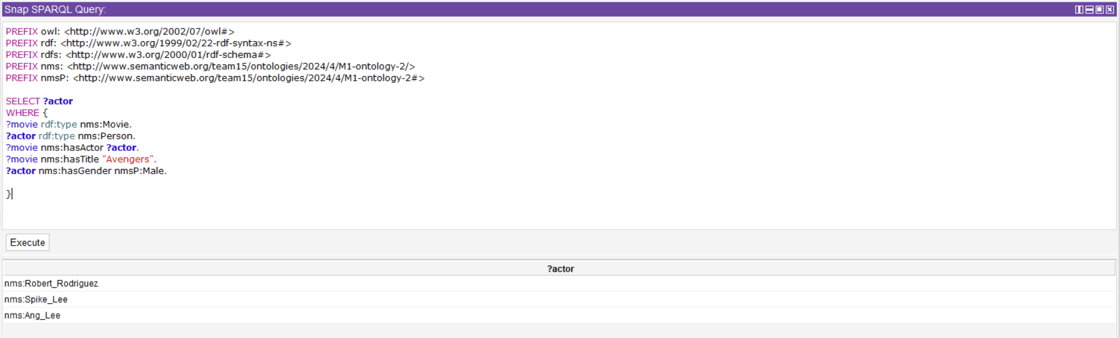

1. How many movies have both "Action" and "Thriller" as genres?

PREFIX owl: <http://www.w3.org/2002/07/owl#>

PREFIX rdf: <http://www.w3.org/1999/02/22-rdf-syntax-ns#>

PREFIX rdfs: <http://www.w3.org/2000/01/rdf-schema#>

PREFIX nms: <http://www.semanticweb.org/team15/ontologies/2024/4/M1-ontology-2/>

PREFIX nmsP: <http://www.semanticweb.org/team15/ontologies/2024/4/M1-ontology-2#>

SELECT (COUNT(?movie) AS **?totalMovies**)

WHERE {

?movie rdf:type nms:Movie.

?movie nms:hasGenre nmsP:Thriller.

?movie nms:hasGenre nmsP:Action.

}

1. List all the movies written by a specific writer.

PREFIX owl: <http://www.w3.org/2002/07/owl#>

PREFIX rdf: <http://www.w3.org/1999/02/22-rdf-syntax-ns#>

PREFIX rdfs: <http://www.w3.org/2000/01/rdf-schema#>

PREFIX nms: <http://www.semanticweb.org/team15/ontologies/2024/4/M1-ontology-2/>

PREFIX nmsP: <http://www.semanticweb.org/team15/ontologies/2024/4/M1-ontology-2#>

SELECT **?Movie**

WHERE {

**?Movie** nms:hasWriter nms:J.J._Adams

}

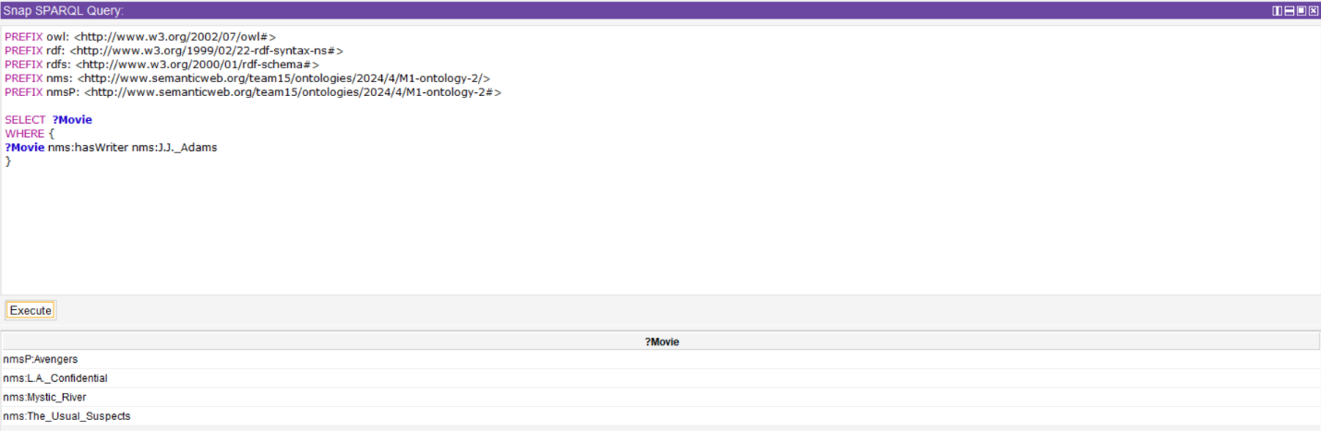

1. Find movies with a certain language.

PREFIX owl: <http://www.w3.org/2002/07/owl#>

PREFIX rdf: <http://www.w3.org/1999/02/22-rdf-syntax-ns#>

PREFIX rdfs: <http://www.w3.org/2000/01/rdf-schema#>

PREFIX nms: <http://www.semanticweb.org/team15/ontologies/2024/4/M1-ontology-2/>

PREFIX nmsP: <http://www.semanticweb.org/team15/ontologies/2024/4/M1-ontology-2#>

SELECT **?AllMovies**

WHERE {

?Movies nms:hasTitle **?AllMovies**.

?Movies nms:hasLanguage "en".

}

1. List the name of Actors older than 51 years.

PREFIX owl: <http://www.w3.org/2002/07/owl#>

PREFIX rdf: <http://www.w3.org/1999/02/22-rdf-syntax-ns#>

PREFIX rdfs: <http://www.w3.org/2000/01/rdf-schema#>

PREFIX nms: <http://www.semanticweb.org/team15/ontologies/2024/4/M1-ontology-2/>

PREFIX nmsP: <http://www.semanticweb.org/team15/ontologies/2024/4/M1-ontology-2#>

SELECT **?actor**

WHERE {

**?actor** rdf:type nms:Actor.

**?actor** nms:hasAge ?age

FILTER(?age > 51).

}

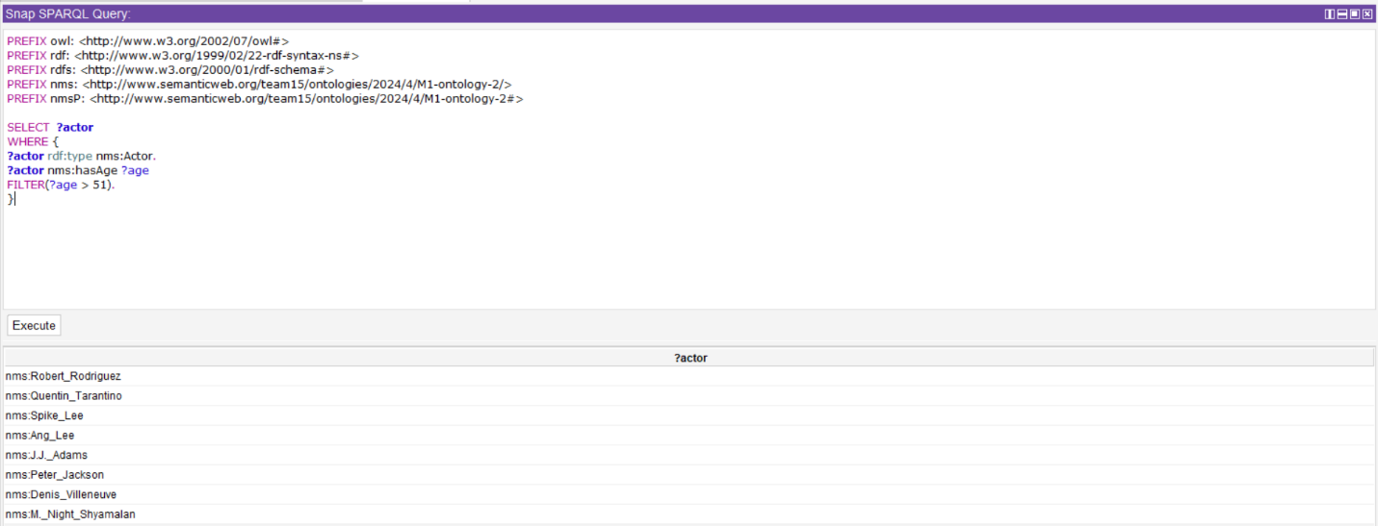

# More SPARQL Queries:

1. Output all the thriller movies, and if one of those thrillers is Action then also print its director.

PREFIX owl: <http://www.w3.org/2002/07/owl#>

PREFIX rdf: <http://www.w3.org/1999/02/22-rdf-syntax-ns#>

PREFIX rdfs: <http://www.w3.org/2000/01/rdf-schema#>

PREFIX nms: <http://www.semanticweb.org/team15/ontologies/2024/4/M1-ontology-2/>

PREFIX nmsP: <http://www.semanticweb.org/team15/ontologies/2024/4/M1-ontology-2#>

SELECT DISTINCT **?movieLabel** **?director**

WHERE {

?movie nms:hasTitle **?movieLabel**.

?movie nms:hasGenre nmsP:Thriller.

OPTIONAL {

?movie nms:hasGenre nmsP:Action.

?movie nms:hasDirector **?director**.

}

}

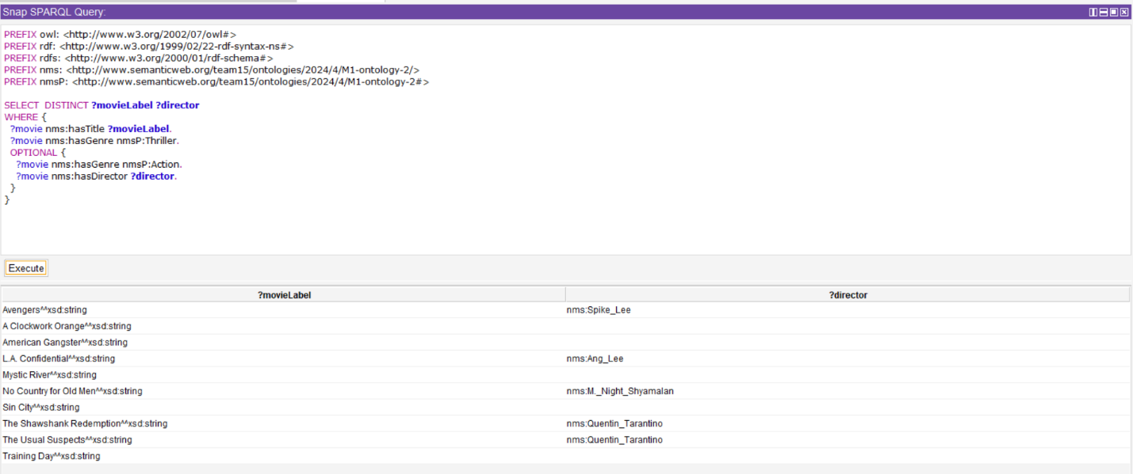

1. List the movie titles and their respective directors for movies that belong to the genre "Action" or "Drama."

PREFIX owl: <http://www.w3.org/2002/07/owl#>

PREFIX rdf: <http://www.w3.org/1999/02/22-rdf-syntax-ns#>

PREFIX rdfs: <http://www.w3.org/2000/01/rdf-schema#>

PREFIX nms: <http://www.semanticweb.org/team15/ontologies/2024/4/M1-ontology-2/>

PREFIX nmsP: <http://www.semanticweb.org/team15/ontologies/2024/4/M1-ontology-2#>

SELECT **?movieLabel** **?director**

WHERE {

?movie nms:hasTitle **?movieLabel**.

?movie nms:hasGenre nmsP:Action.

?movie nms:hasDirector **?director**.

{

?movie nms:hasGenre nmsP:Action.

}

UNION {

?movie nms:hasGenre nmsP:Drama.

}

}

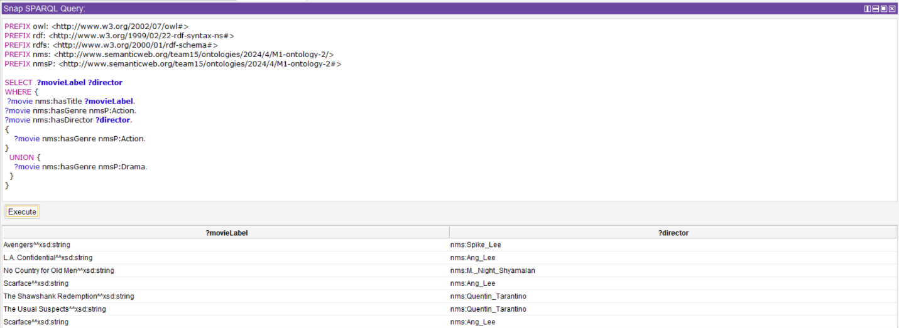

1. List movie titles, release years, and directors for movies that belong to either the "Action" or "Drama"

PREFIX owl: <http://www.w3.org/2002/07/owl#>

PREFIX rdf: <http://www.w3.org/1999/02/22-rdf-syntax-ns#>

PREFIX rdfs: <http://www.w3.org/2000/01/rdf-schema#>

PREFIX nms: <http://www.semanticweb.org/team15/ontologies/2024/4/M1-ontology-2/>

PREFIX nmsP: <http://www.semanticweb.org/team15/ontologies/2024/4/M1-ontology-2#>

SELECT **?movieLabel** **?releaseYear** **?director**

WHERE {

{

?movie nms:hasTitle **?movieLabel**;

nms:hasGenre nmsP:Action;

nms:hasDirector **?director**;

nms:hasYear **?releaseYear**.

}

UNION {

?movie nms:hasTitle **?movieLabel**;

nms:hasGenre nmsP:Drama;

nms:hasDirector **?director**;

nms:hasYear **?releaseYear**.

}

}

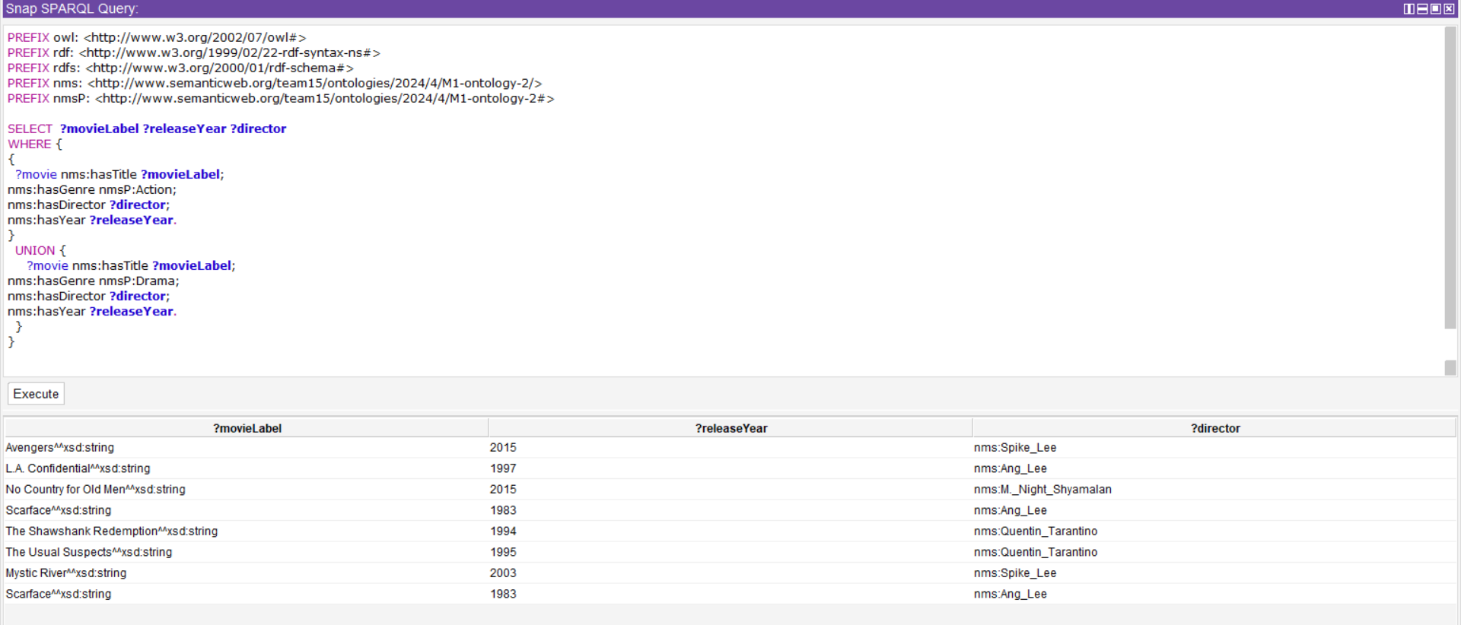

1. List movie titles that have genre action, and their release year if there is any.

PREFIX owl: <http://www.w3.org/2002/07/owl#>

PREFIX rdf: <http://www.w3.org/1999/02/22-rdf-syntax-ns#>

PREFIX rdfs: <http://www.w3.org/2000/01/rdf-schema#>

PREFIX nms: <http://www.semanticweb.org/team15/ontologies/2024/4/M1-ontology-2/>

PREFIX nmsP: <http://www.semanticweb.org/team15/ontologies/2024/4/M1-ontology-2#>

SELECT **?movieLabel** **?releaseYear**

WHERE {

?movie rdf:type nms:Movie.

?movie nms:hasTitle **?movieLabel**.

?movie nms:hasGenre nmsP:Action.

OPTIONAL {

?movie nms:hasYear **?releaseYear**.

}

}

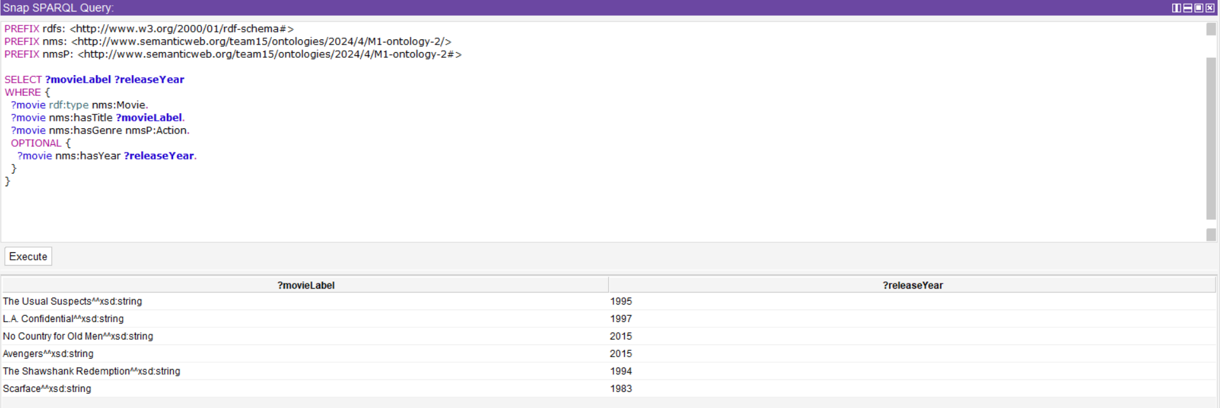

# Manipulating The Ontology in Python

## Ontology1

### Code

*from* rdflib *import* Graph

*from* rdflib.tools.rdf2dot *import* rdf2dot

def load_ontology(file_path):

*# Load the TTL file into an RDF graph*

    g = Graph()

    g.parse(file_path, format='ttl')

*return* g

def get_persons(graph):

    persons = set()

*# Iterate through all triples in the graph*

*for* subj, pred, obj *in* graph:

*# Check if the predicate is 'rdf:type' and the object is 'Person'*

*if* pred.endswith('type') and (str(obj).endswith('Actor') or str(obj).endswith('Writer') or str(obj).endswith('Director')):

            persons.add(subj)

*return* persons

def display_persons(file_path):

*# Load the ontology*

    graph = load_ontology(file_path)

*# Get all the Persons from the ontology*

    persons = get_persons(graph)

*# Display the Persons*

    print("Persons Without Using Inference and Query:")

*for* person *in* persons:

        print(person)

def visualize_graph(file_path, output_file):

*# Load the ontology*

    graph = load_ontology(file_path)

*# Create a stream to write DOT data*

*with* open(output_file, 'w') *as* f:

*# Convert RDF graph to DOT format and write to the stream*

        rdf2dot(graph, f)

*# Example usage*

*if* __name__ == "__main__":

    ttl_file = "Ontology_phase1_team15.ttl"  *# Path to your TTL file*

    output_dot_file = "graph.dot"  *# Output DOT file*

    display_persons(ttl_file)

    visualize_graph(ttl_file, output_dot_file)

### output:

## Ontology2

### Code

*from* rdflib *import* Graph, Namespace

*from* rdflib.plugins.sparql *import* prepareQuery

*# Define namespaces*

BASE = Namespace("http://www.semanticweb.org/team15/ontologies/2024/4/M1-ontology-2/")

RDF = Namespace("http://www.w3.org/1999/02/22-rdf-syntax-ns#")

def load_ontology(file_path):

*# Load the TTL file into an RDF graph*

    g = Graph()

    g.parse(file_path, format='ttl')

*return* g

def read_query_from_file(query_file):

*# Read the SPARQL query from the file*

*with* open(query_file, 'r') *as* f:

        query_text = f.read()

*return* query_text

def get_persons_with_query(graph, query_text):

    persons = set()

*# Prepare a SPARQL query from the text*

    query = prepareQuery(query_text, initNs={"rdf": RDF, "base": BASE})

*# Execute the query and collect the results*

    results = graph.query(query)

*for* row *in* results:

        persons.add(row.person)

*return* persons

def display_persons_with_query(file_path, query_file):

*# Load the ontology*

    graph = load_ontology(file_path)

*# Read the SPARQL query from the file*

    query_text = read_query_from_file(query_file)

*# Get all the Persons who are actors, directors, or writers using SPARQL query*

    persons = get_persons_with_query(graph, query_text)

*# Display the Persons*

    print("Persons:")

*for* person *in* persons:

        print(person)

*# Example usage*

*if* __name__ == "__main__":

    ttl_file = "Ontology_phase1_team15.ttl"  *# Path to your TTL file*

    query_file = "query.txt"    *# Path to your SPARQL query text file*

    display_persons_with_query(ttl_file, query_file)

query file

SELECT ?person

WHERE {

{

?person rdf:type base:Actor .

}

UNION

{

?person rdf:type base:Director .

}

UNION

{

?person rdf:type base:Writer .

}

}

### Output

## Ontology3

### Code

*from* rdflib *import* Graph, RDF, RDFS, OWL, Namespace

*from* owlrl *import* DeductiveClosure, RDFS_Semantics

def load_ontology(file_path):

*# Load the TTL file into an RDF graph*

    g = Graph()

    g.parse(file_path, format='ttl')

*# Apply Deductive Closure reasoning with RDFS semantics to the graph*

    DeductiveClosure(RDFS_Semantics).expand(g)

*return* g

def get_actors(graph, ns):

    actors = set()

*# Iterate through all inferred triples in the graph*

*for* subj, pred, obj *in* graph:

*# Check if the subject is an Actor*

*if* (subj, RDF.type, ns.Actor) in graph:

            actors.add(subj)

*return* actors

def display_actors(file_path):

*# Load the ontology and apply Deductive Closure reasoning*

    graph = load_ontology(file_path)

*# Define namespace*

    ns = Namespace("http://www.semanticweb.org/team15/ontologies/2024/4/M1-ontology-2/")

*# Get all the Actors from the ontology*

    actors = get_actors(graph, ns)

*# Display the Actors*

    print("Actors Using Inference without query")

*for* actor *in* actors:

        print(actor)

*# Example usage*

*if* __name__ == "__main__":

    ttl_file = "Ontology_phase1_team15.ttl"  *# Path to your TTL file*

    display_actors(ttl_file)

### Output

## Ontology4

### Code

*from* rdflib *import* Graph, RDF, RDFS, OWL, Namespace, Literal

*from* owlrl *import* DeductiveClosure, RDFS_Semantics

def load_ontology(file_path):

*# Load the TTL file into an RDF graph*

    g = Graph()

    g.parse(file_path, format='ttl')

*# Apply Deductive Closure reasoning with RDFS semantics to the graph*

    DeductiveClosure(RDFS_Semantics).expand(g)

*return* g

def get_movie_info(graph, ns, movie_name):

    movie_info = {}

*# Iterate through all inferred triples in the graph*

*for* subj, pred, obj *in* graph:

*# Check if the subject is an instance of Movie with the given name*

*if* (subj, RDF.type, ns.Movie) in graph and (subj, ns.hasTitle, Literal(movie_name)) in graph:

*# Get movie year, country, genres, and actors*

            year = graph.value(subj, ns.hasYear)

            country = graph.value(subj, ns.hasCountry)

            genres = [genre *for* genre *in* graph.objects(subj, ns.hasGenre)]

            actors = [actor *for* actor *in* graph.objects(subj, ns.hasActor)]

            movie_info = {

                'Year': year,

                'Country': country,

                'Genres': genres,

                'Actors': actors

            }

*break*

*return* movie_info

def display_movie_info(file_path, movie_name):

*# Load the ontology and apply Deductive Closure reasoning*

    graph = load_ontology(file_path)

*# Define namespace*

    ns = Namespace("http://www.semanticweb.org/team15/ontologies/2024/4/M1-ontology-2/")

*# Get movie information*

    movie_info = get_movie_info(graph, ns, movie_name)

*# Display movie information*

*if* movie_info:

        print("Movie Information:")

        print("Name:", movie_name)

        print("Year:", movie_info.get('Year'))

        print("Country:", movie_info.get('Country'))

        print("Genres:", ', '.join(movie_info.get('Genres')))

        print("Actors:", ', '.join(movie_info.get('Actors')))

*else*:

        print("Error: Movie '{}' not found.".format(movie_name))

*# Example usage*

*if* __name__ == "__main__":

    ttl_file = "Ontology_phase1_team15.ttl"  *# Path to your TTL file*

    movie_name = input("Enter the name of the movie: ")

    display_movie_info(ttl_file, movie_name)

### Output

## Ontology5

### Code

*from* rdflib *import* Graph, RDF, Namespace

*from* rdflib.plugins.sparql *import* prepareQuery

*from* owlrl *import* DeductiveClosure, RDFS_Semantics, OWLRL_Semantics

*# Define namespaces*

BASE = Namespace("http://www.semanticweb.org/team15/ontologies/2024/4/M1-ontology-2#")

RDF = Namespace("http://www.w3.org/1999/02/22-rdf-syntax-ns#")

def load_ontology(file_path, rule_path):

*# Load the TTL file into an RDF graph*

    g = Graph()

    g.parse(file_path, format='ttl')

    g.parse(rule_path, format='ttl')

*# Apply Deductive Closure reasoning with RDFS semantics to the graph*

    DeductiveClosure(OWLRL_Semantics).expand(g)

*return* g

def get_actor_directors(graph):

    persons = set()

*# Prepare a SPARQL query from the text*

    query = prepareQuery("""

        SELECT DISTINCT ?actorDirector

        WHERE {

            ?actorDirector rdf:type base:ActorDirector .

        }

        """, initNs={"rdf": RDF, "base": BASE})

*# Execute the query and collect the results*

    results = graph.query(query)

*for* row *in* results:

        persons.add(row["actorDirector"])

*return* persons

def display_actor_directors(file_path, rule_path):

*# Load the ontology*

    graph = load_ontology(file_path, rule_path)

*# Get all the actor-directors from the ontology*

    actor_directors = get_actor_directors(graph)

*# Display the actor-directors*

    print("Actor-Directors:")

*for* actor_director *in* actor_directors:

        print(actor_director)

*# Example usage*

*if* __name__ == "__main__":

    ttl_file = "Ontology_phase1_team15.ttl"  *# Path to your TTL file*

    rule_file = "rule.ttl"

    display_actor_directors(ttl_file, rule_file)

Rule File  
@prefix owl: <http://www.w3.org/2002/07/owl#> .

@prefix : <http://www.semanticweb.org/team15/ontologies/2024/4/M1-ontology-2/> .

@prefix ns: <http://www.semanticweb.org/team15/ontologies/2024/4/M1-ontology-2#> .

# Define ActorDirector as an intersection of Actor and Director

ns:ActorDirector a owl:Class ;

owl:equivalentClass [

a owl:Class ;

owl:intersectionOf ( :Actor :Director )

] .

### Output

## Ontology6

### Code

*from* rdflib *import* Graph, RDF, Namespace, OWL

*from* owlrl *import* DeductiveClosure, RDFS_Semantics, OWLRL_Semantics

*# Define namespaces*

BASE = Namespace("http://www.semanticweb.org/team15/ontologies/2024/4/M1-ontology-2#")

RDF = Namespace("http://www.w3.org/1999/02/22-rdf-syntax-ns#")

def load_ontology(file_path, rule_path):

*# Load the TTL file into an RDF graph*

    g = Graph()

    g.parse(file_path, format='ttl')

    g.parse(rule_path, format='ttl')

*# Apply Deductive Closure reasoning with RDFS semantics to the graph*

    DeductiveClosure(OWLRL_Semantics).expand(g)

*return* g

def get_actor_writer(graph):

    actor_writers = set()

*# Iterate through all inferred triples in the graph*

*for* subj, pred, obj *in* graph:

*# Check if the subject is an ActorWriter*

*if* (subj, RDF.type, BASE.ActorWriter) in graph:

            actor_writers.add(subj)

*return* actor_writers

def display_actor_writer(file_path, rule_path):

*# Load the ontology*

    graph = load_ontology(file_path, rule_path)

*# Get all the actor-directors from the ontology*

    actor_writers = get_actor_writer(graph)

*# Display the actor-directors*

    print("ActorWriter:")

*for* actor_writer *in* actor_writers:

        print(actor_writer)

def get_director_writer(graph):

    director_writers = set()

*# Iterate through all inferred triples in the graph*

*for* subj, pred, obj *in* graph:

*# Check if the subject is an ActorWriter*

*if* (subj, RDF.type, BASE.WriterDirector) in graph:

            director_writers.add(subj)

*return* director_writers

def display_director_writer(file_path, rule_path):

*# Load the ontology*

    graph = load_ontology(file_path, rule_path)

*# Get all the actor-directors from the ontology*

    director_writers = get_director_writer(graph)

*# Display the actor-directors*

    print("DirectorWriter:")

*for* director_writer *in* director_writers:

        print(director_writer)

def get_director_writer_actor(graph):

    director_writers_actor = set()

*# Iterate through all inferred triples in the graph*

*for* subj, pred, obj *in* graph:

*# Check if the subject is an ActorWriter*

*if* (subj, RDF.type, BASE.ActorWriterDirector) in graph:

            director_writers_actor.add(subj)

*return* director_writers_actor

def display_director_writer_actor(file_path, rule_path):

*# Load the ontology*

    graph = load_ontology(file_path, rule_path)

*# Get all the actor-directors from the ontology*

    director_writers_actor = get_director_writer_actor(graph)

*# Display the actor-directors*

    print("DirectorWriterActor:")

*for* director_writer_actor *in* director_writers_actor:

        print(director_writer_actor)

*# Example usage*

*if* __name__ == "__main__":

    ttl_file = "Ontology_phase1_team15.ttl"  *# Path to your TTL file*

    rule_file = "rule.ttl"

    display_actor_writer(ttl_file, rule_file)

    display_director_writer(ttl_file, rule_file)

    display_director_writer_actor(ttl_file,rule_file)

Rule File  
  
Rule File  
@prefix owl: <http://www.w3.org/2002/07/owl#> .

@prefix : <http://www.semanticweb.org/team15/ontologies/2024/4/M1-ontology-2/> .

@prefix ns: <http://www.semanticweb.org/team15/ontologies/2024/4/M1-ontology-2#> .

# Define ActorWriter as an intersection of Actor and Writer

ns:ActorWriter a owl:Class ;

owl:equivalentClass [

a owl:Class ;

owl:intersectionOf ( :Actor :Writer )

] .

# Define WriterDirector as an intersection of Actor and Writer

ns:WriterDirector a owl:Class ;

owl:equivalentClass [

a owl:Class ;

owl:intersectionOf ( :Director :Writer )

] .

# Define ActorWriterDirector as an intersection of Actor and Writer and Director

ns:ActorWriterDirector a owl:Class ;

owl:equivalentClass [

a owl:Class ;

owl:intersectionOf ( :Actor :Director :Writer )

] .

### Output

# Application

## Code

*from* rdflib *import* Graph, URIRef, Namespace

*from* rdflib.namespace *import* RDF, RDFS, XSD

BASE = Namespace("http://www.semanticweb.org/team15/ontologies/2024/4/M1-ontology-2/")

BASE2 = Namespace("http://www.semanticweb.org/team15/ontologies/2024/4/M1-ontology-2#")

*# Define a Movie class to represent each movie*

class Movie:

    def __init__(self, title, actors, director, genres, year):

*self*.title = title

*self*.actors = actors

*self*.director = director

*self*.genres = genres

*self*.year = year

*# Define a class to manage the movie database*

class MovieDatabase:

    def __init__(self):

*self*.movies = []

    def load_from_ttl(self, ttl_file):

        g = Graph()

        g.parse(ttl_file, format="ttl")

*# Iterate over all triples in the graph*

*for* subj, pred, obj *in* g:

*# Check if the subject is a movie*

*if* (subj, RDF.type, BASE.Movie) in g:

*# Initialize variables to store movie details*

                title = None

                actors = set()

                director = None

                genres = set()

                year = None

*# Extract movie details from triples*

*if* (subj, BASE.hasTitle, None) in g:

                    title = str(g.value(subj, BASE.hasTitle))

*if* (subj, BASE.hasActor, None) in g:

                    actors.update(str(actor) *for* actor *in* g.objects(subj, BASE.hasActor))

*if* (subj, BASE.hasDirector, None) in g:

                    director = str(g.value(subj, BASE.hasDirector))

*if* (subj, BASE.hasGenre, None) in g:

                    genres.update(str(genre) *for* genre *in* g.objects(subj, BASE.hasGenre))

*if* (subj, BASE.hasYear, None) in g:

                    year = int(g.value(subj, BASE.hasYear))

*# Create a Movie object and append it to the list of movies*

                movie = Movie(title, list(actors), director, list(genres), year)

*self*.movies.append(movie)

    def search_movies(self, included_actors=[], included_directors=[], included_genres=[], excluded_actors=[], excluded_directors=[], excluded_genres=[]):

        result = []

*for* movie *in* *self*.movies:

*if* (not included_actors or set(movie.actors).intersection(included_actors)) \

                    and (not included_directors or movie.director in included_directors) \

                    and (not included_genres or set(movie.genres).intersection(included_genres)) \

                    and (not excluded_actors or not set(movie.actors).intersection(excluded_actors)) \

                    and (not excluded_directors or movie.director not in excluded_directors) \

                    and (not excluded_genres or not set(movie.genres).intersection(excluded_genres)):

                result.append(movie)

*return* result

def prompt_and_process_input(prompt):

*"""*

*Prompt the user for input and process it into URIs.*

*"""*

    names = input(prompt).split(',')

*if* not names:

*return* []

*else*:

*return* [BASE + name.strip() *for* name *in* names]

def prompt_and_process_input_for_genres(prompt):

*"""*

*Prompt the user for input and process it into URIs.*

*"""*

    names = input(prompt).split(',')

*if* not names:

*return* []

*else*:

*return* [BASE2 + name.strip() *for* name *in* names]

*# Main function*

def main():

*# Create a movie database*

    movie_database = MovieDatabase()

*# Load movie data from TTL file*

    movie_database.load_from_ttl("Ontology_phase1_team15.ttl")

*# Take input from User*

    included_actor_uris = prompt_and_process_input("Actor names to include separated by commas: ")

    excluded_actor_uris = prompt_and_process_input("Actor names to exclude separated by commas: ")

    included_genre_uris = prompt_and_process_input_for_genres("Genre types to include separated by commas: ")

    excluded_genre_uris = prompt_and_process_input_for_genres("Genre types to exclude separated by commas: ")

    included_director_uris = prompt_and_process_input("Director names to include separated by commas: ")

    excluded_director_uris = prompt_and_process_input("Director names to exclude separated by commas: ")

*# Check if any of the lists are empty and replace them with []*

    included_actor_uris = included_actor_uris *if* included_actor_uris!=[BASE] *else* []

    excluded_actor_uris = excluded_actor_uris *if* excluded_actor_uris!=[BASE] *else* []

    included_director_uris = included_director_uris *if* included_director_uris!=[BASE] *else* []

    excluded_director_uris = excluded_director_uris *if* excluded_director_uris!=[BASE] *else* []

    included_genre_uris = included_genre_uris *if* included_genre_uris!=[BASE2] *else* []

    excluded_genre_uris = excluded_genre_uris *if* excluded_genre_uris!=[BASE2] *else* []

*# Search for movies based on criteria*

    found_movies = movie_database.search_movies(

                                                included_actors=included_actor_uris,

                                                included_genres=included_genre_uris,

                                                included_directors=included_director_uris,

                                                excluded_actors=excluded_actor_uris,

                                                excluded_genres=excluded_genre_uris,

                                                excluded_directors=excluded_director_uris,

                                            )

*# Display the found movies*

    print("------------------------------------------------------------------")

*if* found_movies:

        print("Found movies:")

        printed_titles = set()  *# Set to store encountered titles*

*for* movie *in* found_movies:

*if* movie.title not in printed_titles:  *# Check if title is not already printed*

                print("Movie Title:", movie.title)

                print("Movie Release Year:", movie.year)

                print("Movie Genre:", ", ".join(movie.genres))

                print("Movie Director Name:", movie.director)

                print("Movie Actor Name:", ", ".join(movie.actors))

                print("----------")

                printed_titles.add(movie.title)  *# Add title to printed set*

*else*:

        print("There are no movies with this info.")

*if* __name__ == "__main__":

    main()

## Output

# RDF GRAPH USING PYTHON

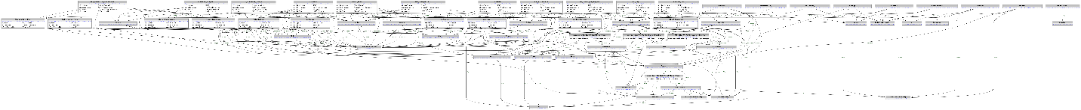

# DFD

