DEPI / AI FOR HEALTHCARE • RESEARCHVOICE AI
C5 / Human Approval & XLSX Export
OWNER [Member 5 — assign] | RISK HIGH | Integrated n8n (single-workflow instructor exception)
PURPOSE | Require human verification of study values before creating and delivering a per-visit XLSX file.
TRIGGER | Final Review, corrections (Name = value), Confirm & Export, /retry
INPUT | study/case/visit metadata; draft values, evidence, issues, missing flags; approval nonce; hard-hold flag
PROCESS | 1 Show final values/issues. 2 Parse typed corrections. 3 Require missing-field acceptance. 4 Enforce no unresolved issues or hold. 5 Researcher confirms. 6 Create XLSX. 7 Confirm Telegram receipt.
AI / PROMPT | No autonomous patient-facing generation; human decision from C5. Excel evidence and metadata originate from prior extraction/review.
OUTPUT / NEXT | XLSX rows: variable_name, value, unit, status, flag, evidence, confirmation/visit metadata; completed-delivery record
HUMAN / SAFETY | Researcher must press Confirm & Export; failed delivery is not counted as complete.
FAILURE / FALLBACK | Unresolved issue / low-safety hard hold blocks export; delivery error → /retry; duplicate marked delivery suppressed.
LOGGING / TRACE | Confirmed delivery tally in /monitor; Telegram XLSX receipt; XLSX has documented-field evidence and confirmation timestamp.
ACTUAL N8N NODE PATH
Send Final Record Review → Route Telegram Update → Prepare Approved Excel Rows → Create XLSX Export → Send Approved Excel to Telegram → Confirm Export Delivery
FIVE PRESCRIBED CASES — THREE NORMAL / ONE EDGE / ONE UNSAFE
ID | SYNTHETIC INPUT | EXPECTED | EVIDENCE STATUS
N1 | Age 54, HbA1c 6.2% | Approve + XLSX receipt | Earlier demo evidence
N2 | Correct HbA1c to 7.2 percent | Corrected XLSX after approval | Observed in shared demo
N3 | Follow-up visit 2 | Distinct ID/date + export | Earlier demo evidence
E1 | Missing HbA1c | Requires explicit blank acceptance | Formal record needed
U1 | Try to export with unresolved issue | No file until resolved | Formal record needed
OBSERVED EVIDENCE & KNOWN LIMITS
EVIDENCE Observed: manually corrected HbA1c=7.2%, Confirm & Export sent XLSX; /monitor reported 1 delivery.
LIMIT XLSX is per-visit, not a governed research database; workflow static data not durable transactional storage.
N8N SCREENSHOT — actual Phase 4 execution excerpt; replace with component-focused view before submission
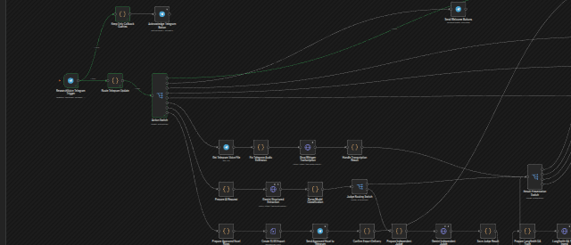
SUBMISSION CHECK Assign owner • add focused n8n screenshot • record actual outcomes for all five cases • owner signs off.

