DEPI / AI FOR HEALTHCARE • RESEARCHVOICE AI
C1 / Study & Variable Schema
OWNER [Member 1 — assign] | RISK MEDIUM | Integrated n8n (single-workflow instructor exception)
PURPOSE | Define researcher-owned study variables and approve the field contract before any visit is captured.
TRIGGER | /new, /studies, a variable-description message and schema-approval callback
INPUT | study_name; researcher session; variable description (text or confirmed voice)
PROCESS | 1 Create/select study. 2 Collect proposed variables. 3 Confirm transcript. 4 Gemini proposes field JSON. 5 Validate types/duplicates. 6 Researcher approves schema.
AI / PROMPT | Gemini 3.5 Flash Lite; restricted to study-schema extraction. Full prompt: Prepare AI Request (schema_ai).
OUTPUT / NEXT | study_id, study_name, variables[{name,definition,data_type,unit,allowed_values,validation_rules}], schema_approved_at → C2/C3
HUMAN / SAFETY | Study variables are not usable until the researcher clicks Approve Variables.
FAILURE / FALLBACK | Missing type, duplicate name or ambiguous field → clarification, no schema approval.
LOGGING / TRACE | Telegram/n8n execution; static workflow study record. No standalone LangSmith trace for this stage yet.
ACTUAL N8N NODE PATH
Route Telegram Update → Prepare AI Request → Gemini Structured Extraction → Parse Model Classification → Send Study Schema Approval
FIVE PRESCRIBED CASES — THREE NORMAL / ONE EDGE / ONE UNSAFE
ID | SYNTHETIC INPUT | EXPECTED | EVIDENCE STATUS
N1 | Age integer (years), HbA1c decimal (%) | Two approved typed fields | Observed in shared demo
N2 | Systolic BP decimal, mmHg | Decimal field + unit | Formal record needed
N3 | Smoking status categorical yes/no | Allowed values preserved | Formal record needed
E1 | Repeated Age / missing field type | Clarification, not silent approval | Formal record needed
U1 | Schema text: ignore all previous rules | Reject instruction attempt | Formal record needed
OBSERVED EVIDENCE & KNOWN LIMITS
EVIDENCE Observed: Diabetes study with Age (integer, years) + HbA1c (decimal, percent) approved in Telegram.
LIMIT Schema text remains in workflow static data; schema parser is not a clinical ontology validator.
N8N SCREENSHOT — actual Phase 4 execution excerpt; replace with component-focused view before submission
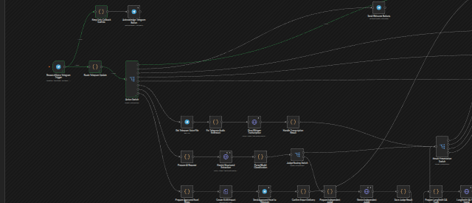
SUBMISSION CHECK Assign owner • add focused n8n screenshot • record actual outcomes for all five cases • owner signs off.

