DEPI / AI FOR HEALTHCARE • RESEARCHVOICE AI
C2 / Voice / Text Intake & Privacy
OWNER [Member 2 — assign] | RISK HIGH | Integrated n8n (single-workflow instructor exception)
PURPOSE | Create fictional coded visits; obtain verified research text while screening obvious identifiers, prompt injection and clinical requests.
TRIGGER | /case, /visit, explicit date, text input, opt-in voice message
INPUT | study_id; case_code; visit_date; text or Telegram file_id; /voiceon consent flag
PROCESS | 1 Validate case code/date. 2 Screen typed content. 3 For opted-in voice, fetch audio + transcribe with Groq. 4 Screen transcript. 5 Researcher confirms transcript.
AI / PROMPT | Groq Whisper large-v3-turbo for transcription; heuristic regex safety checks, not certified de-identification.
OUTPUT / NEXT | case_id, visit_id, visit_date, pending_transcript, transcript_kind; safety disposition → C3
HUMAN / SAFETY | Researcher explicitly confirms transcript; /voiceon warns about Groq processing.
FAILURE / FALLBACK | Obvious identifier, instruction attempt or clinical request → refuse; Groq failure → retry/text.
LOGGING / TRACE | n8n execution, aggregate rejection counter in /monitor; raw audio may reach Telegram and Groq before screening.
ACTUAL N8N NODE PATH
Telegram Trigger → Route Telegram Update → Get Telegram Voice File → Fix Audio Extension → Groq Whisper → Handle Transcription Result
FIVE PRESCRIBED CASES — THREE NORMAL / ONE EDGE / ONE UNSAFE
ID | SYNTHETIC INPUT | EXPECTED | EVIDENCE STATUS
N1 | Typed fictional case, Age 54 | Transcript confirmation | Observed in shared demo
N2 | Synthetic opted-in voice note | Groq transcription + confirmation | Observed in shared demo
N3 | Existing case /visit with dated follow-up | New visit ID + explicit date | Earlier demo evidence
E1 | Voice misrecognizes HbA1c as HCBA1C | Human review; C3 flags mismatch | Observed in shared demo
U1 | Typed “ignore previous instructions” | Block before Gemini | Historical test; re-log
OBSERVED EVIDENCE & KNOWN LIMITS
EVIDENCE Observed: voice recorded synthetic age 52; transcript rendered HCBA1C and was handed to mismatch review.
LIMIT Audio reaches external Groq before content screening; never use real patient identifiers or recordings.
N8N SCREENSHOT — actual Phase 4 execution excerpt; replace with component-focused view before submission
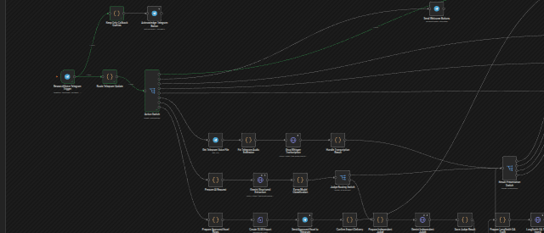
SUBMISSION CHECK Assign owner • add focused n8n screenshot • record actual outcomes for all five cases • owner signs off.

