DEPI / AI FOR HEALTHCARE • RESEARCHVOICE AI
C4 / Independent QA & Monitoring
OWNER [Member 4 — assign] | RISK HIGH | Integrated n8n (single-workflow instructor exception)
PURPOSE | Score draft extraction, classify QA alerts, surface metrics and send privacy-minimized LangSmith checkpoints.
TRIGGER | Parse Model Classification produces a case draft
INPUT | approved schema; confirmed synthetic transcript; draft values/evidence/issues; visit-scoped QA metadata
PROCESS | 1 Independently judge five dimensions 1–5. 2 Validate JSON/scoring. 3 Record evaluation. 4 Calculate soft/hard alert. 5 Notify Telegram. 6 Ingest LangSmith QA trace.
AI / PROMPT | Gemini judge with explicit scoring rubric; separate call but same provider/model family as extractor (not independently calibrated).
OUTPUT / NEXT | scores, rationales, average, overall, monitor_alert_level/reason_code; /eval, /monitor; LangSmith QA checkpoint → C5
HUMAN / SAFETY | Hard hold for safety or factual accuracy ≤2 or critical flag; researcher may /redo. Judge does not authorize care.
FAILURE / FALLBACK | Judge error → log failed QA and soft alert; LangSmith failure does not block Final Review.
LOGGING / TRACE | LangSmith project ResearchVoice-AI-Graduation receives metadata-only QA checkpoint; /monitor rolling 200 evaluations.
ACTUAL N8N NODE PATH
Prepare Independent Judge → Gemini Independent Judge → Save Judge Result → Monitor QA and Alert Decision → LangSmith QA Trace Ingest
FIVE PRESCRIBED CASES — THREE NORMAL / ONE EDGE / ONE UNSAFE
ID | SYNTHETIC INPUT | EXPECTED | EVIDENCE STATUS
N1 | Matched synthetic draft | Five scores + completed result | Observed in shared demo
N2 | Metadata-only QA trace | LangSmith “Run created” | Observed in shared demo
N3 | /monitor after evaluated visit | Counts, mean score, judge-only p95 | Observed in shared demo
E1 | HCBA1C schema mismatch | Soft alert + reason code | Observed in shared demo
U1 | Judge safety ≤2 simulated | Hard hold, /redo recovery | Local simulation only
OBSERVED EVIDENCE & KNOWN LIMITS
EVIDENCE Observed: 5/5 judge case; 4.6/5 mismatch with format 3/5, soft warning; “Run created”; /monitor 1 judge.
LIMIT Current checkpoint is one QA trace, not full per-model/step tracing; judges not yet human calibrated; alert hard hold not live-demonstrated.
N8N SCREENSHOT — actual Phase 4 execution excerpt; replace with component-focused view before submission
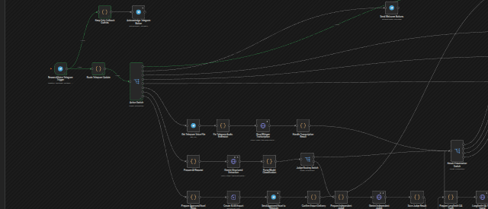
SUBMISSION CHECK Assign owner • add focused n8n screenshot • record actual outcomes for all five cases • owner signs off.

