Observed Synthetic Demo — Evidence Annex
  - Actual screenshot exhibits + interpretation; a single demonstration is not a representative benchmark

One documented complicated research-data visit
Scenario: fictional Diabetes research study with Age and HbA1c schema. Voice transcription produced a nonmatching HbA1c-like variable label. The draft left HbA1c undocumented; the system produced a soft alert; the researcher manually corrected HbA1c to 7.2 percent and approved export. Judge ratings describe the original model draft BEFORE human correction.

Voice transcript review
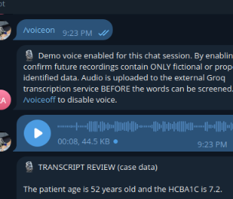
Shows researcher confirmation of transcribed synthetic case data.

Soft alert / mismatched field
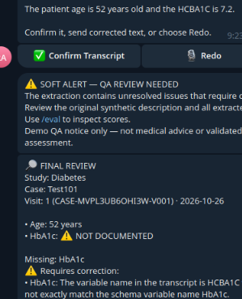
Shows review requirement when approved schema variable is not matched.

Correction and delivery
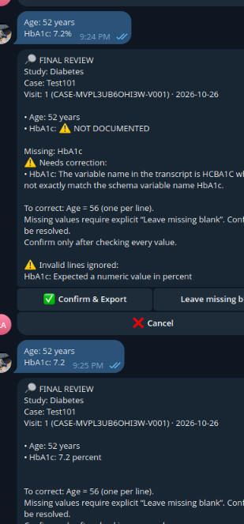
Shows researcher correction, confirmation and approved XLSX delivery.

Judge, monitoring and LangSmith results
Metric | Observed output
QA status | Completed
Scores | Factual 5; grounded 5; safety 5; format 3; bias 5
Judge mean | 4.6/5 · needs review
Soft alert | unresolved_extraction_issues · alert_required true
Judge duration | 10,490 ms
Rolling /monitor | 1 judge completed, 0 failed, 1 soft warning, 0 hard holds, 1 confirmed Excel delivery
LangSmith | Run created; trace visible in LangSmith project

QA scores and monitoring
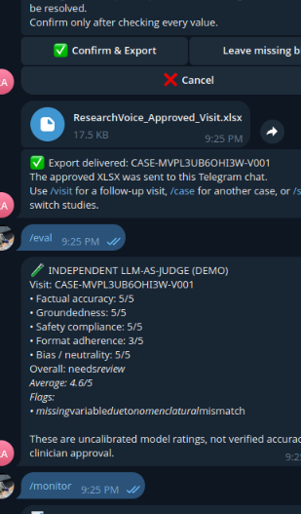

LangSmith trace evidence
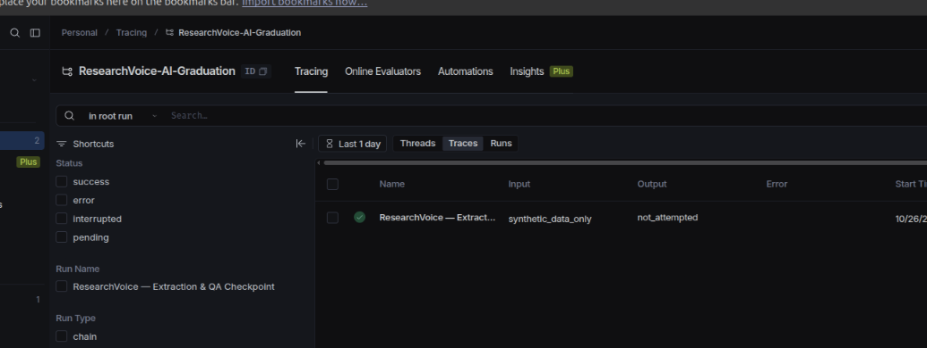
Evidence limitation: current QA trace is a checkpoint, not a full step-by-step capture of every input, model call, and output. Safety checks are best-effort; synthetic data only. The human reviewers have not yet calibrated these scores.

