**(Table of Contents)**

**1** Chapter one (Introduction) :

**1.1** Introduction & Problem ……………………………………………………………………(3)

**1.2** Genetral Objectives ……………………………………………………………………….…(4)

**2** Chapter two (Analysis) :

**2.1** Overview .…………………………………………………………………………………………(6)

**2.2** Analysis Objectives ………………………………………………………………………..(7-8)

**2.3** System Structure ………………………………………………………………………………(8)

**2.4** System proccess …………….…………………………………………………………………(9)

**3** Chapter three (System Screens) :

**3.1** ERD ………………..…………………………………………..……………………………..……(11)

**3.2** Scema …………………………………………..…………………………………………………(12)

**3.3** System Screens …………………………………………..………………………………(13-17)

**4** Chapter four (Implementation) :

**4.1** Installation Procedure …..…………………………..……………………………………(19)

**4.2** Project Implementation ..……………………………………..……………………(19-20)

**4.3** Source Code ………………….……………………………………..……………………(21-25)

**4.4** Cocclusion ………………….……………………………………..……………………………(26)

**4.5** Future Work ………………….…………………………………..……………………………(26)

**Chapter 1**

**1.1 Introduction & Problem**

Our main problem is that in medical laboratories in particular and the medical field in general, we need to link all types of organization data to each other so that if we make a change to certain data, other operations are changed or performed on other data according to what the requirements and nature of the current system are, so we were reviewing the system today For an analysis laboratory in which the paper body of the organization’s management is compensated for by a complete semi-electronic system through a small local network that brings together the company’s members in the form of a website that connects and directs them to and from a data base that collects various enterprise data.

According to previous words ..

Our system today is mainly functioned to be under obey of end-users to ease the process of medical tests without any troubles may appear when record or result or insert all data needed to watch the company and do it’s best according to functions needed to be.

**1.2 Objectieves**

Our objective is to create a web-based application to a Medical Laboratory named ‘FCAI Lab’ to insert customers, employee, managers, medical tests data and retrieve them into (charts, diagrams) ,(reports) due to every employee access in our system or user ability.. so :

1. User-Friendly Inerface is designed into our system, according to **HCI** requirments for Our end-users (workers, Users).
2. Easy Database is structured to help in get best Performance of transactions.
3. Almost every process done is recorded in our system to watch and prevent Hacking or Unauthorized login.
4. Ease Finicial Proccess that ,usally, require Human to perform it like calculate salaries, income, and outcome of hole business monthly.

**Chapter 2**

**2.1 Introduction & Overview**

There is no doubt these days that the digital transformation of modern medical facilities and institutions has become an inevitable matter to secure and improve the medical and service level of medical matters, from the administration side and from the users side as well, so that each of them is up to date for the things they have in common in the medical process.

The following section provides an overview of the specifications of the requirements of the derivative programs for the analytics lab management system from the administrative and the service side.

**2.2 Analysis Objective**

The main objective of the lab project is to make things easier for the client in terms of dealing with the system. By recording his complete data, he can book from room in his home and know the appropriate dates for him and the laboratory so that he can go and do the analysis for him as well as the laboratory's goals to improve personnel management, improve facilities and safety, improve customer satisfaction, and develop a quality year plan for the next year. The most important thing that distinguishes the analysis lab project is the speed of knowing the results of the analysis and knowing the necessary procedures to improve the client’s health, and, after the client registers his data, it will remain in the analysis lab system, such as blood type, number of hemoglobin balls, and the percentage of white blood cells in the body. All this data will remain in the system and the client can query in addition, a result of analysis and the facilitation of all financial transactions for him One of the distinctive objectives of the analysis lab system is that it is possible to make a graph for the most people who suffer from the same disease, so it is possible to know the most tests that were done in a month. And, through the system, it is possible to define the net profit of the company and determine the expenses necessary to purchase the equipment we need, and the new equipment can be determined needs maintenance, refurbishment, sale, or replacement.

One of the distinctive objectives of the analysis lab system is that it is possible to make a graph for the most people who suffer from the same disease, so it is possible to know the most tests that were done in a month. And, through the system, it is possible to define the net profit of the company and determine the expenses necessary to purchase the equipment we need.

**2.3 Project Structure**

* Customer:

He/she is the person who comes to the medical lab to do some medical tests and record some data related to him/her and his analysis.

* Supplier:

He/she is the person who brings the medical tools to the laboratory, and contracts with him/her and the company supplying those tools and sets laws and terms between the two parties. All data is recorded about him and the company that supplied those medical tools.

* Receptionist (Admin 0):

He/she is the person responsible for recording all medical data about patients and visitors to the medical analysis laboratory. He/she asks about the information required for analysis and records the patient in the laboratory's database.

* Manger (Admin 1):

He/she is the person responsible for all the conditions and affairs of the medical analysis laboratory and is responsible for contracts with any pharmaceutical company or some hospitals.

* Technical (Admin 2) :

He/she is the person responsible for receiving samples, marking them for analysis, and applying laboratory tests according to standard procedures. He/she also has some other skills that enable him to perform his/her job well.

**2.4 System proccess**

1. The lab system able to record customer data (profile).
2. The lab system able to delete customer data (profile).
3. The lab system able to update customer data (profile).
4. The lab system allows the system manager to add new worker profile.
5. The lab system allows the system manager to edit new worker profile.
6. The lab system allows the system manager to delete new worker profile.
7. The lab system allows the customer to book through the home.
8. The lab system allows the customer to book through lab (offline) through worker (Admin 0 or 1).
9. The lab system shows the result of the patient analysis online to the customer.
10. The lab system will send the patient's analysis results directly to the doctor in some cases.
11. System lab performance a backup plan to copy and protect data against the possibility of sudden loss.
12. **The lab system makes statistics for the number of monthly visits.**
13. **The lab system generates statistics for the most performed analyzes.**
14. **The lab system generates monthly income and outcome.**
15. **The lab system allow financial manager to increase or decrease worker salary.**
16. The lab system allows the patient to do complaint online from home.
17. The lab system allows the patient to do complaint offline from lab through worker (Admin 0 or 1).
18. The lab system shows all previous tests in table of customer.
19. The lab system list all workers in company.
20. The lab system records and listing late attendance for workers.
21. The lab system records and login attemps to avoid Unauthorized login.

**Chapter 3**

**3.1 Entity Relation Diagram**

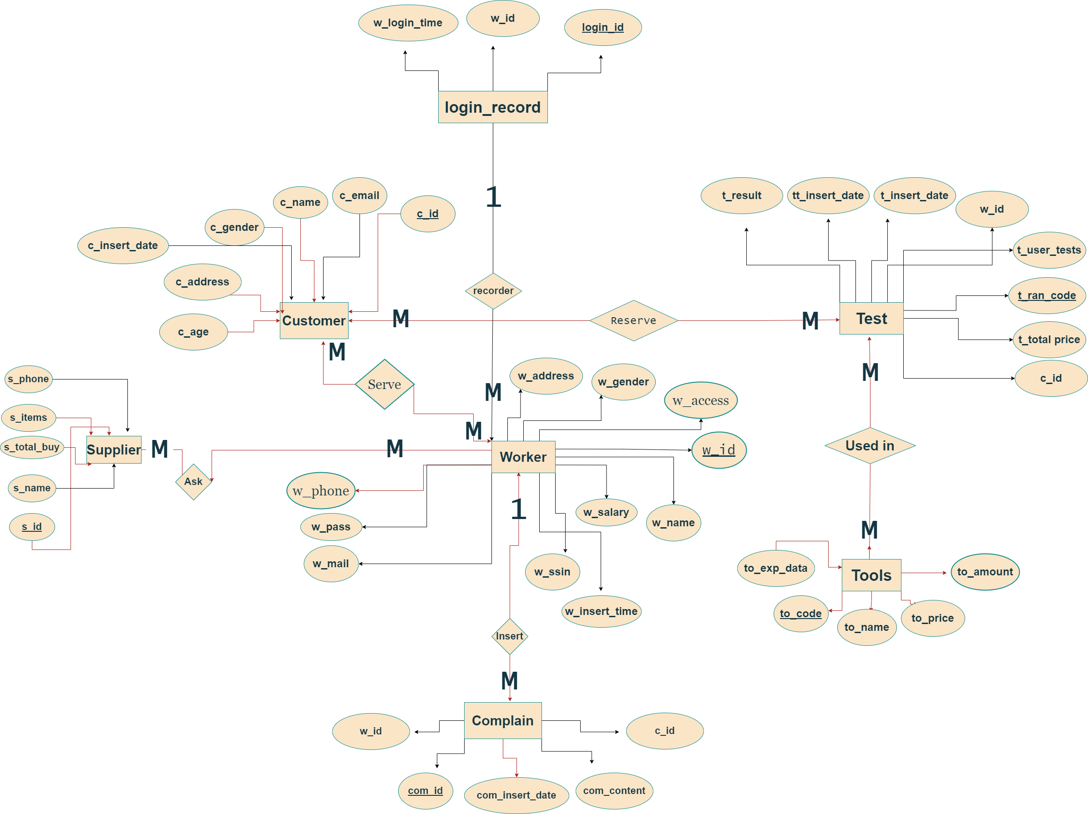

**3.2 Scema**

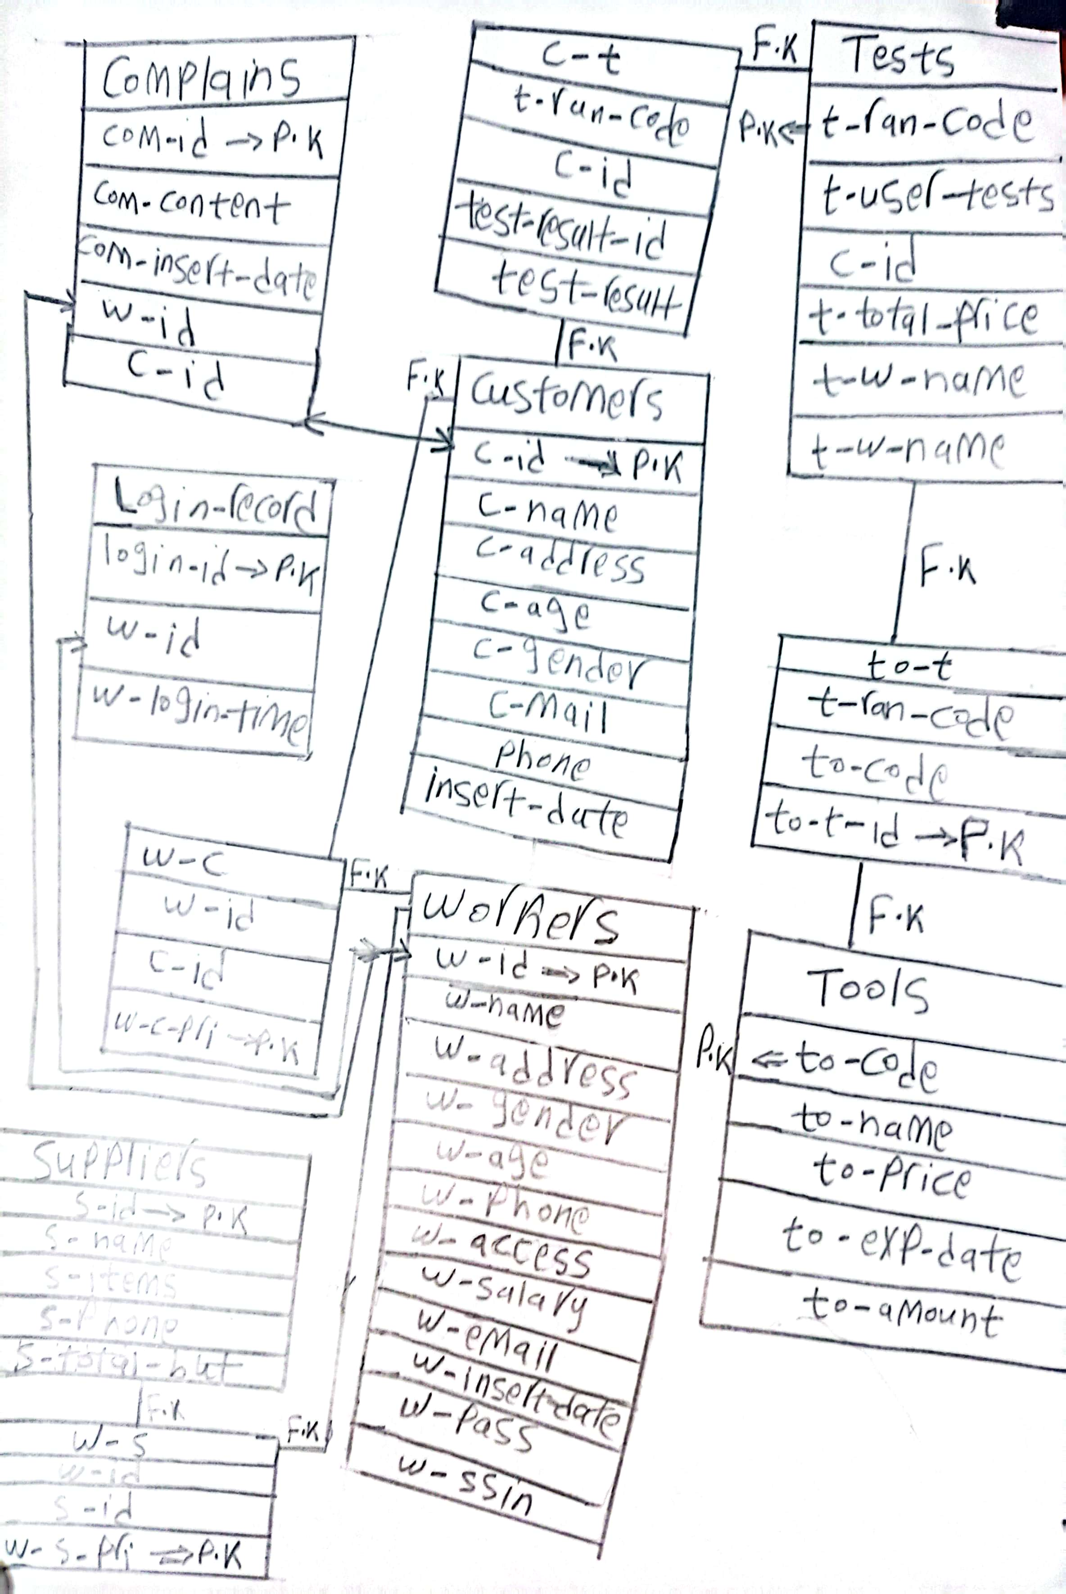

**3.3 Project Screens**

**Login Admin due to access :**

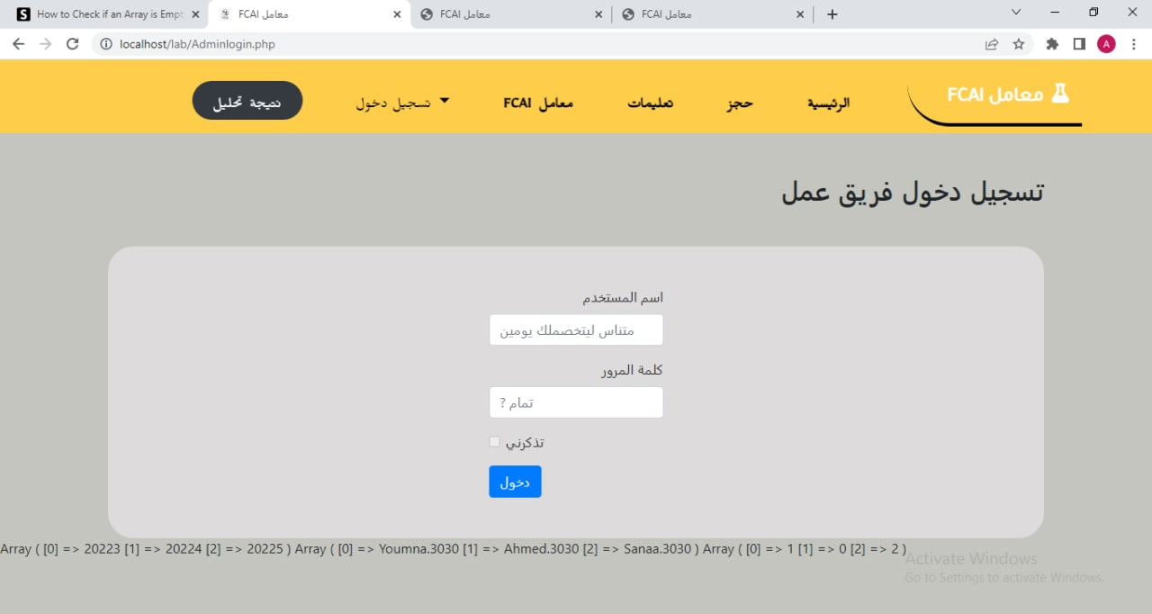

**Admin 1 (Manager) Dashboard :**

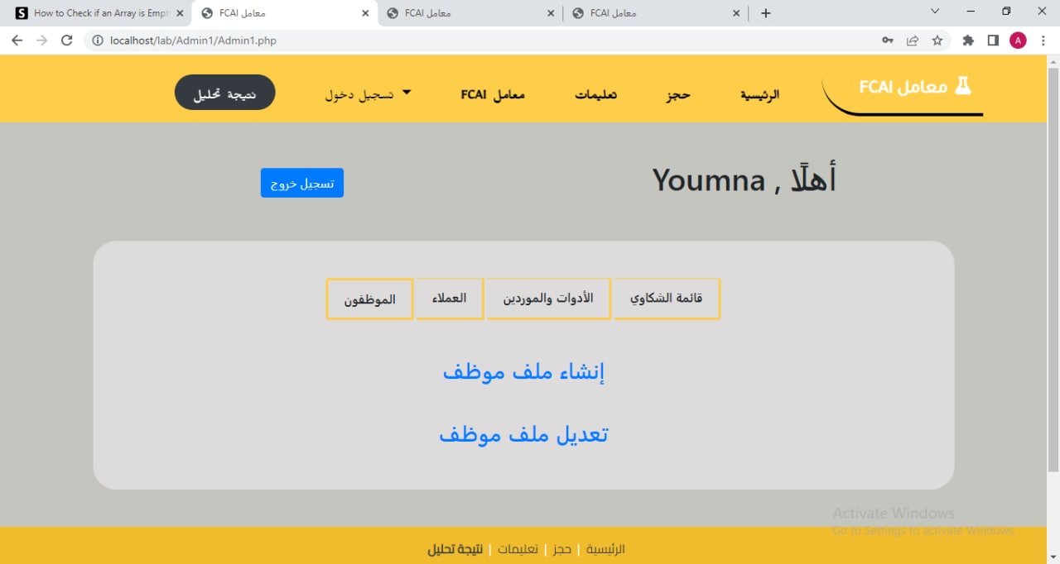

**Admin 0 (employee) Dashboard :**

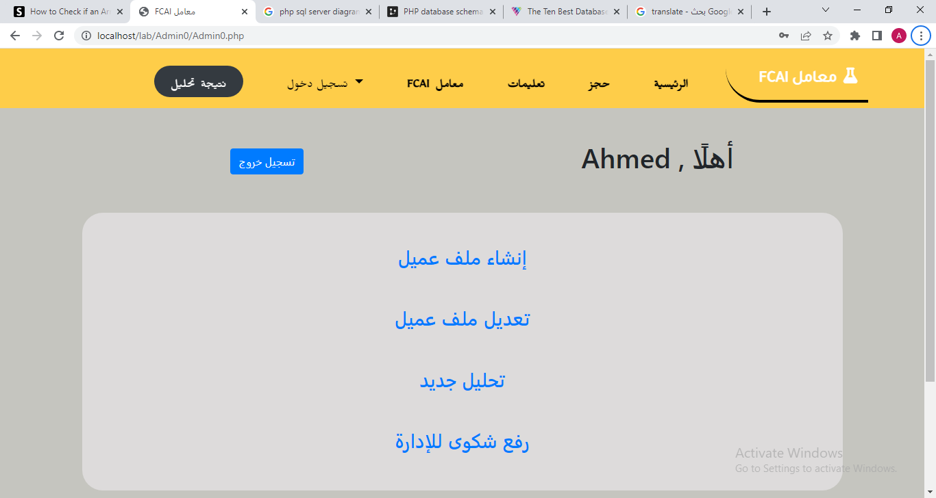

**Admin 2 (Medical employee or manager) Dashboard :**

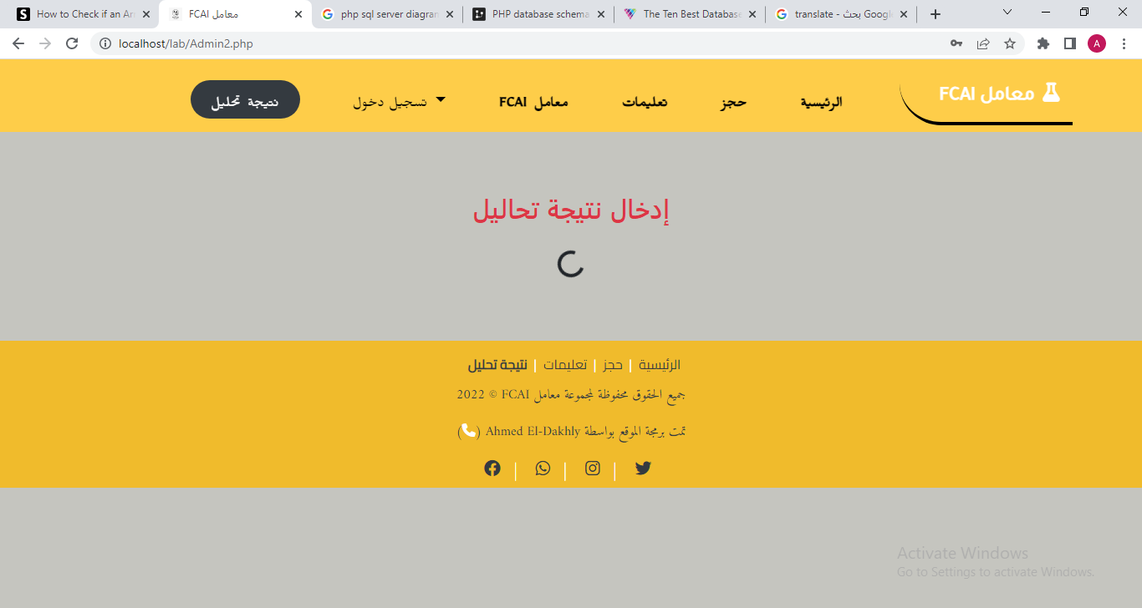

..

..

**Admin 1 Some Features :**

(Create - Update Worker Account)

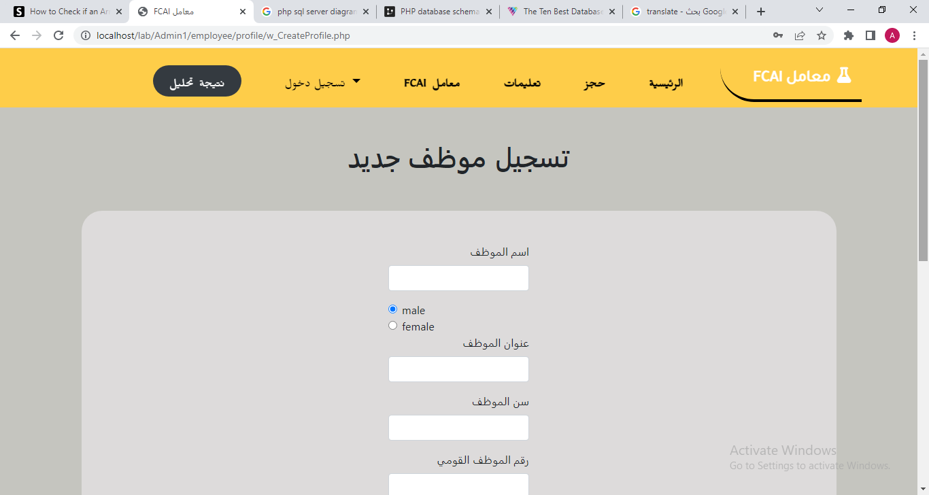

(Full control of employee operatons) :

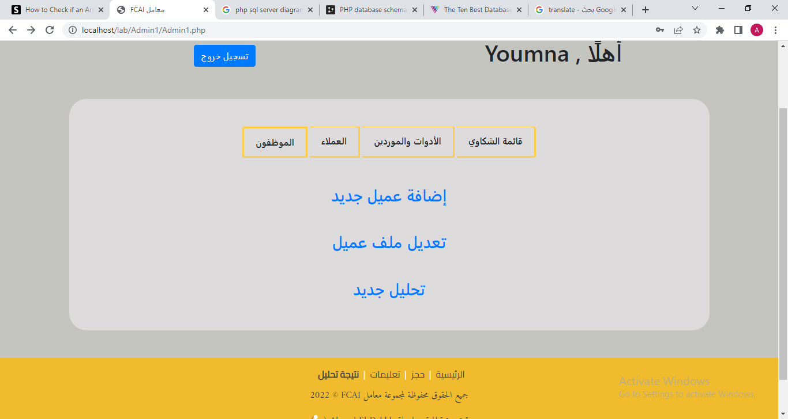

(Show – Edit Complains of customers) :

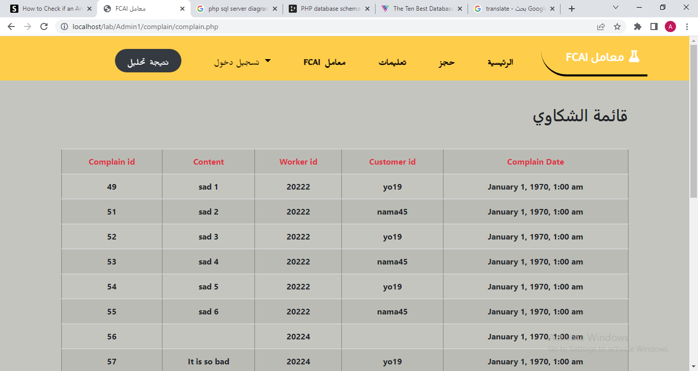

Etc..

**Admin 0 Some Features :**

**..**

**(All of them are part of Admin1 access)**

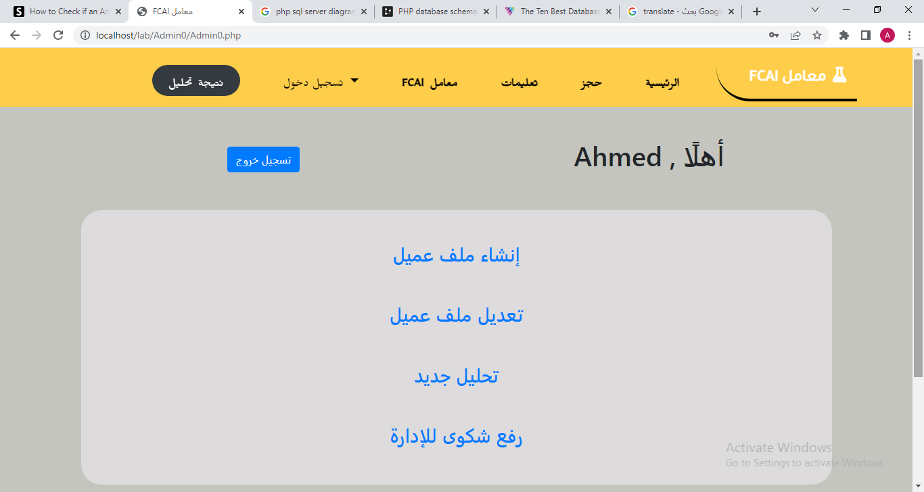

**..**

..

**Chapter 4**

**4.1 Installation Procedure**

For Company Workers :

1. Windows Os with at least Windows 7.
2. Xampp Server (Panel v 3.2.4).
3. Preferd SQL server 2019.

After install, just remain to open our system in web application form.

**4.2 Project Implementation**

The project can be accessed by 3 users admins :

* **Admin 1 (Manager) : Can Access hole project with full access :**
  + Add or edit **worker** account.
  + Add or edit **customer** data.
  + View test tools remain and used.
  + Edit or view all complains
  + View System history (login time).
* **Admin 0 (Manager) :** 
  + Can Access only : user data and edit it.
  + create tests
  + Insert complains.
* **Admin 2 (Technical one) :** Can only Insert test result into database.
* Also Our System **can be accessed by Our Users to Only view Their Test Result** and details online.

**4.3 Source Code**

**Admin Login :**

//select & fetch required columns from worker table to login (user,pass,access):

$sql = "SELECT w_id,w_pass,w_access from worker";

$params = array(1, "some data");

$login_time = date("Y-m-d h:i:s");

$stmt = sqlsrv_query( $conn, $sql, $params);

$row = sqlsrv_fetch_array( $stmt, SQLSRV_FETCH_ASSOC);

// Arrays to insert Prevoius columns in :

$user = [];

$pass = [];

$access = [];

while( $row = sqlsrv_fetch_array( $stmt, SQLSRV_FETCH_ASSOC) ) {

    array_push($user, $row['w_id']);

    array_push($pass, $row['w_pass']);

    array_push($access, $row['w_access']);

}

// Recieve login data :

$userinput=$_REQUEST['user'];

$passinput=$_REQUEST['pass'];

if (in_array($userinput, $user) && in_array($passinput, $pass) && (array_search($userinput, $user) == array_search($passinput, $pass))) {

    //Insert login time

    $insert_record = "INSERT INTO login_record (login_w_id, login_time) Values('$userinput', '$login_time')";

    $stmt_insert_record = sqlsrv_query( $conn, $insert_record, $params);

    //Redirect employee to dashboard due to his "access"

    if ($access[array_search($userinput, $user)]== 1) {

        echo "<meta http-equiv='refresh' content='0;url=./Admin1/Admin1.php'>";

    }

    if ($access[array_search($userinput, $user)]== 0) {

        echo "<meta http-equiv='refresh' content='0;url=./Admin0/Admin0.php'>";

    }

      if ($access[array_search($userinput, $user)]== 2) {

        echo "<meta http-equiv='refresh' content='0;url=./Admin2.php'>";

    }

}

//Pass worker id to his dashboard (to select his name) :

$_SESSION['w_id'] = $userinput;

?>

**Insert new Customer data :**

$c_name=$_REQUEST['c_name'];

$c_address=$_REQUEST['c_address'];

$c_age=$_REQUEST['c_age'];

$c_gender=$_REQUEST['c_gender'];

$c_phone=$_REQUEST['c_phone'];

$c_mail=$_REQUEST['c_mail'];

$c_insert_date = date("Y-m-d h:i:s");

$c_id1 = substr($c_name, 0, 2);

$c_id2 = substr($c_gender, 0, 2);

$c_id3 = substr($c_age, 0, 2);

$c_id = $c_id1 . $c_id2 . $c_id3;

//insert worker into row :

$sql = "INSERT INTO customer (c_id, c_name, c_address, c_age, c_gender, c_phone, c_mail, c_insert_date) VALUES ('$c_id', '$c_name', '$c_address', '$c_age', '$c_gender', '$c_phone', '$c_mail', '$c_insert_date');";

$params = array(1, "some data");

$stmt = sqlsrv_query($conn, $sql, $params);

// test query success :

if(sqlsrv_rows_affected($stmt)){

    echo "<div class='row'><div class='p-5 mt-5 col-9 mx-auto text-center h3 text-danger' style='background:rgb(221, 219, 219)'>تم إضافة العميل بنجاح</div></div>";

}

?>

**Test Creation :**

    $c_id = $_REQUEST['t_id'];

    $c_name = $_REQUEST['t_name'];

    $tests = $_REQUEST['tests'];

    $t_tests = implode(', ', $tests);

    // fun. to create random code to test (unique name)

    function testcode()

    {

        $alphabet = "abcdefghijklmnopqrstuwxyzABCDEFGHIJKLMNOPQRSTUWXYZ0123456789";

        $pass = array();

        $alphaLength = strlen($alphabet) - 1;

        for ($i = 0; $i < 8; $i++) {

            $n = rand(0, $alphaLength);

            $pass[] = $alphabet[$n];

        }

        return implode($pass);

    }

    $t_ran_code = testcode();

// create array, add each test price to as index, then sum all and decrease tools

    $price = [];

    $cbc = 200;

    $urine = 139;

    $gpt = 110.25;

    $got = 80;

    $tsh = 168;

    $t3 = 216;

    $t4 = 130.5;

    $t_insert_date = date("Y-m-d h:i:s");

    $sql = "IF EXISTS (SELECT c_id FROM customer WHERE c_id = '$c_id') print'exist' else print'no'";

    $params = array(1, "some data");

    $stmt = sqlsrv_query( $conn, $sql, $params);

    $row = sqlsrv_fetch_array( $stmt, SQLSRV_FETCH_ASSOC);

    $res = implode('',$row);

  if ($res = "exist") {

    if (in_array('cbc', $tests)) {

        array_push($price, $cbc);

        $sql_cbc1 = "UPDATE tool SET to_amount = to_amount-1 WHERE to_name = 'aaa'";

        $params = array(1, "some data");

        $stmt = sqlsrv_query($conn, $sql_cbc1, $params);

        $sql_cbc2 = "UPDATE tool SET to_amount = to_amount-1 WHERE to_name = 'bbb'";

        $stmt = sqlsrv_query($conn, $sql_cbc2, $params);

    }

    if (in_array('urine', $tests)) {

        array_push($price, $urine);

        $sql_urine1 = "UPDATE tool SET to_amount = to_amount-1 WHERE to_name = 'ddd'";

        $params = array(1, "some data");

        $stmt = sqlsrv_query($conn, $sql_urine1, $params);

        $sql_urine2 = "UPDATE tool SET to_amount = to_amount-1 WHERE to_name = 'hhh'";

        $stmt = sqlsrv_query($conn, $sql_urine2, $params);

        $sql_urine3 = "UPDATE tool SET to_amount = to_amount-1 WHERE to_name = 'hhh'";

        $stmt = sqlsrv_query($conn, $sql_urine3, $params);

    }

    /*

    if (in_array('gpt', $tests)) {

        array_push($price, $gpt);

    }

    if (in_array('got', $tests)) {

        array_push($price, $got);

    }

    if (in_array('tsh', $tests)) {

        array_push($price, $tsh);

    }

    if (in_array('t3', $tests)) {

        array_push($price, $t3);

    }

    if (in_array('t4', $tests)) {

        array_push($price, $t4);

    }

    */

    $t_price = array_sum($price);

    $sql = "INSERT INTO test (t_ran_code, t_user_tests, c_id, t_total_price, t_insert_date, t_w_name) VALUES('$t_ran_code', '$t_tests', '$c_id', '$t_price', '$t_insert_date' , '$worker')";

    $sql2 = "SELECT c_name from customer where c_id = '$c_id'";

    $params = array(1, "some data");

    $stmt = sqlsrv_query($conn, $sql, $params);

    $stmt2 = sqlsrv_query( $conn, $sql2, $params);

    $row2 = sqlsrv_fetch_array( $stmt2, SQLSRV_FETCH_ASSOC);

    $c_name = implode('',$row2);

    if(sqlsrv_rows_affected($stmt2)){

        echo "<hr>";

    echo "<div class='row'><div class='p-5 mt-5 col-9 mx-auto text-center h3' style='background:rgb(221, 219, 219)'> $t_price  : سعر التحليل <br><br> الرجاء تحصيله من العميل</div></div>";

        echo "<div class='row mt-3 mx-auto text-center'> <div class='col-12'><a class='btn btn-secondary' href='reciet.php' target='_blank'>طباعة الايصال</a></div></div>";

}else{

echo "<div class='row'><div class='p-5 mt-5 col-9 mx-auto text-center h3 text-danger' style='background:rgb(221, 219, 219)'>الرجاء إدخال البيانات بصورة صحيحة</div></div>";

}

}

// data will be exported to reciet :

$_SESSION['c_name'] = $c_name;

$_SESSION['c_id'] = $c_id;

$_SESSION['t_ran_code'] = $t_ran_code;

$_SESSION['t_insert_date'] = $t_insert_date;

$_SESSION['t_total_price'] = $t_price;

$_SESSION['t_tests'] = $t_tests;

**4.4 Conclusion**

Today we are talking about a system for managing analytical laboratories and how to transform its facility from an expensive paper body to a comutarized form in which all daily and non-daily operations are conducted in a systematic and recorded manner so that random decisions or matters are avoided, which includes disorganization within the work environment instead of protection from hacking attempts

**4.5 Future Work**

* Adding a special aspect to dealing with medical unions and government agencies.
* Auto-mail sending or SMS is served to supplier to In order to provide the company with required equipment.
* Auto-mail sending or SMS is served to workers only if salary increase or decrease due to good work or latte attendance .. etc.
* Provide new side for user to help in decision making about their health after generating Test result