DESCRIPTIVES VARIABLES=date trade_balance inflation exports imports balance_deficit
/STATISTICS=MEAN STDDEV MIN MAX.

Descriptives

Notes
Output Created |  | 08-OCT-2022 20:30:22
Comments
Input | Data | /Users/ahmed/Desktop/Untitled2.sav
Input | Active Dataset | DataSet1
Input | Filter | <none>
Input | Weight | <none>
Input | Split File | <none>
Input | N of Rows in Working Data File | 12
Missing Value Handling | Definition of Missing | User defined missing values are treated as missing.
Missing Value Handling | Cases Used | All non-missing data are used.
Syntax |  | DESCRIPTIVES VARIABLES=date trade_balance inflation exports imports balance_deficit  /STATISTICS=MEAN STDDEV MIN MAX.
Resources | Processor Time | 00:00:00.00
Resources | Elapsed Time | 00:00:00.00

Descriptive Statistics
 | N | Minimum | Maximum | Mean | Std. Deviation
Date | 11 | . | . | . | 00:00:03.317
trade_balance | 11 | 957,0 | 6.340,0 | 4.537,727 | 1.759,9075
inflation | 11 | 13.0 | 163.3 | 45.900 | 41.5807
exports | 11 | 3.093 | 11.404 | 5.11645 | 2.867037
imports | 11 | 7.850 | 10.044 | 9.23345 | .659265
balance_deficit | 11 | -957,000 | 6.340,000 | 4.240,40036 | 2.405,941231
Valid N (listwise) | 11

Notes
Output Created |  | 08-OCT-2022 20:33:43
Comments
Input | Data | /Users/ahmed/Desktop/Untitled2.sav
Input | Active Dataset | DataSet1
Input | Filter | <none>
Input | Weight | <none>
Input | Split File | <none>
Input | N of Rows in Working Data File | 12
Syntax |  | GRAPH  /HISTOGRAM=inflation  /PANEL COLVAR=trade_balance COLOP=CROSS ROWVAR=date ROWOP=CROSS.
Resources | Processor Time | 00:00:00.31
Resources | Elapsed Time | 00:00:01.00

Notes
Output Created |  | 08-OCT-2022 20:34:06
Comments
Input | Data | /Users/ahmed/Desktop/Untitled2.sav
Input | Active Dataset | DataSet1
Input | Filter | <none>
Input | Weight | <none>
Input | Split File | <none>
Input | N of Rows in Working Data File | 12
Syntax |  | GRAPH  /HISTOGRAM=date  /PANEL COLVAR=trade_balance COLOP=CROSS ROWVAR=inflation ROWOP=CROSS.
Resources | Processor Time | 00:00:00.22
Resources | Elapsed Time | 00:00:00.00

GGraph

Notes
Output Created |  | 08-OCT-2022 20:35:10
Comments
Input | Data | /Users/ahmed/Desktop/Untitled2.sav
Input | Active Dataset | DataSet1
Input | Filter | <none>
Input | Weight | <none>
Input | Split File | <none>
Input | N of Rows in Working Data File | 12
Syntax |  | GGRAPH  /GRAPHDATASET NAME="graphdataset" VARIABLES=trade_balance date MISSING=LISTWISE REPORTMISSING=NO  /GRAPHSPEC SOURCE=INLINE.  BEGIN GPL  SOURCE: s=userSource(id("graphdataset"))  DATA: trade_balance=col(source(s), name("trade_balance"))  DATA: date=col(source(s), name("date"), unit.category())  GUIDE: axis(dim(1), label("trade_balance"))  GUIDE: axis(dim(2), label("Date"))  GUIDE: text.title(label("Simple Bar of Date by trade_balance"))  ELEMENT: interval(position(trade_balance*date), shape.interior(shape.square))  END GPL.
Resources | Processor Time | 00:00:00.43
Resources | Elapsed Time | 00:00:00.00

Notes
Output Created |  | 08-OCT-2022 20:36:56
Comments
Input | Data | /Users/ahmed/Desktop/Untitled2.sav
Input | Active Dataset | DataSet1
Input | Filter | <none>
Input | Weight | <none>
Input | Split File | <none>
Input | N of Rows in Working Data File | 12
Syntax |  | GGRAPH  /GRAPHDATASET NAME="graphdataset" VARIABLES=trade_balance date MISSING=LISTWISE REPORTMISSING=NO  /GRAPHSPEC SOURCE=INLINE.  BEGIN GPL  SOURCE: s=userSource(id("graphdataset"))  DATA: trade_balance=col(source(s), name("trade_balance"))  DATA: date=col(source(s), name("date"))  GUIDE: axis(dim(1), label("trade_balance"))  GUIDE: axis(dim(2), label("Date"))  GUIDE: text.title(label("Simple Histogram of Date by trade_balance"))  ELEMENT: interval(position(trade_balance*date), shape.interior(shape.square))  END GPL.
Resources | Processor Time | 00:00:00.16
Resources | Elapsed Time | 00:00:00.00

Notes
Output Created |  | 08-OCT-2022 20:40:30
Comments
Input | Data | /Users/ahmed/Desktop/Untitled2.sav
Input | Active Dataset | DataSet1
Input | Filter | <none>
Input | Weight | <none>
Input | Split File | <none>
Input | N of Rows in Working Data File | 12
Syntax |  | GGRAPH  /GRAPHDATASET NAME="graphdataset" VARIABLES=trade_balance date MISSING=LISTWISE REPORTMISSING=NO  /GRAPHSPEC SOURCE=INLINE.  BEGIN GPL  SOURCE: s=userSource(id("graphdataset"))  DATA: trade_balance=col(source(s), name("trade_balance"))  DATA: date=col(source(s), name("date"), unit.category())  GUIDE: axis(dim(1), label("trade_balance"))  GUIDE: axis(dim(2), label("Date"))  GUIDE: text.title(label("Simple Histogram of Date by trade_balance"))  SCALE: cat(dim(2), include("2010", "2011", "2012", "2013", "2014", "2015", "2016", "2017"  , "2018", "2019", "2020"))  ELEMENT: interval(position(trade_balance*date), shape.interior(shape.square))  END GPL.
Resources | Processor Time | 00:00:00.21
Resources | Elapsed Time | 00:00:00.00

Notes
Output Created |  | 08-OCT-2022 20:41:57
Comments
Input | Data | /Users/ahmed/Desktop/Untitled2.sav
Input | Active Dataset | DataSet1
Input | Filter | <none>
Input | Weight | <none>
Input | Split File | <none>
Input | N of Rows in Working Data File | 12
Syntax |  | GGRAPH  /GRAPHDATASET NAME="graphdataset" VARIABLES=balance_deficit date MISSING=LISTWISE REPORTMISSING=NO  /GRAPHSPEC SOURCE=INLINE.  BEGIN GPL  SOURCE: s=userSource(id("graphdataset"))  DATA: balance_deficit=col(source(s), name("balance_deficit"))  DATA: date=col(source(s), name("date"), unit.category())  GUIDE: axis(dim(1), label("balance_deficit"))  GUIDE: axis(dim(2), label("Date"))  GUIDE: text.title(label("Simple Histogram of Date by balance_deficit"))  SCALE: cat(dim(2), include("2010", "2011", "2012", "2013", "2014", "2015", "2016", "2017"  , "2018", "2019", "2020"))  ELEMENT: interval(position(balance_deficit*date), shape.interior(shape.square))  END GPL.
Resources | Processor Time | 00:00:00.20
Resources | Elapsed Time | 00:00:00.00

Notes
Output Created |  | 08-OCT-2022 20:42:15
Comments
Input | Data | /Users/ahmed/Desktop/Untitled2.sav
Input | Active Dataset | DataSet1
Input | Filter | <none>
Input | Weight | <none>
Input | Split File | <none>
Input | N of Rows in Working Data File | 12
Syntax |  | GGRAPH  /GRAPHDATASET NAME="graphdataset"  VARIABLES=date[LEVEL=ordinal] inflation[LEVEL=scale]  MISSING=LISTWISE REPORTMISSING=NO  /GRAPHSPEC SOURCE=VIZTEMPLATE(NAME="Bar"[LOCATION=LOCAL]  MAPPING( "values"="inflation"[DATASET="graphdataset"]  "categories"="date"[DATASET="graphdataset"] "Summary"="sum"))  VIZSTYLESHEET="Traditional"[LOCATION=LOCAL]  LABEL='BAR: date-inflation'  DEFAULTTEMPLATE=NO.
Resources | Processor Time | 00:00:01.00
Resources | Elapsed Time | 00:00:01.00

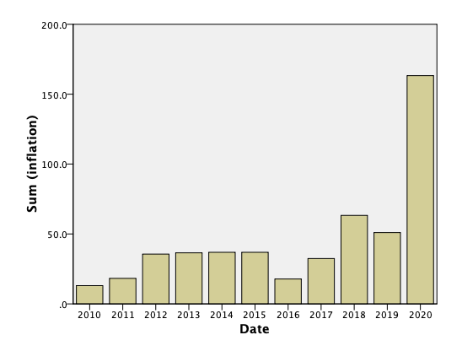

GGRAPH
/GRAPHDATASET NAME="graphdataset"
VARIABLES=trade_balance[LEVEL=scale] date[LEVEL=ordinal]
MISSING=LISTWISE REPORTMISSING=NO
/GRAPHSPEC SOURCE=VIZTEMPLATE(NAME="Bar"[LOCATION=LOCAL]
MAPPING( "values"="trade_balance"[DATASET="graphdataset"]
"categories"="date"[DATASET="graphdataset"] "Summary"="sum"))
VIZSTYLESHEET="Traditional"[LOCATION=LOCAL]
LABEL='BAR: date-trade_balance'
DEFAULTTEMPLATE=NO.

GGraph

Notes
Output Created |  | 08-OCT-2022 20:43:50
Comments
Input | Data | /Users/ahmed/Desktop/Untitled2.sav
Input | Active Dataset | DataSet1
Input | Filter | <none>
Input | Weight | <none>
Input | Split File | <none>
Input | N of Rows in Working Data File | 12
Syntax |  | GGRAPH  /GRAPHDATASET NAME="graphdataset"  VARIABLES=trade_balance[LEVEL=scale] date[LEVEL=ordinal]  MISSING=LISTWISE REPORTMISSING=NO  /GRAPHSPEC SOURCE=VIZTEMPLATE(NAME="Bar"[LOCATION=LOCAL]  MAPPING( "values"="trade_balance"[DATASET="graphdataset"]  "categories"="date"[DATASET="graphdataset"] "Summary"="sum"))  VIZSTYLESHEET="Traditional"[LOCATION=LOCAL]  LABEL='BAR: date-trade_balance'  DEFAULTTEMPLATE=NO.
Resources | Processor Time | 00:00:00.23
Resources | Elapsed Time | 00:00:01.00

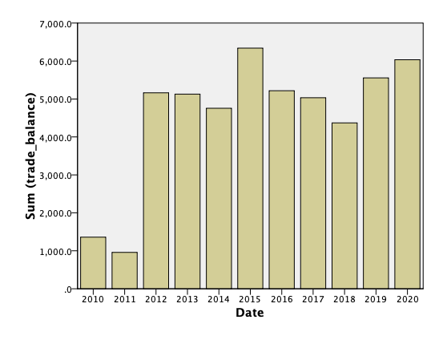

GGRAPH
/GRAPHDATASET NAME="graphdataset"
VARIABLES=exports[LEVEL=scale] date[LEVEL=ordinal]
MISSING=LISTWISE REPORTMISSING=NO
/GRAPHSPEC SOURCE=VIZTEMPLATE(NAME="Bar"[LOCATION=LOCAL]
MAPPING( "values"="exports"[DATASET="graphdataset"] "categories"="date"[DATASET="graphdataset"]
"Summary"="sum"))
VIZSTYLESHEET="Traditional"[LOCATION=LOCAL]
LABEL='BAR: date-exports'
DEFAULTTEMPLATE=NO.

GGraph

Notes
Output Created |  | 08-OCT-2022 20:44:06
Comments
Input | Data | /Users/ahmed/Desktop/Untitled2.sav
Input | Active Dataset | DataSet1
Input | Filter | <none>
Input | Weight | <none>
Input | Split File | <none>
Input | N of Rows in Working Data File | 12
Syntax |  | GGRAPH  /GRAPHDATASET NAME="graphdataset"  VARIABLES=exports[LEVEL=scale] date[LEVEL=ordinal]  MISSING=LISTWISE REPORTMISSING=NO  /GRAPHSPEC SOURCE=VIZTEMPLATE(NAME="Bar"[LOCATION=LOCAL]  MAPPING( "values"="exports"[DATASET="graphdataset"] "categories"="date"[DATASET="graphdataset"]  "Summary"="sum"))  VIZSTYLESHEET="Traditional"[LOCATION=LOCAL]  LABEL='BAR: date-exports'  DEFAULTTEMPLATE=NO.
Resources | Processor Time | 00:00:00.18
Resources | Elapsed Time | 00:00:00.00

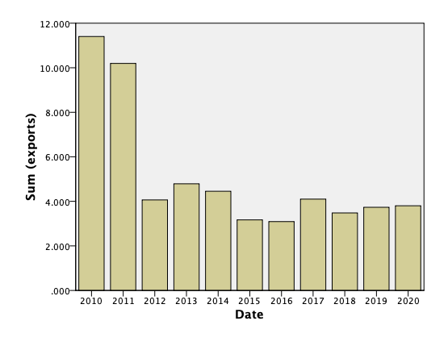

GGRAPH
/GRAPHDATASET NAME="graphdataset"
VARIABLES=trade_balance[LEVEL=scale] date[LEVEL=ordinal]
MISSING=LISTWISE REPORTMISSING=NO
/GRAPHSPEC SOURCE=VIZTEMPLATE(NAME="Bar"[LOCATION=LOCAL]
MAPPING( "values"="trade_balance"[DATASET="graphdataset"]
"categories"="date"[DATASET="graphdataset"] "Summary"="sum"))
VIZSTYLESHEET="Traditional"[LOCATION=LOCAL]
LABEL='BAR: date-trade_balance'
DEFAULTTEMPLATE=NO.

GGraph

Notes
Output Created |  | 08-OCT-2022 20:44:50
Comments
Input | Data | /Users/ahmed/Desktop/Untitled2.sav
Input | Active Dataset | DataSet1
Input | Filter | <none>
Input | Weight | <none>
Input | Split File | <none>
Input | N of Rows in Working Data File | 12
Syntax |  | GGRAPH  /GRAPHDATASET NAME="graphdataset"  VARIABLES=trade_balance[LEVEL=scale] date[LEVEL=ordinal]  MISSING=LISTWISE REPORTMISSING=NO  /GRAPHSPEC SOURCE=VIZTEMPLATE(NAME="Bar"[LOCATION=LOCAL]  MAPPING( "values"="trade_balance"[DATASET="graphdataset"]  "categories"="date"[DATASET="graphdataset"] "Summary"="sum"))  VIZSTYLESHEET="Traditional"[LOCATION=LOCAL]  LABEL='BAR: date-trade_balance'  DEFAULTTEMPLATE=NO.
Resources | Processor Time | 00:00:00.20
Resources | Elapsed Time | 00:00:00.00

GGRAPH
/GRAPHDATASET NAME="graphdataset"
VARIABLES=trade_balance[LEVEL=scale] date[LEVEL=ordinal]
MISSING=LISTWISE REPORTMISSING=NO
/GRAPHSPEC SOURCE=VIZTEMPLATE(NAME="Bar"[LOCATION=LOCAL]
MAPPING( "values"="trade_balance"[DATASET="graphdataset"]
"categories"="date"[DATASET="graphdataset"] "Summary"="sum"))
VIZSTYLESHEET="Traditional"[LOCATION=LOCAL]
LABEL='BAR: date-trade_balance'
DEFAULTTEMPLATE=NO.

GGraph

Notes
Output Created |  | 08-OCT-2022 20:45:37
Comments
Input | Data | /Users/ahmed/Desktop/Untitled2.sav
Input | Active Dataset | DataSet1
Input | Filter | <none>
Input | Weight | <none>
Input | Split File | <none>
Input | N of Rows in Working Data File | 12
Syntax |  | GGRAPH  /GRAPHDATASET NAME="graphdataset"  VARIABLES=trade_balance[LEVEL=scale] date[LEVEL=ordinal]  MISSING=LISTWISE REPORTMISSING=NO  /GRAPHSPEC SOURCE=VIZTEMPLATE(NAME="Bar"[LOCATION=LOCAL]  MAPPING( "values"="trade_balance"[DATASET="graphdataset"]  "categories"="date"[DATASET="graphdataset"] "Summary"="sum"))  VIZSTYLESHEET="Traditional"[LOCATION=LOCAL]  LABEL='BAR: date-trade_balance'  DEFAULTTEMPLATE=NO.
Resources | Processor Time | 00:00:00.15
Resources | Elapsed Time | 00:00:00.00

GGRAPH
/GRAPHDATASET NAME="graphdataset"
VARIABLES=date[LEVEL=ordinal] imports[LEVEL=scale]
MISSING=LISTWISE REPORTMISSING=NO
/GRAPHSPEC SOURCE=VIZTEMPLATE(NAME="Bar"[LOCATION=LOCAL]
MAPPING( "values"="imports"[DATASET="graphdataset"] "categories"="date"[DATASET="graphdataset"]
"Summary"="sum"))
VIZSTYLESHEET="Traditional"[LOCATION=LOCAL]
LABEL='BAR: date-imports'
DEFAULTTEMPLATE=NO.

GGraph

Notes
Output Created |  | 08-OCT-2022 20:46:02
Comments
Input | Data | /Users/ahmed/Desktop/Untitled2.sav
Input | Active Dataset | DataSet1
Input | Filter | <none>
Input | Weight | <none>
Input | Split File | <none>
Input | N of Rows in Working Data File | 12
Syntax |  | GGRAPH  /GRAPHDATASET NAME="graphdataset"  VARIABLES=date[LEVEL=ordinal] imports[LEVEL=scale]  MISSING=LISTWISE REPORTMISSING=NO  /GRAPHSPEC SOURCE=VIZTEMPLATE(NAME="Bar"[LOCATION=LOCAL]  MAPPING( "values"="imports"[DATASET="graphdataset"] "categories"="date"[DATASET="graphdataset"]  "Summary"="sum"))  VIZSTYLESHEET="Traditional"[LOCATION=LOCAL]  LABEL='BAR: date-imports'  DEFAULTTEMPLATE=NO.
Resources | Processor Time | 00:00:00.19
Resources | Elapsed Time | 00:00:00.00

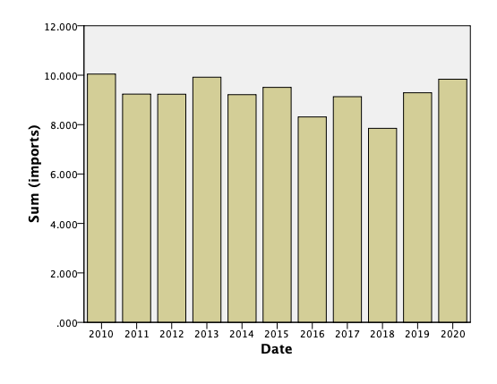

GGRAPH
/GRAPHDATASET NAME="graphdataset"
VARIABLES=balance_deficit[LEVEL=scale] date[LEVEL=ordinal]
MISSING=LISTWISE REPORTMISSING=NO
/GRAPHSPEC SOURCE=VIZTEMPLATE(NAME="2-D Dot Plot"[LOCATION=LOCAL]
MAPPING( "x"="date"[DATASET="graphdataset"] "y"="balance_deficit"[DATASET="graphdataset"]))
VIZSTYLESHEET="Traditional"[LOCATION=LOCAL]
LABEL='2-D DOT PLOT: date-balance_deficit'
DEFAULTTEMPLATE=NO.

GGraph

Notes
Output Created |  | 08-OCT-2022 20:46:10
Comments
Input | Data | /Users/ahmed/Desktop/Untitled2.sav
Input | Active Dataset | DataSet1
Input | Filter | <none>
Input | Weight | <none>
Input | Split File | <none>
Input | N of Rows in Working Data File | 12
Syntax |  | GGRAPH  /GRAPHDATASET NAME="graphdataset"  VARIABLES=balance_deficit[LEVEL=scale] date[LEVEL=ordinal]  MISSING=LISTWISE REPORTMISSING=NO  /GRAPHSPEC SOURCE=VIZTEMPLATE(NAME="2-D Dot Plot"[LOCATION=LOCAL]  MAPPING( "x"="date"[DATASET="graphdataset"] "y"="balance_deficit"[DATASET="graphdataset"]))  VIZSTYLESHEET="Traditional"[LOCATION=LOCAL]  LABEL='2-D DOT PLOT: date-balance_deficit'  DEFAULTTEMPLATE=NO.
Resources | Processor Time | 00:00:00.18
Resources | Elapsed Time | 00:00:00.00

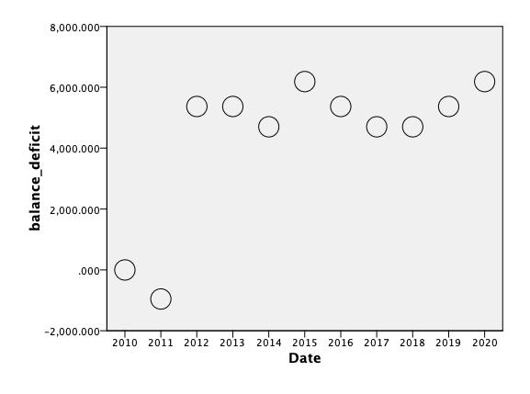

GGRAPH
/GRAPHDATASET NAME="graphdataset"
VARIABLES=balance_deficit[LEVEL=scale] date[LEVEL=ordinal]
MISSING=LISTWISE REPORTMISSING=NO
/GRAPHSPEC SOURCE=VIZTEMPLATE(NAME="Bar"[LOCATION=LOCAL]
MAPPING( "values"="balance_deficit"[DATASET="graphdataset"]
"categories"="date"[DATASET="graphdataset"] "Summary"="sum"))
VIZSTYLESHEET="Traditional"[LOCATION=LOCAL]
LABEL='BAR: date-balance_deficit'
DEFAULTTEMPLATE=NO.

GGraph

Notes
Output Created |  | 08-OCT-2022 20:46:26
Comments
Input | Data | /Users/ahmed/Desktop/Untitled2.sav
Input | Active Dataset | DataSet1
Input | Filter | <none>
Input | Weight | <none>
Input | Split File | <none>
Input | N of Rows in Working Data File | 12
Syntax |  | GGRAPH  /GRAPHDATASET NAME="graphdataset"  VARIABLES=balance_deficit[LEVEL=scale] date[LEVEL=ordinal]  MISSING=LISTWISE REPORTMISSING=NO  /GRAPHSPEC SOURCE=VIZTEMPLATE(NAME="Bar"[LOCATION=LOCAL]  MAPPING( "values"="balance_deficit"[DATASET="graphdataset"]  "categories"="date"[DATASET="graphdataset"] "Summary"="sum"))  VIZSTYLESHEET="Traditional"[LOCATION=LOCAL]  LABEL='BAR: date-balance_deficit'  DEFAULTTEMPLATE=NO.
Resources | Processor Time | 00:00:00.20
Resources | Elapsed Time | 00:00:00.00

