AUTONOMOUS SAFETY RC CAR
PIC16F877A · Raspberry Pi · Firebase · Android
https://v0-rc-car-dashboard.vercel.app/
https://lab1-f7c43-default-rtdb.firebaseio.com/

Technical Project Report
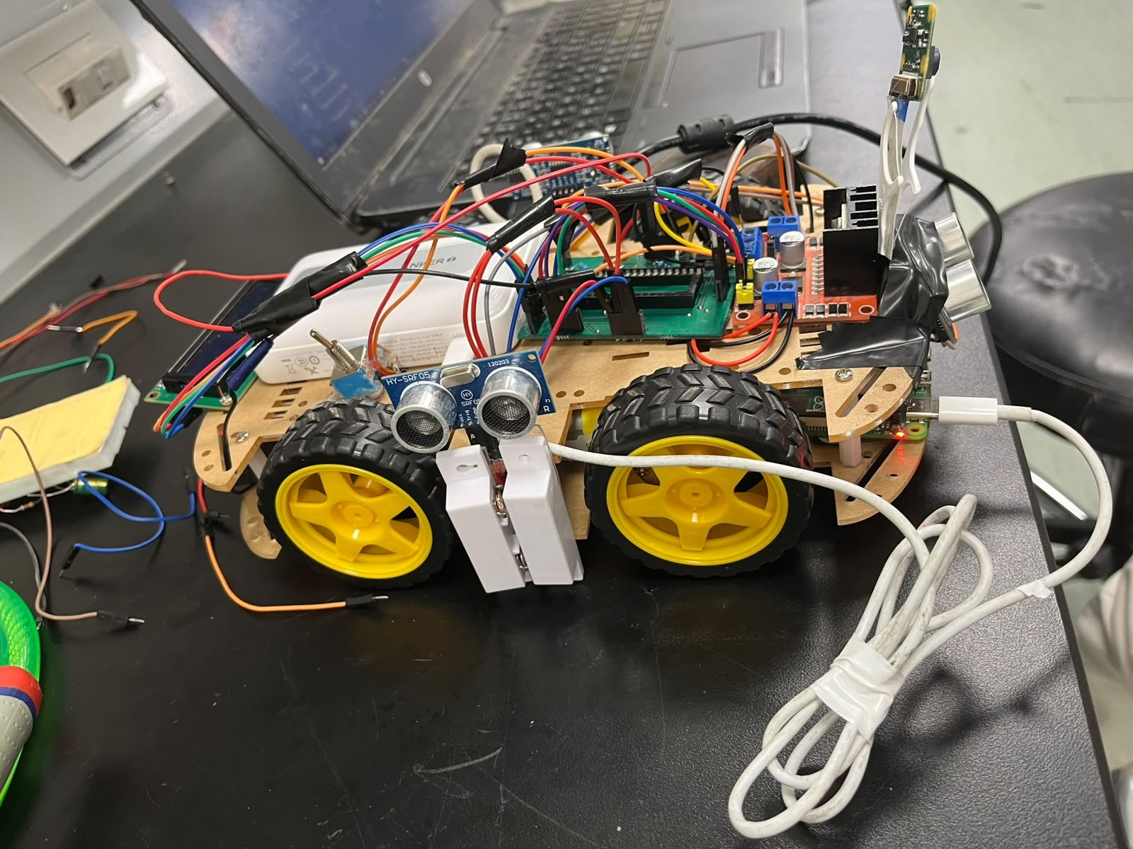
Figure 1 — Assembled RC Car prototype
Ahmed Salah 202200212

Ahmed Mohamed 202200294

Abdelhady Mohamed 202201172

Youssef Mohamed 202200286

Ahmed Yasser 202200477

Table of Contents
Table of Contents 2
1. Introduction 3
1.1 Objectives 3
2. System Architecture 3
2.1 Data Flow 3
3. Hardware Design 4
3.1 Component List 4
3.2 Pin Connections 4
Motor Driver (L298N) 4
HC-SR04 Ultrasonic Sensors 5
LCD (I2C PCF8574 Backpack) 5
Bluetooth / UART (RC7 = TX, RC6 = RX on PIC) 5
Safety Sensors 5
3.3 PCB Design 5
4. PIC Firmware (main.c) 7
4.1 Project Architecture (Layered Driver Model) 7
4.2 Safety State Machine 7
4.3 Autonomous Obstacle Avoidance 7
4.4 UART Command Interface 8
5. Raspberry Pi Software 9
5.1 final.py — Combined UART/Firebase Bridge 9
5.2 eye_to_pic.py — Eye Monitor Relay 9
5.3 lane_detection_firebase.py — Vision Pipeline 9
6. Firebase Realtime Database 9
7. Next.js Web Dashboard 11
8. Physical Build 12
9. Power Supply 13
10. Testing & Results 14
11. Future Work 14
12. Conclusion 14

1. Introduction
This report documents the design, implementation, and testing of an autonomous safety RC car. The system demonstrates how embedded microcontroller firmware, computer vision, cloud connectivity, and a web dashboard can be combined into a single cohesive platform.
The primary objective was to build a self-driving RC car that enforces real-world automotive safety rules — door status, seatbelt status, and driver attentiveness — before allowing the vehicle to move. A PIC16F877A microcontroller serves as the real-time control core, while a Raspberry Pi handles vision and cloud communication.

1.1 Objectives
- Implement fully autonomous obstacle-avoidance using three HC-SR04 ultrasonic sensors
- Enforce a layered safety state machine (door → seatbelt → eyes-open) with motor kill-switch
- Detect lane markings via Raspberry Pi camera and publish offset data to Firebase
- Monitor driver eye state on an Android device using ML and relay commands to PIC over UART
- Stream all telemetry to a Firebase Realtime Database and display it on a Next.js dashboard
- Design and manufacture a custom PCB to consolidate all connections

2. System Architecture
The system is composed of five interacting layers:
- PIC16F877A firmware — real-time safety state machine and motor control
- Raspberry Pi — UART bridge, lane-detection vision pipeline, Firebase I/O
- Android app — driver eye monitoring via on-device ML, Firebase publisher
- Firebase Realtime Database — shared cloud message bus
- Next.js dashboard — browser-based monitoring and manual control UI

2.1 Data Flow
The diagram below summarises how data moves between components:

┌─────────────┐ UART 9600 ┌──────────────────────────────┐
│ PIC16F877A │◄──────────────►│ Raspberry Pi │
│ (main.c) │ telemetry / │ final.py │ lane_det.py │
└──────┬──────┘ eye cmds └─────┬──────┴────────┬────────┘
│ │ │
Motors, Firebase Firebase
LCD, Sensors /car_telemetry /lane_status
│ │
┌──────▼───────────────▼──────┐
│ Firebase Realtime Database │
└──────┬───────────────┬───────┘
│ │
Next.js Dashboard Android App
(monitoring/ctrl) /eye_monitor

3. Hardware Design

3.1 Component List
Component | Quantity | Role
PIC16F877A | 1 | Main microcontroller (firmware)
Raspberry Pi (Zero 2W / 3B+) | 1 | Vision + Firebase bridge
HC-SR04 Ultrasonic Sensor | 3 | Front / Left / Right obstacle detection
L298N H-Bridge Module | 1 | DC motor driver
DC Gear Motors | 4 | Wheel drive (4WD chassis)
HC-05 Bluetooth Module | 1 | Optional wireless serial (legacy)
LCD 16×2 with I2C PCF8574 | 1 | On-car status display
Magnetic Door Switch | 1 | Door-open safety interlock (RA0)
Seatbelt Push-Button | 1 | Seatbelt safety interlock (RA1)
20 MHz Crystal + 22 pF caps | 1 set | PIC oscillator
Anker USB Power Bank | 1 | Raspberry Pi power supply
Custom PCB (EasyEDA) | 1 | PCB consolidating all connections

3.2 Pin Connections
The following table reflects the actual connections used on the physical car:

Motor Driver (L298N)
PIC Pin | L298N Pin | Function
RD4 | IN1 | Motor A — Left wheel forward
RD5 | IN2 | Motor A — Left wheel reverse
RD6 | IN3 | Motor B — Right wheel forward
RD7 | IN4 | Motor B — Right wheel reverse

HC-SR04 Ultrasonic Sensors
Sensor | TRIG Pin | ECHO Pin
Front | RB1 | RB2
Left | RD0 | RD1
Right | RB3 | RB4

LCD (I2C PCF8574 Backpack)
Signal | PIC Pin | Pull-up
SDA | RC4 (pin 23) | 4.7 kΩ to +5V
SCL | RC3 (pin 18) | 4.7 kΩ to +5V

Bluetooth / UART (RC7 = TX, RC6 = RX on PIC)
Signal | PIC Pin | Notes
TX | RC7 | UART RX from HC-05 / Raspberry Pi
RX | RC6 | 1kΩ+2kΩ divider to protect 3.3V targets

Safety Sensors
Sensor | PIC Pin | Logic (with 10 kΩ pull-up to VCC)
Magnetic door switch | RA0 | 0 = door closed (safe), 1 = door open (danger)
Seatbelt switch | RA1 | 1 = belt fastened (safe), 0 = unbuckled (danger)

3.3 PCB Design
A custom two-layer PCB was designed in EasyEDA to consolidate all signal routing, decouple power rails, and reduce breadboard wiring errors. The board hosts the PIC16F877A in a DIP-40 socket, the crystal oscillator circuit, UART level-shifting resistors, and female headers for all peripheral connectors.

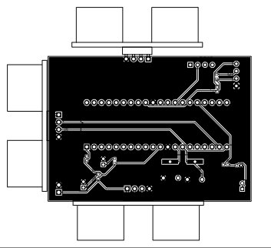
Figure 2 — Custom PCB layout (EasyEDA)

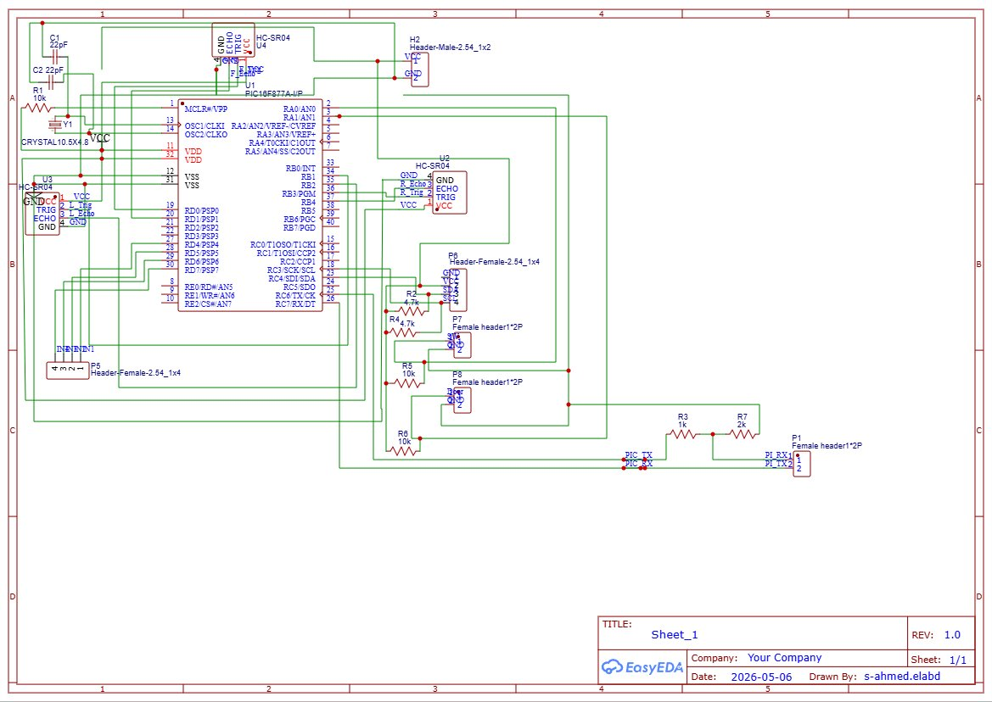
Figure 3 — Full circuit schematic

4. PIC Firmware (main.c)

4.1 Project Architecture (Layered Driver Model)
The firmware follows a strict MCAL → HAL → APP layered architecture, commonly used in professional automotive embedded software:

Layer | Location | Responsibility
APP | APP/main.c | System integration, state machine, main loop
HAL | HAL/Motor, HAL/HC-SR04, HAL/LCD, HAL/Bluetooth, HAL/Switch | Peripheral abstraction
MCAL | MCAL/UART, MCAL/GPIO, MCAL/I2C, MCAL/PWM, MCAL/TMR1, MCAL/EXT_INT | Register-level drivers
SERVICES | SERVICES/STD_TYPES.h, BIT_MATH.h, config.h | Shared types and macros

4.2 Safety State Machine
The firmware enforces four mutually-exclusive system states, evaluated in priority order on every loop iteration. Any unsafe condition immediately calls Motor_Stop() and shows an alert on the LCD.

State | Trigger Condition | LCD Line 0 | Motor Action
STATE_DOOR_OPEN | RA0 == 1 (door open) | "!! DOOR OPEN !!" | Motor_Stop()
STATE_NO_BELT | RA1 == 0 (belt unfastened) | "!! NO SEATBELT !" | Motor_Stop()
STATE_EYES_CLOSED | eyes_open == 0 (UART 'C') | "!! DROWSY DRIVER" | Motor_Stop()
STATE_SAFE | All checks pass | "F:xx L:xx R:xx" | Autonomous driving

4.3 Autonomous Obstacle Avoidance
When in STATE_SAFE and MODE_AUTO, the firmware samples all three ultrasonic sensors and applies the following decision tree (OBSTACLE_DIST = 30 cm):
- Front > 30 cm: Motor_Forward()
- Front ≤ 30 cm, Left > Right and Left > 30 cm: Motor_Turn_Left() for 400 ms
- Front ≤ 30 cm, Right > Left and Right > 30 cm: Motor_Turn_Right() for 400 ms
- All directions blocked: Motor_Reverse() 600 ms → Motor_Turn_Right() 600 ms (escape spin)

Three fixed sensors (rather than a single servo-mounted sensor) were chosen to eliminate Timer1 conflicts between servo PWM ISR and ultrasonic echo timing, and to remove inrush current spikes from servo movement.

4.4 UART Command Interface
Byte | Source | Effect
'E' | Raspberry Pi (eye relay) | eyes_open = 1 → unblock STATE_SAFE
'C' | Raspberry Pi (eye relay) | eyes_open = 0 → STATE_EYES_CLOSED, Motor_Stop()
'A' | Dashboard / Pi | Switch to MODE_AUTO
'M' | Dashboard / Pi | Switch to MODE_MANUAL, Motor_Stop()
'F' | Manual mode | Motor_Forward()
'B' | Manual mode | Motor_Reverse()
'L' | Manual mode | Motor_Turn_Left()
'R' | Manual mode | Motor_Turn_Right()
'S' | Manual mode | Motor_Stop()

5. Raspberry Pi Software

5.1 final.py — Combined UART/Firebase Bridge
final.py is the primary production script. It performs two tasks in a single 10 Hz loop:
- Reads PIC telemetry lines (F:xxx R:xxx L:xxx D:x B:x) from UART and pushes structured JSON to Firebase /car_telemetry at up to 5 Hz
- Polls Firebase /eye_monitor every 500 ms and sends 'E' or 'C' to the PIC when the eye state changes
The script includes fail-safe shutdown (SIGINT/SIGTERM sends 'C') and dry-run mode for testing without hardware.

# Run in production:
sudo python3 final.py

# Test without UART hardware:
python3 final.py --dry-run -v

5.2 eye_to_pic.py — Eye Monitor Relay
eye_to_pic.py is a standalone script that polls the Firebase /eye_monitor path (published by the Android app) and relays 'E'/'C' bytes to the PIC. It handles stale data detection (STALE_MS = 2000), exponential backoff on network failure, and a 5-second heartbeat re-send.

5.3 lane_detection_firebase.py — Vision Pipeline
This script captures frames from the PiCamera2 at 640×480, applies the following pipeline, and publishes results to Firebase /lane_status:
- Greyscale conversion and binary threshold (pixels < 90 = black tape)
- Morphological opening with 15×15 kernel to eliminate grout-line noise
- Row-scan from bottom to ROI top, finding the widest gap between tape strips
- Outlier rejection using median absolute deviation
- Weighted quadratic fit (x = f(y)) with bottom rows weighted more
- EMA temporal smoothing (α = 0.20) for stable centre-line tracking
- Pixel offset from frame centre pushed to Firebase; displayed on OpenCV overlay

6. Firebase Realtime Database
Firebase serves as the shared message bus between all system components. Three top-level nodes are used:

Path | Writer | Reader(s) | Update Rate
/car_telemetry | final.py (Pi) | Dashboard, Android app | ≤5 Hz
/eye_monitor | Android app | final.py, eye_to_pic.py | ≤10 Hz
/lane_status | lane_detection_firebase.py | Dashboard | ≤5 Hz

The telemetry node stores: front/left/right distance (cm), door status (OPEN/CLOSED), belt status (FASTENED/UNBUCKLED), and a server-side timestamp. The eye_monitor node stores: state (OPEN/CLOSED/UNKNOWN), probability scores, FPS, and timestamp.
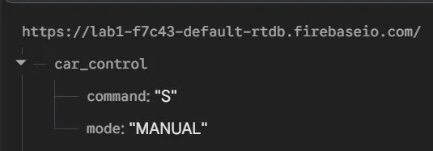
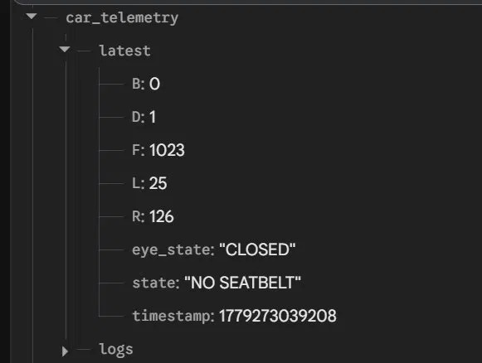
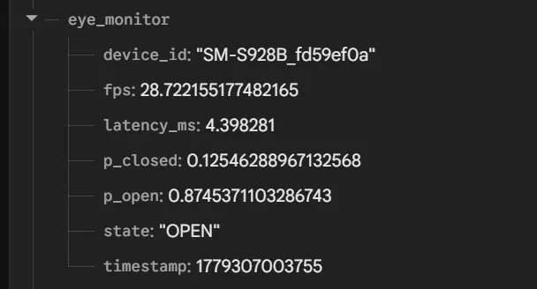
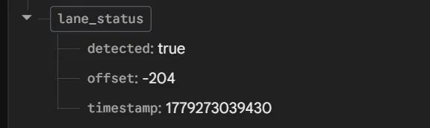

7. Next.js Web Dashboard
The web dashboard is built with Next.js 14 and Shadcn/UI components. It subscribes to all three Firebase paths and renders live telemetry including:
- Ultrasonic distance gauges (Front / Left / Right) with obstacle warning indicators
- Safety status panel (door, seatbelt, eye state) with colour-coded alerts
- Drive mode selector (AUTO / MANUAL) sending UART commands via Firebase
- Lane offset visualiser showing centre-line deviation in real time
- Connection health indicator (Firebase latency and last-update timestamp)

cd rc-car-dashboard
pnpm install
pnpm dev # http://localhost:3000

8. Physical Build
The RC car chassis is a standard 4WD wooden/acrylic platform. The custom PCB is mounted centrally on the top layer, with the Raspberry Pi and Anker power bank occupying the upper deck. Ultrasonic sensors are mounted at front, left, and right via 3D-printed brackets. The LCD is mounted upright on the rear of the upper deck for visibility.

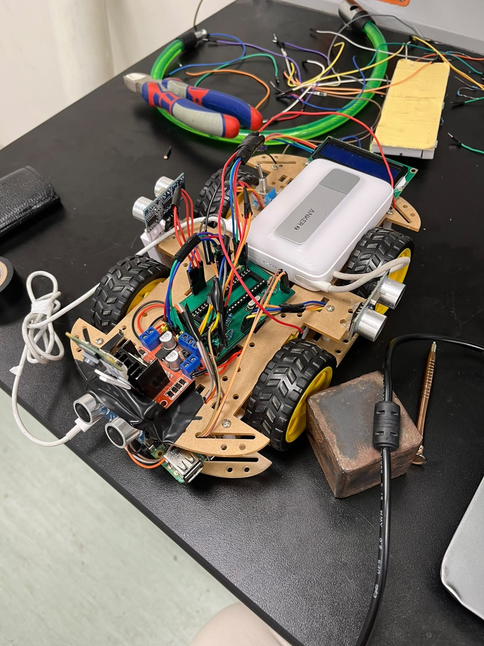
Figure 4 — Side view showing PCB, Raspberry Pi, and wiring

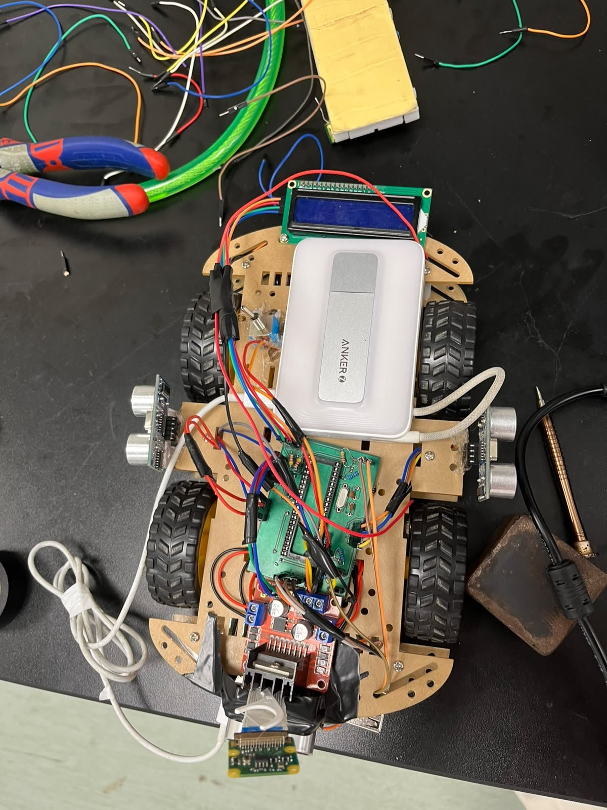
Figure 5 — Top view showing LCD display and Anker power bank

9. Power Supply
Channel | Voltage | Powers
Ch. 1 | +5V | PIC, HC-SR04 ×3, LCD I2C, HC-05, Raspberry Pi
Ch. 2 | +5–12V | L298N motor supply (depends on motor rating)
Ch. 3 | +5V | Servo signal (optional — separate from PIC rail)

All three channels share a common GND bus. Mandatory decoupling: 100 nF ceramic at PIC VDD pins, each HC-SR04, and the PCF8574; 100 µF electrolytic at L298N motor input.

10. Testing & Results
Test | Method | Result
Obstacle avoidance | Placed objects at < 30 cm on each sensor axis | Car stopped and navigated around all obstacles
Door safety interlock | Opened magnetic door switch mid-run | Motors stopped within one loop cycle (~50 ms)
Seatbelt interlock | Released seatbelt button during autonomous run | Motors stopped; LCD showed NO SEATBELT alert
Eye-close detection | Covered Android camera mid-run | UART 'C' received; STATE_EYES_CLOSED triggered; car stopped
Lane detection | Ran car along black duct-tape lane | Offset pushed to Firebase; centre-line visible on OpenCV overlay
UART telemetry | Monitored Firebase /car_telemetry during run | 5 Hz updates received; all fields populated correctly
Dashboard live update | Opened dashboard during autonomous run | All gauges and status indicators updated in real time

11. Future Work
- PID-controlled lane following using the lane-offset signal from the Pi
- Servo-mounted single-sensor scanning mode (ISR-safe path already implemented in firmware)
- Speed control via PWM on L298N ENA/ENB pins using PIC CCP modules
- OTA firmware updates over Firebase → Pi → UART bootloader
- Battery voltage monitoring with ADC and low-battery alert on LCD
- Dashboard authentication and multi-car fleet management

12. Conclusion
This project successfully integrates a PIC16F877A real-time controller, Raspberry Pi vision and cloud bridge, Android eye-monitoring, and a web dashboard into a unified autonomous safety car platform. The layered firmware architecture keeps each driver independent and testable. The use of Firebase as a shared message bus decouples all components so any layer can be updated or replaced without affecting the others.
The most significant technical achievement is the four-layer safety state machine that enforces door, seatbelt, and driver-attentiveness checks in priority order, guaranteeing that motors cannot run unless all safety conditions are met simultaneously — a pattern directly applicable to real automotive systems.

— End of Report —

