

Final Project Report: “Modern Hotel Network Design”

CIE 447 – Computer Networks  
Dr: Mohamed Samir  
Eng: Mohamed Saleh

Eng: Amira Ezzeldine



AHMed Salah 202200212  
Ahmed Mohamed 202200977  
Ahmed Mohamed 202200294

Contents

**IP Addressing** 3

**HOW ADDRESSES WERE REACHED** 6

Initial Address Pool Given 6

Subnetting Plan 6

Original VLAN Subnet Breakdown 7

Router-to-Router Link Subnets 7

**Changes Made for the Relocation Scenario** 8

1. Admin Department Relocated to first floor 8

2. Sales Department Moved to Remote Site 8

3. **Routing Updates (OSPF)** 9

**Testing and Verification** 10

1- Pinging hosts in the same vlan: 10

2- Pinging hosts from different vlan but on the same floor: 10

3- Pinging hosts on different floor: 11

4- Testing Web and DNS 11

5. Network after relocation 12

6. Assigning Ip using DHCP for admin after relocation 13

7. Assigning Ip using DHCP for sales after relocation 13

8. Testing web from admin and sales after relocation 14

**Table of Figures**

Figure 1 5

Figure 2 10

Figure 3 10

Figure 4 11

Figure 5 11

Figure 6 12

Figure 7 12

Figure 8 13

Figure 9 13

Figure 10 14

Figure 11 14

# **IP Addressing**

We effectively planned and realized a complete IP addressing and subnetting plan for a three-story hotel, each of which had several departments. Subnets were allocated according to the number of hosts needed in each department, applying VLSM concepts. DHCP servers were installed per floor, DNS and Web servers were set up, and routers were connected via serial connections.

Floor 1)

|  |  |  |  |
| --- | --- | --- | --- |
| VLAN | Department | Subnet | Gateway IP |
| 80 | Reception | 192.168.2.64/27 | 192.168.2.65 |
| 70 | Store | 192.168.2.120/29 | 192.168.2.121 |
| 60 | Logistics | 192.168.2.136/29 | 192.168.2.137 |

Floor 2)

|  |  |  |  |
| --- | --- | --- | --- |
| VLAN | Department | Subnet | Gateway IP |
| 30 | Sales | 192.168.2.32/27 | 192.168.2.32 |
| 40 | HR | 192.168.2.128/28 | 192.168.2.129 |
| 50 | Finance | 192.168.2.96/27 | 192.168.2.97 |

Floor 3)

|  |  |  |  |
| --- | --- | --- | --- |
| VLAN | Department | Subnet | Gateway IP |
| 20 | Admin | 192.168.2.112/27 | 192.168.2.113 |
| 10 | IT | 192.168.2.0/26 | 192.168.2.1 |

And for the servers:

|  |  |  |
| --- | --- | --- |
| Server | VLAN | IP Address |
| DNS Server | 20 | 192.168.2.162 |
| Web Server | 50 | 192.168.2.98 |
| DHCP Server 1 | 80 | 192.168.2.66 |
| DHCP Server 2 | 40 | 192.168.2.130 |
| DHCP Server 3 | 10 | 192.168.2.2 |

And for the routers:

|  |  |  |  |  |
| --- | --- | --- | --- | --- |
| Link | Subnet | R1 IP | R2 IP | R3 IP |
| R1-R2 | 192.168.2.148/30 | .149 | .150 | — |
| R2-R3 | 192.168.2.152/30 | — | .153 | .154 |
| R1-R3 | 192.168.2.156/30 | .157 | — | .158 |

the subnet mask determines how many hosts are available.

And the formula to calc hosts in the subnet is:

The subtraction of 2 accounts for:

* Network address
* Broadcast address

For floor one for example for Reception which is Vlan 80

|  |  |
| --- | --- |
| 192.168.2.64/27 | |
|  |

Reception might have 20–25 PCs. /27 gives room for growth (30 usable IPs) which is 32-2.

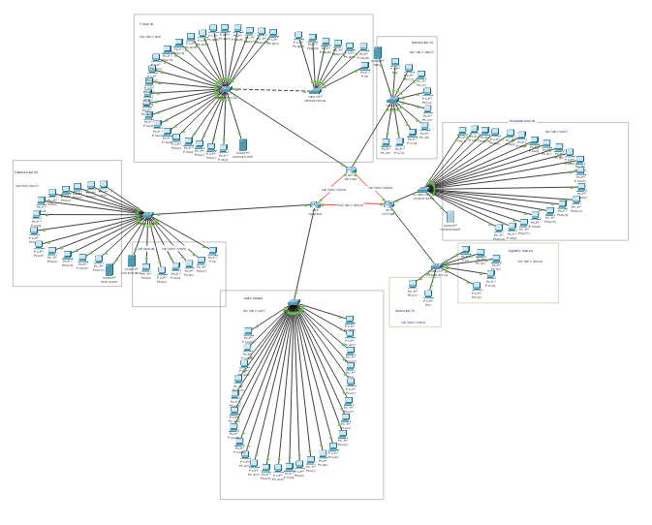

Figure 1

# **HOW ADDRESSES WERE REACHED**

## Initial Address Pool Given

* **Allocated Network:** 192.168.2.0/24
* **Total Usable IPs:** 254 (from 192.168.2.1 to 192.168.2.254)
* **Requirement:** Subnet the /24 space to accommodate different VLANs with specific device counts.

## Subnetting Plan

For each department (VLAN), we took a deliberate approach in designing the network infrastructure to cater specifically to the unique requirements of each unit. In devising the network layout, our primary focus was on selecting subnets that could efficiently accommodate the expected number of devices within each department. This involved strategically choosing subnet sizes that were tailored to the device density, ensuring that we optimized the available IP addresses without unnecessary waste.

Additionally, we carefully aligned the boundaries of these subnets to prevent any potential overlap, thereby guaranteeing a streamlined and organized network structure. By establishing clear boundaries, we aimed to eliminate any potential conflicts or confusion that might arise from IP address duplication or misalignments.

Furthermore, in the subnet allocation process, we made it a point to reserve one IP address for the gateway within each VLAN, ensuring that network traffic could flow smoothly and securely. This dedicated gateway IP served as a crucial entry point for external communications and helped in efficiently managing the network traffic flow.

Moreover, anticipating the need for dedicated servers within certain departments, we also assigned an additional IP address for the server where necessary. By setting aside this reserved IP, we ensured that the server had a distinct and secure connection point within the VLAN, enabling efficient data transfer and communication.

Lastly, to streamline the network's overall architecture, we ensured that OSPF links and inter-router subnets were allocated their own dedicated space. By segregating these critical components into separate spaces, we aimed to enhance network efficiency, minimize potential routing issues, and facilitate smoother communication between routers across the network. This meticulous planning and allocation of resources were essential in building a robust and optimized network infrastructure that could effectively meet the diverse needs of each department while ensuring seamless connectivity and operational reliability.

## Original VLAN Subnet Breakdown

|  |  |  |  |  |  |
| --- | --- | --- | --- | --- | --- |
| VLAN | Dept | Devices | Needed Hosts | Subnet | Reason |
| 10 | IT | 30 | ≥ 32 | 192.168.2.0/26 | 64 IPs; 62 usable |
| 30 | Sales | 25 | ≥ 32 | 192.168.2.32/27 | 32 IPs; 30 usable |
| 80 | Reception | 20 | ≥ 32 | 192.168.2.64/27 | 32 IPs; aligned next |
| 50 | Finance | 13 | ≥ 16 | 192.168.2.96/28 | 16 IPs; 14 usable |
| 70 | Store | 2 | ≥ 8 | 192.168.2.120/29 | 8 IPs |
| 20 | Admin (before fix) | 9 | ≥ 13 | 192.168.2.112/28 | 16 IPs, but not enough when DHCP misbehaved |
| 60 | Logistics | 5 | ≥ 8 | 192.168.2.136/29 | 8 IPs |
| 40 | HR | 6 | ≥ 16 | 192.168.2.128/28 | 16 IPs |
| 20 | Admin (after fix) | 9 | ≥ 20 | 192.168.2.160/27 | 32 IPs; fixed DHCP issue |

## Router-to-Router Link Subnets

Each serial link between routers needed **2 IPs**, so we used /30 subnets (4 IPs, 2 usable).

|  |  |  |
| --- | --- | --- |
| Link | Subnet | IPs Used |
| R1-R2 | 192.168.2.148/30 | .149 & .150 |
| R2-R3 | 192.168.2.152/30 | .153 & .154 |
| R1-R3 | 192.168.2.156/30 | .157 & .158 |

# **Changes Made for the Relocation Scenario**

## Admin Department Relocated to first floor

To seamlessly facilitate the transition of the Administration department's physical move from the third floor to the first floor, various adjustments were made to the network infrastructure. These modifications were crucial to ensuring a smooth relocation process and maintaining operational continuity within the company's network environment.

Regarding the router configuration updates necessitated by the relocation, specific changes were made to accommodate the Admin department's shift. This involved removing the subinterface for the Admin VLAN from the router located on the third floor, a necessary step in realigning the network resources to reflect the new departmental location. Simultaneously, a new subinterface was established on the first-floor router, replicating the same VLAN ID (20) and subnet (192.168.2.160/27) to ensure network consistency and address allocation fluidity.

Moreover, in terms of DHCP configuration adjustments, it was imperative to realign the DHCP settings to match the relocation of the Admin department. The DHCP pool originally assigned to the Admin department on the third-floor server was withdrawn, reflecting the shift in physical location. Concomitantly, a fresh DHCP pool was created on the first-floor server to cater to the Admin VLAN's IP address provisioning requirements. This new pool replicated the subnet settings previously established, ensuring a seamless transition for Admin devices seeking network connectivity.

By executing these changes meticulously, the network team successfully ensured that all Admin devices in the relocated department could efficiently connect to the network and acquire IP addresses from the first-floor resources. These modifications were carefully orchestrated to prevent any overlapping IP allocations or network disruptions, thereby guaranteeing a smooth transition for the Administration department while upholding the overall network integrity and operational efficiency of the organization.

## Sales Department Moved to Remote Site

Still uses the same VLAN and subnet, which is essential for maintaining consistency and seamless communication within the network infrastructure. The subnet assigned is 192.168.2.32/27, with a corresponding gateway at 192.168.2.33.

Regarding the remote connection setup, an additional router, R4, has been introduced to replicate the main headquarters environment effectively. This new addition, R4, has been interconnected with R2 through a dedicated serial link to facilitate secure and efficient data transfer.

To establish communication between R2 and R4 seamlessly, a fresh subnet has been allocated specifically for the R2–R4 link, designated as 192.168.2.192/30. In this configuration, R2 operates with the IP address 192.168.2.193, while R4 is identifiable on the network with the IP address 192.168.2.194.

The integration of these routers with distinct IP addresses enables a more robust network architecture, ensuring streamlined connectivity and enhancing the overall network performance. This strategic implementation not only enhances the network's scalability but also optimizes data transmission efficiency between R2 and the newly incorporated R4, effectively catering to the network's evolving requirements.

## **Routing Updates (OSPF)**

Incorporating the recent network changes into the OSPF configurations involved the introduction of two key elements: the addition of the new Admin subnet at 192.168.2.160/27 and the inclusion of the Sales WAN link with the address of 192.168.2.192/30. These alterations were made to ensure seamless integration of these essential network assets into the OSPF routing scheme, thereby enabling improved network efficiency and resiliency. By incorporating the Admin subnet and Sales WAN link into the OSPF advertisements, network administrators aimed to enhance the overall connectivity and reachability within the network infrastructure. This strategic move not only expands the coverage of OSPF routing updates but also enhances the visibility and accessibility of these specific network segments within the broader network framework. Furthermore, by dynamically advertising the Admin subnet and Sales WAN link within the OSPF routing domain, the network gains increased flexibility in adapting to changing network conditions and requirements. Ultimately, the successful addition of these new network elements to the OSPF advertisements acts as a proactive measure to maintain network scalability and performance in the face of evolving organizational demands and network dynamics.

# **Testing and Verification**

## Pinging hosts in the same vlan:

Figure 2

## Pinging hosts from different vlan but on the same floor:

Figure 3

## Pinging hosts on different floor:

Figure 4

## Testing Web and DNS

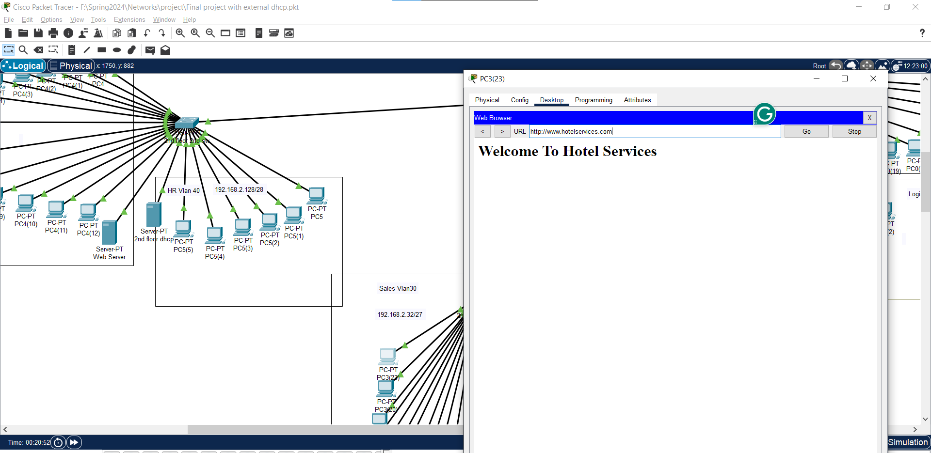

Figure 5

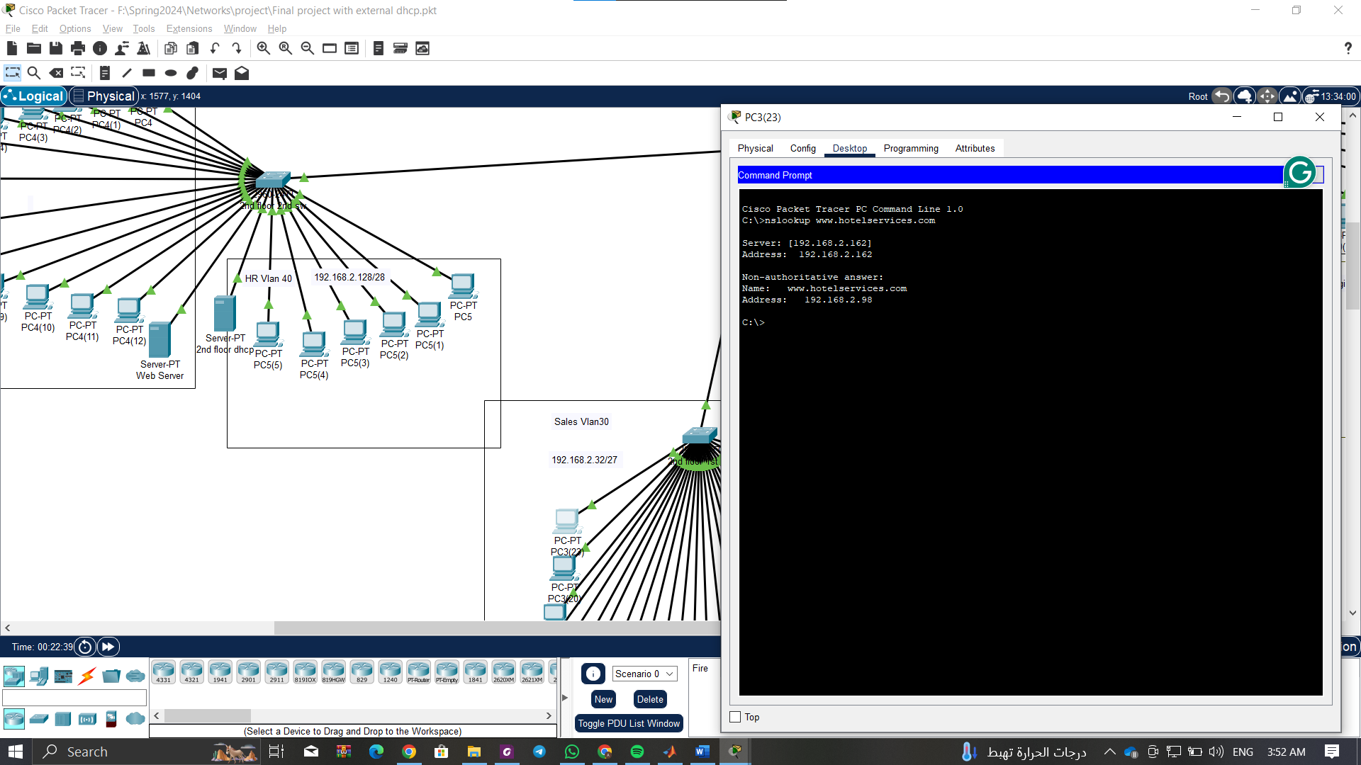

Figure 6

## Network after relocation

Figure 7

## Assigning Ip using DHCP for admin after relocation

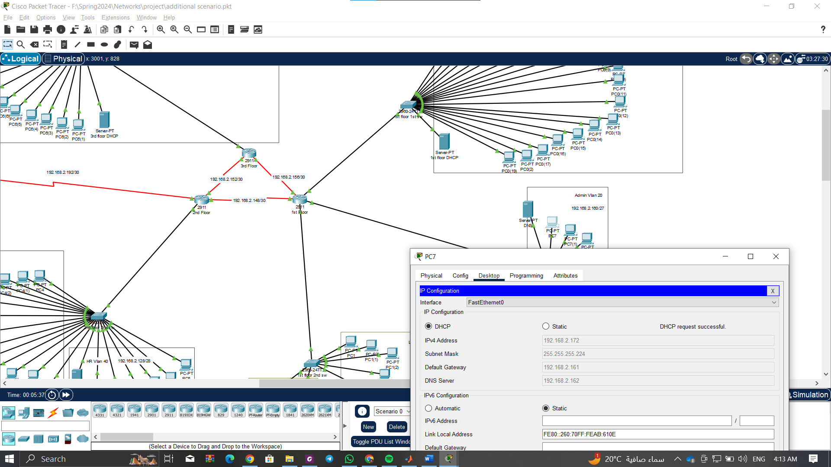

Figure 8

## Assigning Ip using DHCP for sales after relocation

Figure 9

## Testing web from admin and sales after relocation

Figure 10  
  
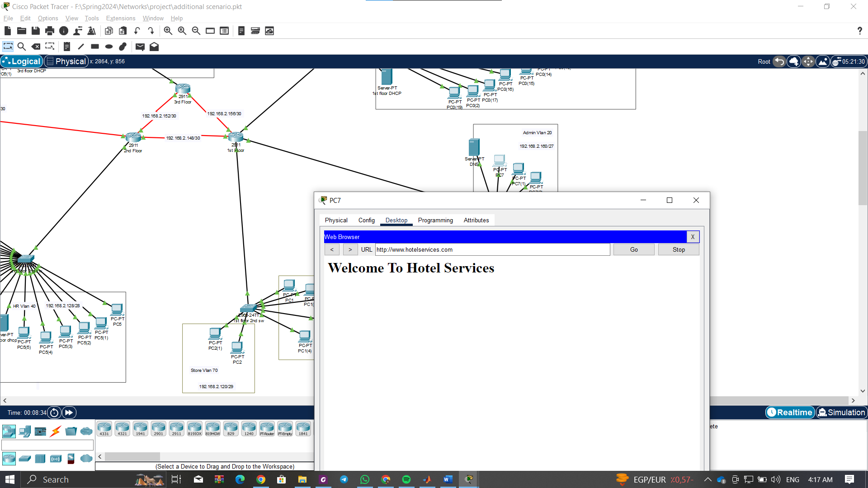

Figure 11