4. Documentation

4.1 Documentation of Architectures
4.1.1 VGG-19 Architecture (Training from Scratch)
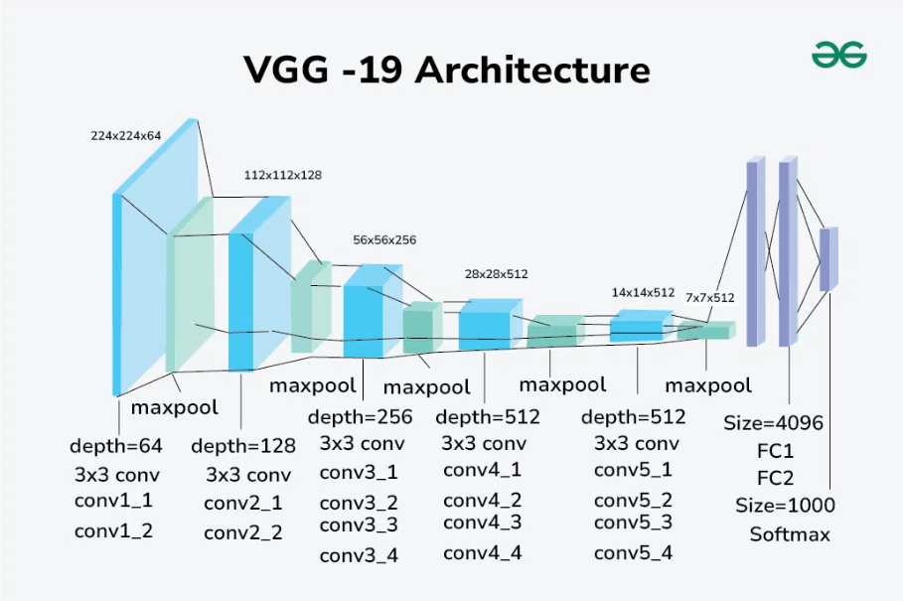

Overview
VGG-19 is a deep Convolutional Neural Network proposed by the Visual Geometry Group (VGG) at Oxford University.
It follows a simple and uniform design principle using small convolutional filters (3×3) while increasing network depth.
Step-by-Step Architecture
- Input Layer
RGB image of size 224×224×3.
- Convolutional Blocks
  - Five sequential blocks
  - Each block consists of multiple Conv2D layers with ReLU activation
  - Followed by MaxPooling (2×2)
  - Number of filters increases progressively:
64 → 128 → 256 → 512 → 512
- Fully Connected Layers
  - Flatten
  - Dense (4096)
  - Dense (4096)
- Output Layer
  - Dense layer with Softmax activation
Key Characteristics
- Simple and interpretable architecture
- Very large number of parameters
- Computationally expensive
- Suitable as a baseline model
Paper Title: Very Deep Convolutional Networks for Large-Scale Image Recognition
Authors: Karen Simonyan & Andrew Zisserman
📄 Link: https://arxiv.org/abs/1409.1556 arXiv

4.1.2 ResNet-50 Architecture (Transfer Learning)
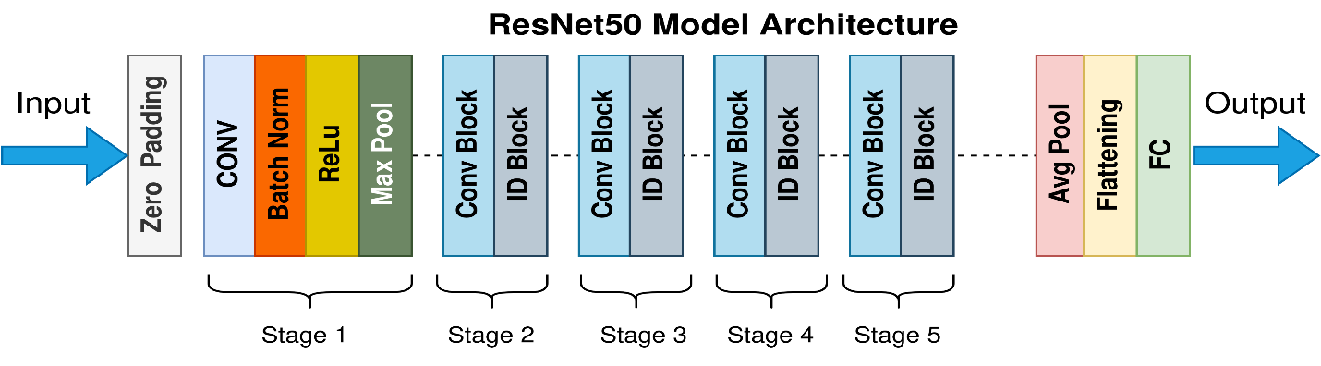
Overview
ResNet-50 introduces residual learning to address the vanishing gradient problem in deep neural networks by using skip connections.
Step-by-Step Architecture
- Input Layer (224×224×3)
- Initial Convolution + MaxPooling
- Residual Stages (conv2 to conv5)
  - Each stage contains residual blocks
  - Each block includes convolutional layers, batch normalization, and skip connections
- Global Average Pooling
- Classification Head (removed during transfer learning)
Key Characteristics
- Deep and stable architecture
- Fewer parameters than VGG
- Highly effective when fine-tuned correctly
Paper Title: Deep Residual Learning for Image Recognition
Authors: Kaiming He, Xiangyu Zhang, Shaoqing Ren, Jian Sun
📄 Link: https://arxiv.org/pdf/1512.03385
4.1.3 Inception V1 (GoogLeNet) – Transfer Learning
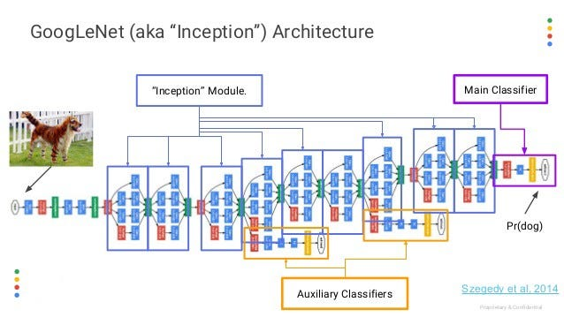
Overview
Inception V1 uses Inception modules that apply multiple convolutional operations in parallel to capture features at different spatial scales.
Step-by-Step Architecture
- Input Layer
- Inception Modules
  - Parallel operations:
1×1 Conv, 3×3 Conv, 5×5 Conv, MaxPooling
  - Outputs are concatenated
- Dimensionality Reduction using 1×1 convolutions
- Global Average Pooling
- Softmax Output Layer
Key Characteristics
- Efficient multi-scale feature extraction
- Reduced computational cost
- Well-suited for transfer learning
Paper Title: Going Deeper with Convolutions
Authors: Christian Szegedy, Wei Liu, Yangqing Jia, et al.
📄 Link (Paper page & context): https://en.wikipedia.org/wiki/Inception_(deep_learning_architecture)
4.1.4 MobileNet V2 Architecture (Transfer Learning)
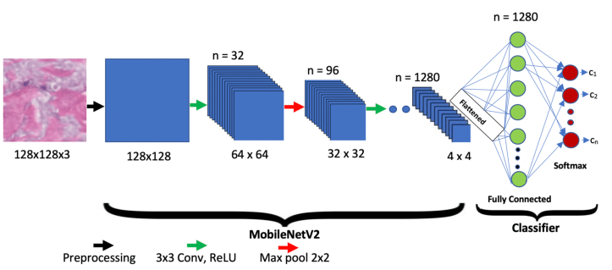
Overview
MobileNet V2 is designed for lightweight and resource-constrained environments using depthwise separable convolutions and inverted residual blocks.
Step-by-Step Architecture
- Initial Convolution
- Depthwise Separable Convolutions
  - Depthwise convolution
  - Pointwise (1×1) convolution
- Inverted Residual Blocks
- Global Average Pooling
- Dense Output Layer
Key Characteristics
- Lightweight and fast
- Low computational cost
- Suitable for mobile and real-time applications
Paper Title: MobileNetV2: Inverted Residuals and Linear Bottlenecks
Authors: Mark Sandler, Andrew Howard, Menglong Zhu, Andrey Zhmoginov, Liang-Chieh Chen
📄 Link: https://arxiv.org/abs/1801.04381 arXiv

4.2 Comparative Analysis of Models
Experimental Results Summary
Model | Accuracy | Precision | Recall | F1-Score | AUC (Macro)
VGG-19 (Scratch) | 0.7127 | 0.7381 | 0.7127 | 0.7155 | 0.9615
Inception V1 (TL) | 0.9667 | 0.9672 | 0.9667 | 0.9667 | 0.9986
ResNet-50 (TL) | 0.4893 | 0.5045 | 0.4893 | 0.4245 | 0.9264
MobileNet V2 (TL) | 0.9027 | 0.9072 | 0.9027 | 0.9021 | 0.9943

Pros and Cons of Each Architecture
VGG-19
- Pros: Simple design, strong baseline
- Cons: Heavy model, prone to overfitting when trained from scratch
ResNet-50
- Pros: Deep architecture, residual connections
- Cons: Sensitive to fine-tuning strategy, underperformed in this experiment
Inception V1
- Pros: Best overall performance, strong multi-scale feature extraction
- Cons: Complex internal design
MobileNet V2
- Pros: Lightweight, fast, high accuracy relative to complexity
- Cons: Slightly lower accuracy than Inception

Explanation of Performance Differences
Inception V1 achieved the best performance because:
- It extracts features at multiple spatial scales simultaneously
- It generalizes well to food image datasets with varying textures and shapes
- Transfer learning effectively leveraged pre-trained representations without overfitting
ResNet-50 underperformed due to insufficient fine-tuning and high sensitivity to hyperparameters.

Final Conclusion
- Inception V1 is the most suitable architecture for the given task and dataset.
- MobileNet V2 provides an excellent balance between accuracy and efficiency.
- VGG-19 serves as a strong academic baseline.
- ResNet-50 requires more careful fine-tuning to achieve optimal performance.

