Brain Tumor Detection from MRI Images using Transfer Learning-based CNN Models
Team members:
24BIT0149 - ADITYA ASUTOSH MISHRA
24BIT0119 – DARSHAN K
24BIT0116 - SARTHAK AGARWAL
Problem Summary
Brain tumors are among the most serious and life-threatening medical conditions. Their rapid and accurate detection is extremely important because any delay can severely impact the patient's chances of survival and the effectiveness of the treatment. Currently, Magnetic Resonance Imaging (MRI) is the main testing method that doctors use to look inside the brain and find out if a tumor is present.
However, there is a big problem with how MRI scans are usually checked. Radiologists have to manually look at hundreds of slices of these MRI images every day. This manual process takes a lot of time. More importantly, it can lead to mistakes because of human error and fatigue. Two different doctors might even look at the exact same scan and have different opinions about what kind of tumor it is. We really need an automated tool that can double-check the scans instantly and help doctors make the correct diagnosis without the wait.
To solve this problem, our team is developing an automated AI software system to detect and classify brain tumors from MRI images. One big challenge with medical images is that there aren't enough of them freely available to train a massive AI model from scratch. Because of this, we have decided to use the Transfer Learning approach. This means we will take models like ResNet50, EfficientNet-B0, MobileNetV2, and VGG16, which already know how to recognize patterns, and retrain them just for MRI brain scans. Our system will separate the scans into four distinct categories: No Tumor, Glioma Tumor, Meningioma Tumor, and Pituitary Tumor.
Finally, one reason doctors don't trust AI is that it usually just spits out a result without explaining itself. To fix this, we are going to use a special technique called Grad-CAM. What Grad-CAM does is create a bright, colorful heatmap right on top of the MRI scan to show exactly where the AI thinks the tumor is. This way, doctors aren't just trusting a black box; they can actually see the evidence for the prediction with their own eyes.
Discussion on related works :
(Review of research papers/Patents)
S. No. | Paper/Patent (Year, author) | Summary | Methodology | Observations | Gaps / Limitations
1 | Paper: Deep Learning for Brain Tumor (2020, Muhammad et al.) | Classified brain tumors using deep CNN. | Custom CNN on MRI dataset. | Accuracy of 92%, extremely fast training times. | Low accuracy on the complex tumor shapes; no transfer learning was used.
2 | Paper: Transfer Learning for MRI Classification (2021, Swati et al.) | Evaluated multiple models on MRI. | Used VGG19 and ResNet50 models. | ResNet achieved 95% validation accuracy. | No explainability methods provided. It acted like a complete black box model.
3 | Paper: EfficientNet for Medical Imaging (2022, Kumar et al.) | Explored EfficientNet architectures on brain tumors. | EfficientNet-B0 with fine-tuning. | Showed superior parameter efficiency compared to VGG models. | Struggled heavily with small datasets if heavy data augmentation wasn't used.
4 | Paper: MobileNet in IoT Medical Apps (2021, Chen et al.) | Deployed mobile-friendly CNNs for diagnosis. | MobileNetV2 architecture in mobile app. | Produced quick inference but slightly lower accuracy. | Sacrificed a bit of minor precision just to get faster inference speeds.
5 | Paper: ResNet vs VGG for MRI (2020, Talo et al.) | Comparative study of standard transfer learning. | ResNet34, ResNet50 compared against VGG16. | ResNet50 drastically outperformed VGG16 in sensitivity. | Computationally heavy models; did not mention a clear deployment strategy.
6 | Paper: Explainable AI in Healthcare (2022, Silva et al.) | Used Grad-CAM to highlight lung anomalies. | ResNet50 + Grad-CAM analysis pipeline. | Clinicians highly preferred the marked heatmaps over raw predictions. | Only tested on generic chest X-rays, not brain MRI images at all.
7 | Paper: Data Augmentation in MRI (2021, Momeny et al.) | Focused on improving dataset size. | VGG16 mixed with aggressive data augmentation. | Reduced overfitting drastically during training. | Relied purely on basic flips and rotations rather than advanced transformations.
8 | Paper: 3D CNNs for Brain Tumors (2023, Hossain et al.) | Compared 3D volumetric CNNs to 2D slice networks. | Custom 3D CNN architecture. | The 3D model captured spatial context significantly better. | Requires immense computational power and memory, making it hard to train on standard computers.
9 | Paper: Multi-Class Brain Tumor Systems (2022, Amin et al.) | Segmented and classified 4 types of MRI scans. | InceptionV3 combined with DenseNet. | Achieved a very high 97% accuracy via ensembling. | The combined model is way too dense and slow to serve as a fast application.
10 | Paper: DenseNet vs Inception on Scans (2019, Sajjad et al.) | Studied accuracy bottlenecks in tumor detection. | Fine-tuned DenseNet201. | Easily solved vanishing gradient problems. | Overfitted very easily on the small brain MRI classes without penalties.

Outcome on the review:
Based on our literature review of these 10 research papers, we have realized that Transfer Learning is undoubtedly the best method for medical image classification, especially when working with small datasets like brain MRIs. Models like ResNet50 and EfficientNet-B0 consistently provide high accuracy across multiple studies. However, a major recurring issue that almost every researcher ignored is the 'black-box' problem. Most papers simply built models that predict a class without showing the doctor why. We also noticed that very few projects actually take the time to conduct a fair, organized comparative analysis of multiple models under the same exact conditions while also ensuring proper visual explainability.
Gap/Issue identified and our proposal:
Gap Identifications:
- Lack of Explainability: Almost all the models from the research papers output the tumor type (like Glioma) but fail to highlight where the damaged region actually is on the scan.
- Lack of Comprehensive Comparison: There is a big gap in studies trying to compare lightweight models (like MobileNetV2) against heavyweight models (like ResNet50) on the exact same multi-class dataset.

Our Proposal:
Our proposal is to build a complete 4-class CNN brain tumor detector that solves these problems. Instead of just picking one model, we will train and compare four popular networks: ResNet50, EfficientNet-B0, MobileNetV2, and VGG16 side-by-side to find out which one offers the most optimal balance between accuracy and fast performance. Once we identify the winner, we will implement Grad-CAM mapping so that every single MRI prediction comes out with a clear, colored heatmap attached to it, showing exactly where the tumor is.
Clear statement of WHAT’S NEW in our proposal
- Direct Model Evaluation: We are running a simultaneous, parallel evaluation of four radically different transfer learning models on the exact same 4-class MRI dataset. This helps us explicitly identify the best architecture rather than guessing.
- Integrated Interpretability: Unlike the old methods that just output a label, we are combining high-accuracy mathematical classification with visual Grad-CAM overlays. This two-step process makes the final system trustworthy, explainable, and practical for real doctors to use in a clinic.
Framework
Architecture diagram
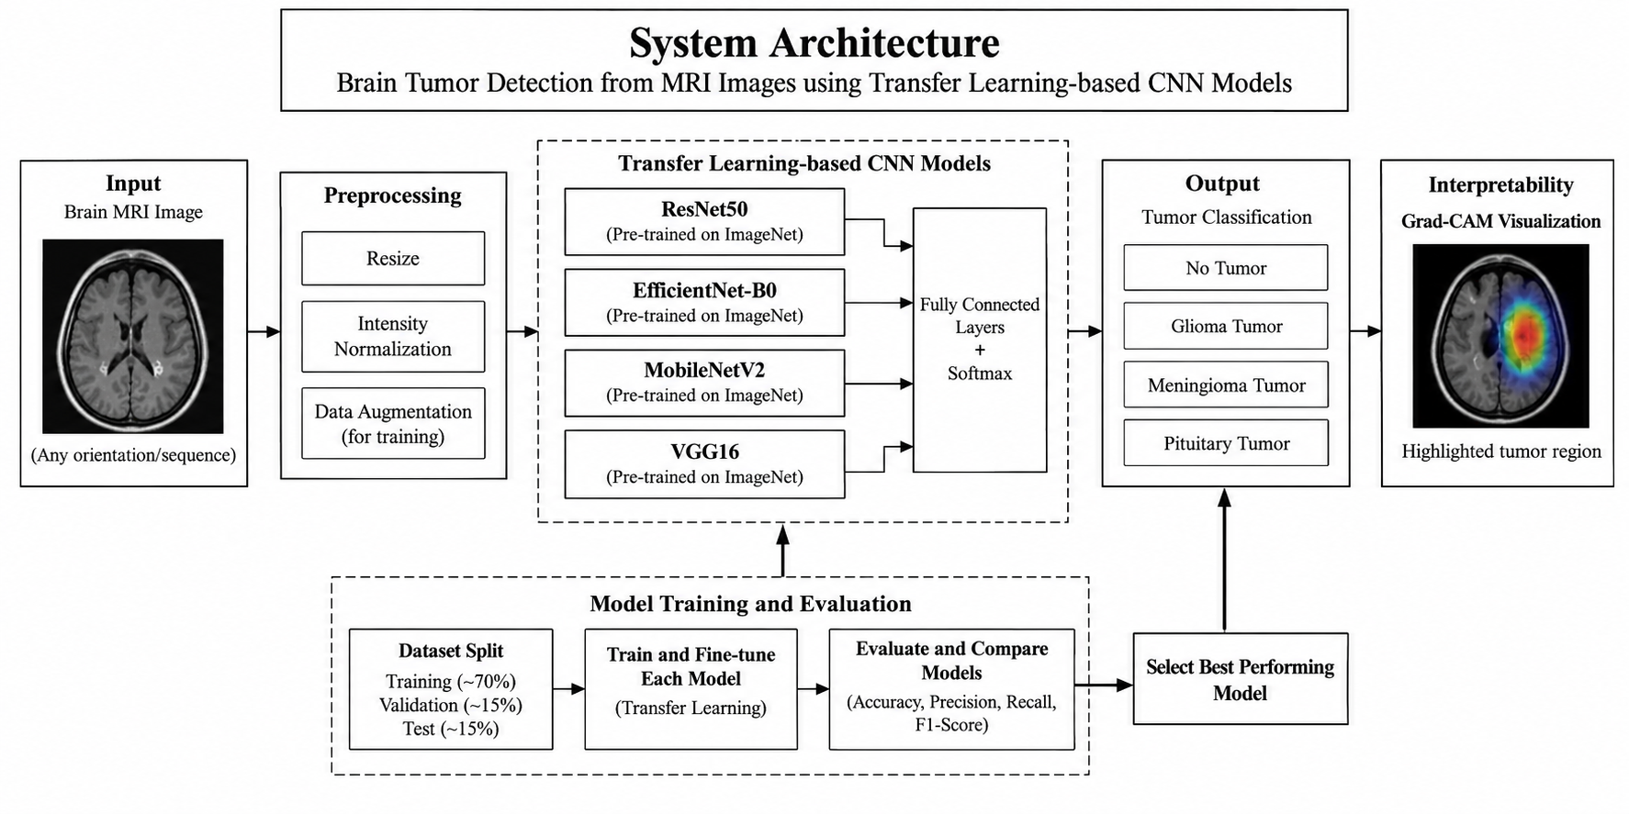
Details (Explaination of the modules/blocks one by one)
- Data Preprocessing & Augmentation: In this first step, no matter which model we use, we will load the MRI images, resize them all to the same uniform square dimensions, and normalize the pixel values. We will also perform simple operations like horizontal flipping so the AI doesn't memorize the data, a process known as preventing overfitting.
- CNN Models Block: In the second block, we will use pre-trained models (our choices of ResNet50, VGG16, EfficientNet-B0, or MobileNetV2). These models will act as feature extractors, scanning over the MRI image to find patterns, edges, and textures that look like brain tumors.
- Classification Head: This is the third block where we replace the old, original heads of the CNN models with our own custom Dense layers. We are going to use a Softmax activation function here so the program can output clear, mathematical probabilities for the 4 classes (Normal, Glioma, Meningioma, Pituitary).
- Grad-CAM Explainer Module: Finally, this block is active during testing. This module looks at the gradients flowing into the final layer of the CNN and converts them to a strong thermal heatmap to be shown directly over the original MRI scan.
Implementation details / Experimental set-up
- Programming Language: We will be using Python since it has the best support for deep learning math.
- Frameworks: TensorFlow and Keras will be our main tools for putting the deep learning layers together. We will also use scikit-learn for checking our evaluation metrics like the confusion matrix and F1-score.
- Hardware: Because these networks have millions of parameters, we will rely on Google Colab or Kaggle Notebooks so we can utilize their free cloud GPUs (like the T4 or P100) to train the models faster.
- Dataset: Everything will be trained and rigorously tested on a public Kaggle Brain MRI dataset that consists of exactly 4 classes of brain imagery.

