END-TO-END MLOPS
Heart Disease Classification

https://github.com/AA-ATUL/mlops-heart-disease
Experimental Learning Assignment
Repository: https://github.com/AA-ATUL/mlops-heart-disease
Data Acquisition • EDA • Model Training • MLflow • CI/CD • Docker • Kubernetes • Monitoring

demo video link: https://drive.google.com/file/d/1EqWCO05G2MI6rp97EpvIbKMQiu_6Q1j_/view?usp=sharing

1. Executive Summary
This project implements an end-to-end machine-learning workflow for binary heart-disease classification. It automates data acquisition, exploratory data analysis (EDA), feature preprocessing, model comparison and tuning, experiment tracking, automated tests, container packaging, Kubernetes deployment, and API metrics.
The UCI Heart Disease dataset contains 303 records and 14 original columns. Logistic Regression and Random Forest were evaluated using stratified cross-validation. Logistic Regression was selected with mean cross-validation ROC-AUC of 0.9025. On the held-out test set, it achieved accuracy 0.8852, precision 0.8387, recall 0.9286, and ROC-AUC 0.9665.

Project objectives
- Create a reusable preprocessing and classification pipeline.
- Track parameters, metrics, and artifacts with MLflow.
- Automate linting, tests, model execution, and image build in GitHub Actions.
- Expose predictions and operational metrics through FastAPI.
- Package the service with Docker and demonstrate Kubernetes deployment.

Deliverables map
Requirement | Project evidence
Code and scripts | src/
Tests | tests/
CI/CD | .github/workflows/ci.yml
Model and evaluation | models/ and reports/
Container | Dockerfile
Kubernetes | deployment/
Screenshots | screenshots/

2. System Architecture
The workflow is separated into data, modeling, delivery, and runtime stages. The saved preprocessing-plus-model pipeline is loaded by the API so inference applies the same transformations used during training.
Stage | Implementation | Output
Data | UCI download, cleaning, binary target | Dataset
EDA | Histograms, correlation heatmap, class balance | Figures
Modeling | Two classifiers, tuning, stratified CV | Selected pipeline
Tracking | MLflow experiment runs | Metrics and artifacts
CI | GitHub Actions, Ruff, pytest, Docker build | Workflow evidence
Serving | FastAPI endpoints | Predictions and metrics
Runtime | Docker + Kubernetes manifests | Deployed service
Architecture flow: UCI dataset → download/preprocess → EDA → train/tune/compare → MLflow → saved model pipeline → FastAPI → Docker → Kubernetes Deployment/Service/Ingress → health, prediction, and metrics endpoints.

Repository structure
src/ contains download, preprocessing, EDA, training, tracking, and API code. tests/ contains automated tests. models/ contains the serialized pipeline. reports/ contains figures and evaluation outputs. deployment/ contains Kubernetes manifests. screenshots/ contains validation evidence. .github/workflows/ci.yml defines CI.

3. Data Acquisition and EDA
The acquisition script downloads the UCI Heart Disease dataset using ucimlrepo (dataset ID 45). The original target field num is converted to a binary label: 0 represents no detected disease; values greater than 0 represent disease present.
Data check | Observed result
Records | 303
Original columns | 14
Missing values | 6 total: ca=4, thal=2
Duplicate rows | 0 reported
Negative class | 164
Positive class | 139
The EDA script generates feature histograms, a correlation heatmap, and a class-balance plot. These figures help inspect distributions, feature relationships, and target balance.

EDA evidence
Insert the existing files from reports/figures/ here before exporting the final PDF. Keep figure captions concise and ensure labels remain readable.
- Feature histograms: inspect feature ranges and skew.
- Correlation heatmap: inspect pairwise feature correlations.
- Class-balance chart: compare positive and negative target counts.

4. Preprocessing and Feature Engineering
The model pipeline uses numeric and categorical preprocessing branches. Numeric missing values are imputed with the median and numeric features are standardized. Categorical missing values are imputed with the most frequent category and categorical variables are one-hot encoded.
Keeping preprocessing inside the fitted scikit-learn pipeline reduces the risk of training-serving skew because the same learned transformations are reused during prediction.
Setting | Configuration
Train/test split | Stratified 80/20
Random seed | 42
Training records | 242
Test records | 61
Cross-validation | 5-fold StratifiedKFold
Tuning objective | ROC-AUC

Reproduce the workflow
python -m pip install -r requirements.txt
python src/download_data.py
python src/preprocess_data.py
python src/eda.py
python src/train_model.py
python src/track_experiments.py
python -m pytest tests -v
ruff check src tests
The dataset is acquired by script; a separate manual data download is not required.

5. Model Development and Evaluation
Logistic Regression and Random Forest are compared. GridSearchCV tunes candidate hyperparameters using five-fold stratified cross-validation. Mean CV ROC-AUC is used to compare the best configuration from each model family.
Model/configuration | Mean CV ROC-AUC
Logistic Regression (C=1) | 0.902493
Random Forest (100 trees, max_depth=None) | 0.897204
Logistic Regression was selected based on its higher mean cross-validation ROC-AUC.
Held-out test metric | Result
Accuracy | 0.8852
Precision | 0.8387
Recall | 0.9286
ROC-AUC | 0.9665

Interpretation
The selected model correctly classified 88.5% of test examples. Recall of 92.9% indicates that most positive examples in this test split were identified, while precision of 83.9% reflects the fraction of positive predictions that were correct. ROC-AUC summarizes discrimination across classification thresholds.
These values are specific to this dataset and split; they do not establish clinical suitability or generalization to other populations.

Saved artifacts
The selected pipeline is saved at models/best_model.joblib. Evaluation tables, metrics, confusion matrix, and ROC plot are written under reports/.

6. Experiment Tracking with MLflow
The tracking script records candidate runs and the selected-model evaluation in the Heart Disease Classification experiment. Logged information includes hyperparameters, cross-validation metrics, test metrics, model comparison tables, cross-validation results, EDA plots, evaluation plots, and the saved selected model artifact where applicable.

Run and inspect MLflow
python src/track_experiments.py
mlflow ui
Open http://127.0.0.1:5000. If a local SQLite tracking database is configured, use the same tracking URI as the project so the UI displays the intended experiment history.

7. CI/CD and Automated Testing
The workflow in .github/workflows/ci.yml triggers on pushes and pull requests to main or master. It configures Python 3.12, installs dependencies, runs Ruff, acquires and preprocesses data, generates EDA outputs, trains models, tracks MLflow runs, runs pytest, builds the Docker image, and uploads reports and the saved model as workflow artifacts.
Quality gate | Validation
Lint | ruff check src tests — reported passing
Automated tests | 9 tests reported passing
Data/model stages | Included in workflow
Docker image | Build step included
Artifact upload | Reports and saved model
Workflow status | Latest run confirmed green

CI/CD scope
The workflow builds the Docker image but does not publish it to a registry or automatically deploy it. Kubernetes deployment is demonstrated separately using the deployment manifests and local Minikube.

Screenshot
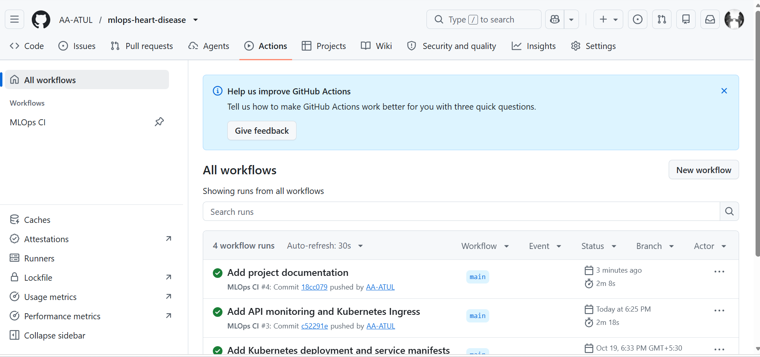

8. API, Docker, and Kubernetes Deployment

FastAPI
- GET /health — service/model health.
- POST /predict — JSON prediction, label, confidence, and disease probability.
- GET /metrics or /metrics/ — Prometheus-format request and prediction metrics.
Start locally with: uvicorn src.api:app --host 0.0.0.0 --port 8000. Interactive API documentation is available at http://127.0.0.1:8000/docs.

Docker
Build and run: docker build -t heart-disease-api:local .
docker run --rm -p 8000:8000 heart-disease-api:local
The Dockerfile uses a Python 3.12 slim base image, installs dependencies, copies the API and saved model pipeline, and starts Uvicorn on port 8000.

Kubernetes
deployment/ contains Deployment, Service, and Ingress manifests. Local Minikube validation covered resource status, health checks, sample predictions, and metrics.
kubectl apply -f deployment/deployment.yaml
kubectl apply -f deployment/service.yaml
kubectl apply -f deployment/ingress.yaml
kubectl get deployments,pods,services,ingress

9. Monitoring, Limitations, and Conclusion
The API instruments request counts, prediction counts, and request latency in Prometheus format and logs request/prediction activity. The metrics endpoint and existing screenshots provide evidence of basic operational observability.

Limitations and future work
- The dataset is small and historical; external validation is needed.
- Metrics reflect one held-out split and are not clinical evidence.
- Future improvements include calibration, drift detection, dashboards/alerts, API authentication and authorization, and security hardening.
- Real-world healthcare use would require clinical, privacy, regulatory, and governance review.

Reproducibility checklist
- Install requirements.txt in a clean Python environment.
- Run data acquisition, preprocessing, EDA, training, and tracking scripts.
- Run pytest and Ruff; confirm GitHub Actions is green.
- Build and test the Docker image and sample API request.
- Apply Kubernetes manifests and capture genuine deployment/metrics screenshots.
- Include MLflow and CI screenshots; verify report page count and PDF size.
- Record a concise narrated demonstration (4–5 minutes maximum).

Conclusion
The project demonstrates an end-to-end MLOps workflow from scripted data acquisition and model selection through experiment tracking, automated quality checks, containerized API serving, Kubernetes deployment, and basic monitoring.
Repository: https://github.com/AA-ATUL/mlops-heart-disease

SCREENSHOTS
