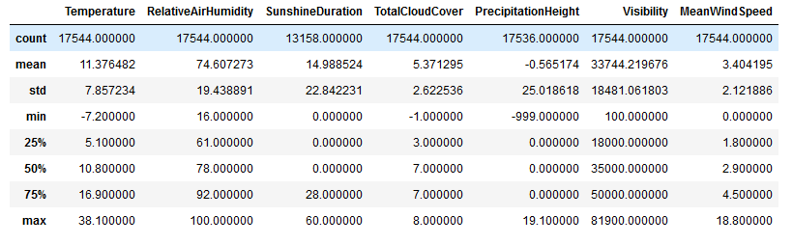

Figure 1 Weather Dataset with error values and missing data

Figure 2 Weather Dataset without errors with missing data

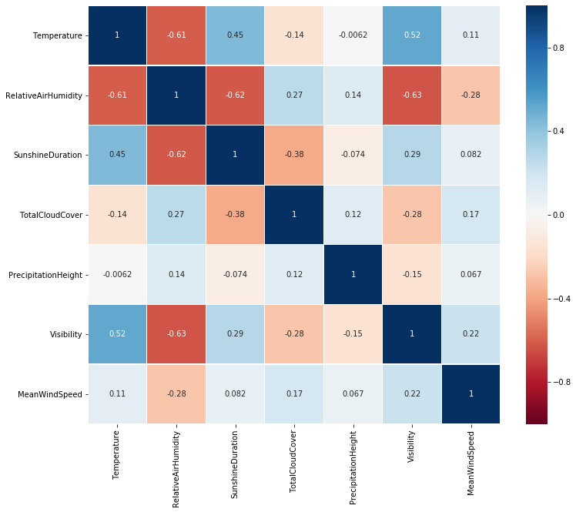

Figure 3Heatmap Person Correlation with weather features

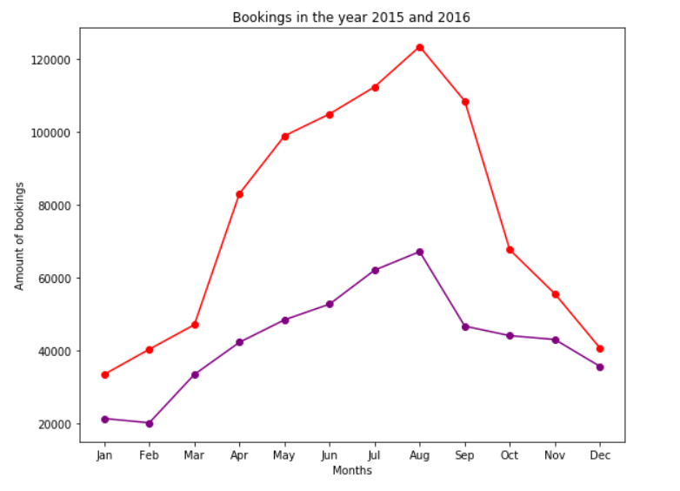

Figure 4 Booking amounts per month for both years

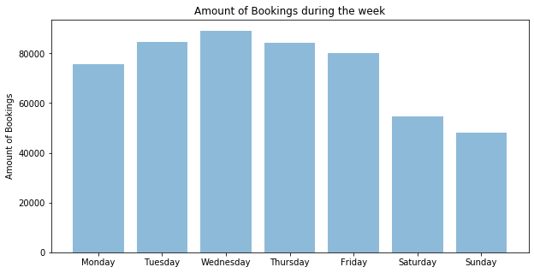

Figure 5 Booking Amounts per weekday

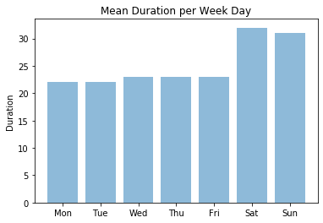

Figure 6 Mean trip duration for weekdays

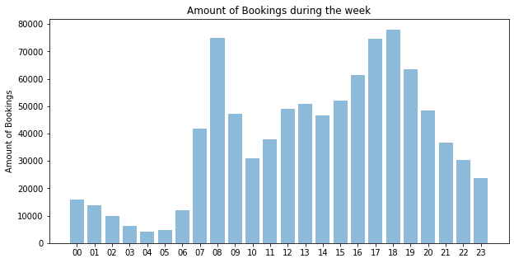

Figure 7 Booking amounts per hour (year 2016)

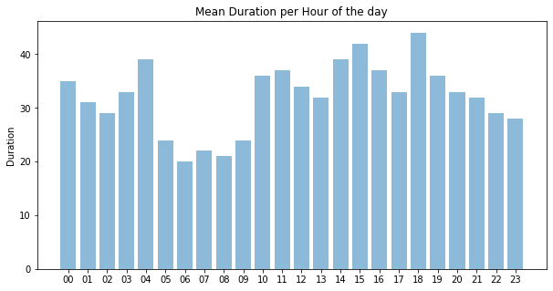

Figure 8Mean Booking duration per hour (Year 2015,2016)

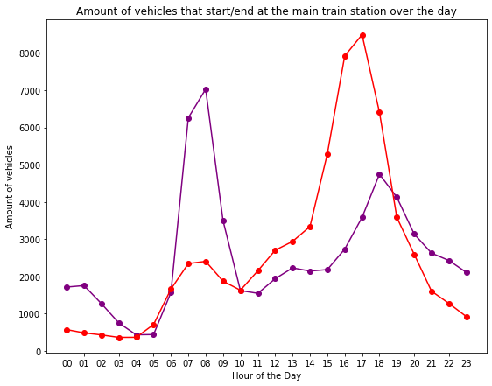

Figure 9 Amount of vehicels that start/end at the main train station over the day

CLUSTERS

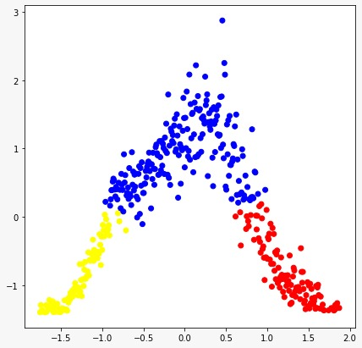

Figure 10 Trip type cluster (Amount of bookings – temperature)

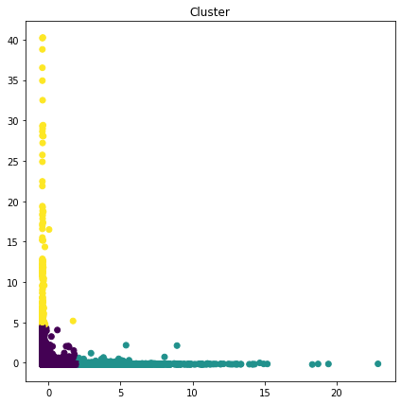

Figure 11Customer type cluster (amount of bookings – duration)

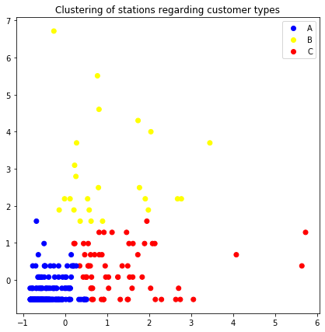

Figure 12 Station types regarding customer types cluster (Stations with regular customers -Stations with occasional customers)

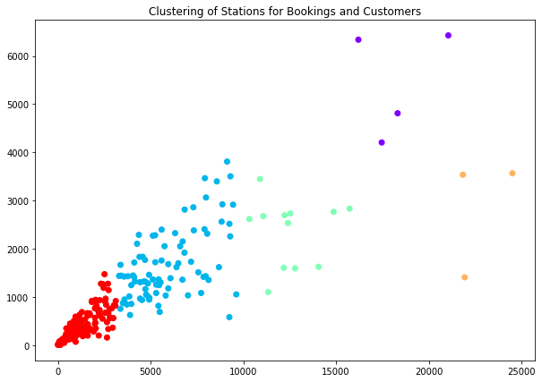

Figure 13 Clustering of stations for bookings and customers (Customers – Amount of bookings)

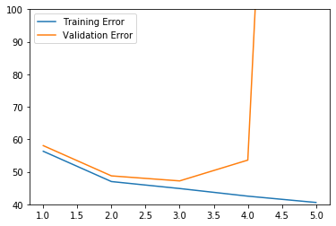

Figure 14 Training and Validation Error for Polynomial Model

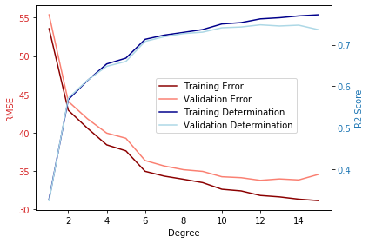

Figure 15 RMSE and R² for Polynomial Model with normalization

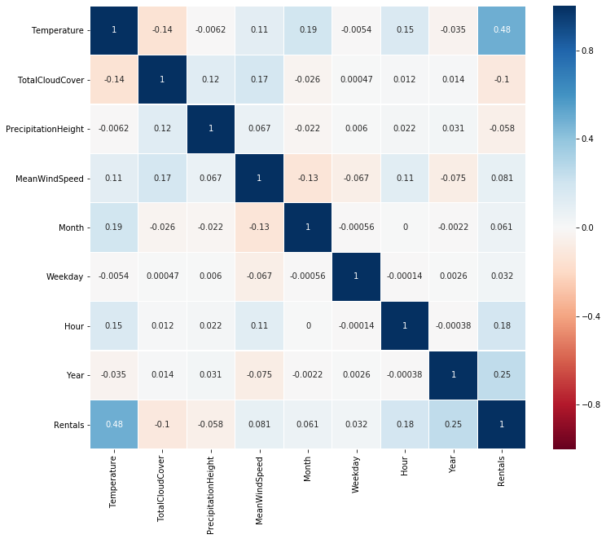

Figure 16Heat Map with Pearson Correlation for all features