|  |
| --- |
|  |

|  |
| --- |
|  |
| **Date** |
| **2/10/2016** |
|  |



2/10/2016

Submitted by

*Abdul Aziz(1207001) and*

*Md. Montasir Bin Shams(1207023).*

*Khulna University of Engineering & Technology, Khulna-9203*

Department of Computer Science and Engineering

***CSE 3204***

*Project On: “*Implementation of Keypad and Bluetooth Controlled LCD display.*”*

*Submitted to:*

*Mr. Saifuddin Mahmud*

*Assistant Professor, Dept. of CSE,KUET*

*&*

*Mr. Mahtab Ahmed*

*Lecturer, Dept. of CSE,KUET*

Objectives:

* To learn about Arduino UNO and its different Pin functions.
* To learn about LCD display, Keypad and their different functions.
* To display Scrollable characters in the LCD display.
* Make Users/Customers information available when engaging in different activities.

Introduction:

Interfacing a character LCD to an arduino is one of the coolest things that any one can do on the arduino. Most of the best arduino projects around the world sport one of these LCD displays. These LCDs can be used to display information from the arduino or any sensor connected to it. For example, you can create a temperature monitoring system, which displays the temperature on the arduino. Or user can make his own speedometer, that displays the speed via the LCD. So, depending on what people want to build, an LCD is a highly useful output device for arduino. Another thing that is related to LCD display is Keypad. Keypad is often needed to provide input to an Arduino system, and membrane-type keypads are an economical solution for many applications. They are quite thin and can easily be mounted wherever they are needed.

OverView:

In this Project,We are dealing with LCD display, displaying scrollable characters connected with an Arduino UNO.LCD display is controlled by a 4X3 membrance keyboard and android device via Bluetooth shield. This project is actually designed to make peoples work easier and flexible. An illustration can make it clear, why we dealt with such a project. Suppose, In a University there always exist interaction among teachers, students and stuffs. They need to communicate with each other on different matters. Sometimes, it happens that a student may need to communicate with his supervisor/teacher physically but the mentor is not available at that moment. So, it is disgusting for the student to wait…If the teacher uses our device he can set some messages by using keypad or Android device depending on the case what he/she is currently involved.

Apparatus:

Hardware:

* + Arduino UNO
  + 16X2 LCD display
  + 4X3 membrance Keypad
  + 10k Potentiometer
  + 300 ohm resistor
  + Bluetooth Shield
  + Connecting Wire

Software:

* Arduino IDE

How does it works:

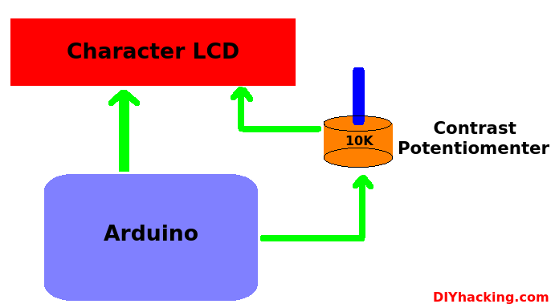

Features:

* + Users can set some predefined scrollable messages ( programmatically burned on the display) by pressing different keys.
  + Post any message on the display by using Android device which communicates with display via Bluetooth module.
  + By using GSM module user can post information from anywhere(Yet not implemented)

Circuit Diagram:

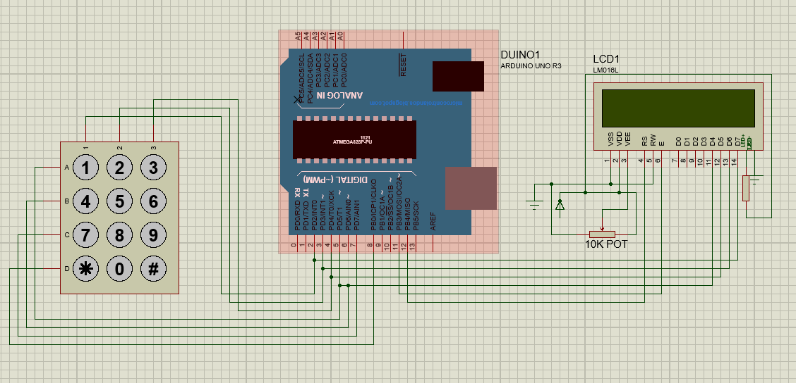

Fig1: Keypad controlled LCD Display

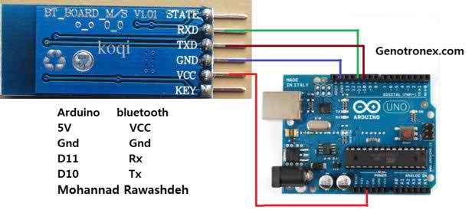

Fig1: Bluetooth Interfacing with Arduino.

Code:

#include <Keypad.h>

#include <Wire.h>

// include the library code:

#include <LiquidCrystal.h>

// initialize the library with the numbers of the interface pins

LiquidCrystal lcd(12, 11, 5, 4, 3, 2);

const byte rows = 4;

const byte cols =3;

char keys[rows][cols]={

{'1','2','3'},

{'4','5','6'},

{'7','8','9'},

{'*','0','#'}

};

byte rowPins[rows]={8,7,6,5};

byte colPins[cols]={4,3,2};

Keypad keypad = Keypad(makeKeymap(keys),rowPins,colPins,rows,cols);

void setup(){

// set up the LCD's number of columns and rows:

lcd.begin(16, 2);

lcd.setCursor(0,0);

//lcd.print("We pressed: ");

lcd.print("Help : Press Keys for Diff. Actions...");

lcd.setCursor(0,1);

// lcd.print("for Diff. Action");

lcd.print("1:Class, 3:Tea, 4:Mosque, 6:Lab, 7:Home.");

func();

}

void loop(){

char key= keypad.getKey();

//keypad.waitForKey();

//lcd.setCursor(3,0);

if(key=='1'){

lcd.clear();

lcd.print("Now, I am in Class room.");

}

else if(key=='2'){

lcd.clear();

lcd.print("Now, I am at Meeting. :)");

}

else if(key=='3') {

lcd.clear();

lcd.print("Now, I am at Tea Break. :D");

}

else if(key=='4') {

lcd.clear();

lcd.print("I am at Central Mosque.");

}

else if(key=='5'){

lcd.clear();

lcd.print("Now, I am at Lunch. <3:D");

//lcd.print("5");

}

else if(key=='6'){

lcd.clear();

lcd.print("Now, I am at Laboratory.");

}

else if(key=='7') {

lcd.clear();

lcd.print("Now, I am at Home. <3 B|");

}

else if(key=='8'){

lcd.setCursor(1,0);

lcd.print("Help: Press...");

}

else {

//if(key != NO_KEY)

//lcd.print(key);

}

// scroll 13 positions (string length) to the left

// to move it offscreen left:

//func();

}

void func()

{

for (int positionCounter = 0; 1; positionCounter) {

// scroll one position left:

lcd.scrollDisplayLeft();

// wait a bit:

delay(250);

loop();

}

}

Discussion:

From this project we have learnt how to work with arduino,LCD display and keypad combinedly.That was a great journey..Finally, we are successfully completed our project.It can display any character.But there arose some problem while implementing.Sometimes,It shows garbage values .Cost is also an important factor.