ThemeCloner: Holdings-Free Discovery of Thematic Exposure via Latent Factor Projection
Working Draft

Abstract
Thematic investing groups companies by exposure to a structural economic driver, such as artificial intelligence, clean energy, or cybersecurity, rather than by traditional sector or industry classification. The baskets used to define or express a theme in a portfolio are typically built manually, inherently focused on large cap companies given the availability of analyst coverage, and backward looking. It is rarely clear in advance which themes are economically coherent enough to trade. In this paper we present ThemeCloner, an engine that does not use holdings and that extracts a theme's statistical signature from the return co-movement of thematic reference baskets, such as exchange traded funds (ETFs), in a broad large and midcap universe, and projects that signature onto a disjoint uncovered and underexplored universe of assets (for example small cap universe) to discover stocks with genuine thematic exposure that no classification or ETF holding has labeled.
Using principal component analysis on factor-residualized, standardized returns, our central result is a diagnostic: a theme produces clean, investable baskets if and only if it uniquely owns a latent factor. Concentration alone is not enough: a theme can be concentrated on a factor it shares with others, yielding baskets that look clean but are contaminated, so it is distinctness of factor ownership, not coherence per se, that determines tradeability. The same criterion also flags theme overlap and tests whether the discovered signals survive controls for stock level momentum. This gives a direct answer to the claim that thematic investing is simply momentum.
To validate that the diagnostic measures genuine structure rather than rediscovering taxonomy, we calibrate it against GICS sector and subsector classifications as control labels. The calibration yields a striking result: sectors do not define the coherence ceiling. Coherence is regime dependent rather than taxonomic. In the 2018-26 sample, several cross sector themes are more distinctly owned latent factors than the GICS sectors they span, because a structural driver has fractured those sectors internally. The work offers both a portable discovery tool and a pre-trade test for when a theme is economically real rather than a marketing label.

1. Introduction
Thematic investing has become one of the most prominent organizing ideas in modern asset management. Investors increasingly want exposure to structural shifts such as artificial intelligence, the energy transition, cybersecurity, and automation, which cut across traditional sector taxonomies. The industry packages these ideas into thematic baskets and products, such as thematic ETFs, index provider theme indices, and sellside baskets. These group companies by shared exposure to a trend rather than by predefined sector classifications, such as the Global Industry Classification Standard (GICS) or the Industry Classification Benchmark (ICB). The premise is that the relevant axis of comovement is the theme, not the sector.

Three difficulties undermine this premise in practice. First, thematic baskets are biased toward large capitalization companies and are defined by holdings. They are built from the constituent lists of thematic products, so smaller companies that may carry a theme’s purest exposure, but that no reference basket includes, are invisible to them. Second, the baskets are manually constructed from holdings data and fundamental classification, which makes them costly to build, opaque, and difficult to extend to a universe the index provider has not already labeled. Third, there is no principled way to know in advance which themes are economically coherent enough to trade. Some themes correspond to genuine, distinct patterns of comovement, while others are taxonomic labels imposed on companies that do not actually move together. A recurring skeptical claim, voiced informally across the industry but never, to our knowledge, tested directly, sharpens this point: thematic investing may simply be momentum in disguise. Under this view, thematic baskets earn returns because their constituents have recently risen, not because they share a durable economic driver.

This paper addresses all three difficulties. We ask whether a theme’s signature can be recovered from return comovement alone, without holdings data, and whether that signature can be projected onto a separate universe to discover thematically exposed stocks that no existing classification has labeled. We then ask what distinguishes a theme that yields clean, investable baskets from one that does not. Finally, we ask whether the discovered signal is genuinely distinct from momentum.

Our approach, ThemeCloner, treats thematic ETF returns as labels for a latent factor rather than as lists of constituents. We residualize a broad large and mid capitalization universe against standard risk factors, extract latent factors from the residual comovement using principal component analysis, and identify each theme’s fingerprint by regressing its ETFs onto those factors. We then project a separate small capitalization universe into the same factor space and score each stock by its similarity to each fingerprint, yielding candidate baskets. The method never uses ETF holdings. The ETF price series is the theme definition.

Our central finding is diagnostic: a theme produces clean, investable baskets if and only if it uniquely owns a latent factor. Coherence, meaning how concentrated a theme’s fingerprint is, is necessary but not sufficient. A theme can be concentrated on a factor it shares with other themes, producing baskets that look clean but are contaminated. Distinctiveness, meaning whether the theme owns its dominant factor, is the operative criterion. This same mechanism explains three otherwise separate phenomena: which themes yield good baskets, why commodity themes contaminate one another, and which themes survive a momentum control. It is, in effect, a test before trading of whether a theme is economically real, computable before any basket is built.

To establish that this diagnostic measures genuine structure rather than merely rediscovering sector taxonomy, we calibrate it against GICS sectors and subsectors as control labels. The natural prior is that sectors should define the coherence ceiling, since a sector should own a factor in the PCA model almost by definition. The calibration validates the diagnostic and produces a striking result in its own right: sectors do not sit at the top of the coherence distribution. Coherence depends on regime rather than taxonomy. In our 2018 to 2026 sample, several themes that cut across sectors are more distinct owners of latent factors than the broad GICS sectors they draw from, because the dominant structural driver of the period, capital expenditure on artificial intelligence, has split those sectors internally. The fact that a theme spanning multiple sectors can be a tighter covariance cluster than the sector itself is strong evidence that the diagnostic captures real structure missed by standard sector classifications. We develop this result as a validation of the method rather than as a separate claim about thematic investing’s legitimacy.

We make four contributions. We present an engine for thematic stock discovery that does not use holdings and can operate across universes. We introduce a coherence and distinctiveness diagnostic that determines, before any basket is built, whether a theme is a genuine covariance cluster or a taxonomic label. This is the paper’s central contribution. We provide direct evidence on the thematic versus momentum question, showing that the answer is conditional on factor ownership. Finally, by calibrating the diagnostic against GICS controls, we document that coherence depends on regime, which validates that the method resolves structure finer than standard sector classification.

2. Related Work

2.1 Latent Factor Models of Returns

Our factor extraction step builds on the literature that estimates latent asset pricing factors statistically rather than specifying them in advance. The risk premium PCA (RP-PCA) framework of Lettau and Pelger generalizes principal component analysis by penalizing pricing errors across the cross section. This can reveal economically important low variance factors that ordinary PCA, which ranks components by variance alone, can bury beneath high variance noise. This makes RP-PCA a natural starting point for theme discovery. In the language of this literature, themes are weak factors: they explain only a modest share of residual variance and resemble the low variance but real structure that RP-PCA is designed to recover. As we show in Section 3.3, however, the specific signal RP-PCA uses to identify weak factors is one our discovery objective does not use. In our setting, the method therefore reduces to ordinary PCA applied to a carefully constructed residual covariance.

2.2 Text-Based and Classification-Free Company Grouping
A related literature derives company relationships from sources other than returns. Industry networks built from regulatory filing text produce peer groups that differ from fixed classifications such as SIC or GICS, and recent work learns company embeddings from disclosures that recover industry and similarity structure. A complementary approach derives themes from disclosure language rather than return comovement and tests whether theme membership based on language anticipates later ETF inclusion (Amini et al., working paper). These approaches share our goal of moving beyond fixed taxonomies, but they operate on text. ThemeCloner operates on return covariance. The two sources provide complementary signals for the same underlying question: what economically groups firms.

2.3 Thematic Investing and Its Coherence
The closest work to ours examines thematic investing from a risk perspective, defining a theme through a factor model and testing whether thematic baskets capture coherent common risk. That work tests the coherence of given baskets. We differ in objective and direction: we discover basket members across separate universes, and we use coherence not only to validate baskets but also to predict which themes are tradeable at all. Related practitioner work argues that companies within a theme should correlate with the theme’s macro drivers while decorrelating from adjacent sectors. This is the fundamental data counterpart to the statistical separation we measure.

2.4 Momentum and the Thematic Critique
The claim that thematic investing is repackaged momentum has not, to our knowledge, been tested directly. The most relevant evidence is that momentum is not a standalone factor, but rather the time series autocorrelation of other factor returns, and that factor momentum subsumes much of individual stock momentum. This frames our distinction precisely. Momentum is a temporal property of factor returns, while a theme is a contemporaneous covariance structure across the cross section. The two are different mathematical objects. We therefore test their separation empirically rather than asserting it.

3. Methodology
ThemeCloner extracts the statistical signature of an investment theme from the return co-movement of thematic exchange-traded funds (ETFs), then projects that signature onto a separate, unexplored universe of stocks to identify names with genuine thematic exposure. The method is holdings-free by construction: ETF price series are used as theme labels, and no constituent data is required at any stage. This section describes the three-universe architecture, the residualization and factor-extraction steps, and the diagnostics that determine when a theme is recoverable.

3.1 Three-Universe Architecture

The pipeline separates three roles that are often conflated in thematic analysis:

Theme definition universe: Each theme is represented by two to three US listed thematic ETFs. Their returns define the theme. Holdings are never used.

Covariance universe: This is the large and mid capitalization cross section on which latent factors are estimated. We use US listed stocks above a USD 1 billion market capitalization floor, approximately 2,500 names, restricted to a single time zone to avoid foreign exchange and closing price timing artifacts.

Target universe: This is the small capitalization universe in which candidates are sought. It consists of Nasdaq and NYSE names below the covariance universe floor, after metadata filters, approximately 2,100 names. This is where the method searches for previously unlabeled thematic exposure.

Keeping these universes distinct is essential. The covariance universe must be broad and clean enough for themes to appear as genuine latent factors. The target universe must be separate so that discovered names are genuinely new rather than reidentified ETF constituents.

A subtler overlap risk is that a thematic ETF may hold some stocks that also appear in the target universe. If so, overlap could mechanically raise the correlation between a discovered basket and the ETF used to validate it. Two features limit this concern. First, holdings are never used in discovery: the ETF enters only through its return series, so the model cannot select a stock because it is an ETF constituent. Second, the market capitalization split puts most reference ETFs, which are liquidity constrained and weighted toward large and mid capitalization stocks, in a different size regime from the below threshold target universe. Any effective ETF exposure to a discovered candidate should therefore be small. We treat a direct screen for holdings overlap, excluding any target stock held by a theme ETF, as a robustness check for future work.

3.2 Residualization
Raw returns are dominated by market, size, value, and momentum exposures. Running factor extraction on raw returns causes high beta or high momentum stocks to load on many themes, producing pervasive contamination. We therefore residualize all return series against the Fama French five factors, optionally augmented with momentum and commodity sector controls, before factor extraction. Section 4 describes these controls. The residual is the component of each stock’s return that standard risk factors cannot explain.

Residuals are then winsorized at the 1st and 99th percentiles and standardized to unit volatility. This converts the subsequent decomposition from a covariance analysis into a correlation analysis, preventing any single high volatility stock from dominating the extracted factors. This standardization step proved decisive. Without it, factors were driven by a small number of volatile names. With it, each factor became an interpretable sector, style, or thematic axis.

3.3 Factor Extraction
We extract K=15 latent factors from the standardized residuals of the covariance universe. Although risk premium PCA (RP-PCA) is a natural starting point for recovering weak factors such as themes, as discussed in Section 2.1, our objective makes ordinary principal component analysis (PCA) the appropriate specification.

The reason follows from the difference between two objectives. RP-PCA identifies weak factors by using information in mean returns. Its penalty rewards factors that help price the cross section, so a low variance factor that carries a risk premium can be pulled forward. Theme discovery is not a pricing question. We ask whether a theme corresponds to a distinct pattern of comovement, not whether it earns a premium. To isolate that comovement, we residualize returns against standard risk factors and work with residuals that are mean zero in the estimation sample. The information RP-PCA relies on, pricing error in the cross section of mean returns, is therefore removed by design. In this setting, the penalty term is uninformative, and RP-PCA reduces to PCA on the residual covariance. We confirm this empirically: theme detectability is invariant to the RP-PCA penalty weight across a range spanning two orders of magnitude.

This raises an immediate question. If themes are weak factors, does ordinary PCA risk burying them beneath high variance components, which is the problem RP-PCA was designed to solve? In our setting, residualization performs that role through a different mechanism. By projecting out the Fama French factors and the dominant market and style variation before the decomposition, we remove the high variance structure that would otherwise dominate the leading components. Weak theme factors are therefore less likely to be buried when PCA is applied to the residual structure. For factor pricing, the RP-PCA premium penalty carries information and can improve on PCA. For factor discovery, that information is not part of the object of interest. Residualization, rather than the pricing penalty, is what makes weak factors visible. PCA on standardized residuals is therefore the appropriate tool.

The choice of K=15 is justified by a factor count sweep reported in the Appendix. Each label’s distinctiveness is essentially invariant to K over the tested range, except for one theme whose dominant factor resolves only at K=15 or above. We therefore use K=15, the smallest factor count that resolves all themes without degrading the others.

3.4 Theme Fingerprints and Projection
Each theme’s ETF returns are residualized using the same procedure and regressed on the K extracted factors, yielding a K dimensional loading vector: the theme’s fingerprint in factor space. For each theme, the fingerprint is the centroid of its constituent ETFs’ loading vectors, which reduces individual ETF construction noise. Every stock in the target universe is then projected into the same factor space and scored by cosine similarity between its loading vector and each theme fingerprint. The highest scoring names for each theme form the candidate basket.

3.5 Diagnostics: Coherence and Distinctiveness
Two diagnostics, computed before basket construction, assess whether a theme is recoverable. Coherence measures how concentrated a theme’s fingerprint is across factors. It is computed as the average of three normalized concentration metrics: a concentration ratio, a Herfindahl index, and an entropy based effective factor count. Distinctiveness measures whether a theme uniquely owns its dominant factor or shares it with other themes.

The distinction between sharing a dominant factor and sharing a secondary factor is central. Themes can overlap on secondary axes without contaminating one another, because those axes do not drive the projection used to form the basket. Contamination occurs when multiple themes share the same dominant factor, since that factor drives scoring and therefore determines which stocks enter the candidate basket. Distinctiveness therefore measures overlap on the dominant axis specifically, not overlap in general.

The accompanying factor sharing map records, for each factor, which themes load on it most strongly. As shown in Section 4, distinctiveness, rather than coherence alone, is the operative criterion for producing clean baskets.

3.6 Validation
Candidate baskets are validated out of sample, in a held out evaluation period, against the theme ETFs along two axes. The first is correlation: whether the equal weighted candidate basket comoves with the theme ETF benchmark. The second is beta decomposition: we regress the basket return on the ETF benchmark return to separate comovement, captured by correlation, from amplitude, captured by beta, and then recover annualized alpha. This two axis validation distinguishes baskets that track the theme at full amplitude from those with muted exposure. It also separates the effect of excluding mega capitalization stocks from genuine signal attenuation.

3.7 Data and Proxies
Several inputs are proxied because of data access constraints. Each proxy is noted for reproducibility. MSCI ACWI constituents require a vendor license and are proxied by free index lists, ultimately restricted to US listings. ETF constituent holdings are not used. ETF return series serve as theme labels, which is the method’s holdings free feature rather than a limitation. The Russell 2000 constituent list requires an FTSE Russell license and is proxied by a metadata filtered Nasdaq and NYSE cross section. There is no canonical commodity factor library, so we proxy the Bakshi, Gao, and Rossi commodity factors with liquid commodity sector ETFs.

4. Results
We organize the results as a sequence of findings, each building on the previous one. We report results for eleven themes that cut across sectors: Robotics and AI, AI Infrastructure, Clean Energy, Cybersecurity, Defense, Fintech, US Infrastructure, Agribusiness, Critical Minerals, Water, and Timber and Forestry. We also report six calibration controls: three GICS sectors, Financials, Technology, and Energy, and three GICS subsectors, Banks, Software, and Biotech. Themes are admitted only if their defining ETF ensemble spans multiple GICS sectors. Single industry funds, such as biotech ETFs, are excluded as themes and used instead as subsector controls. This admissibility rule is applied before estimation, not selected after observing results.

4.1 Themes Are Weak but Recoverable Latent Factors

After residualization and standardization, each extracted factor corresponds to an interpretable sector, style, or thematic axis. Examples include utilities versus semiconductors, banks versus energy, and REITs versus homebuilders. Themes appear as latent factors with best single factor R2 values of approximately 0.08 to 0.21. These are weak factors by construction: they explain only a modest share of residual variance. They are nevertheless clearly present and economically interpretable, rather than statistical artifacts.

4.2 Clean Factors Require a Clean Universe

This finding is methodological but consequential. Before imposing the market capitalization floor and standardizing residuals, extracted factors were dominated by a small number of highly volatile stocks. In one instance, a single stock carried a loading of 0.89. Penny stocks and crypto related names also distorted the factor structure. Two interventions were decisive: a USD 1 billion market capitalization floor for the covariance universe, and winsorization followed by unit volatility standardization of residuals. After both steps, the factor structure became cleanly interpretable. Statistical theme detection is only as reliable as the covariance universe on which the factors are estimated.

4.3 A Theme Is Tradeable If and Only If It Uniquely Owns a Factor
This is the central finding. Coherence alone does not predict basket quality. A theme can be highly concentrated yet still produce contaminated baskets if its dominant factor is shared. The operative criterion is distinctiveness: a theme produces clean, correct baskets when it uniquely owns a distinct latent factor, and suffers mutual contamination when several themes load most strongly on the same factor. The factor sharing map below, from the baseline specification, makes the mechanism explicit.

The distinction between sharing a dominant factor and sharing a secondary factor is central. Themes can overlap on secondary axes without contaminating one another, because those axes do not drive the projection used to form the basket. Contamination occurs when multiple themes share the same dominant factor, since that factor drives scoring and therefore determines which stocks enter the candidate basket. Distinctiveness therefore measures overlap on the dominant axis specifically, not overlap in general.

A worked example illustrates the mechanism. AI Infrastructure, Robotics and AI, and Agribusiness all load partially on several common factors, which could suggest mutual contamination. Their dominant factors differ, however: AI Infrastructure peaks on factor 1, Robotics and AI on factor 4, and Agribusiness on factor 3. Each theme is therefore identifiable and separable into its own basket despite secondary overlap. By contrast, US Infrastructure’s dominant factor is the broad cyclical factor 4, which five other labels also load on. It is therefore identifiable as a theme but not cleanly separable, and its basket is correspondingly contaminated.

Factor | Themes loading on it (baseline)
factor_1 | AI Infrastructure (unique)
factor_3 | Fintech, Agribusiness (shared)
factor_4 | US Infrastructure, Robotics & AI, Clean Energy, Critical Minerals (shared)
factor_5 | Defense (unique)
factor_6 | Cybersecurity (unique)
Table 1. Factor-sharing map, baseline specification (FF5 residualization, no commodity controls). Themes that uniquely own a factor (AI Infrastructure, Defense, Cybersecurity) yield clean baskets; the four themes sharing factor_4 mutually contaminate one another.
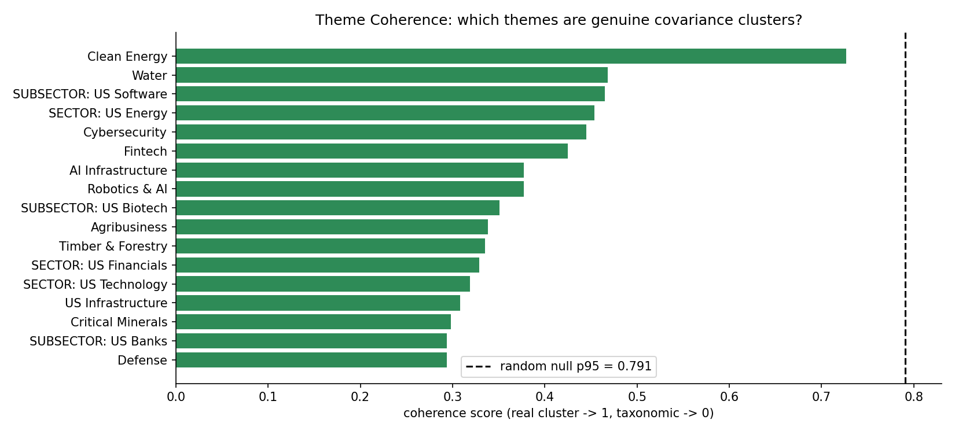
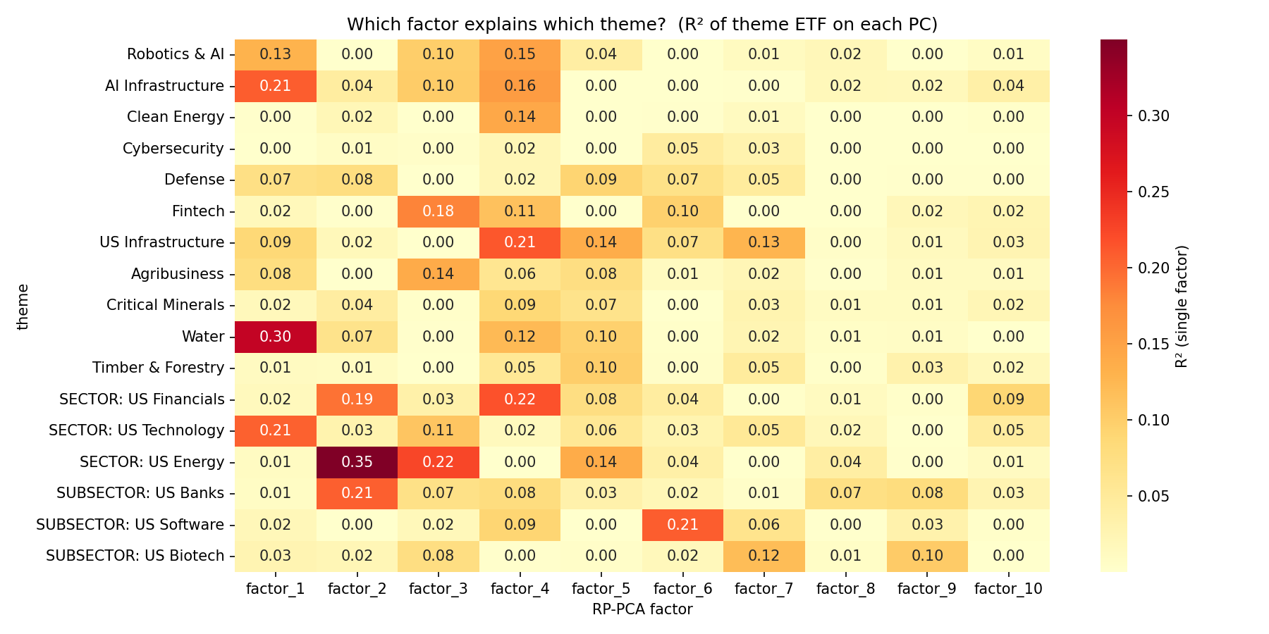
The themes that uniquely own a factor, including AI Infrastructure, Defense, and Cybersecurity, produce the cleanest baskets. By contrast, themes that share factor 4, a broad cyclical and materials axis, bleed into one another. Clean Energy baskets, for example, include mining names because Critical Minerals shares the same dominant factor.

4.4 Commodity-Linked Themes Fuse via Shared Commodity Beta
The factor 4 pileup has an economic explanation. Clean energy and critical minerals companies share substantial commodity input and capital cycle exposure. Without an explicit control, that shared commodity beta forms a single latent factor onto which multiple themes load. Adding commodity sector ETF controls to the residualization, as proxies for the Bakshi, Gao, and Rossi commodity factors, breaks the pileup apart. After commodity residualization, the four theme factor 4 cluster separates, and the affected baskets improve materially.

Theme | Baseline basket character | With commodity controls
Clean Energy | Gold miners (AU, GFI, AEM, KGC, WPM, FNV) | Genuine clean-energy (BELFA, ENS, WATT, ASPN, CSIQ, TAC)
Agribusiness | Pipelines and miners (ENB, FNV, KGC) | Food and agriculture (POST, PPC, BJ, GEF)
Table 2. Effect of commodity-factor controls on two contaminated themes. Clean Energy ETF correlation rose from 0.70 to 0.88 after commodity residualization.

This is both a limitation and a prescription. Themes whose narrative driver overlaps with a commodity factor require explicit commodity controls to separate the thematic signal from shared commodity beta.

4.5 Validation: Two-Regime Beta
Out of sample validation against theme ETFs shows high correlation across themes, ranging from 0.78 to 0.95, confirming that candidate baskets comove with their ETF benchmarks. The beta decomposition adds a sharper result: baskets fall into two amplitude regimes that broadly align with the factor ownership finding.
Theme | ETF corr. | Beta | Basket cum. | ETF cum.
AI Infrastructure | 0.92 | 1.18 | 2.13 | 4.69
Robotics & AI | 0.88 | 1.07 | 1.18 | 0.65
Defense | 0.87 | 1.00 | 1.39 | 1.36
US Infrastructure | 0.94 | 0.98 | 1.79 | 1.49
Agribusiness | 0.78 | 1.08 | 0.01 | 0.40
Fintech | 0.88 | 0.94 | -0.31 | -0.04
Cybersecurity | 0.83 | 0.97 | -0.11 | 1.59
Critical Minerals | 0.81 | 0.89 | -0.63 | 0.92
Clean Energy | 0.70 | 0.66 | -0.35 | 0.40
Table 3. Out-of-sample validation. Correlation is uniformly high; beta separates themes that track at full amplitude (beta >= 1) from commodity-contaminated themes (beta < 1). Cumulative returns are over the 2018-2026 sample.
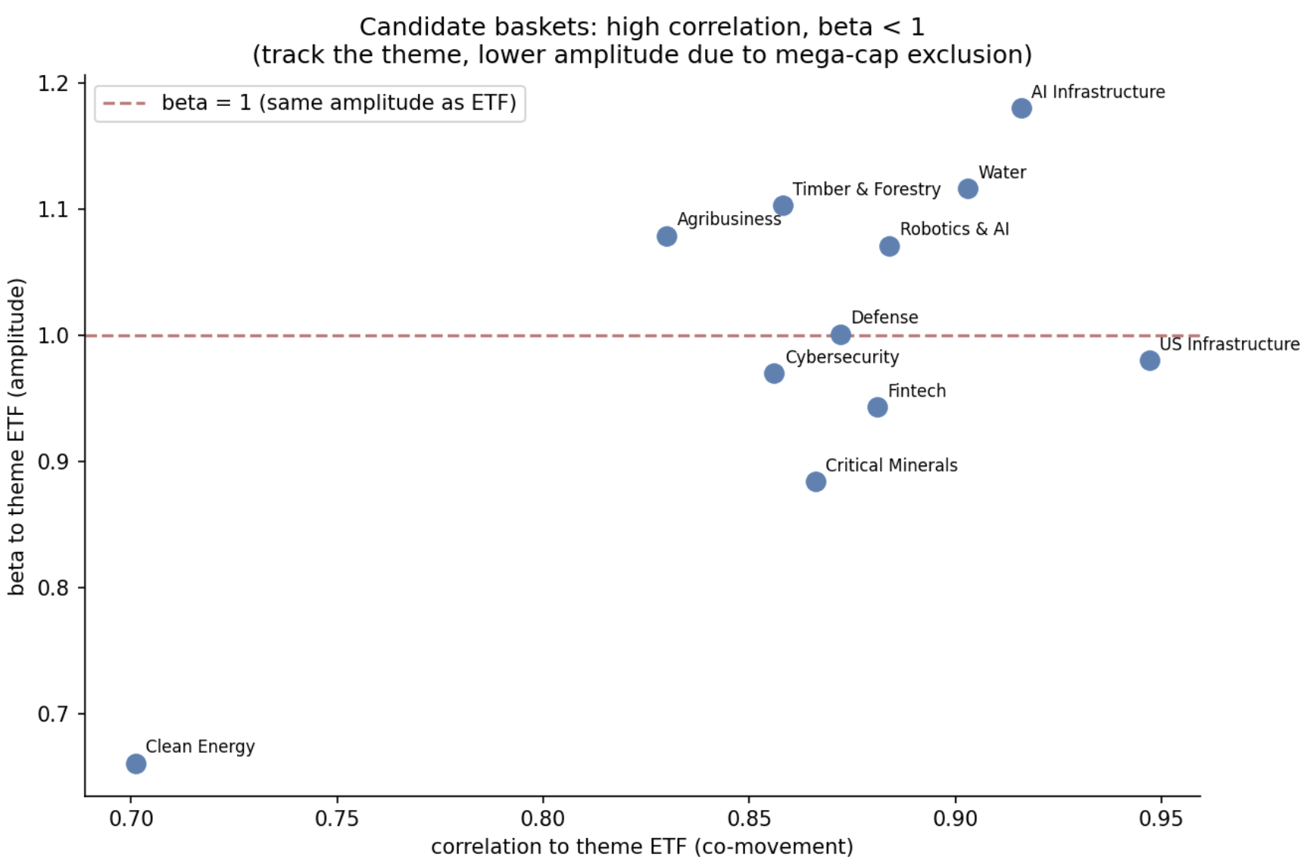

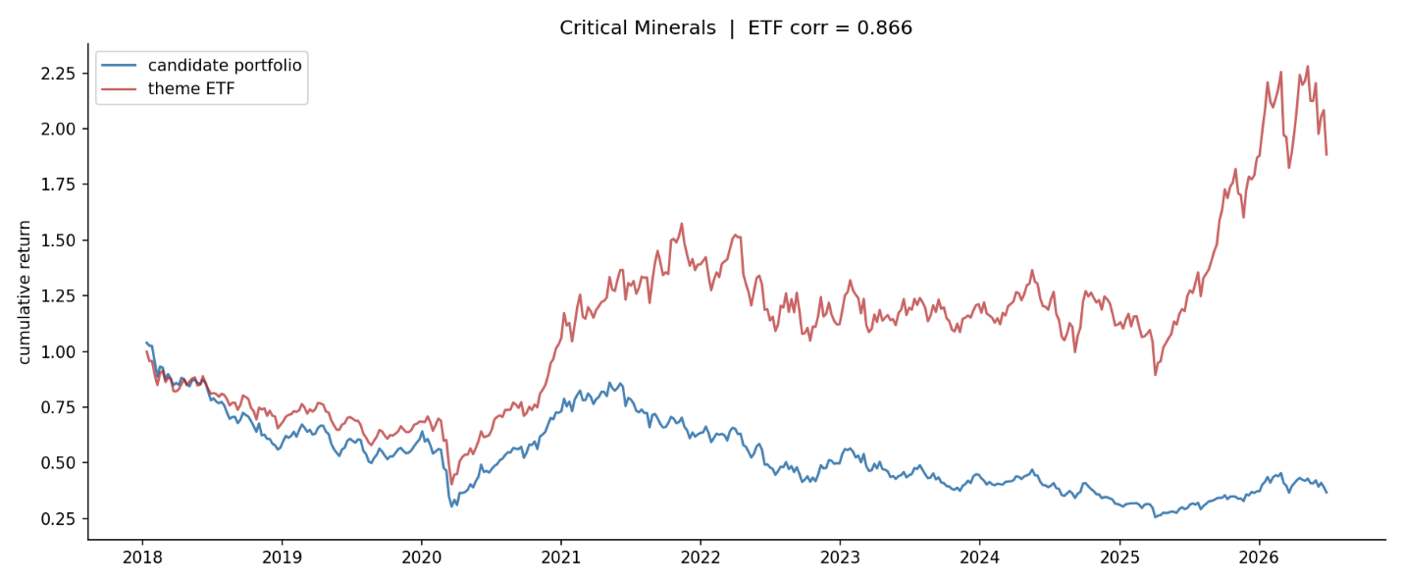
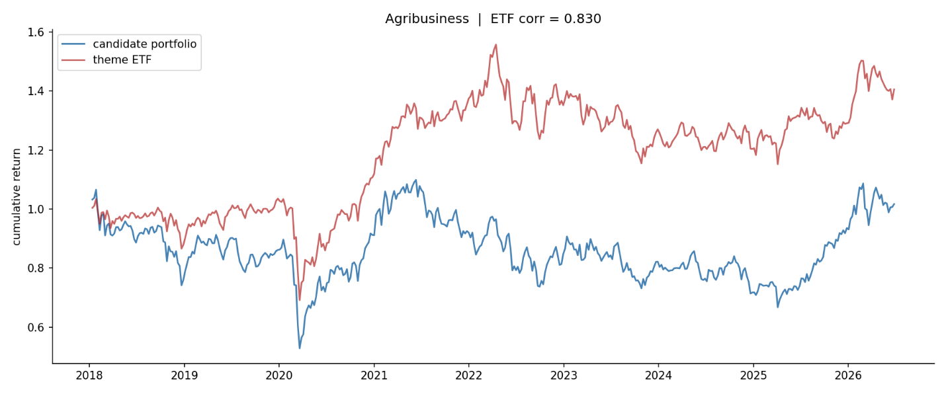
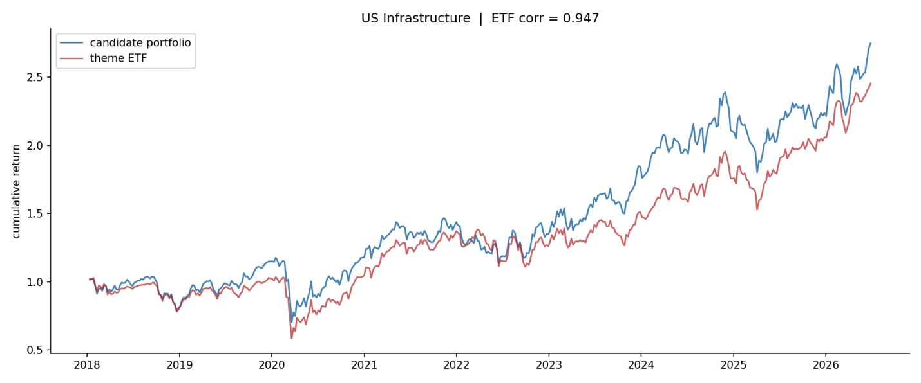
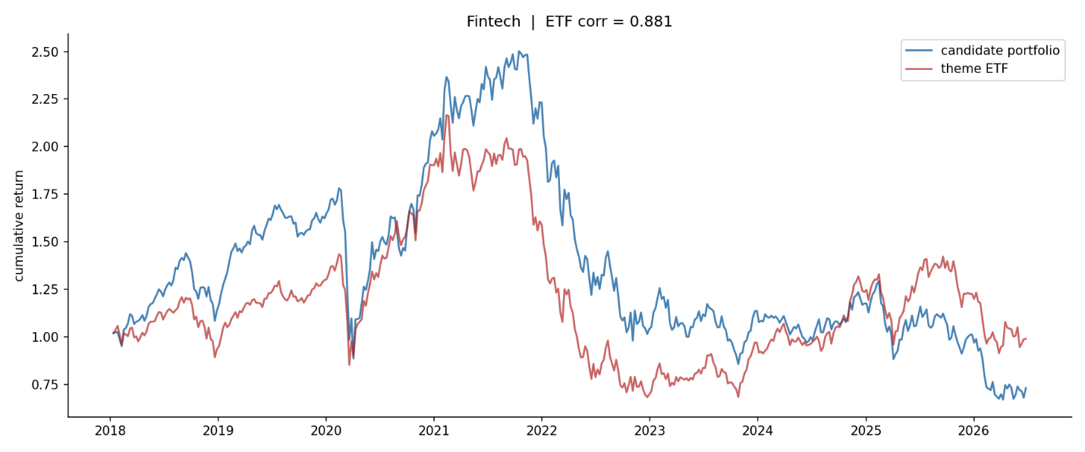
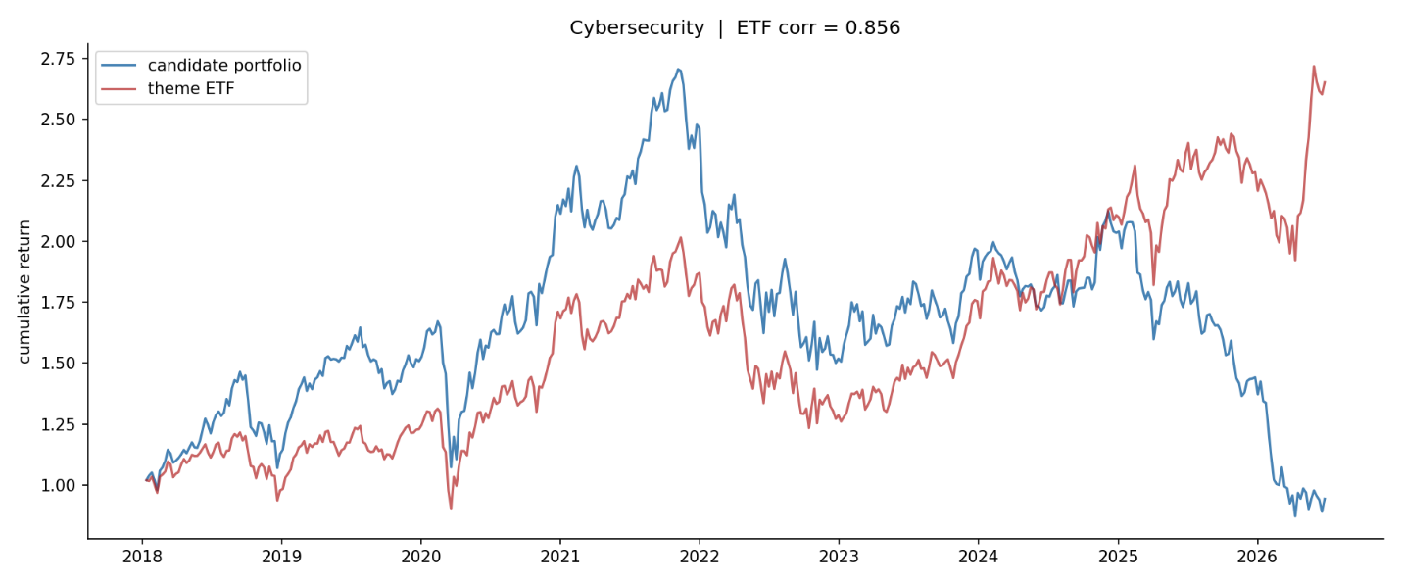
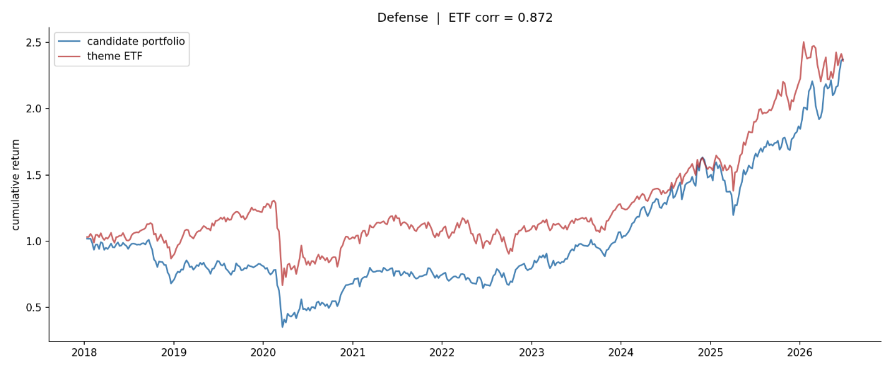
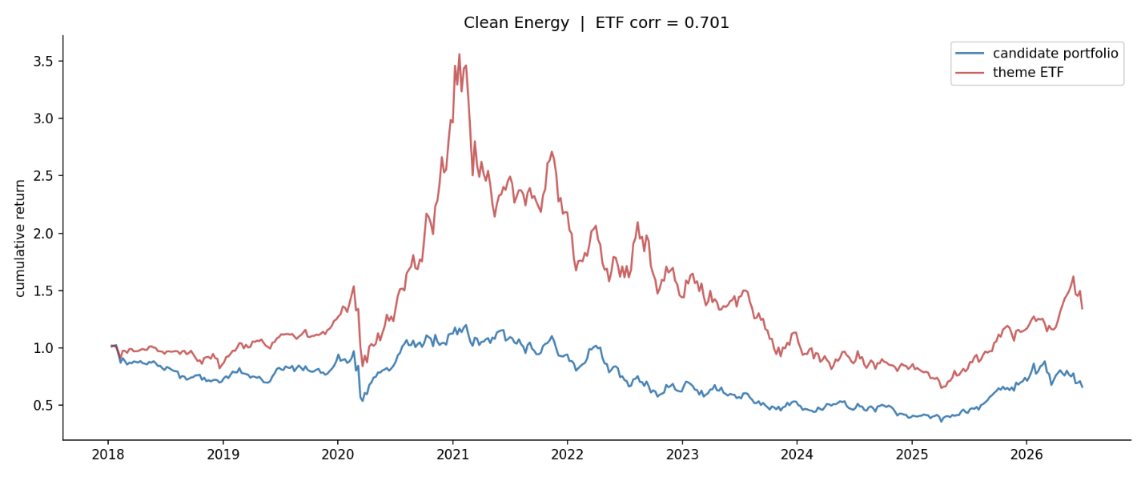
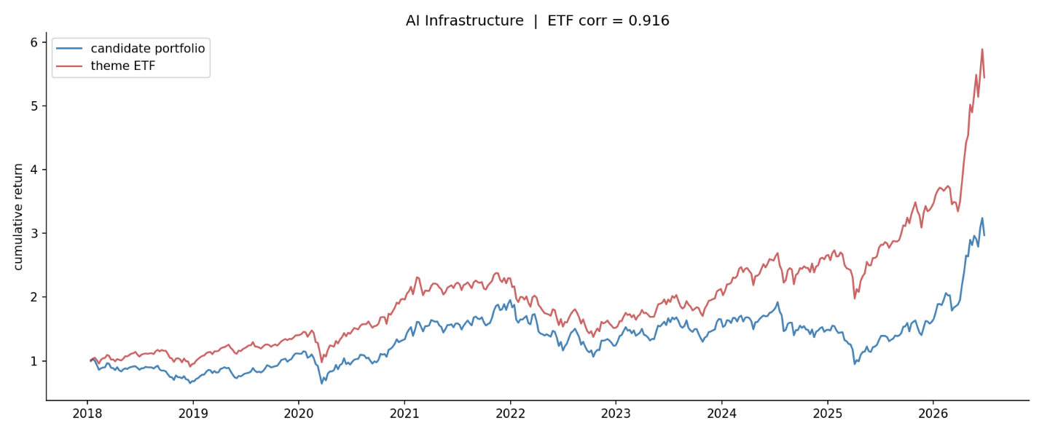
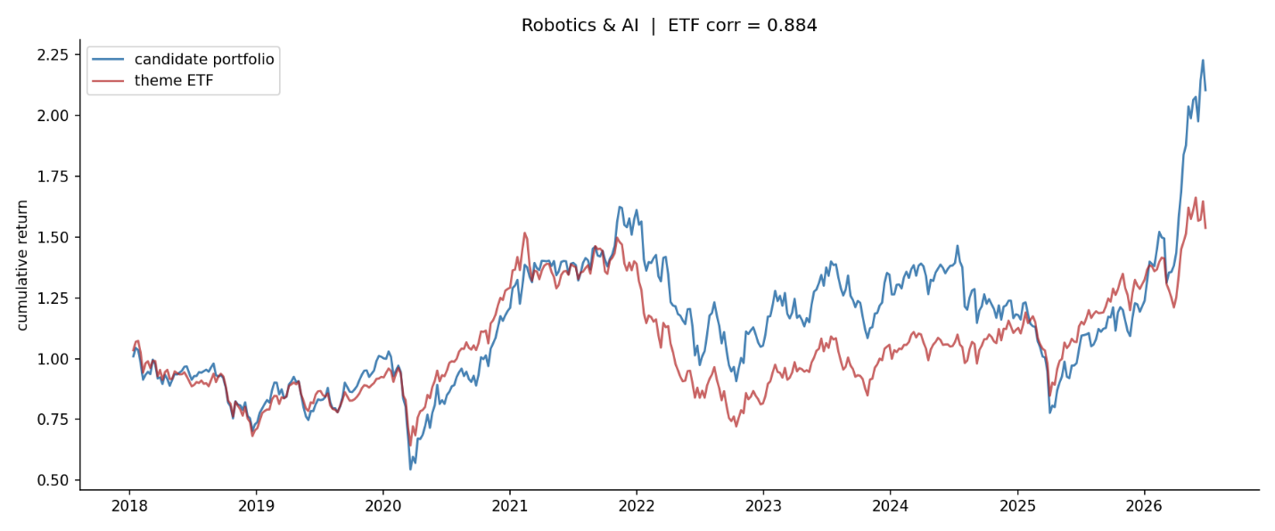

Several themes track their ETFs at full amplitude, with beta near or above 1: AI Infrastructure at 1.18, Robotics and AI at 1.07, Defense at 1.00, US Infrastructure at 0.98, and Agribusiness at 1.08. Commodity contaminated themes are more muted, with beta below 1, most clearly Clean Energy at 0.66. Where a level gap coexists with beta near or above 1, the gap reflects mega capitalization exclusion rather than weak thematic exposure. For example, AI Infrastructure tracks at beta 1.18 but reaches only 2.13 versus the ETF’s 4.69. The small capitalization basket comoves with the theme factor at full amplitude, but structurally cannot hold the capitalization weighted mega capitalization winners that drive the ETF’s level.

4.6 Coherence Is Regime-Dependent, Not Taxonomic (or Validating the Diagnostic Against GICS Controls)
To calibrate the coherence scale, we introduce GICS sectors and subsectors as control labels. The natural expectation is that sectors should sit at the top, since a sector should own a latent factor almost by construction. The data contradict this expectation, and that contradiction is one of the paper’s most important empirical results. When all labels are ranked by distinctiveness, GICS sectors are scattered among the themes rather than above them. US Financials, a textbook sector, ranks near the bottom, below themes that cut across sectors, such as Water and AI Infrastructure.

Label | Type | Distinctiveness | Dominant factor
US Energy | sector | 0.319 | factor_2
US Software | subsector | 0.314 | factor_6
Water | theme | 0.247 | factor_1
US Biotech | subsector | 0.200 | factor_7
US Banks | subsector | 0.189 | factor_2
AI Infrastructure | theme | 0.172 | factor_1
US Technology | sector | 0.171 | factor_1
Fintech | theme | 0.170 | factor_3
US Financials | sector | 0.139 | factor_4
US Infrastructure | theme | 0.137 | factor_4
Table 5. Distinctiveness of themes and GICS controls (top ten of seventeen labels). Sectors are interleaved with themes rather than dominating; US Financials ranks below the cross-sector themes Water and AI Infrastructure.

The mechanism is visible in the factor sharing structure. The broad Technology sector loads on one factor, while its Software subsector loads on a different factor and semiconductors load on a third. The sector is split across factors because its subindustries have decoupled. In the 2018 to 2026 sample, the dominant structural driver, capital expenditure on artificial intelligence, has separated semiconductors and AI infrastructure names from the rest of Technology. As a result, the broad sector is a less coherent cluster than its own fragments. The same fracture explains why US Financials, spanning banks, insurers, payments, and capital markets businesses that no longer move as one, fails to own a factor.

This yields a reinterpretation of coherence itself. Coherence is not a fixed attribute of taxonomy, meaning theme versus sector, but a regime dependent attribute of comovement. A GICS sector is a coherent covariance cluster only when its subindustries comove. When a structural force splits a sector internally, a theme that spans subindustries can become the better defined cluster. On this view, a theme is a grouping that has decoupled from its GICS parent because a new economic driver cuts across the old classification. A theme is economically real when it is more coherent than the sectors it draws from. Water outscoring US Financials is therefore a proof of concept, not an anomaly. We confirm that the ordering is invariant to the number of extracted factors over the tested range, as reported in the Appendix, so it is a stable structural property of the regime rather than an artifact of factor count.

5. Discussion

5.1 Purity versus Amplitude
A natural objection is that small-cap baskets lag their large-cap ETF benchmarks in cumulative return. This does not indicate failure. It reflects a distinction between purity and amplitude. Small-cap companies can have higher thematic purity: a pure-play company may derive a larger share of its economics from the theme than a diversified large-cap company. At the portfolio level, however, an equal-weighted small-cap basket can have lower realized amplitude than a cap-weighted ETF. The ETF concentrates in cap-weighted mega-cap winners, while the equal-weighted basket holds a broader cross-section, including the idiosyncratic losers that characterize the fat left tail of small-cap thematic universes. Purity is a stock-level property about economic exposure. Amplitude is a portfolio-level property about realized sensitivity to the theme benchmark. This motivates more sophisticated basket construction, including beta-weighting and idiosyncratic-risk trimming, as future work.

5.2 The Diagnostic as a Pre-Trade Filter

The coherence and distinctiveness diagnostics are valuable independently of the discovery engine. They constitute a test of whether a theme is economically real, meaning a genuine covariance cluster that the market trades as a unit, or merely a taxonomic label imposed on companies that belong to different covariance clusters. A theme that does not resolve into a distinct factor provides evidence that the market does not trade it as a coherent unit. That is itself decision-relevant for a thematic portfolio manager assessing whether a theme is tradeable.

5.3 Practical Use

For a multi-strategy portfolio manager with a days-to-weeks horizon, the value of the engine is not in replicating an ETF’s return, since that exposure is directly purchasable. The value is in surfacing the small-cap expression of a theme, which is typically less crowded and less capacity-constrained than the mega-cap names already owned by large funds. A basket that reliably co-moves with a theme at correlation near 0.9 is a tradeable instrument. It can be sized, hedged against the ETF or the crowded large-cap names, and rotated. The amplitude gap is part of the opportunity set, not an error term.

5.4 The Momentum Question: Factor Ownership Predicts Independence
A recurring industry critique holds that thematic investing is repackaged momentum. We test this directly with a three-part battery applied to the discovered small-cap candidates. First, an independent double sort asks whether the return spread by theme score survives within momentum quintiles. Second, Fama-MacBeth cross-sectional regressions test whether the theme coefficient survives after controlling for each stock’s own momentum, with Newey-West standard errors. Third, a spanning regression tests whether the theme long-short portfolio earns alpha relative to the momentum factor and the Fama-French five factors. Throughout, momentum is each stock’s own prior 12-month return excluding the most recent month, computed in the target universe. This is distinct from the momentum factor used in residualization.

The answer is not universal, and that is the finding. It is theme-specific and lines up with the factor-ownership diagnostic in Section 4.3. The themes that uniquely own a latent factor are the themes whose signal survives the momentum control.

Theme | Owns factor? | Double sort | FM joint t | Spanning alpha
US Infrastructure | strong | +1.31% | 4.19 | +16.3% (t 3.77)
Defense | unique | +1.22% | 3.37 | +12.8% (t 3.06)
Robotics & AI | shared | +0.61% | 2.24 | n.s.
AI Infrastructure | unique | +0.58% | 1.84 | n.s.
Agribusiness | weak | +0.21% | 0.77 | n.s.
Cybersecurity | weak | +0.18% | 0.40 | n.s.
Clean Energy | contaminated | +0.02% | 0.18 | n.s.
Critical Minerals | shared | -0.26% | -0.44 | -8.8% (n.s.)
Fintech | shared | -0.57% | -1.57 | -8.5% (n.s.)
Table 4. Momentum battery on discovered candidates, ordered by double-sort spread. Themes that uniquely own a factor (US Infrastructure, Defense) survive all three tests; themes that share a factor or own none show no independent signal, and two show negative signal. Double sort is the theme Q5-minus-Q1 forward-return spread averaged within momentum quintiles; FM joint t is the Newey-West t-statistic on the theme coefficient after adding momentum.
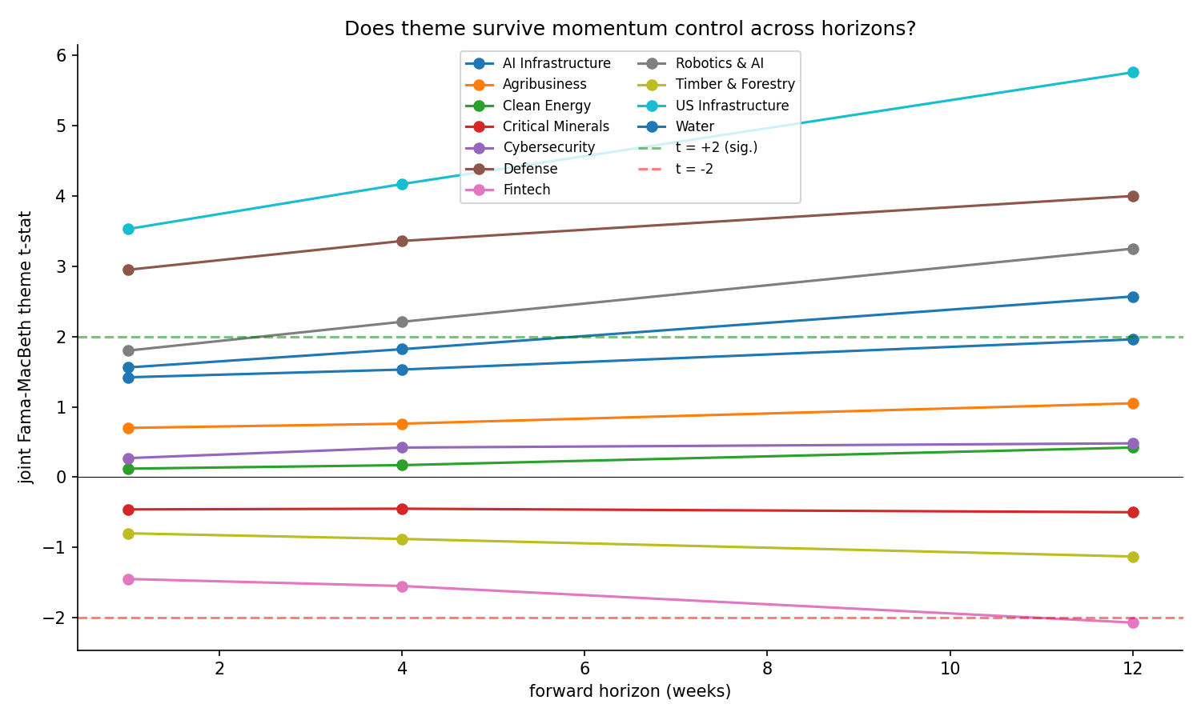
Two themes, US Infrastructure and Defense, pass all three tests decisively, with theme coefficients essentially unchanged after adding momentum controls. These are clean cases showing that the discovered signal is not momentum in disguise. Themes that share a factor or own none show no significant independent signal. Fintech and Critical Minerals show negative theme coefficients, indicating that their candidate baskets load on the wrong side of the momentum adjusted signal. Crucially, the pass and fail pattern is not random: the survivors are precisely the factor owners identified in advance by the coherence diagnostic, which both mitigates the multiple testing concern and integrates the momentum question into the paper’s central mechanism. The answer to whether thematic investing is just momentum is therefore conditional. It depends on whether the theme is a coherent, distinctly owned factor, and the coherence diagnostic predicts which themes those are.

We confirm these results across forward return horizons of one, four, and twelve weeks. US Infrastructure and Defense remain significant at every horizon, while the null themes remain close to zero throughout. Notably, for the two robust themes, the t-statistic rises monotonically with horizon: for US Infrastructure, from 3.53 at one week to 5.76 at twelve weeks, and for Defense, from 2.95 to 4.00. If the effect were merely a short horizon momentum echo, it would be expected to decay as the horizon lengthens. The fact that the theme signal instead strengthens is consistent with a slow moving structural signal that compounds over weeks, providing additional mechanistic separation between theme and momentum.

5.5 Limitations
- The out-of-sample validation metric, ETF correlation, is necessary but not sufficient. A basket may correlate with an ETF for non-thematic reasons. A second validation axis based on fundamental sector or industry overlap would strengthen the claim.

- The number of factors, K=15, is set on the basis of a sweep showing that distinctiveness is invariant to K across the tested range, as reported in the Appendix. Formal information-criterion selection is left to future work.

- The momentum battery uses each stock’s own trailing return as the momentum control. Results are reported across one-, four-, and twelve-week horizons, but a longer sample and additional momentum specifications would further strengthen the conditional claim

- Several data inputs are proxied because of licensing constraints, which may introduce off-theme holdings and attenuate measured performance.

6. Conclusion
We set out to recover investment themes from return comovement alone, determine what makes a theme tradeable, and test whether thematic exposure is distinct from momentum. ThemeCloner extracts a theme’s signature from the residual comovement of thematic ETFs and projects it onto a disjoint small-cap universe, discovering thematically exposed stocks without using holdings data. The method’s central output is not a single basket but a diagnostic: a theme yields clean, investable baskets if and only if it uniquely owns a latent factor. This same criterion of factor ownership predicts which themes contaminate one another and which survive a momentum control.

The most consequential finding is that coherence is regime dependent rather than taxonomic. Introduced as a calibration ceiling, GICS sectors instead scatter among the themes, and several themes that cut across sectors are more distinct owners of latent factors than the sectors they span. The reason is that a structural driver, artificial intelligence capital expenditure in our sample, fractures sectors internally, so that a theme spanning subindustries becomes the better defined cluster. This supplies an economic rationale for thematic investing that does not rest on narrative. Themes matter because sectors cohere only when their subindustries do. When a new driver cuts across the old taxonomy, the theme is the more faithful description of how the market actually moves.

On the momentum question, our answer is conditional and tied to the same mechanism. The discovered signal survives controls for stock-level momentum, across forward horizons, for the themes that own a distinct factor. For themes that share a factor or own none, the signal is weak or absent. Thematic investing is therefore not reducible to momentum, but not every theme is distinct from momentum either. The distinction holds when the theme is a genuine covariance cluster with distinct factor ownership. The diagnostic, computed before any basket is formed, tells the practitioner which case they are in.

Several extensions follow naturally. The regime dependence result invites a multi-period study of how the coherence ordering shifts across historical regimes, which our framework is designed to support. Validation can be strengthened with a fundamentals based axis beyond return correlation, and the small-cap amplitude gap invites more sophisticated basket construction. We leave these extensions to future work, having established within the present regime that themes are recoverable latent factors, that factor ownership determines tradeability, and that the long-standing question of whether thematic investing is merely momentum has a precise mechanism based answer.

Appendix A. Robustness of Coherence to the Number of Factors
The coherence and distinctiveness diagnostics depend on the number of extracted factors, K. With 17 labels and a limited factor count, factor sharing is partly mechanical: when there are fewer factors than distinct clusters, labels are forced to share. To confirm that our findings are not artifacts of a particular K, especially the regime coherence ordering in which several cross-sector themes rank above GICS sectors, we re-estimate the factor model and recompute distinctiveness at K=10,15,20, and 25.

The ordering is essentially invariant to K. Each label’s distinctiveness is stable across the tested range, with the single exception of Cybersecurity, whose dominant factor resolves only at K=15 or above. We therefore adopt K=15 as the default in the main analysis. It is the smallest factor count that resolves every theme, while leaving all other labels’ distinctiveness unchanged. Critically, the headline comparison is robust at every tested factor count: the cross-sector theme Water is a more distinct factor owner than the US Financials sector at K=10,15,20, and 25.

Label | Type | K=10 | K=15 | K=20 | K=25
US Energy | sector | 0.321 | 0.321 | 0.321 | 0.321
US Software | subsector | 0.314 | 0.314 | 0.314 | 0.314
Water | theme | 0.247 | 0.247 | 0.247 | 0.247
Cybersecurity | theme | 0.068 | 0.247 | 0.247 | 0.247
US Biotech | subsector | 0.200 | 0.200 | 0.200 | 0.200
US Banks | subsector | 0.190 | 0.190 | 0.190 | 0.190
AI Infrastructure | theme | 0.172 | 0.172 | 0.172 | 0.172
US Technology | sector | 0.171 | 0.171 | 0.171 | 0.171
Fintech | theme | 0.170 | 0.170 | 0.170 | 0.170
US Financials | sector | 0.139 | 0.139 | 0.139 | 0.139
US Infrastructure | theme | 0.137 | 0.137 | 0.137 | 0.137
Agribusiness | theme | 0.132 | 0.132 | 0.132 | 0.132
Timber & Forestry | theme | 0.108 | 0.108 | 0.108 | 0.108
Defense | theme | 0.101 | 0.101 | 0.101 | 0.101
Robotics & AI | theme | 0.097 | 0.097 | 0.097 | 0.097
Clean Energy | theme | 0.092 | 0.092 | 0.092 | 0.092
Critical Minerals | theme | 0.057 | 0.057 | 0.057 | 0.057
Table A1. Distinctiveness by number of factors K, all seventeen labels, sorted by mean across K. Values are invariant to K except Cybersecurity (resolves at K>=15). Water (theme) exceeds US Financials (sector) at every K.
