**E-commerce store for online shopping**

**An E-commerce online store is a website through which customers can place orders and individuals buy and sell goods and services over the Internet**

**This shopping store is a web project, which helps users/clients/couriers to find products that they want in their location, so there will be sellers and simple users. Sellers are users/shop owners that post their products on the site.**

**Products are divided by categories, though so users can get the product they want. By creating your account(client) you will have access to your card, cart, profile, and orders that you will purchase.**

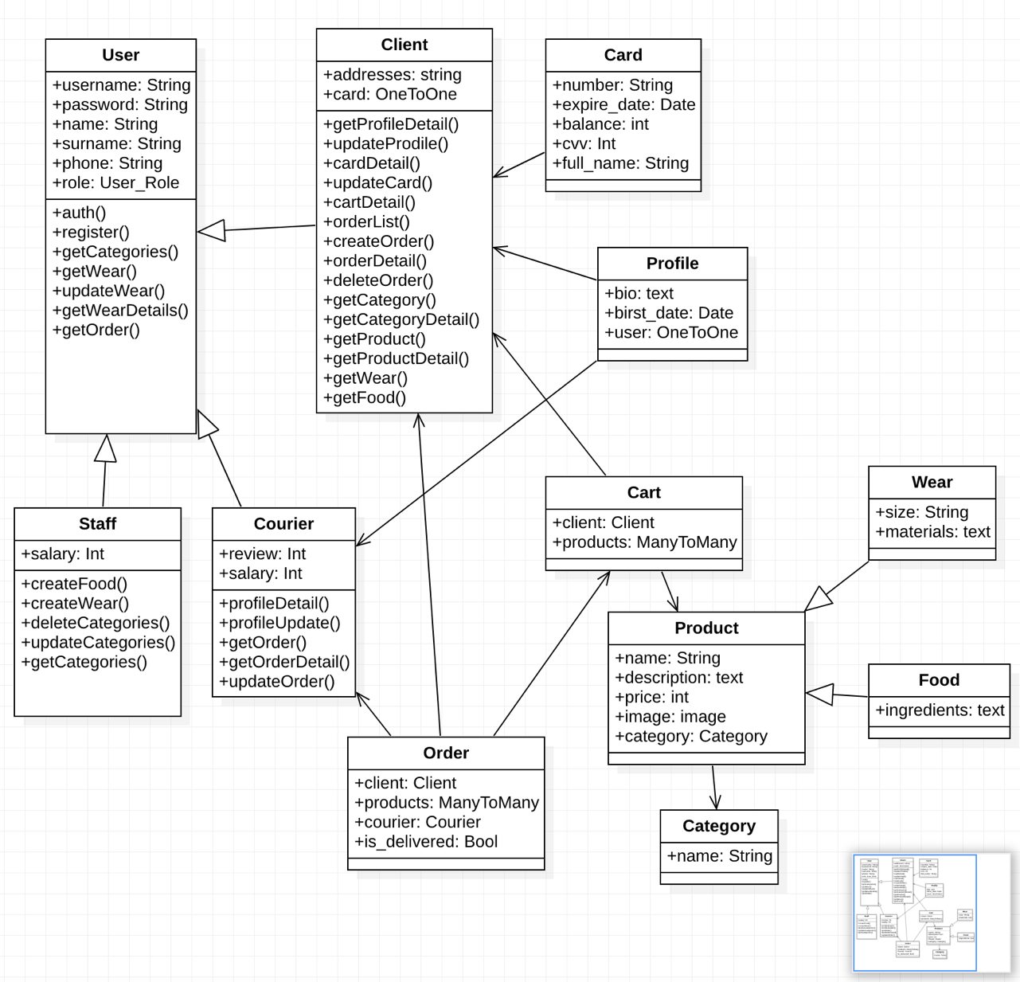

Configure database in settings.py  
### DATABASES = {  
 'default': {  
 'ENGINE': 'django.db.backends.postgresql_psycopg2',  
 'NAME': 'your_db_name',  
 'USER': 'your_username',  
 'PASSWORD': 'your_pasword',  
 'HOST': 'localhost',  
 'PORT': '5432',  
 }}

1. **Obtain JWT Token**

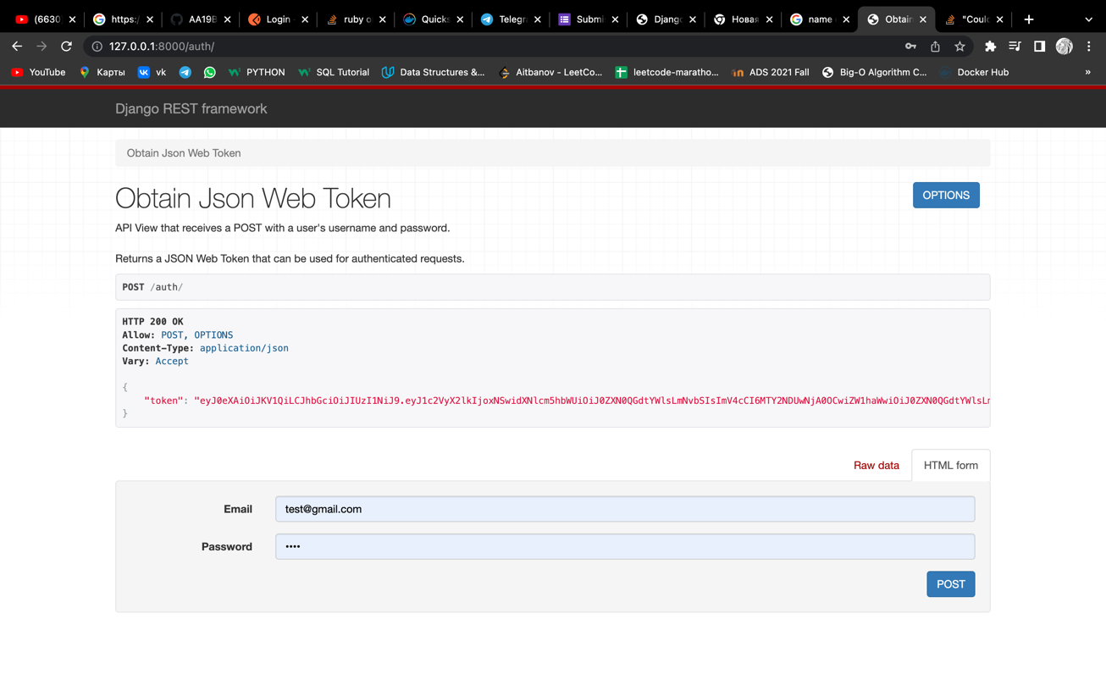

1. **PUT methods for client card profile**Изображение выглядит как текст

   Автоматически созданное описаниеИзображение выглядит как текст

   Автоматически созданное описаниеИзображение выглядит как текст

   Автоматически созданное описание

**3.DockerFile**

**

**5. Docker Commands**

**docker – compose build - > for building the image**

**docker – compose up - > aggregates the output of each container**