**Assignment 1, Web Application Development**

**Intro to Containerization: Docker**

**Exercise 1: Installing Docker**

1. **Objective**: Install Docker on your local machine.
2. **Steps**:
   * Follow the installation guide for Docker from the official website, choosing the appropriate version for your operating system (Windows, macOS, or Linux).
   * After installation, verify that Docker is running by executing the command docker --version in your terminal or command prompt.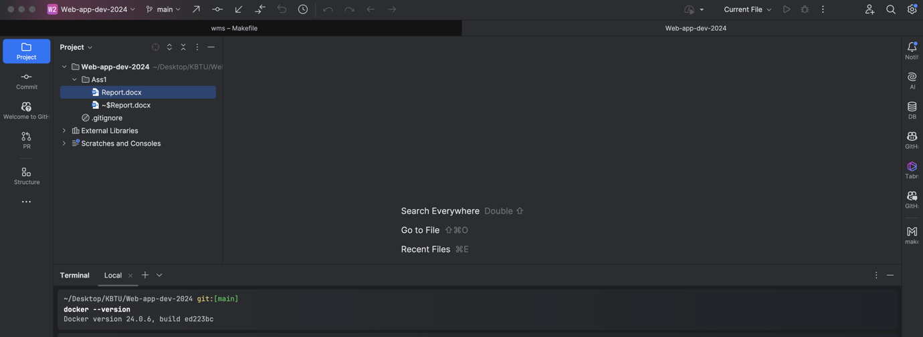
   * Run the command docker run hello-world to verify that Docker is set up correctly. 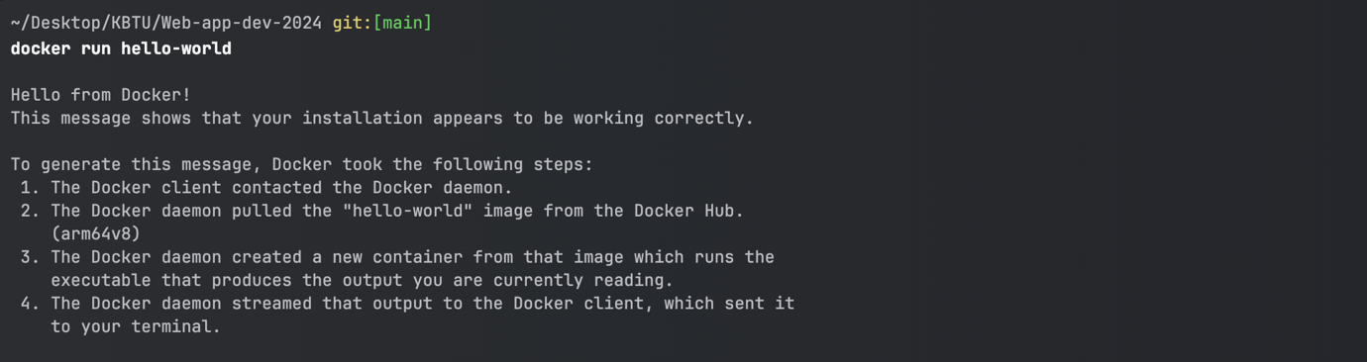
3. **Questions**:
   * What are the key components of Docker (e.g., Docker Engine, Docker CLI)?

• **Docker Engine:** The core part of Docker that manages containers. It includes:

• **Docker Daemon**: Runs in the background, managing Docker objects like images, containers, networks, and volumes.

• **REST API**: Allows communication between Docker Daemon and Docker CLI or other services.

• **Docker CLI**: The command-line interface used to interact with Docker. It communicates with the Docker Daemon to execute tasks like running containers, pulling images, etc.

• **Docker Hub**: A public registry where Docker images are stored and can be pulled by users to run containers.

• **Docker Compose:** A tool to define and run multi-container Docker applications using a docker-compose.yml file.

* + How does Docker compare to traditional virtual machines?

**Docker**:

• Uses containers that share the host OS kernel, making them lightweight and faster to start.

• Containers are isolated but run on the same OS, allowing efficient resource utilization.

• Ideal for deploying applications consistently across different environments.

• Lower overhead because there’s no need for a full OS per container.

**Traditional Virtual Machines:**

• Each VM runs its own full operating system on top of the host system via a hypervisor.

• VMs are more isolated from each other than containers but require more resources.

• VMs are slower to start due to the need to boot up an entire OS for each machine.

• Better suited for running multiple different OS environments on a single physical machine.

* + What was the output of the docker run hello-world command, and what does it signify?
  + It shows that intsallation was OK!
  + 

**Exercise 2: Basic Docker Commands**

1. **Objective**: Familiarize yourself with basic Docker commands.
2. **Steps**:
   * Pull an official Docker image from Docker Hub (e.g., nginx or ubuntu) using the command docker pull <image-name>.

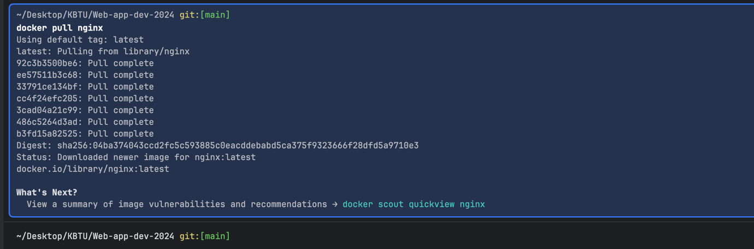

* + List all Docker images on your system using docker images.

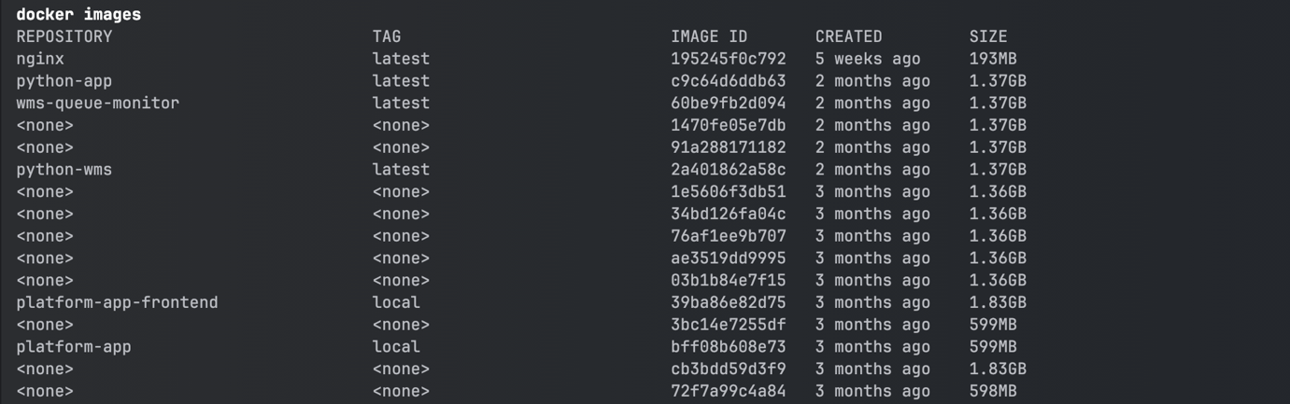

* + Run a container from the pulled image using docker run -d <image-name>.

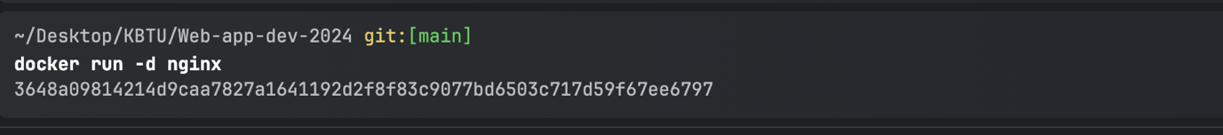

* + 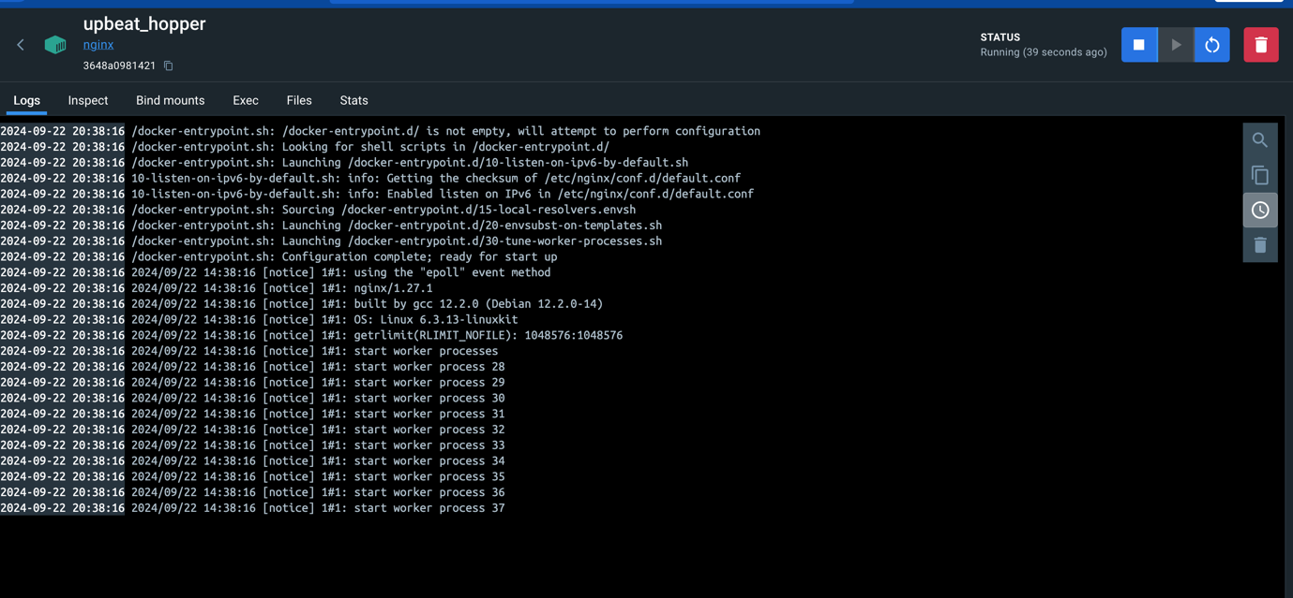List all running containers using docker ps and stop a container using docker stop <container-id>.
  + 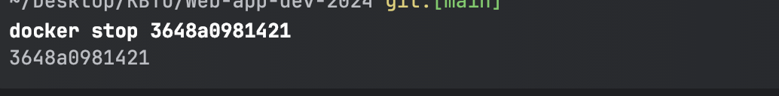

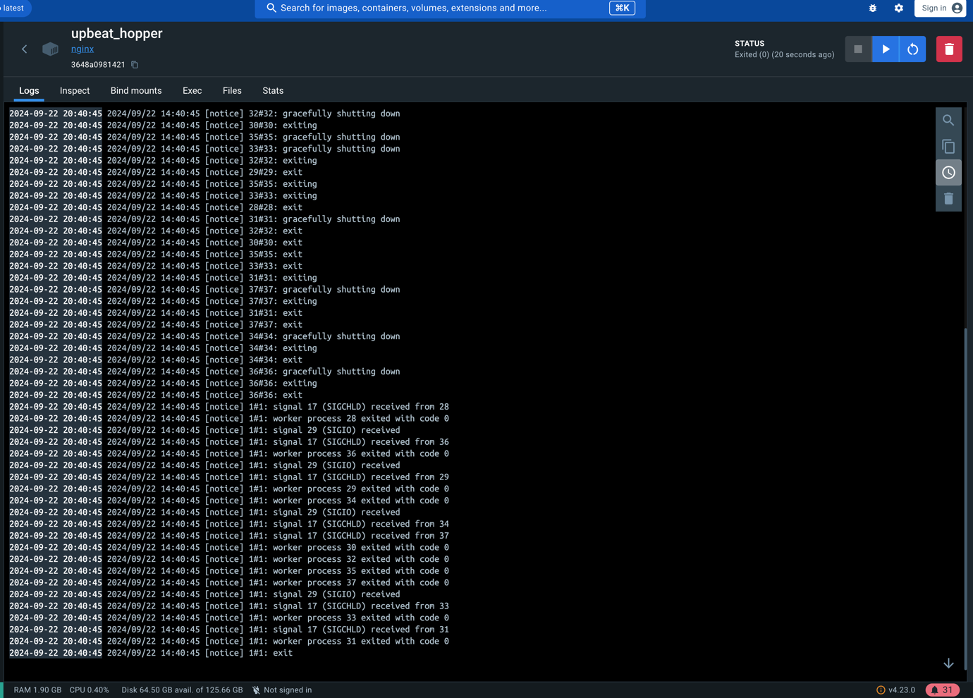

**Questions**:

* + What is the difference between docker pull and docker run?

**docker pull <image>:**

• This command downloads a Docker image from a registry (like Docker Hub) to your local system.

• It does not create or start a container. It only ensures the image is available locally for use.

**docker run <image>:**

• This command pulls the image (if it’s not already available locally) and then creates and starts a container from the image.

• It combines both downloading the image (if necessary) and running the container in one step.

* + How do you find the details of a running container, such as its ID and status?

**docker ps**: Lists all running containers, displaying details like Container ID, image name, creation time, status, and port mappings.

* + What happens to a container after it is stopped? Can it be restarted?

• When a container is stopped (via docker stop <container_name>), the container’s process halts, but the container still exists in a stopped state.

• Yes, it can be restarted using the docker start <container_name> command. The stopped container retains all of its configurations, and when restarted, it will resume its previous state.

• You can also use docker restart <container_name> to stop and immediately start the container in one command.

**Exercise 3: Working with Docker Containers**

1. **Objective**: Learn how to manage Docker containers.
2. **Steps**:
   * Start a new container from the nginx image and map port 8080 on your host to port 80 in the container using docker run -d -p 8080:80 nginx.
   * 
   * Access the Nginx web server running in the container by navigating to http://localhost:8080 in your web browser.

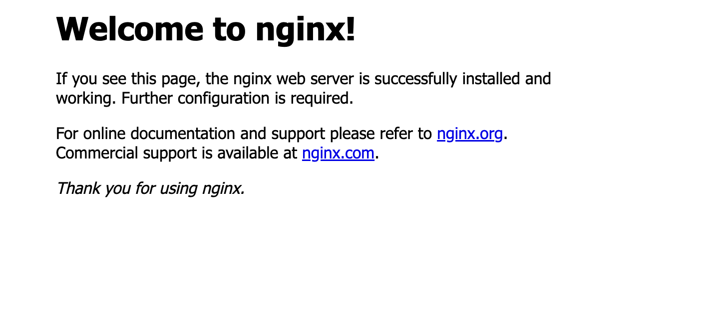

* + Explore the container's file system by accessing its shell using docker exec -it <container-id> /bin/bash.
  + 
  + Stop and remove the container using docker stop <container-id> and docker rm <container-id>.
  + 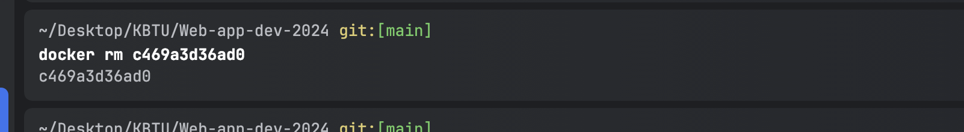

1. **Questions**:
   * How does port mapping work in Docker, and why is it important?

• Port mapping in Docker allows you to access a service running inside a Docker container from the host machine. When a container runs, it is isolated and only accessible from within Docker’s internal network. Port mapping makes it accessible from the outside.

• The syntax is: docker run -p <host_port>:<container_port> <image>

• Host port: The port on your machine (or host OS) that will be exposed.

• Container port: The port inside the container that the service listens on.

• For example, running docker run -p 8080:80 nginx will map port 80 (inside the container) to 8080 (on the host machine). This means you can access the web server running inside the container by visiting http://localhost:8080.

• Importance:

• Port mapping is crucial because it allows containers to communicate with the outside world (e.g., other services, applications, or users) and makes it possible for users to access services running in a container from a browser or API client.

• Without port mapping, services running in containers would be isolated and inaccessible from the host system.

* + What is the purpose of the docker exec command?

• docker exec allows you to run additional commands inside a running container. This is useful for debugging or interacting with a container while it’s already running.

* + How do you ensure that a stopped container does not consume system resources?

Once a container is stopped (using docker stop <container_name>), it does not consume CPU or memory resources anymore. However, it may still occupy disk space for its configuration, logs, or state.

• To completely remove a stopped container and ensure it doesn’t consume any system resources (including disk space), you should use docker rm <container_name> to delete the container.

**Dockerfile**

**Exercise 1: Creating a Simple Dockerfile**

1. **Objective**: Write a Dockerfile to containerize a basic application.
2. **Steps**:
   * Create a new directory for your project and navigate into it.
   * Create a simple Python script (e.g., app.py) that prints "Hello, Docker!" to the console.
   * Write a Dockerfile that:
     + Uses the official Python image as the base image.
     + Copies app.py into the container.
     + Sets app.py as the entry point for the container.
   * Build the Docker image using docker build -t hello-docker ..
   * Run the container using docker run hello-docker.
   * 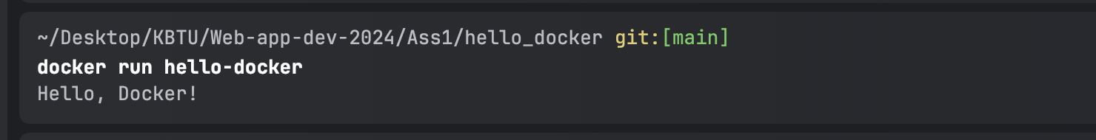
3. **Questions**:
   * What is the purpose of the FROM instruction in a Dockerfile?

The FROM instruction specifies the base image to be used for your Docker imag

* + How does the COPY instruction work in Dockerfile?

The COPY instruction in a Dockerfile is used to copy files and directories from your host machine (the directory where the Dockerfile is located) into the Docker container.

• Syntax: COPY <source> <destination>

• <source>: The file or directory on your host machine that you want to copy.

• <destination>: The path inside the container where the file/directory should be copied.

* + What is the difference between CMD and ENTRYPOINT in Dockerfile?

CMD provides default commands that can be overridden, while ENTRYPOINT defines a fixed command that will always run. If flexibility is needed, CMD is generally preferred; if the container is designed to run one specific command, ENTRYPOINT is more appropriate.

**Exercise 2: Optimizing Dockerfile with Layers and Caching**

1. **Objective**: Learn how to optimize a Dockerfile for smaller image sizes and faster builds.
2. **Steps**:
   * Modify the Dockerfile created in the previous exercise to:
     + Separate the installation of Python dependencies (if any) from the copying of application code.
     + Use a .dockerignore file to exclude unnecessary files from the image.
   * Rebuild the Docker image and observe the build process to understand how caching works.
   * Compare the size of the optimized image with the original.
3. **Questions**:
   * What are Docker layers, and how do they affect image size and build times?
   * How does Docker's build cache work, and how can it speed up the build process?
   * What is the role of the .dockerignore file?