AUTOMATED STUDENT ATTENDANCE SYSTEM
AI-Suggested, Teacher-Verified Attendance from Classroom Photos
Human-in-the-Loop AI — Complete Project Report
🎓
Field | Details
Project | Automated Student Attendance System (PBL)
Live deployment | https://autoattendance-xjeg.onrender.com (Render · Docker · HTTPS)
Source code | github.com/AA7304-MEH/automated-attendance-system--pbl-
Tech stack (one line) | Python · Flask · SQLAlchemy (SQLite/Postgres) · dlib face_recognition · OpenCV · Pillow · pandas · Gunicorn · Docker
Quality evidence | 61 automated checks passing (11 engine + 50 web) + 20/20 live deployment checks
Demo logins | Admin: teacher@college.edu / teacher123 · Teacher: arjun@college.edu / teacher123 · Student portal: roll no + PIN 1234
Core idea | One classroom photo → every face detected & matched → AI pre-fills attendance → teacher confirms / corrects / assigns → auditable register

CONTENTS
1. Executive Summary · 2. Problem & Objectives · 3. System Architecture · 4. Technology Stack · 5. Face-Recognition Engine (deep dive) · 6. Complete Feature Walkthrough · 7. Database Design · 8. Route Map · 9. Project Structure · 10. Testing & Results · 11. How to Run · 12. Viva Q&A Drill · 13. Limitations & Future Work

1. Executive Summary
Manual roll-call wastes 5–10 minutes of every lecture, is vulnerable to proxy attendance, and produces registers that cannot be audited. This project replaces that ritual with a single photograph. The teacher uploads one picture of the classroom; a face-recognition engine detects every face, converts each into a 128-dimension mathematical signature, and compares it against enrolled students.
The defining design decision is the Human-in-the-Loop (HITL) policy. High-confidence matches (distance ≤ 0.45) arrive pre-approved; medium-confidence matches (0.45–0.60) are shown side-by-side with the registered portrait for the teacher to confirm or correct; unmatched faces are Unknown and can only be assigned by a human. Every stored mark records HOW it was made (auto / review / manual / system-absent), the AI confidence %, and which teacher verified it — a fully auditable register.
Around that core the system ships complete: role-based access (admin + teachers), live analytics, an at-risk alert dashboard with 7-day trends, CSV exports, scheduled email digests, a PIN-protected student self-service portal, hardened security (CSRF, rate limiting, hashed credentials, security headers), Docker deployment on Render, and 61 automated tests plus a 20-point live deployment verification — all passing.

2. Problem Statement & Objectives

Problems addressed
- Roll-call consumes 5–10 minutes of every lecture (≈30+ hours per subject per semester).
- Proxy attendance: one student answering for an absent friend is undetectable on paper.
- Paper registers are error-prone, easy to lose, and impossible to audit after the fact.
- Students below the 75% requirement are discovered too late — at exam form filling.

Objectives
- Mark attendance for an entire class from one photo, in seconds, from any phone browser.
- Keep the teacher as the final authority: the AI suggests, the human decides (HITL).
- Record provenance for every mark: method, AI confidence %, and verifying teacher.
- Surface at-risk students early via thresholds, 7-day trends, alerts and email digests.
- Protect people and data: hashed credentials, CSRF, rate limiting, no real biometrics in git.
- Deploy on commodity infrastructure (Docker, free tier) with zero paid dependencies.

3. System Architecture
┌────────────────────────────────────────────────────────────────┐
│ FRONTEND — server-rendered Jinja2 templates + custom CSS │
│ dashboard · verification UI (HITL) · students · analytics · │
│ alerts · admin · student portal (/me) │
└──────────────────────────┬─────────────────────────────────────┘
▼
┌────────────────────────────────────────────────────────────────┐
│ BACKEND — Flask application (app.py, 23 routes) │
│ auth & roles · CSRF · rate limiting · security headers │
│ HITL confirm logic · reports.py (stats) · mailer.py (email) │
└──────────────────────────┬─────────────────────────────────────┘
▼
┌────────────────────────────────────────────────────────────────┐
│ AI CORE — face_engine/ │
│ detector.py (HOG detection + cropping) │
│ encoder.py (enrollment → 128-d encodings) │
│ recognizer.py (matching + 3-band policy + annotations) │
└──────────────────────────┬─────────────────────────────────────┘
▼
┌────────────────────────────────────────────────────────────────┐
│ DATA — SQLite (Postgres-ready) + files │
│ teachers · students · subjects · attendance_sessions · │
│ attendance | face_encodings.pkl · student_faces/ │
└────────────────────────────────────────────────────────────────┘
The browser talks only to Flask. Flask is the only writer of the database. The face engine is a pure Python library — the web layer never touches dlib directly, which means the engine can be swapped (e.g. InsightFace/YOLOv8) without changing a single route.

4. Complete Technology Stack
Layer | Technology | Why it is used / where
Language | Python 3.13 (3.11 in Docker) | AI/ML ecosystem, readability, team familiarity
Web framework | Flask 3.x + Jinja2 | Lightweight routing + server-rendered templates; ideal for an AI-backed MVP
ORM / DB | Flask-SQLAlchemy + SQLite (Postgres-ready) | Type-safe models, unique constraints, zero-config dev DB; DATABASE_URL swaps in hosted Postgres
Authentication | Flask-Login + Werkzeug hashing | Session-based teacher auth; PBKDF2/scrypt hashing (never plain text)
Face detection | dlib HOG (via face_recognition) | Fast CPU detection of frontal faces; runs on free-tier hardware
Face identity | dlib ResNet — 128-d embeddings | Deep metric embeddings: same person maps to nearby points in 128-d space
Matching | Euclidean distance (NumPy) | One vector subtraction per enrolled student — microseconds, no model call
Image processing | OpenCV 4.11 (headless in Docker) | Crop faces, draw annotated verdicts, encode JPEG outputs
Photo normalization | Pillow (EXIF + Lanczos resize) | Fixes rotated phone photos (EXIF) and tames 12MP images for 512MB RAM
Exports | pandas | One-line CSV export of raw log and student summaries
Email | smtplib (STARTTLS) + HTML template | Console backend for demos, real SMTP via env vars; cron CLI included
Production server | Gunicorn (WSGI) | Worker count tuned via WEB_CONCURRENCY (free tier: 1)
Packaging | Docker + docker-compose | Same image everywhere; data/ volume persists DB + portraits
Hosting | Render.com (free tier) | Auto-builds the Dockerfile, public HTTPS URL, zero-cost demo
Frontend styling | Hand-written CSS3 | Glassmorphism nav, gradients, hover states — zero CDN dependency, works offline
Version control | Git + GitHub | Single source of truth; verified remote sync

Why face_recognition (dlib) and not a cloud face API? It runs 100% offline and free, is well documented, and its distance metric gives interpretable confidence bands — exactly what the Human-in-the-Loop policy needs.

5. The Face-Recognition Engine (Technical Heart)

5.1 Recognition pipeline
- STEP 1 — Detection (HOG): the image is scanned for face-like gradient patterns → boxes (top, right, bottom, left). Fast on CPU; a 'cnn' model is available for GPU accuracy.
- STEP 2 — Embedding: each face is aligned and passed through a ResNet producing 128 numbers (the encoding). A fingerprint: the same person lands close together regardless of lighting, angle or camera.
- STEP 3 — Matching: each classroom encoding is compared to every enrolled encoding with Euclidean distance; smallest wins. Microseconds of math.
- STEP 4 — Policy: the winning distance maps to one of three verdicts (table below).
- STEP 5 — Output: structured results (id, distance, similarity %, verdict) + a color-annotated photo (green/amber/red boxes) + face crops for the comparison UI.

5.2 The three-band Human-in-the-Loop policy
Distance d | Verdict | What the teacher sees | Stored method
d ≤ 0.45 | AUTO-APPROVED (green) | Pre-checked Present card with similarity bar; teacher can still uncheck | auto
0.45 < d ≤ 0.60 | NEEDS REVIEW (amber) | Side-by-side: classroom face VS registered portrait; confirm or correct via dropdown | review (confirmed) / manual (corrected)
nobody ≤ 0.60 | UNKNOWN (red) | Face crop with '?'; teacher assigns a roll number — or leaves absent | manual / stays absent

Everyone the teacher does not mark is written ABSENT (method=system). One photo therefore produces a complete register — and a missed detection can never inflate attendance.

5.3 Measured engine results (reproducible via scripts)
Probe | Result
Group photo: 6 students, 2 loose rows | 6/6 faces detected and enrolled
Augmented copy (mirrored, −18% brightness, 0.85×, JPEG-70) | 6/6 re-identified; distances 0.188–0.262 → all auto-approved
Leave-one-out control (store WITHOUT one student) | That student rejected at distance 0.726 (≫ 0.60) — no false match
Stranger portrait (never enrolled) | Distance 0.802 → Unknown; never auto-approved
Stress test (0.55× + blur + underexposure + JPEG-45) | 2 detectable faces at 0.470 / 0.583 → correctly NEEDS REVIEW; 0 false auto-approvals
Simulated phone photo (pixels rotated 90° + EXIF flag) | Before fix: 0/6 detected. After EXIF normalization: 6/6 auto-approved

Blueprint correction we defend in the viva: the original plan auto-approved at 'confidence ≥ 85%' computed as 1 − distance, i.e. distance ≤ 0.15. Real same-person dlib distances land at 0.20–0.45, so that rule would send EVERY genuine student to manual review. Our bands (0.45 / 0.60) follow dlib conventions and are validated by the probes above.

5.4 Real-world photo hardening (EXIF + resolution)
Phone cameras store pixels sideways and add an EXIF flag telling viewers to rotate. OpenCV and dlib IGNORE that flag — an unprocessed phone upload presents sideways faces and detection fails (proven: 0/6). Every upload is normalized with Pillow: EXIF-transpose to true upright, convert to RGB, downscale to 2000px long side (1600 for enrollment portraits). This also keeps 12MP photos fast and memory-safe on the 512MB free tier.
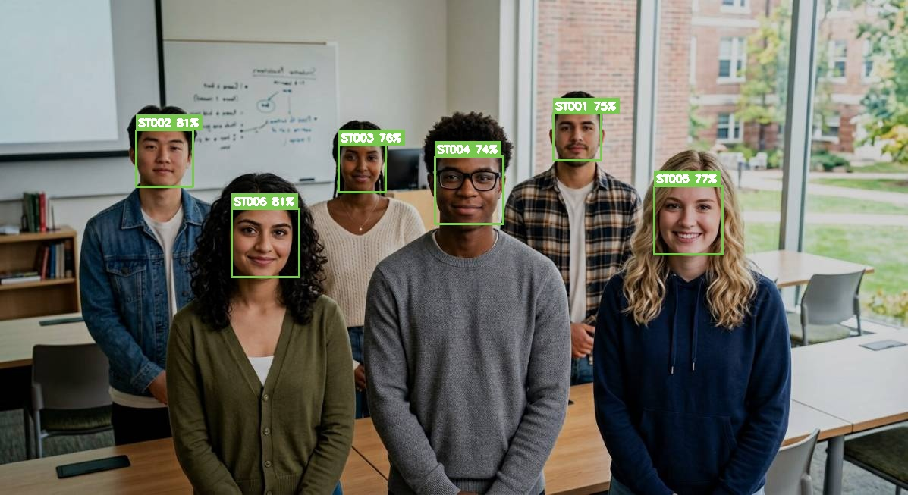
Figure 1 — Good capture: all six students detected, matched, auto-approved (green).
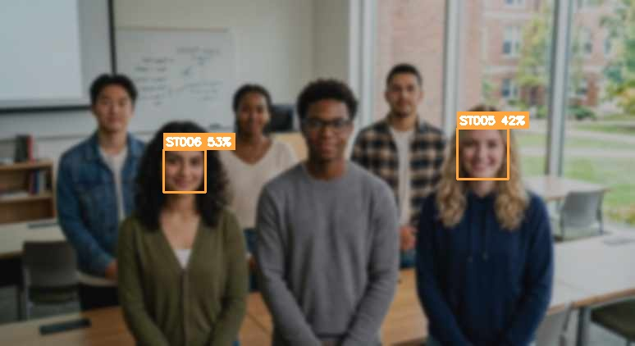
Figure 2 — Degraded capture: only 2 faces detectable, both correctly routed to NEEDS REVIEW (amber).

6. Complete Feature Walkthrough (Every Module)

6.1 Authentication & roles
Teachers log in with email + password (Werkzeug-hashed). Two roles: ADMIN (full visibility, manages accounts and subjects) and TEACHER (sees and marks only assigned subjects and own sessions). Failed logins are rate-limited per IP: 5 failures per 60 seconds. Demo: log in as arjun@college.edu — the Admin page returns 403.

6.2 Teacher dashboard
Landing page: today's present count, your subjects, the 75% at-risk line, and the 8 most recent sessions with verified/pending status. The upload form lives here, including the one-click 'Try the demo photo' button that runs the bundled classroom shot without needing a file.

6.3 Photo upload + AI pass (POST /take_attendance)
Validates extension (.jpg/.jpeg/.png) and 16MB cap, saves with a UUID name, normalizes (EXIF transpose, RGB, downscale), then runs the engine. Results persist as a PENDING AttendanceSession with a JSON payload; face crops and a color-annotated photo are written for the verification screen. Duplicate detections of the same student are deduplicated. Zero faces → friendly error, nothing saved.

6.4 Verification page — the HITL core
Summary chips (auto/review/unknown counts); 'What the AI saw' annotated photo; GREEN pre-checked cards; AMBER side-by-side VS comparison with an identity dropdown preselected to the AI guess (changing it CORRECTS the AI → stored as manual); RED unknown cards with a dropdown of unmatched students; an 'Also present?' multiselect for students the photo missed; sticky confirm bar warning that everyone unmarked will be recorded ABSENT.

6.5 Confirmation & the auditable register
Decisions are written transactionally: AI-guess confirmations store method auto/review with confidence %; changed identities store manual; extra-present stores manual; the rest of the roster stores Absent (system). Every row records verified_by and links to the session. Upsert per (student, subject, date) means same-day re-marks UPDATE instead of duplicating.

6.6 Sessions & provenance
Each upload is a session: subject, teacher, timestamp, original photo, AI verdicts JSON, status pending→verified, decision time. The detail page shows the annotated photo plus present/absent breakdown with per-student method chips (auto 76% / review 53% / manual) — an audit trail months later.

6.7 Student enrollment & management (/students)
Enroll with roll number, name, department, semester, optional portal PIN and a portrait. The portrait is normalized (EXIF + 1600px) and encoded immediately — enrollment fails clearly if no single face is found. Roster shows live attendance bars. CLI alternative: scripts/enroll_students.py --rebuild / --add / --list.

6.8 Analytics (/analytics)
Overall + today donuts, at-risk counter, a pure-SVG daily trend chart with a red dashed 75% line, per-student and per-subject bars. Color language: green ≥ 75%, amber 50–74%, red < 50%. CSV buttons on top.

6.9 Alerts dashboard (/alerts)
The teacher's daily action list. AT-RISK (< 75%): overall %, last-7-days %, trend arrow (recent minus overall), each student's WORST subject (≥ 3 classes). BORDERLINE (< 85%) for early intervention. One implementation (reports.py) powers alerts + CSV + email — single source of truth.

6.10 CSV exports
attendance_raw.csv (every mark: date, time, student, subject, status, method, AI confidence, verified by) and students_summary.csv (totals, %, last-7-day %, trend delta, worst subject, at-risk flag).

6.11 Email digest (+ cron CLI)
Branded HTML email (at-risk table with trend arrows, borderline list, suggested action) to all teachers. CONSOLE backend renders the exact email to data/outputs/emails/ for demos (preview at /alerts/email/preview); SMTP via EMAIL_BACKEND=smtp + SMTP_* env vars. Cron: '0 8 * * * python scripts/send_alerts.py'.

6.12 Admin panel (/admin, admin-only)
Create teacher/admin accounts (password ≥ 6 chars), add subjects, reassign ownership inline. Server-side enforcement: teachers get 403 on subjects/sessions that are not theirs. Seed: admin owns CS201+CS302, Prof. Arjun Nair owns CS405.

6.13 Student self-service portal (/me, public)
Roll number + PIN (hashed; demo 1234) → attendance donut, subject-wise bars, recent history, prominent below-75% warning. Generic errors (no user enumeration), shared rate limiting. Read-only: disputes go to the teacher.

6.14 Security model (cross-cutting)
CSRF token on every POST (400 without it); security headers (CSP self-only, nosniff, DENY frames, referrer policy); rate limiting 5 fails/60s per IP on login AND portal; HttpOnly + SameSite cookies; 16MB upload cap + extension allow-list; login-gated regex-validated media routes (traversal blocked); hashed passwords and PINs; biometrics live in ONE engine-owned pickle, never the DB; repo contains only AI-generated faces.

6.15 Deployment (Docker + Render)
Dockerfile: python3.11-slim + prebuilt dlib-bin (no compile) + explicit deps; face_recognition installed --no-deps on top (Pillow/Click/models listed manually — the missing-Pillow boot bug taught us that). Gunicorn via WEB_CONCURRENCY (default 1 for 512MB). compose mounts ./data. Render auto-builds; first boot creates schema + seeds demo data race-safely (file lock + IntegrityError fallback — fixed a real two-worker crash). Free tier: sleeps ~15 min idle, auto-reseeds on boot.

7. Database Design (5 tables)
Table | Columns & purpose
teachers | id PK | name | email UNIQUE | password_hash (scrypt) | role ('admin'|'teacher')
students | id PK | student_id UNIQUE (roll) | first/last name | email | department | semester | photo_path | portal_pin (hashed) | active
subjects | id PK | name | code UNIQUE (CS201…) | teacher_id FK — course catalogue + ownership
attendance_sessions | id PK | subject_id FK | teacher_id FK | photo_path | results_json (AI verdicts) | status pending→verified | created_at | decided_at
attendance | id PK | session_id FK | student_id FK | subject_id FK | date | time | status | confidence FLOAT | method auto/review/manual/system | verified_by FK | created_at. UNIQUE(student, subject, date) → re-marks UPDATE, never duplicate

Design decision to defend: biometric encodings are NOT in the database. One writer owns them (face_engine's face_encodings.pkl), eliminating two-source-of-truth sync bugs. Older DBs are migrated in place (ALTER TABLE + backfill).

8. Complete Route Map (23 endpoints)
Method | Route | Purpose | Access
GET | / | Redirect to dashboard/login | public
GET/POST | /login | Login (rate-limited) | public
GET | /logout | Clear session | logged in
GET | /teacher/dashboard | Stats, subjects, upload form, recent sessions | teacher (filtered)
POST | /take_attendance | Upload → normalize → AI pass → pending session | owner teacher
GET | /session/<id>/verify | HITL verification page | owner/admin
POST | /session/<id>/confirm | Write final register with provenance | owner/admin
GET | /session/<id> | Session detail + annotated photo | owner/admin
GET/POST | /students | Roster + enroll (live face encoding) | any staff
GET | /analytics | Donuts, SVG trend, per-student/subject bars | any staff
GET | /alerts | At-risk + borderline tables | any staff
GET | /alerts/email/preview | Render the digest email | any staff
POST | /alerts/email/send | Send digest (console/SMTP) | any staff
GET | /export/attendance.csv | Raw log with provenance | any staff
GET | /export/students.csv | Per-student summary + risk flag | any staff
GET | /admin | Accounts + subjects management | ADMIN (403 else)
POST | /admin/teachers/add | Create teacher/admin | ADMIN
POST | /admin/subjects/add | Create subject | ADMIN
POST | /admin/subjects/<id>/assign | Reassign subject | ADMIN
GET/POST | /me | Student portal (roll + PIN) | public (PIN)
GET | /student?student_id= | Staff-side student lookup | any staff
GET | /media/<sid>/<name> | Session crops/annotated image | logged in, regex-guarded
GET | /photo/<name> | Enrollment portraits | logged in, regex-guarded

9. Project Structure (what every file does)
attendance-system/
├── app.py Flask app: 23 routes, HITL confirm, analytics, roles, portal, security
├── config.py Bands (0.45/0.60), 75% threshold, rate limits, paths, EMAIL/DATABASE envs
├── face_engine/
│ ├── detector.py HOG detection → DetectedFace(location, encoding); crop_face
│ ├── encoder.py FaceEncodingStore: enroll (dominant face, replace-on-re-enroll), pickle I/O
│ └── recognizer.py FaceRecognizer.recognize() → 3-band verdicts; .annotate() → color JPEG
├── database/
│ ├── models.py 5 SQLAlchemy models
│ └── seed.py Idempotent demo seed + migrations + race-safe file lock
├── reports.py ONE implementation of per-student stats (UI + CSV + email share it)
├── mailer.py Digest builder + console/SMTP backends
├── templates/ (10 pages) base(glass nav) · login · dashboard · verify(HITL) · session · students ·
│ analytics · alerts · admin · portal · email
├── static/style.css Design system: gradients, glass, cards, chips, bars, responsive menu
├── scripts/ setup_env.sh · enroll_students.py · run_phase2_demo.py · stress_test.py ·
│ send_alerts.py · demo_photo.py · make_project_pdf.py · make_project_docx.py
├── tests/ test_face_engine.py (11) · test_web_flow.py (50)
├── docs/ PROJECT_REPORT.md · DEMO.md · DEPLOY.md · PDF guide · this report
├── Dockerfile python3.11-slim + dlib-bin + gunicorn (WEB_CONCURRENCY aware)
├── docker-compose.yml Port 8000 + ./data volume
└── data/ student_faces/ · uploads/ · outputs/ · face_encodings.pkl · attendance.db

10. Testing & Quality Evidence
Suite / probe | Count | What it proves
tests/test_face_engine.py | 11 PASS | Enrollment integrity (128-d), re-identification, augmentation robustness, stranger rejection
tests/test_web_flow.py | 50 PASS | CSRF, auth, all 3 HITL branches, absent-by-default, correction→manual, enrollment, analytics, CSVs, alerts, email, roles+403s, portal, media ACL, traversal, headers, rate limit
Live deployment smoke (2026-09-21) | 20/20 PASS | Every page, the full AI flow, exports, roles and portal on the production Render URL
Accuracy probes (leave-one-out, stranger, stress) | 5 probes | 0.188–0.262 same-person | 0.726 rejection | 0.802 stranger | 0 false auto-approvals
EXIF phone-photo probe | 0/6 → 6/6 | Real-world rotation handling works

Reproduce: python tests/test_web_flow.py | pytest tests/ -v | python scripts/run_phase2_demo.py | python scripts/stress_test.py | python scripts/demo_photo.py data/uploads/classroom_demo_hard.jpg

11. How to Run It
Local : bash scripts/setup_env.sh → python app.py → http://localhost:8000
Docker: docker compose up --build
Cloud : https://autoattendance-xjeg.onrender.com (Render auto-builds from GitHub)
Demo flow: login teacher@college.edu / teacher123 → 'Try the demo photo' →
verify (green/amber/red) → Confirm → Analytics → Alerts → portal /me (ST005 + 1234)

12. Viva Q&A Drill (likely questions, ready answers)
Question | Your answer
How does the AI recognize a face? | HOG finds the face; a ResNet converts it to 128 numbers; we compare those to every enrolled student with Euclidean distance and take the closest.
What is a 128-d encoding? | A deep-metric embedding: a point in 128-d space where the same person's photos cluster tightly regardless of lighting/angle — a mathematical fingerprint.
Why distance, not a classifier percentage? | Distance is interpretable and thresholdable: honest bands (0.45 auto / 0.60 review) route uncertainty to a human instead of guessing.
Why did you change the blueprint's 85% threshold? | 85% as 1−distance means distance 0.15 — genuine matches never get that close (ours: 0.19–0.26), so every student would need manual review. We validated bands empirically.
What stops the AI marking a stranger present? | Three layers: the 0.60 tolerance (strangers measure ≈0.80), the red Unknown flow requiring human assignment, and absent-by-default. Leave-one-out proves rejection at 0.726.
Two students look alike? | Their distance lands in the amber band → teacher reviews side-by-side and corrects the dropdown; stored as method=manual, so we know when the AI erred.
Can someone cheat with a printed photo? | A 2-D photo can fool pure matching — honest limitation. Production adds liveness detection (blink/depth). In the report's future work.
What if the photo is blurry/far? | Some faces aren't detected → they default Absent (never wrongly present); the teacher uses the 'Also present?' list. Degraded probes never auto-approved anything.
Why SQLite and not MySQL? | Zero-config for demo, fast at college scale; SQLAlchemy + DATABASE_URL make hosted Postgres a config change, not a rewrite.
What is CSRF and how did you stop it? | Cross-Site Request Forgery — attacker form posts as a logged-in user. Every POST must carry the session-embedded token; otherwise 400.
How are passwords protected? | Werkzeug scrypt/PBKDF2 hashing with salts — irreversible. Portal PINs hashed identically.
Why is the data trustworthy? | Every mark stores method, AI confidence %, verifying teacher, and links to the session with the annotated photo — a full audit trail.
How does it handle real phone photos? | EXIF orientation auto-rotation + downscaling on upload; simulation: 0/6 detection before the fix, 6/6 after.
How would you scale to 500 students? | Vectorized distance already handles thousands of encodings in microseconds; Postgres (config-only), GPU/CNN detector or InsightFace, cached encoding matrix, background email workers.
Is face data safe? | Repo contains only AI-generated faces; real biometrics stay in a git-ignored volume. Production requires consent + retention policy (DPDP Act) — stated in the report.
Hardest bug you fixed? | Two gunicorn workers seeding the empty DB simultaneously on first deploy → UNIQUE constraint crash. Fixed with an exclusive file lock + fallback; verified on a fresh-DB deploy.

13. Limitations & Future Work
- Detection ceiling: extreme distance/blur drops faces (absent-by-default + manual list mitigates).
- No liveness/anti-spoofing yet (printed-photo attack) — blink or depth-based liveness is future work.
- Free tier: sleeps after idle; ephemeral disk on redeploys (auto-reseed keeps demos working).
- Accuracy on larger real-world cohorts should be re-validated (bias/lighting audits) before production.
- Roadmap: InsightFace/YOLOv8 engine behind the same interface; OTP-based student identity; parent email alerts; admin PIN-reset UI; timetable-aware absent messaging.

One-line summary for your viva: 'The AI does in three seconds what roll-call does in five minutes — and a teacher, not an algorithm, signs every single mark.'

