AWS Environment with Terraform

Table of contents
Contents
1. Objective 1
2. Steps to use the Terraform Code 2
3. SSH to bastion host 3
3. URLs used as References 4

- Objective:
The objective of this Terraform code is to create a proof-of-concept environment on AWS. It sets up a Virtual Private Cloud (VPC) with public and private subnets, an Application Load Balancer (ALB) with target groups, EC2 instances, and other related resources.

Prerequisites:
Before running the Terraform code, you must have the following:

AWS CLI installed and configured with valid access credentials.
Terraform version CLI installed on your local machine follow the steps below:
- wget https://releases.hashicorp.com/terraform/0.14.7/terraform_0.14.7_linux_amd64.zip
- unzip terraform_0.14.7_linux_amd64.zip
- sudo apt install unzip
- unzip terraform_0.14.7_linux_amd64.zip
- sudo mv /home/ubuntu/terraform /usr/bin

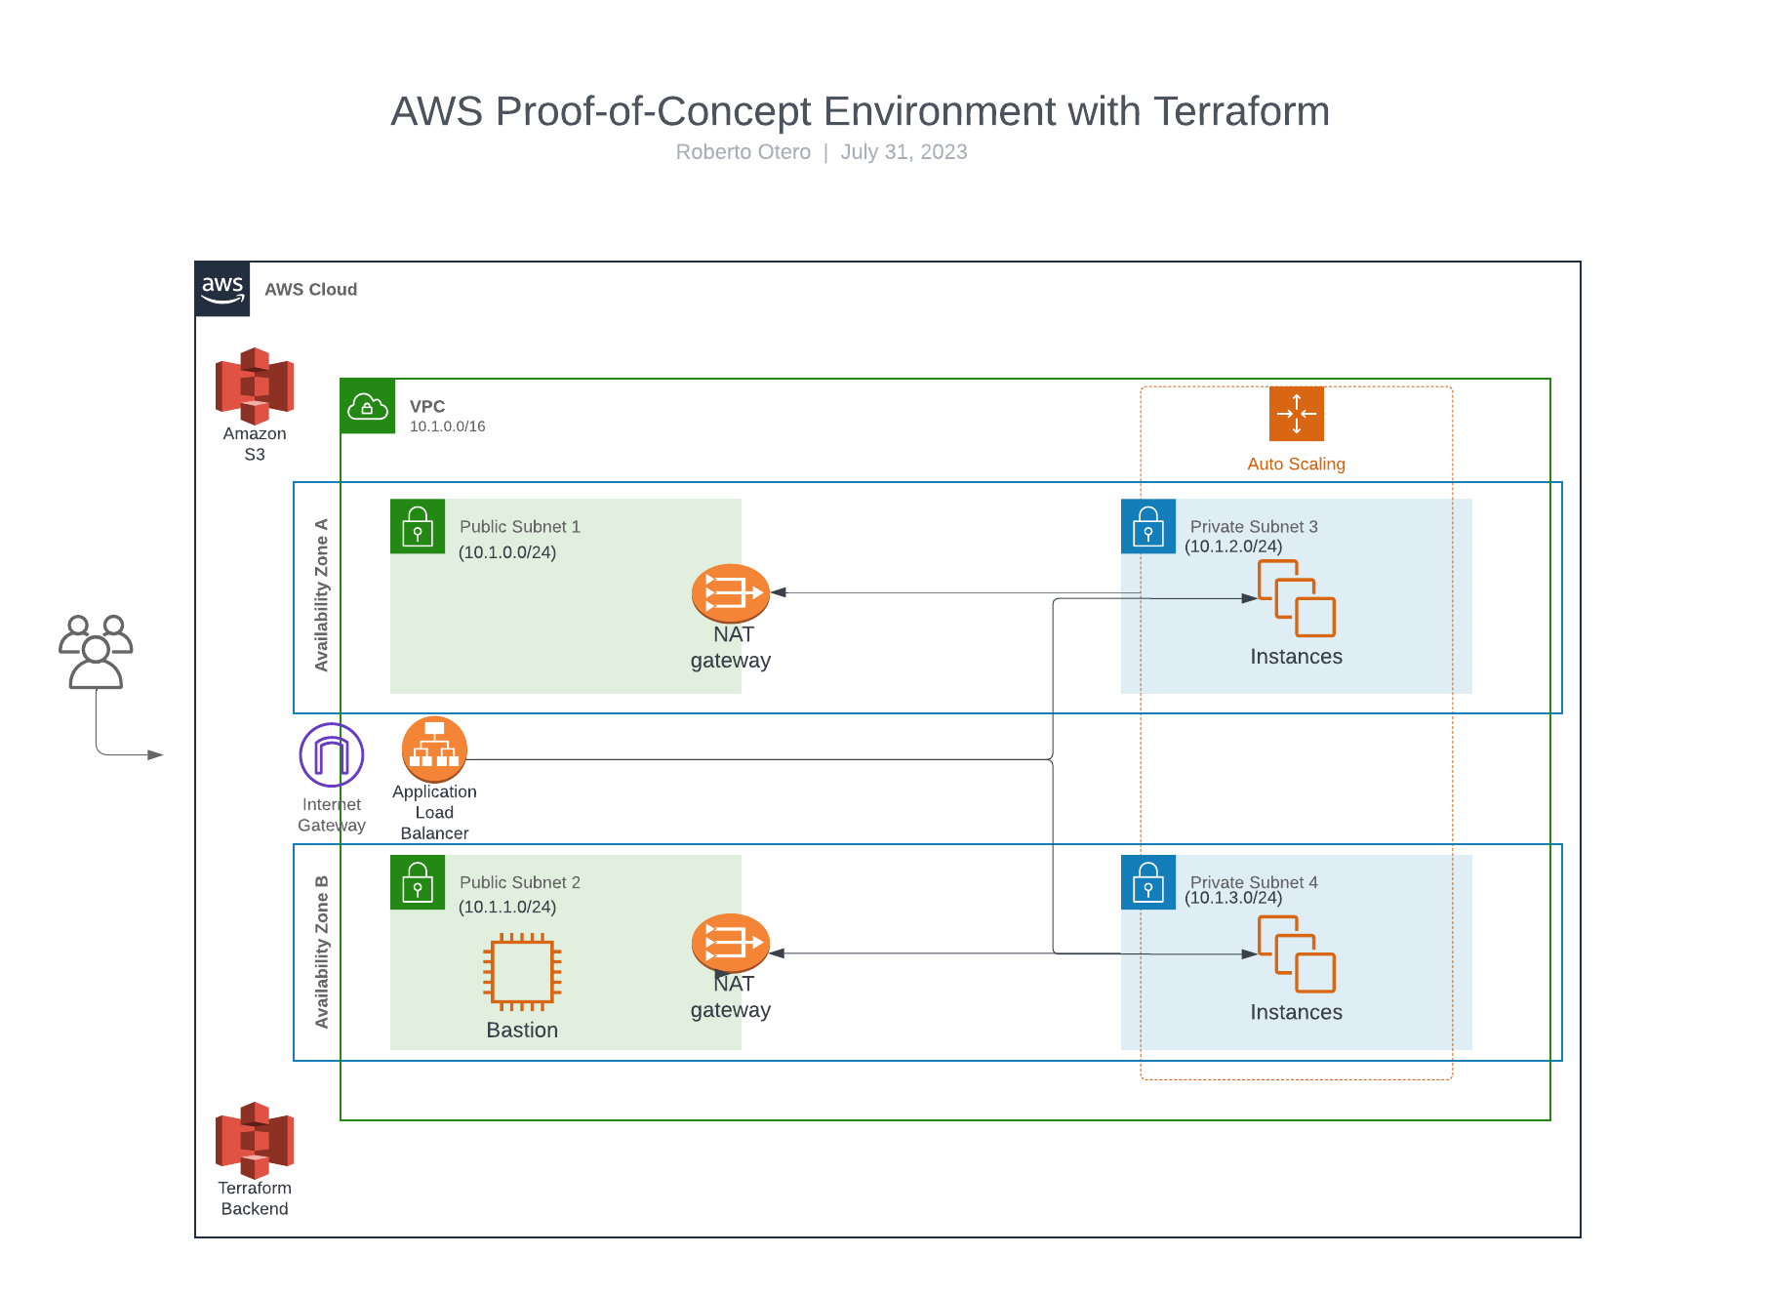
- Steps to use the Terraform Code:
Clone the repository containing the Terraform code to your local machine:
- git clone https://github.com/AA90416/terraform-aws-infra-poc.git

Set the correct permissions to the script in the repository root directory:
- chmod +x init_webserver.sh

Customize Variables:
Open the terraform.tfvars file and review the variables defined.
- Customize the variable values based on your requirements. For example, you can specify the VPC CIDR, subnet CIDRs, security group names, AMI IDs, instance types, and bucket names.
Initialize Terraform:
- Open a terminal and navigate to the directory containing the Terraform code.
- Run the following command to initialize Terraform: terraform init

Validate the Configuration:
- Run the following command to validate the Terraform configuration:
- terraform validate
Plan the Infrastructure:
- Run the following command to see the execution plan of the Terraform:
terraform plan -var-file="terraform.tfvars"
Apply the Configuration:
- If you are satisfied with the plan, apply the Terraform configuration:
terraform apply -var-file="terraform.tfvars"

Terraform will create the AWS infrastructure based on your code.

Access the Outputs:
- After the successful execution of the Terraform configuration, it will display the outputs, including the DNS name of the Application Load Balancer (ALB). You can use the ALB DNS name to access your application.

- SSH to bastion host:
Prerequisites:
- Ensure that you have the .pem private key file available on your local machine. If you don't have the .pem file, request it from the system administrator or obtain it during the setup process.
- You should have the public IP or DNS name of the bastion host to connect to.
Set Appropriate Permissions:
- For security reasons, ensure that the .pem file has the correct permissions. On Unix-based systems, you can set the permissions to 400 (read-only by the owner) using the following command:
chmod 400 /path/to/your/private_key.pem
Connect to the Bastion Host:
- Open your terminal or command prompt on your local machine.
- To connect to the bastion host using SSH, use the following command:
ssh -i /path/to/your/private_key.pem ec2-user@bastion_public_ip_or_dns

Snapshot of Bastion Instance:
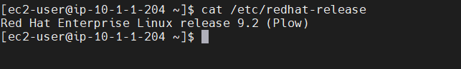

- URLs used as References:
Terraform Code Base:
- https://medium.com/@jeremyreid757/launching-apache-webservers-with-terraform-and-auto-scaling-b95a049bfdc5
- https://aws.plainenglish.io/deploying-a-aws-autoscaling-group-with-terraform-f487b865444f
Scripting:
- https://medium.com/@ertorrez/use-a-script-to-install-and-launch-an-apache-server-on-centos-8-6db6e4b81cbf
Architecture Drawing:
- https://lucid.app

