
1

Mobile App Development Report

Name: ________________________________________
ID:___________________________________________

Lecturer: Amir Tarek
Assistant Lecturer: Nour Elhuda Awny

Table of Contents
Project Description 3
Introduction 3
Project Background 3
Motivation 3
Project Goals 3
Another Application 4
Proposed Application Modeling 4
Product Database 4
Resources 4

Project Description

Introduction
TaskFlow is a Unity/C# based mobile self-reminder app. The app's primary function is to provide an easy and visual approach to task organisation. Rather than keeping tasks on paper or in multiple notes, the user can organise important tasks in a single list, sorted by day of the week. The app also notifies the user about urgent tasks which helps them manage their time and avoid missing important tasks. This project is valuable because there is a need for a simple task manager that is easy to comprehend and quick to use. The TaskFlow app allows the user to register and login, create or edit tasks, prioritise tasks, schedule tasks for one or more days, complete tasks and view weekly progress. This project results in a working cross-platform mobile application with local storage and synchronisation with Firebase.

Project Background
The project is a mobile app for Android and iOS devices. The project is programmed using Unity as the engine, C# as the programming language, UI Toolkit for the user interface and the Firebase Realtime Database as the cloud database. For local storage, the app can also store information on the device and the user can still load the app and check the tasks even when the internet connection is poor or offline. The hardware requirements are a modern mobile phone or tablet with the internet. In terms of software, the project needs Unity, Firebase configuration files, and the mobile tooling for the specific platform. The development process begins with user interface, then with the data model of the task, then with user accounts management, and finally with reminders and progress display.

Motivation
The driving force of TaskFlow is a common user need: users know what they have to do, but they can't keep tasks organised and track them during a week's time. A task manager is more helpful if it not only acts as a storage, but also provides organisation, notifications and progress. During development we expect the following:
Making the user interface intuitive with a lot of features. This can be achieved by splitting the app into a few pages like login, day view, task details and progress view. Properly handling local and cloud storage. This can be improved by using intuitive keys for data storage, consistent sync rules and writing code for save and load functions early. Providing helpful but non-pesky reminders. This can be reduced by polling for upcoming tasks at certain times and displaying only pertinent pop-up messages. Providing reliable sign up and login. This can be addressed by checking input, checking credentials stored and using Firebase as a reliable service. These difficulties can be overcome by implementing good design principles and testing the features gradually.

Project Goals
The primary objective of TaskFlow is to provide the user with a secure and convenient means of scheduling tasks. The user must be able to do the following in the app: Sign up for a new account and login. Log out of the app. Select a day and see the tasks for that day. Create a task with a name, description, time and priority level. Link a task to a single day or multiple days. Check off completed tasks and view weekly progress. Get popups when tasks need to be completed. Another objective is to ensure the app is fast and useful. The app should not require multiple screens or steps to do so.

Another Application
An example of another popular app is Todoist. Todoist also allows users to create tasks, manage their schedules and monitor progress. It has become popular because it has a user-friendly design, and good task management on multiple platforms. The TaskFlow app is unique in that it is based on a simple weekly format and reminder sequence. Rather than provide a range of complex tools up front, it allows the user to get to the point rapidly: select a day, view the tasks for the day, and edit them quickly. The application also offers both local and remote storage via Firebase which allows both speed and backup.

Proposed Application Modeling
The proposed app model illustrates the user interactions with the TaskFlow app and how key features support the entire planning process. The use case diagram shows the actors and features and the activity diagram shows the sequence of steps from login to logout.

Use Case Diagram
Figure 1 shows the use case diagram for the app. The primary actor is the user, with Firebase Database being the system actor. Use cases include signing up, logging in, logging out, choosing the day of the week, adding, or editing a task, allocating a task to days, storing the data locally, synchronising the data with Firebase, completing a task, viewing progress for the week and setting reminders for a task.
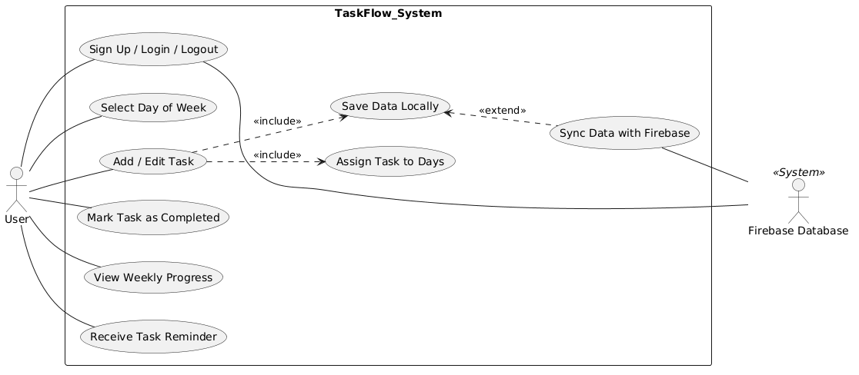
Figure 1. Full use case diagram for TaskFlow.

Use Case Scenario 1: User Login
Use case name: User Login.
Primary actor: User.
User goal: User needs to access his or her tasks and progress.

Preconditions: The user has an account set up, and is on the login page.

Trigger: The user inputs his or her username and password, and clicks login.

Success scenario: The app first compares the entered data to the stored data. Then, the app checks the information with the server, if required. If the data is valid, the app retrieves user tasks and displays the daily view in the weekly calendar.

Exception flows: If the username or password is empty, the app displays an error. If the data is wrong, the app will prevent access and prompt to re-try. In case of no internet connection, the app may use local data.

Postconditions: The user is logged in and can access tasks.

Use Case Scenario 2: Add or Edit Task
Use case name: Add or Edit Task.
Primary actor: User.
Goal: The user wants to create a new task or update an existing one for better planning.
Preconditions: The user is logged in and has opened a selected day page.
Trigger: The user chooses the add button or selects an existing task from the daily list.
Main success scenario: The app opens the task details page. The user enters or updates the task name, description, time, and priority, then chooses one or more days. After pressing save, the app stores the data locally and syncs it with Firebase when the internet is available. The updated task then appears in the correct day list.
Alternative or exception flows: If the task name is empty, the app does not save the task. If there is no connection, the app still keeps the task locally for later synchronisation. If the user edits a task, the app replaces the old values.
Postconditions: A new task is created or an existing task is updated, and the schedule reflects the latest data.

Activity Diagram
In Figure 2, we see the activity diagram of the app. Each time an app is opened. If the user is not logged in, the app proceeds to the sign up/login and verifies the credentials. The user then chooses a day and displays the daily tasks. The user can now create or edit tasks, complete tasks or view the weekly progress, or wait for reminder checks. The activity diagram also illustrates how data is saved: data is saved locally and then uploaded to Firebase if the internet is connected.
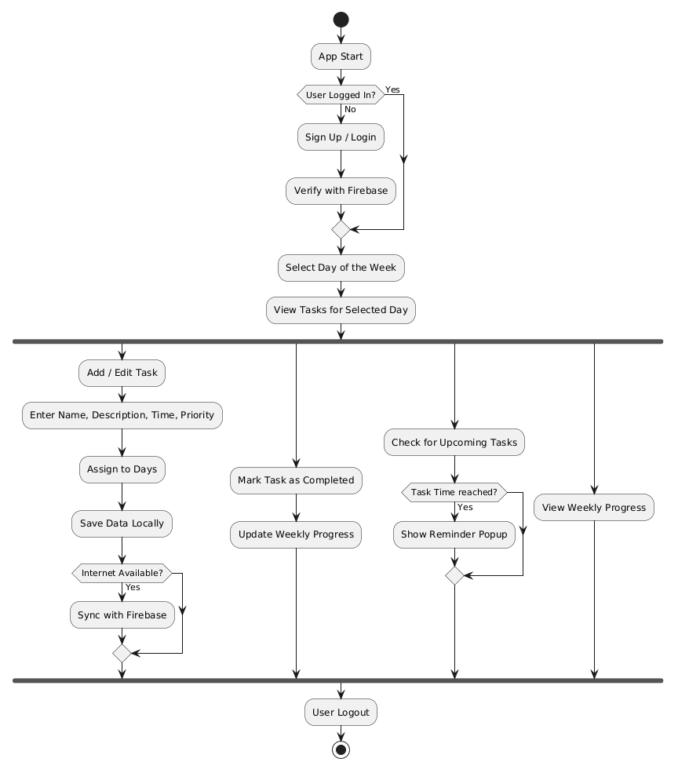
Figure 2. Activity diagram for the TaskFlow application flow.
Together, the use case and activity diagrams give a clear picture of how the system works and help the developer check the final implementation.

Product Database
TaskFlow requires a backend because user data and task information need to be stored securely and be available after the user logs in again. In this project, the Firebase Realtime Database project is an ideal choice for a backend as it can be easily integrated into Unity and it also supports basic cloud synchronisation. The mobile device has a local copy of the user account record and task information, but this is stored in the backend. There are three reasons why this project needs a backend. First, for user continuity: tasks are not lost if the user switches devices or re-installs the app. Second, it allows users to log in and sign up by storing their credentials. Third, it enables the app to recover data for the user who returns after a period of time, enhancing reliability. The data is user login information like name and password, list of daily tasks, list of tasks, task descriptions, priority of tasks, time for tasks, state of tasks (like pending and done), status of notifications (to prevent the same pop up for notifications). It also records the user's progress via the completed task states. While the template refers to product information, in this case the data is task information. The task behaves as an item in the system. The app writes the data locally, checks for an internet connection, then saves the same data to the cloud (Firebase). When the user logs in, the app can use the cloud data and update the local data. This approach facilitates usability and backup.

Resources
The following resources are the most useful for this project because they are either official technical references or strong guides for the same type of application design.
Unity Technologies. (2024). UI Toolkit manual. Unity Documentation.
Firebase. (2024). Firebase Realtime Database for Unity. Firebase Documentation.
Firebase. (2024). Add Firebase to your Unity project. Firebase Documentation.
Microsoft. (2024). C# documentation for collections, DateTime, and asynchronous programming. Microsoft Learn.
Visual Paradigm. (2024). UML use case diagram and activity diagram guides. Visual Paradigm Online.

