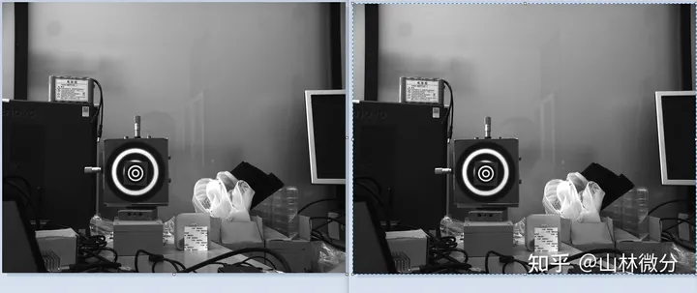
Sub-pixel 2D positioning
Let’s introduce the problem first. The two pictures below are not exactly the same. The target in the image on the right has a small displacement in the vertical direction. We cannot see the displacement of only a few pixels. We hope that the software can accurately calculate it. This has useful applications in engineering.

Now since we want the positional relationship between the targets, we might as well select the target A area on figure left

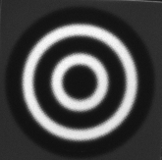
Then we will search in figure right finding a target B area.Then can use the following calculation formula.

represents the grayscale value at each integer pixel position in area A, and represents the grayscale value at each integer pixel position in area B. So to make the two pictures most consistent.This area B must be the smallest C at some i.
Since the target displacement in the two figures is small, we only need to search around the center target point. After finding the precise target point, we perform fitting solution. The fitting method has high accuracy and fast calculation, so it is widely used. The fitting area here is the 9 points in the picture. Of course, we can also select a larger area for fitting, such as a 5*5 area for fitting. It turns out that a larger area does not reduce the error, and sometimes the error is even larger. According to the reference paper, the extreme point after fitting is the location of the sub-pixel point. Based on this programming, calculate the target movement of the two pictures.

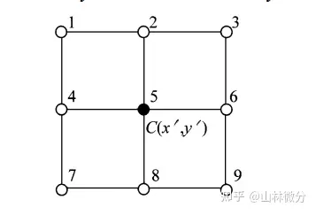
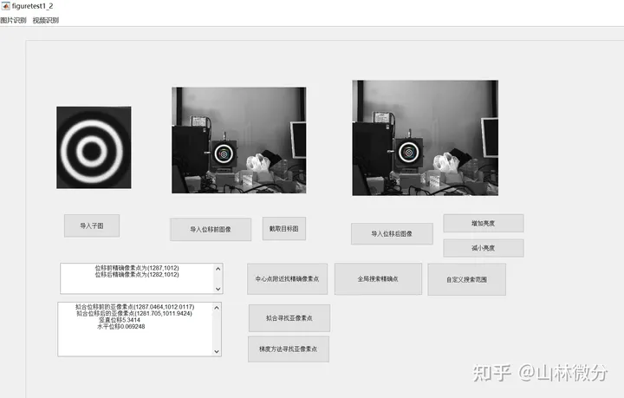
We take the form of intercepting the target in the picture and first find the integer point.Then calculating the sub-pixel points, the vertical displacement is 5.3414 and the horizontal displacement is 0.069248. The target does not move in the horizontal direction, and this horizontal displacement value is the horizontal error.
The coefficient of this experiment is 0.288.The real move is 1.5mm.So 5.208333 is the correct piex.So we know the vertical error is about 0.10567 and horizontal error is about 0.069248.And the real error is 5.3414*0.288 -1.5= 1.5383232-1.5=0.0383232（mm).

[1]Real-time,noncontact and targetless measurement of vertical deflection of bridges usingoff-axis digital image correlation BingPana,LongTiana,Xiaolin Song
[2]The errors in digital image correlation due to overmatched shape functions Liping Yu and Bing Pan

