

|  |  |
| --- | --- |
| Doctors | |
| doctor’s table | columns |
| primary key | id |
|  | doctors |
|  |  |

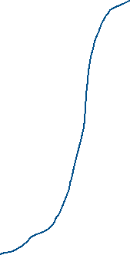

|  |  |
| --- | --- |
| Patients | |
| patient’s table | columns |
| primary key | id |
|  | patients |
|  |  |

|  |  |
| --- | --- |
| Diseases | |
|  | columns |
| primary key | id |
|  | diseases |
|  |  |

|  |  |
| --- | --- |
| Diagnoses | |
|  | columns |
| primary key | id |
| foreign key | Visits_id |
| foreign key | Diseases_id |

|  |  |
| --- | --- |
| Visit | |
|  | columns |
| primary key | id |
| foreign key | Doctors_id |
| foreign key | Patients_id |