**AADA DataBase:**

The AADA database is thematically organised into three MS Excel tables according to the prehistoric era: Stone Age, Bronze Age, and Iron Age periods. Each period contains both period-specific and general artefact categories and accordingly also period-specific and general variables (Table 1). The database is provided also as csv-files.

*Table 1. The artefact categories included in the AADA database.*

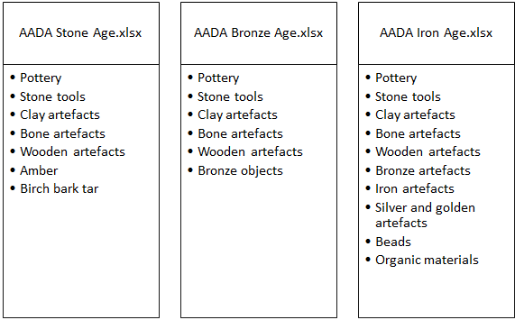

Each row in the table represents a single artefact, while each column represents a specific attribute, such as its type, period, site, and measurements. Pottery forms a different case as the material is not organised according to separate vessels (except pottery detailed in AADA Iron Age), but according to types/styles present in each collection main number. The detailed description of the data is found in the paper Pesonen et al. (2024).

The database also includes a collection of photographs that are found in another Zenodo repository and should be referenced as follows: Moilanen et al. 2024. (Moilanen, U., Pesonen, P., Saipio, J., Tiilikkala, J., Sanwal, M. 2024. Archaeological Artefact Database of Finland (AADA), photograph repository: https://zenodo.org/records/10417384).

The detailed description of the database is found in the paper Pesonen et al. (2024). (Pesonen, P., Moilanen, U., Roose, M., Saipio, J., Tiilikkala, J., Sanwal, M., Immonen, V., Vesakoski, O. & Onkamo, P. 2024. Archaeological Artefact Database of Finland (AADA). Manuscript submitted).