The basic step towards understanding the projects is having basic knowledge of all the Machine-Learning inclined libraries in python.

Pandas - Pandas is an open source Python package that is most widely used for data science/data analysis and machine learning tasks. It is built on top of another package named Numpy, which provides support for multi-dimensional arrays.

NumPy - It supplies an enormous library of high-level mathematical functions that operate on these arrays and matrices.

Spacy - spaCy is designed specifically for production use and helps you build applications that process and “understand” large volumes of text. It can be used to build information extraction or natural language understanding systems, or to pre-process text for deep learning.

Beautifulsoup - Beautiful Soup is a Python library that is used for web scraping purposes to pull the data out of HTML and XML files. It creates a parse tree from page source code that can be used to extract data in a hierarchical and more readable manner.

Text Preprocessing:-
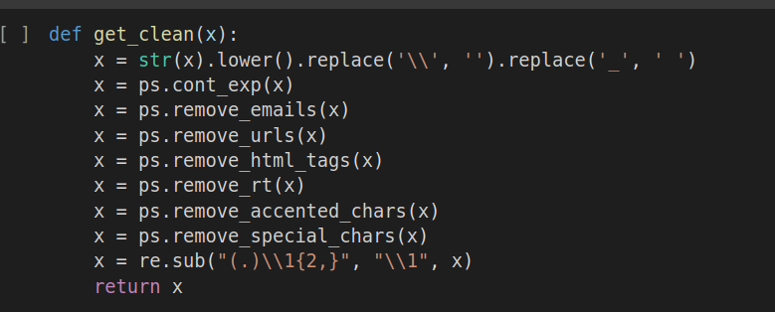

The get_clean() function :-
. It prepares the data and converts it into a model readable form taking out all the special characters, emoticons, emails, links, etc.
.Converting the whole data into lowercase for uniformality.

Anonymous/Lambda Function:-
. In computer programming, an anonymous function is a function definition that is not bound to an identifier. Anonymous functions are often arguments being passed to higher-order functions or used for constructing the result of a higher-order function that needs to return a function.

Storing Data in Optimized Form :-
.Term Frequency-Inverse Document Frequency :-
The term frequency is the number of occurrences of a specific term in a document. Term frequency indicates how important a specific term in a document. Term frequency represents every text from the data as a matrix whose rows are the number of documents and columns are the number of distinct terms throughout all documents.

.Inverse document frequency (IDF) is the weight of a term, it aims to reduce the weight of a term if the term’s occurrences are scattered throughout all the documents.

.Storing the whole data in the two vectors X & Y
.X – Storing Tweets.
.Y – Storing Intentions.

Working :-
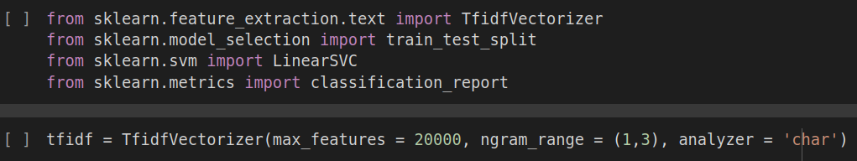
. Using the skLearn library the model is comparing the dataset to the top 20000 words of universal dictionary and filtering out as possitive feelings with respect to the user.

.The objective of a Linear SVC (Support Vector Classifier) is to fit to the data you provide, returning a "best fit" hyperplane that divides, or categorizes, your data. From there, after getting the hyperplane, you can then feed some features to your classifier to see what the "predicted" class is. This makes this specific algorithm rather suitable for our uses, though you can use this for many situations. Let's get started.

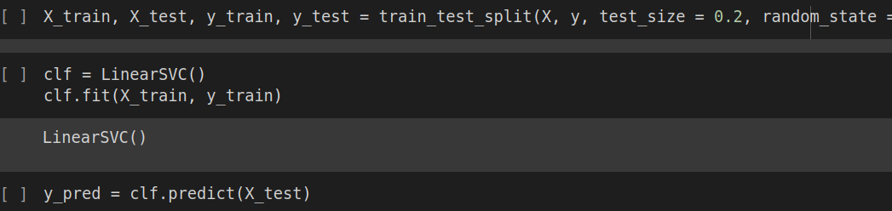
Result:-
. Accuracy:-
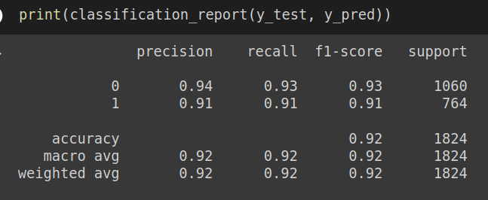
Example:-
