CAMPUSCONNECT 2026
Linux Commands, AWS EC2 & Web Application Verification Report
Student Event Registration Portal

Project | CampusConnect 2026
Server | AWS EC2 / Ubuntu Linux
Application | PHP + MySQL + Apache
Purpose | Document the server setup, database verification, application testing, and screenshots

Overview
This report presents the supplied screenshots in logical order and explains what each screenshot demonstrates. The evidence covers AWS EC2, Linux user management, MySQL database/table verification, Apache and MySQL service status, PHP installation, the CampusConnect web interface, registration, login, database storage, and a localhost curl test.

Screenshot Evidence
Screenshot 5 — AWS EC2 Instance Overview
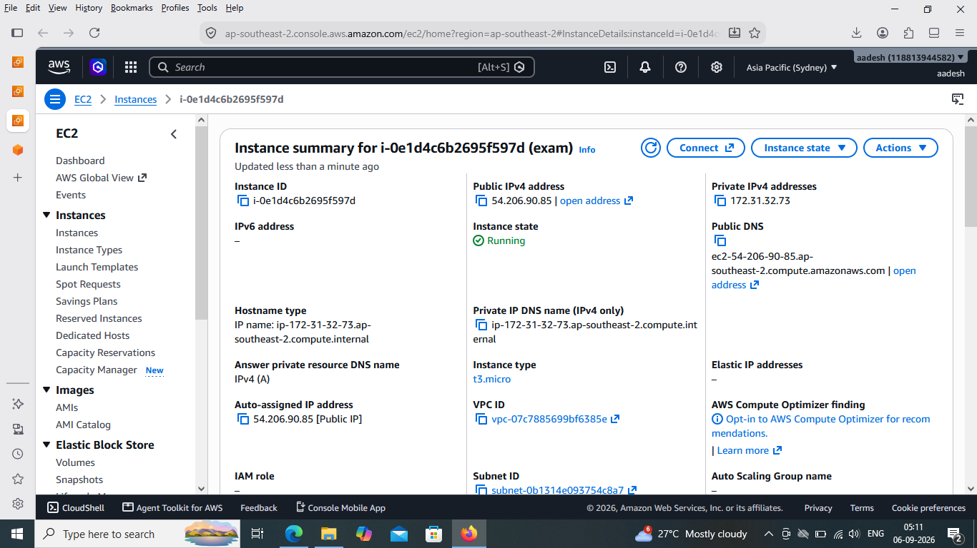
Details: Shows the running AWS EC2 instance used for the CampusConnect deployment. The instance is in the Asia Pacific (Sydney) region and the screen displays its public/private IPv4 information and instance state.
Verification/Result: Key evidence: EC2 instance is Running; Apache/PHP/MySQL work is being performed on this server.

Screenshot 6 — Linux User Creation and Sudo Group
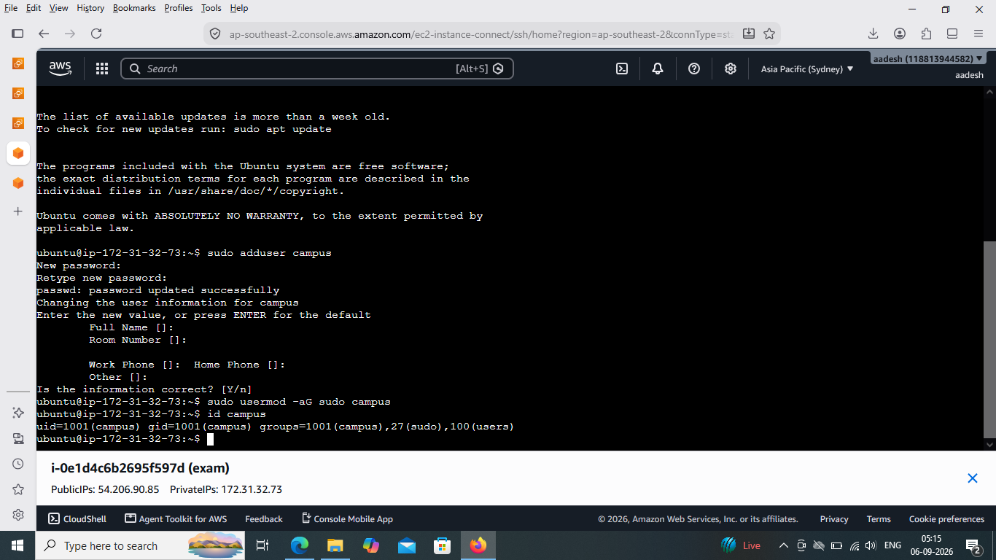
Details: Shows creation of the Linux user 'campus' with sudo access. The command 'sudo adduser campus' creates the account, followed by 'sudo usermod -aG sudo campus'. The 'id campus' command verifies membership in the sudo group.
Verification/Result: Result: the campus user exists and belongs to the sudo group.
Visible command(s):
sudo adduser campus
sudo usermod -aG sudo campus
id campus

Screenshot 7 — MySQL Database and Table Structure
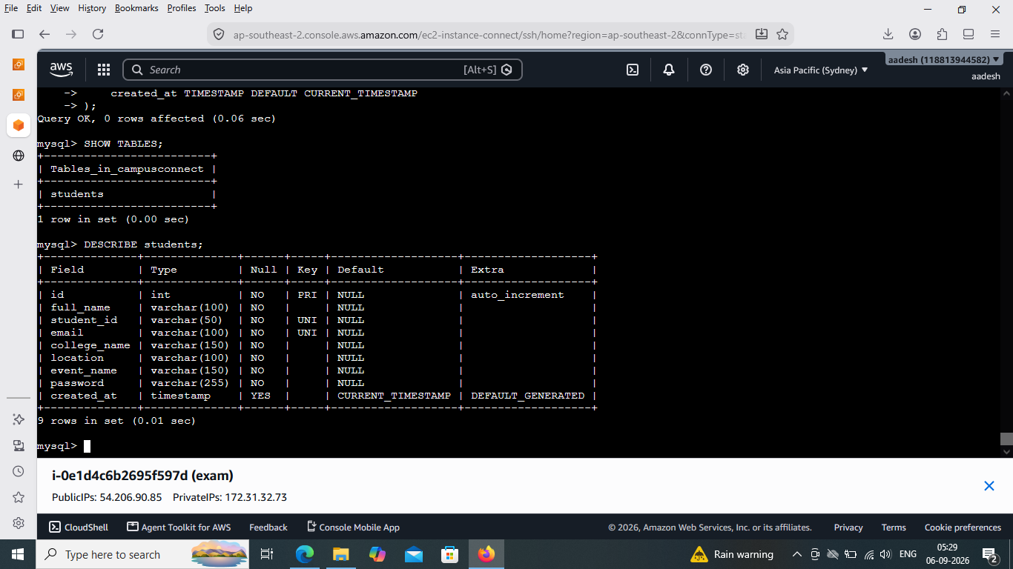
Details: Shows the CampusConnect MySQL database selected with 'use campusconnect;'. 'SHOW TABLES;' confirms the students table exists. 'DESCRIBE students;' verifies the table structure, including id, full_name, student_id, email, college_name, location, event_name, password, and created_at.
Verification/Result: Result: the database and students table are created with the expected fields.
Visible command(s):
use campusconnect;
SHOW TABLES;
DESCRIBE students;

Screenshot 9 — Apache Web Root and Application Files
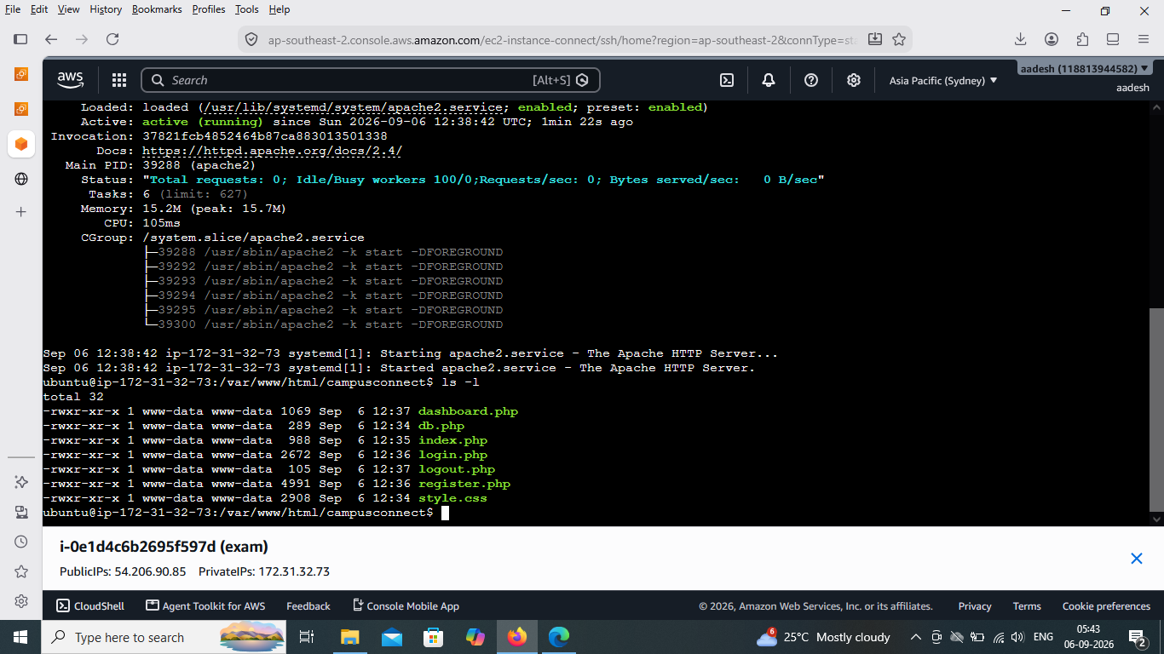
Details: Shows Apache service information and the contents of /var/www/html/campusconnect. The directory contains dashboard.php, db.php, index.php, login.php, logout.php, register.php, and style.css.
Verification/Result: Result: Apache is serving the CampusConnect application files from the web root.
Visible command(s):
sudo systemctl status apache2
ls -l

Screenshot 10 — CampusConnect Home Page
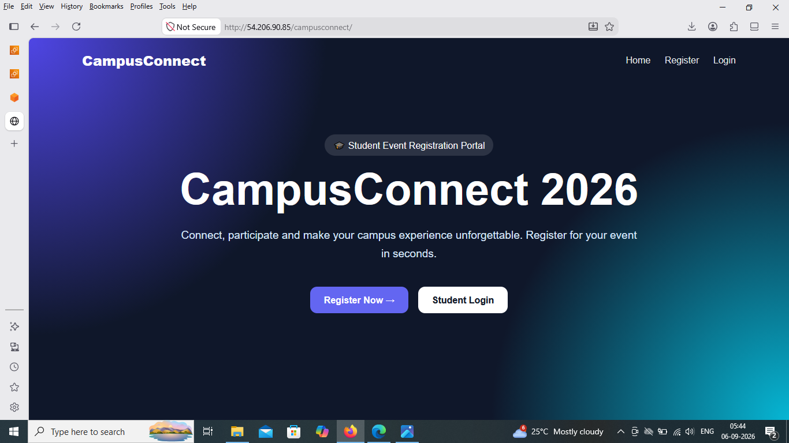
Details: Shows the live CampusConnect 2026 landing page in the browser. The page includes navigation for Home, Register, and Login, plus Register Now and Student Login buttons.
Verification/Result: Result: the main web interface loads successfully from the EC2 server.

Screenshot 12 — Student Registration Form
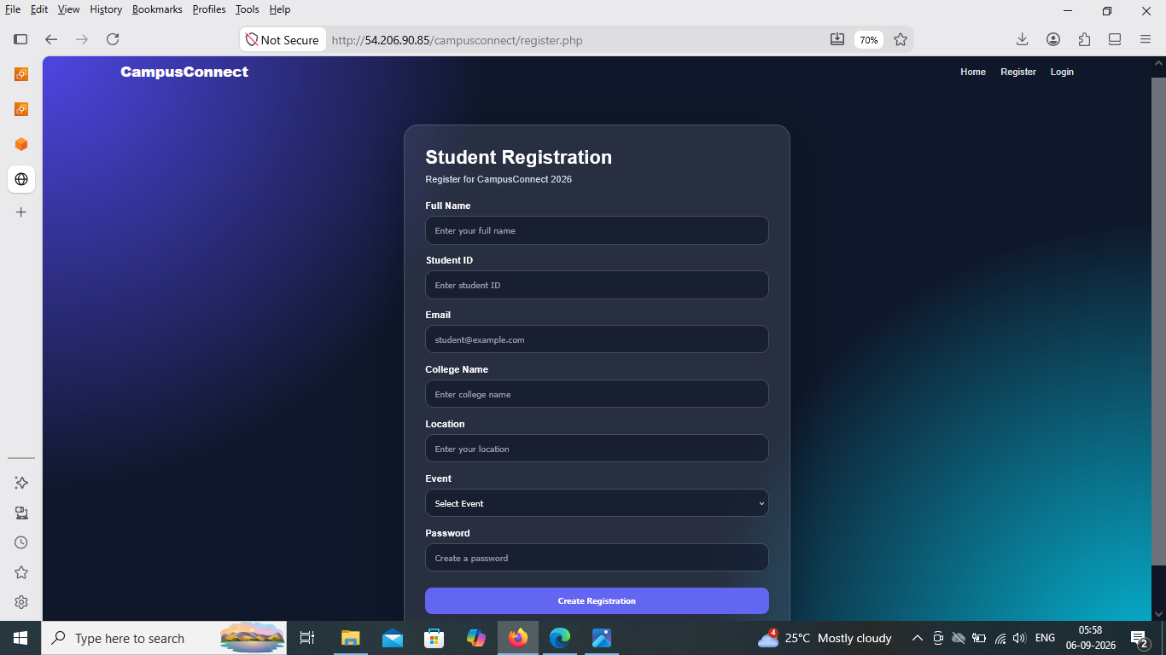
Details: Shows the Student Registration page with fields for Full Name, Student ID, Email, College Name, Location, Event, and Password, followed by the Create Registration button.
Verification/Result: Result: the registration interface is available and ready for student data entry.

Screenshot 13 — Registration Success and Browser Validation
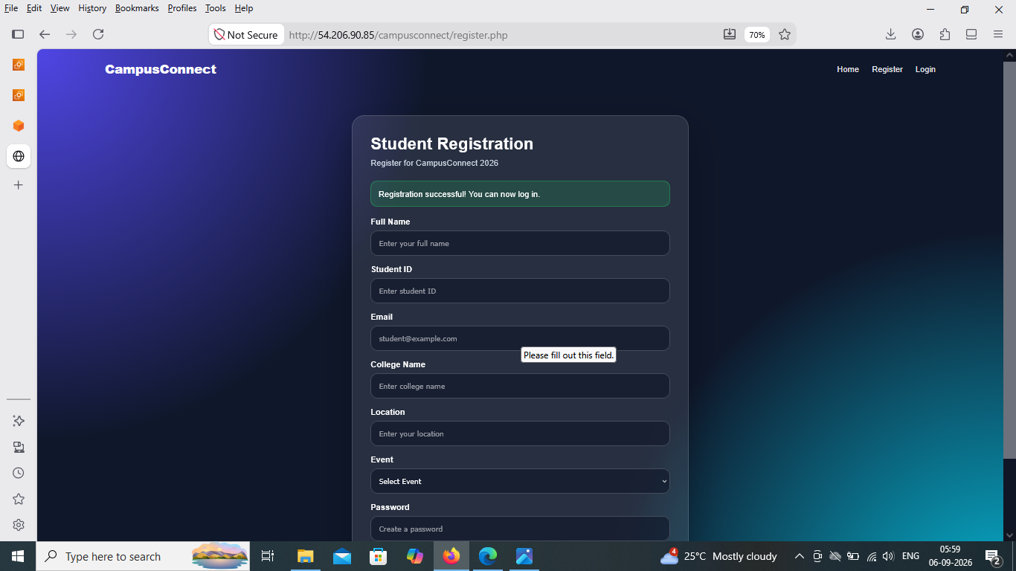
Details: Shows the registration page after a successful submission message. The screen also displays the browser's required-field validation prompt, demonstrating that HTML form validation is active.
Verification/Result: Result: a registration success message is displayed and client-side required-field validation is present.

Screenshot 14 — Student Login Page
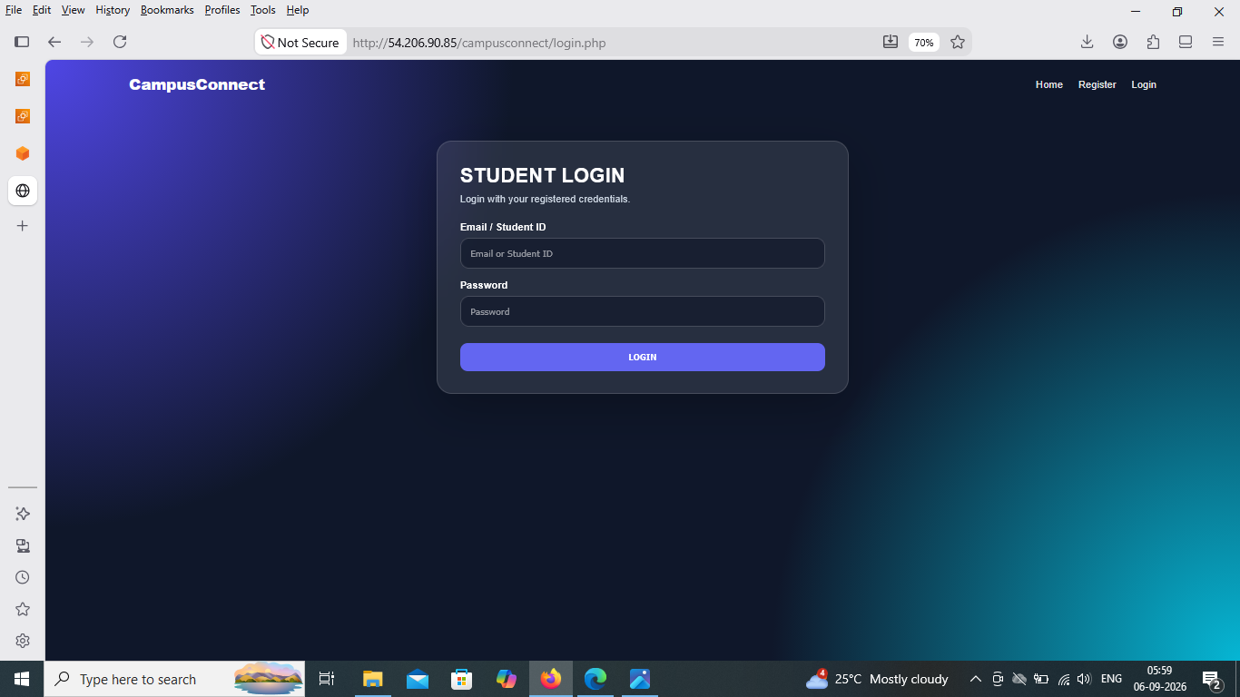
Details: Shows the Student Login page with Email / Student ID and Password fields and a LOGIN button.
Verification/Result: Result: the login interface is available for registered students.

Screenshot 15 — Successful Login and Dashboard
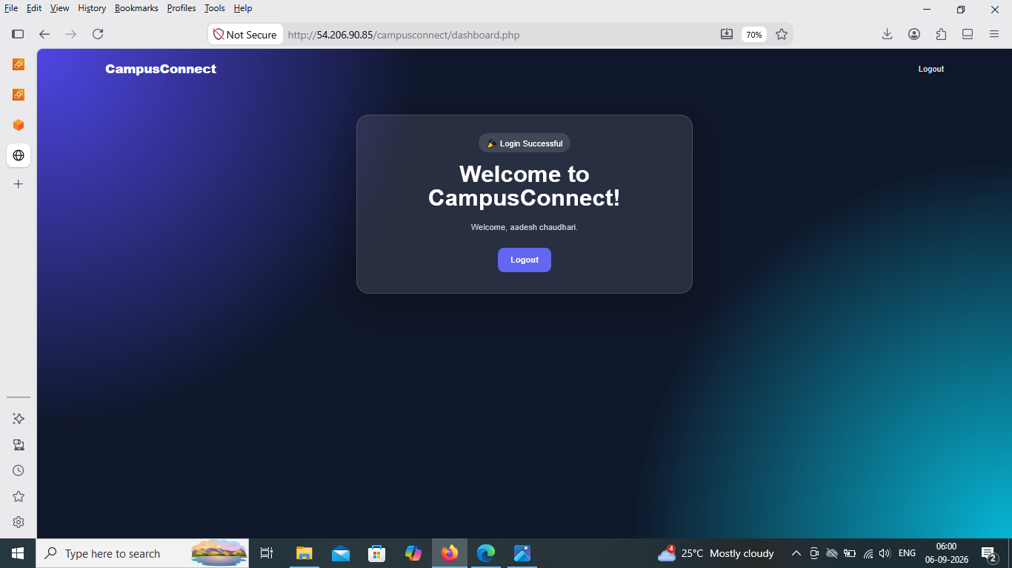
Details: Shows the CampusConnect dashboard after successful authentication. The page displays a Login Successful message, a welcome message, and a Logout control.
Verification/Result: Result: valid credentials successfully create a logged-in session and open the dashboard.

Screenshot 16 — Invalid Login Validation
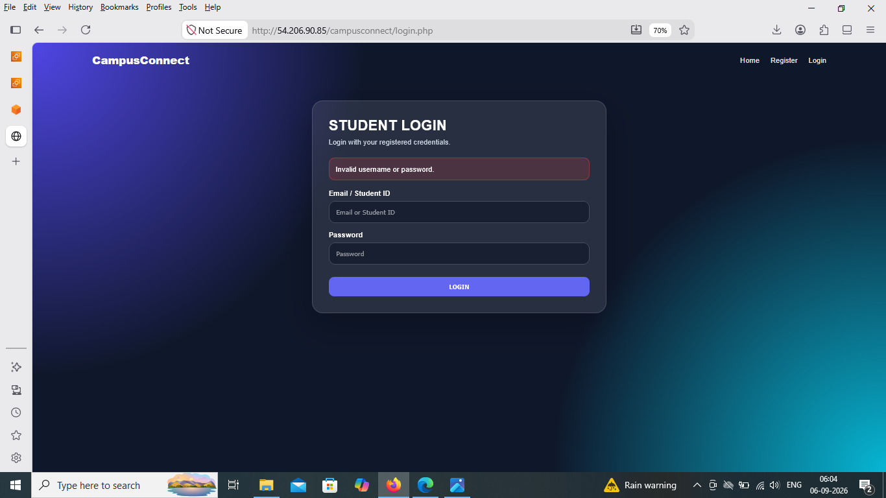
Details: Shows the Student Login page after an unsuccessful authentication attempt. The page displays the message 'Invalid username or password.'
Verification/Result: Result: invalid credentials are rejected and an error message is shown.

Screenshot 17 — Database Record Verification
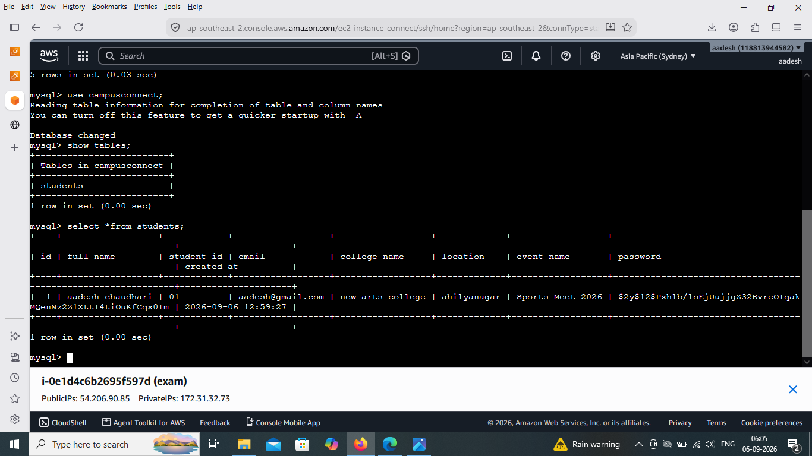
Details: Shows 'select * from students;' in MySQL and a stored student record. The displayed record includes the submitted student details and a hashed password value.
Verification/Result: Result: submitted registration data is stored in the students table.
Visible command(s):
use campusconnect;
select * from students;

Screenshot 18 — Apache Service Status Verification
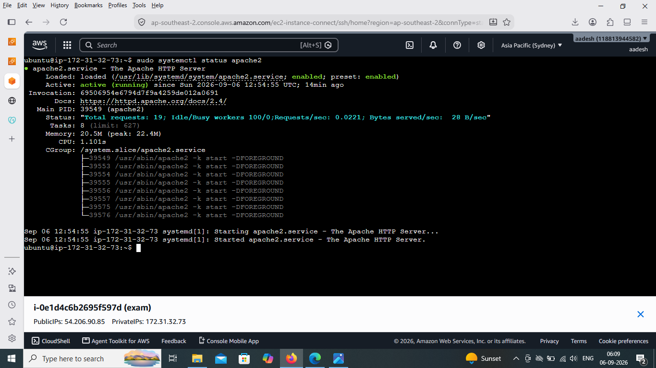
Details: Shows 'sudo systemctl status apache2'. Apache is loaded, enabled, and active (running), with the Apache HTTP Server reported as started.
Verification/Result: Result: the web server is running correctly.
Visible command(s):
sudo systemctl status apache2

Screenshot 19 — MySQL Service Status Verification
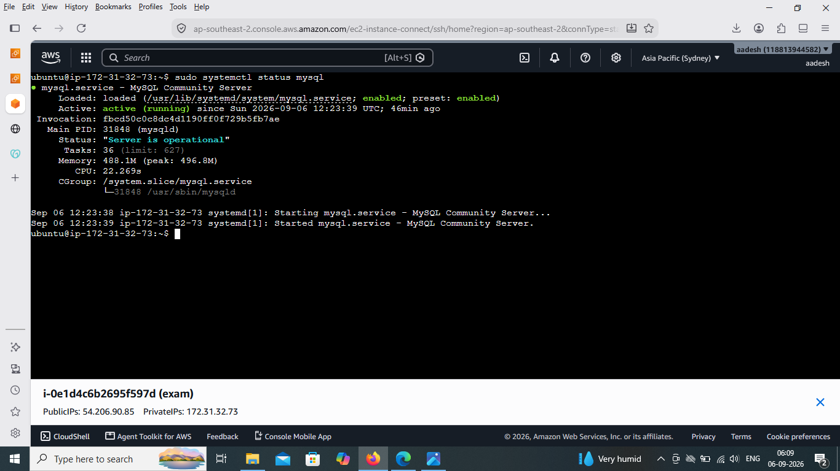
Details: Shows 'sudo systemctl status mysql'. MySQL is loaded, enabled, and active (running), with the server reported as operational.
Verification/Result: Result: the database service is running correctly.
Visible command(s):
sudo systemctl status mysql

Screenshot 20 — PHP Version Verification
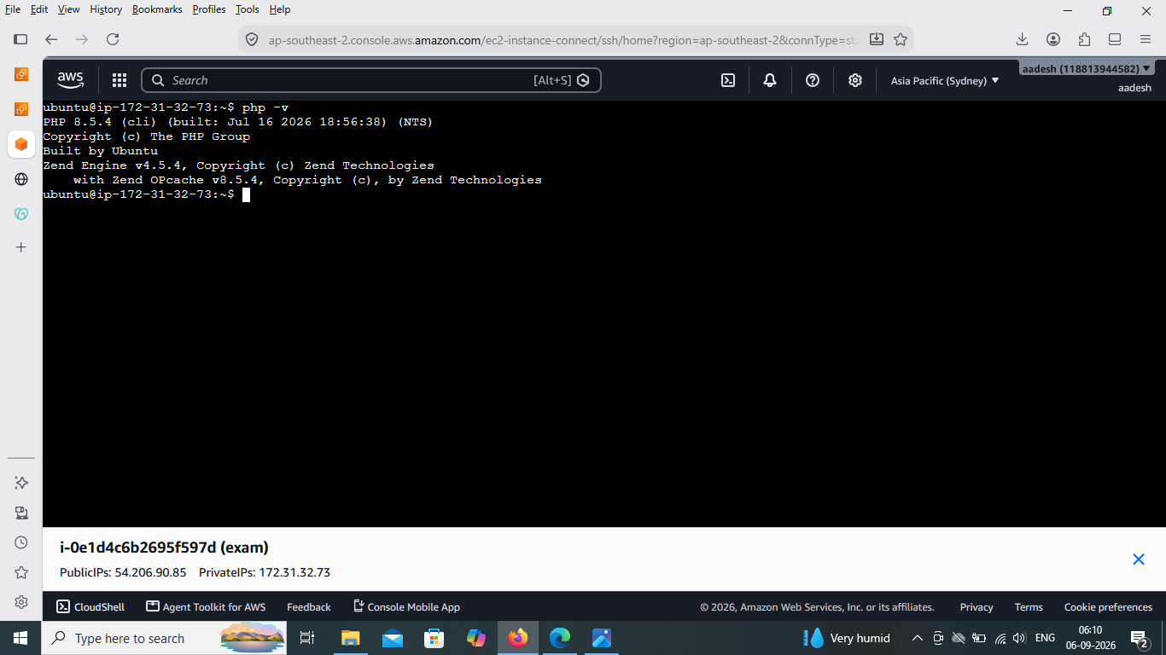
Details: Shows 'php -v' returning PHP 8.5.4 (CLI), together with Zend Engine information.
Verification/Result: Result: PHP is installed and available on the server.
Visible command(s):
php -v

Screenshot 22 — Localhost Application Test with curl
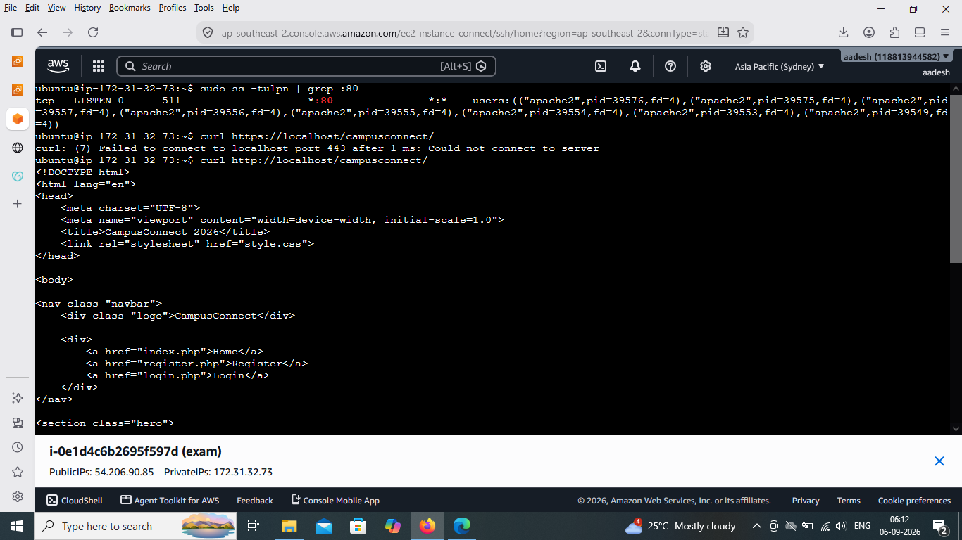
Details: Shows 'curl http://localhost/campusconnect/' returning the application's HTML source, including the CampusConnect 2026 title, stylesheet reference, navigation links, and hero section.
Verification/Result: Result: Apache successfully serves the CampusConnect application locally.
Visible command(s):
sudo ss -tulnp | grep :80
curl https://localhost/campusconnect/
curl http://localhost/campusconnect/

Final Verification Summary
- AWS EC2 instance is running and provides the server environment.
- The Linux 'campus' user was created and verified as a sudo-group member.
- The campusconnect MySQL database contains the students table with the expected registration fields.
- Apache is enabled and active, and the CampusConnect PHP files are present in the Apache web directory.
- PHP 8.5.4 is installed and available from the command line.
- The CampusConnect 2026 home page, registration page, login page, and dashboard are reachable in the browser.
- Successful registration data is stored in MySQL, and the password shown in the database is hashed rather than plain text.
- Invalid login attempts are rejected with an appropriate error message.
- The localhost curl test returns the CampusConnect HTML, confirming the application is being served by Apache.

End of Report

