**Detailed Report on Address Resolution Protocol (ARP) Simulation**

**Using Cisco Packet Tracer**

**1. Introduction to Address Resolution Protocol (ARP)**

The Address Resolution Protocol (ARP) is a crucial communication protocol primarily used in IPv4 networks to map logical IP addresses to physical MAC (Media Access Control) addresses. This translation is essential because while IP addresses provide logical device identification for routing, the actual data transmission in local area networks (LAN) relies on MAC addresses to deliver frames to the correct hardware.

Within the OSI networking model, ARP functions between Layer 3 (Network) and Layer 2 (Data Link), effectively bridging the gap between IP routing and physical address delivery.

**2. Objectives of the Simulation**

* To demonstrate ARP's function in resolving IP addresses to MAC addresses in a LAN environment.
* To visualize the ARP request-reply cycle dynamically using Cisco Packet Tracer.
* To analyze ARP cache operations and understand broadcast domain impact.
* To explore network efficiency gained by using ARP caching.
* To discuss relevant security considerations related to ARP.

**3. Network Setup Details**

**3.1 Device and IP Address Configuration**

In this simulation:

|  |  |  |
| --- | --- | --- |
| Device | IP Address | Example MAC Address |
| PC1 | 10.0.0.1 | 00-14-22-01-23-45 |
| PC2 | 10.0.0.2 | 00-14-22-02-34-56 |
| PC3 | 10.0.0.3 | 00-14-22-03-45-67 |
| PC4 | 10.0.0.4 | 00-14-22-04-56-78 |
| PC5 | 10.0.0.5 | 00-14-22-05-67-89 |
| PC6 | 10.0.0.6 | 00-14-22-06-78-9A |
| PC7 | 10.0.0.7 | 00-14-22-07-89-AB |
| PC8 | 10.0.0.8 | 00-14-22-08-9A-BC |
| PC8 | 10.0.0.9 | 00-14-22-09-AB-CD |

All PCs are connected through a Layer 2 switch within the same subnet (e.g., 10.0.0.0/24), allowing broadcast communication necessary for ARP processes.

**4. ARP Protocol Fundamentals**

**4.1 ARP Packet Structure and Contents**

Each ARP packet contains:

* Hardware Type (Ethernet)
* Protocol Type (IPv4)
* Hardware Size (6 bytes for MAC)
* Protocol Size (4 bytes for IPv4)
* Operation Code (1 for ARP request, 2 for ARP reply)
* Sender MAC and IP addresses
* Target MAC and IP addresses (in ARP requests, target MAC is unknown and set to zero)

**4.2 ARP Mechanism**

* When a source device needs to communicate with a device for which it knows the IP address but not the MAC address, it broadcasts an ARP request packet across the LAN.
* Every device on the LAN receives the broadcast.
* The device with the matching IP address responds directly with an ARP reply containing its MAC address.
* The source device receives this reply and updates its ARP cache to store the IP-to-MAC mapping.
* This cache reduces network traffic by avoiding repeated ARP requests for known addresses.

**5. Simulation Walkthrough**

**5.1 Initial Communication: PC1 to PC8**

* PC1 initiates communication with PC8 by sending a ping message (ICMP echo request) to 10.0.0.8.
* Since PC1’s ARP cache initially lacks an entry for PC8’s IP, it broadcasts an ARP request on the network to find the MAC address associated with 10.0.0.8.
* 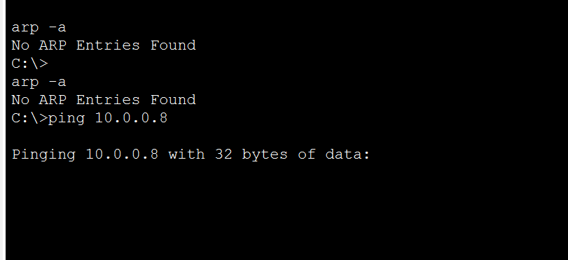
* 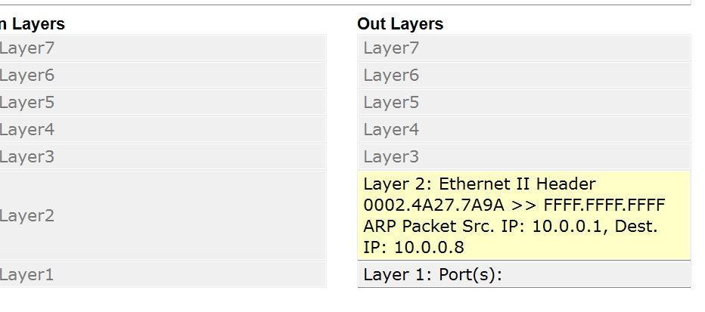

**5.2 Broadcasting ARP Request**

* The ARP request uses a broadcast destination MAC address, FF:FF:FF:FF:FF:FF.
* The Layer 2 switch forwards this broadcast frame out all ports except the one it arrived on.
* PCs 2 through 8 receive the request but discard it since the target IP is not theirs.
* 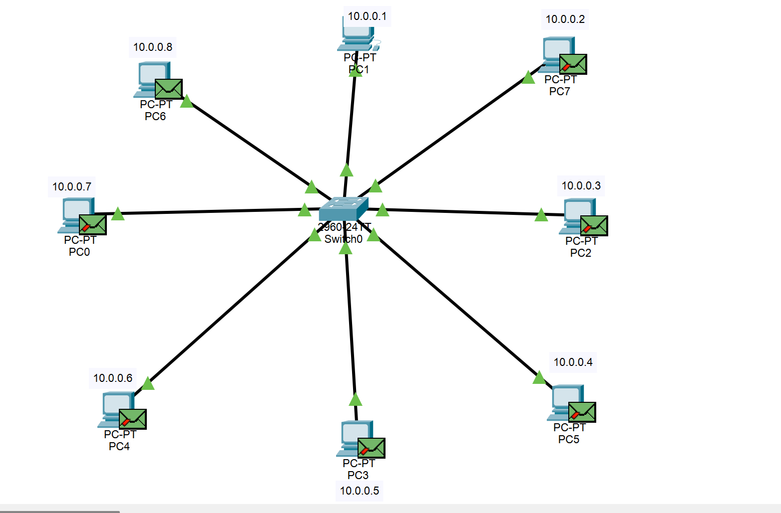

**5.3 Receiving and Responding by PC8**

* PC8 recognizes its IP address in the ARP request.
* PC8 crafts an ARP reply message containing its MAC address and unicasts it back to PC1.
* 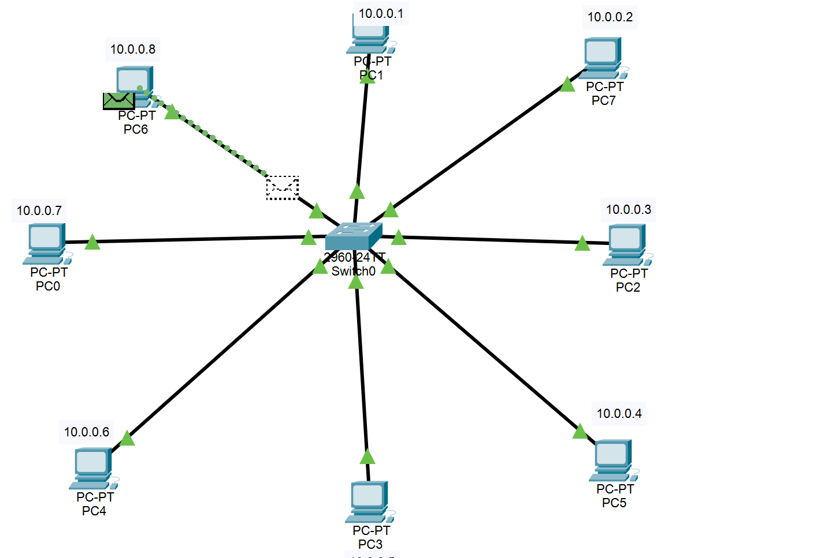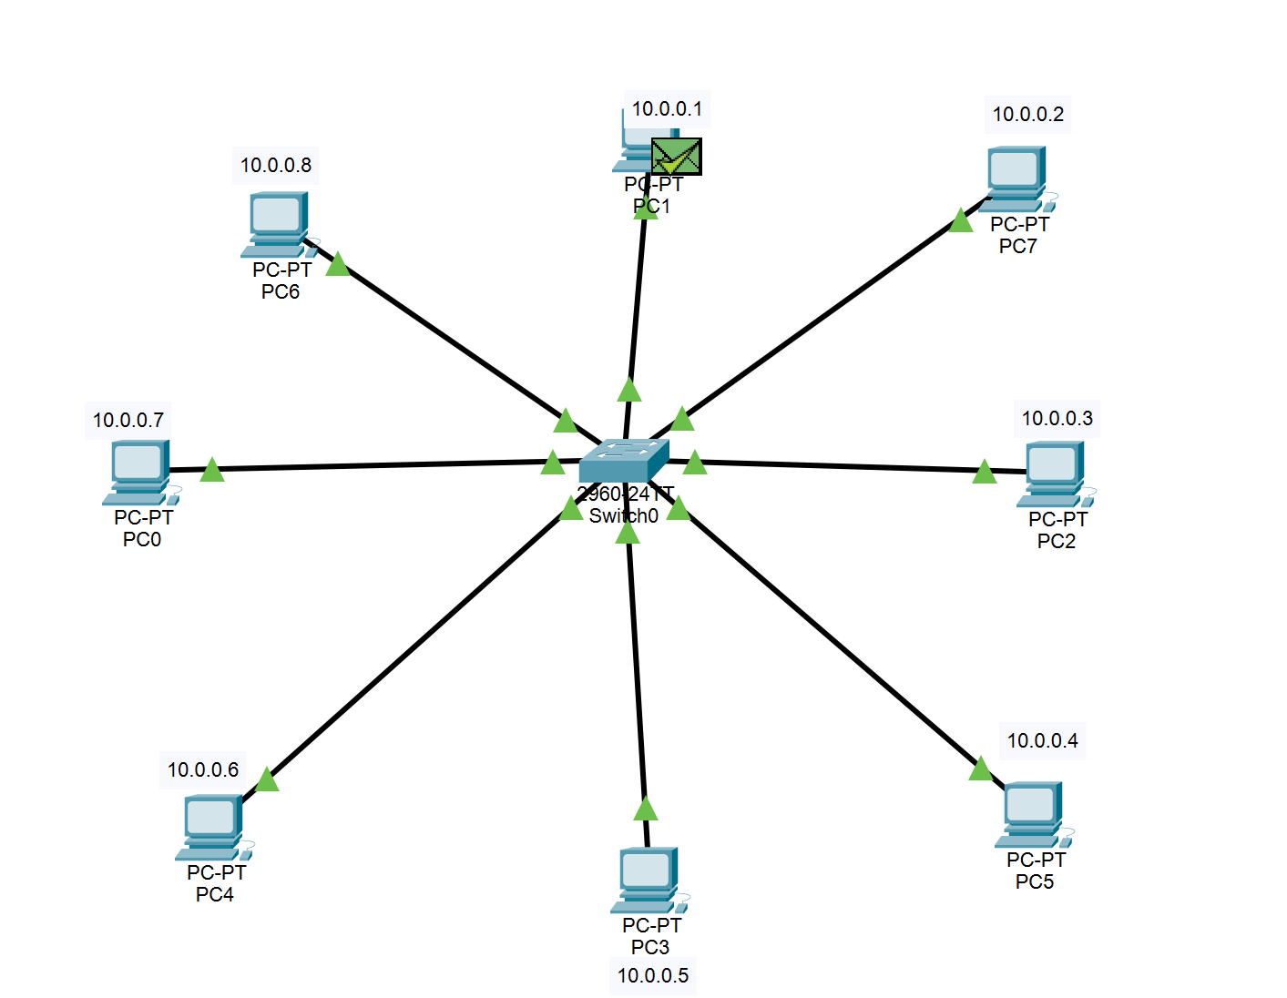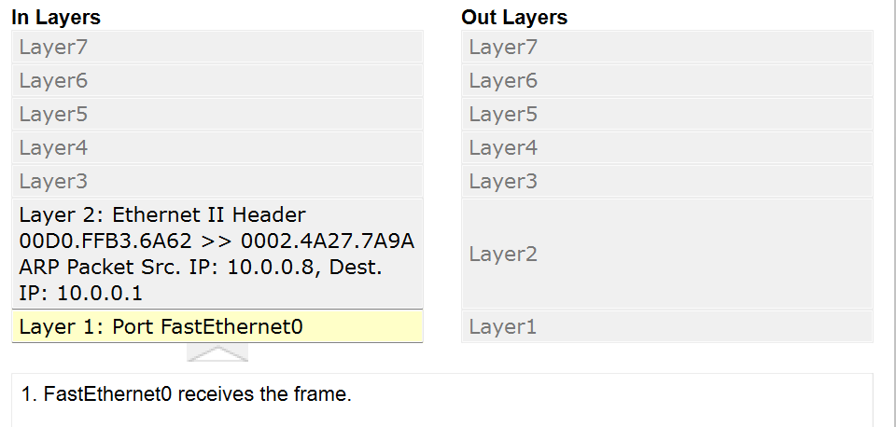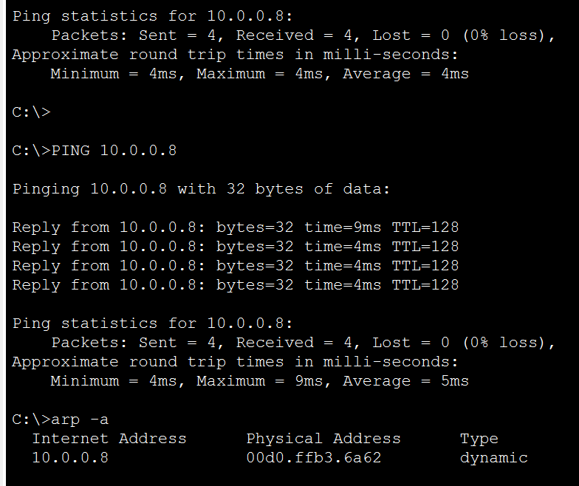

**5.4 Completing the Address Resolution and Communication**

* PC1 receives the ARP reply and records PC8’s MAC address in its ARP cache.
* Subsequent ICMP packets are sent using the resolved MAC address inside Ethernet frames.
* PC8 responds with ICMP echo replies completing the ping process.

**6. ARP Cache Details**

* Each device maintains an ARP cache holding recent IP-to-MAC mappings.
* The cache entries have a timeout period after which they expire and must be refreshed via new ARP requests.
* ARP cache significantly reduces network overhead and accelerates communication.

**7. Visualizing ARP in Cisco Packet Tracer**

* The simulation mode in Cisco Packet Tracer lets users see packets in transit, including ARP request and reply frames.
* The ARP packets can be filtered to focus only on relevant traffic.
* The packet details show layer 2 (MAC) and layer 3 (IP) addresses, operation codes, and broadcast vs unicast delivery.
* Command prompt utilities inside simulated PCs can display current ARP cache entries (arp -a).

**8. Advanced Observations and Practical Aspects**

* **Broadcast Domains:**  
  ARP broadcasts remain within a subnet; communications across subnets require routed traffic.
* **Switch Behavior:**  
  Switches forward broadcasts to all appropriate ports and learn MAC addresses dynamically to optimize traffic flows.
* **Dynamic Addressing:**  
  ARP allows devices to join and communicate without manual MAC address configuration.
* **Impact on Network Performance:**  
  Inefficient or excessive ARP (e.g., broadcast storms) can degrade network performance.
* **Security Risks:**  
  ARP spoofing attacks manipulate ARP replies to misdirect traffic; network security practices should mitigate such risks.

**9. Summary and Conclusion**

This comprehensive simulation of ARP via Cisco Packet Tracer clarifies the crucial role ARP plays in local network communications. The step-by-step broadcast request and unicast reply process exemplifies how devices dynamically discover necessary hardware addresses to enable IP-based communications.