Name – Aadil Nawaz

Email – nawazaadil002@hotmail.com

Course Name – Devops Pro

Assignment – 1

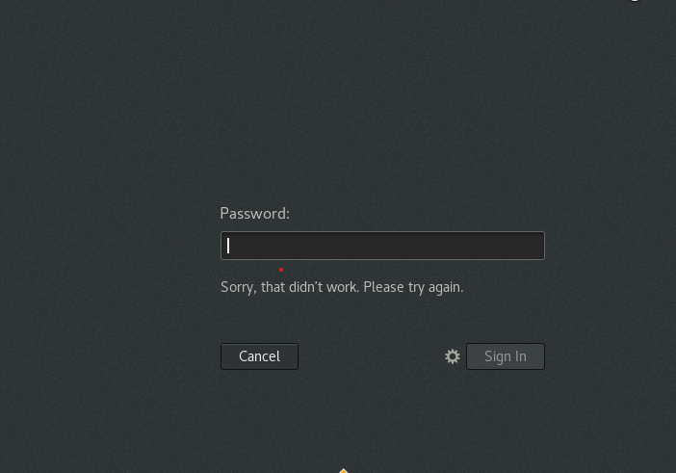

Above is screen shot captured when I tried to login through non-existent user or username.

It did not allow the non-existent user to login, which show that only authorized users are allowed to login to system with valid credentials. If credential is not correct the system will not be authenticated the user to login.

Assignment -2

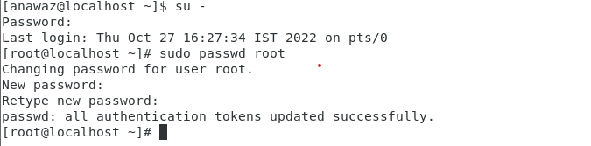

The above is screen shot is captured after changing the password for IneuR0n#4. First I needed to logged in the system as sudo user by giving “su - ” command then entering current login password, which is confirmed by symbol changing of $ to #.The system then is asking to enter new password and confirm the same by re-entering it. Once both the password is entered the system is updating all the authorization token which means that credential use for login and other places where credential are required is updated by the system. This confirms that password have been updated.

As this change only the root user password , the login credential remains the .

The above is screen shot captured when I tried to change the password to 1234 or abcd , because it did not matched the password criteria of the system as states that password have to be greater then 8 characters.

Above is screen shot captured when I did not gave any password .The above message shows that password cannot be blank and if continuously give blank password it throws authentication token manipulation error which mean that it fails to update the token with give credential.

Assignment -3

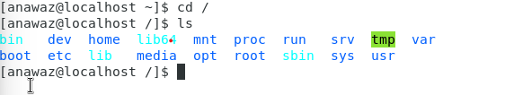

The command - cd / , takes us to root directory of our system. Then ls command list all the directory inside the root(/) directory.

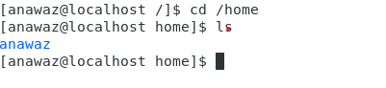

cd /home directory is used to go to home directory from root(/) directory.

Cd .. this will bring us to parent directory of current working directory .

Cd /var/www/html gives that no such file or directory is present in our system. On going inside the var directory we see there is no directory named “www”. This is the reason it gave us the result as no directory found.

cd /root it gives permission denied because I do not have execute power of /root folder.

On further giving ls command it list the directory inside present working directory.

Assignment -4

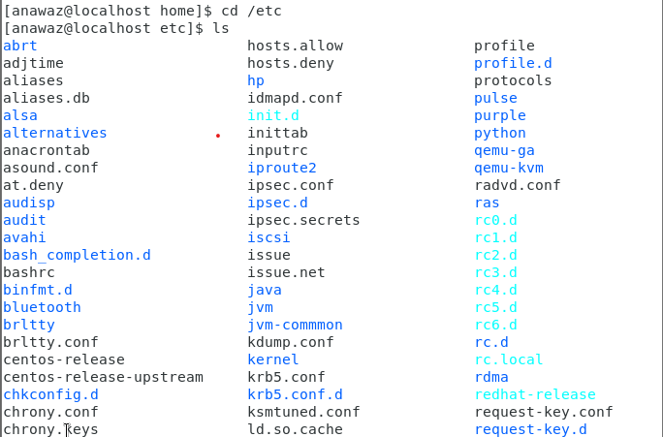

The above screen shot is captured after getting into etc folder and listing its file by giving ls command .The etc folder contains the configuration file. This can be said as the nerve centre of Linux machine.

The difference in output to previous command used is that it is listing executable file (in green) , directory (in blue ) apart from these two which was listed earlier as well we have normal file also list in etc folder which is highlighted by non – colour text .

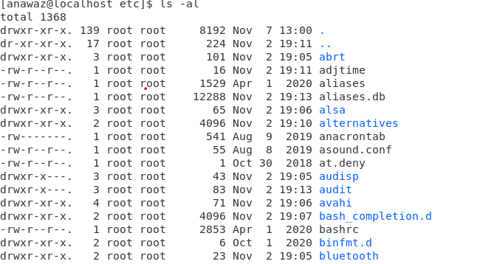

The above is snap on giving the ls – al command .This gives us all the file including hidden files in current directory. It also give us the count of total element inside the current directory.

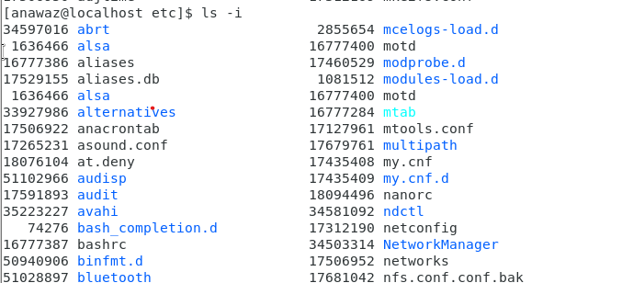

The above is snap after giving ls – i .This gives index number of each file inside the current directory.

Assignment – 5

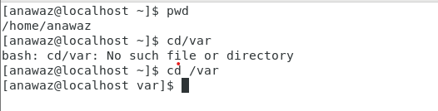

On giving pwd command it gives us current directory , pwd stand for present working directory.

On giving cd /var it take us to var directory inside root directory.