Solution 1.



On giving nano file1.txt it create a nano txt new file with name file1 and will directly take us to newly created file .If same file already exist then it will not create a new file instead will directly take us to that existing file. Below is the screen which will open and we can edit it as per requirement .We can save it by ctrl +o and can exit by ctrl+x.

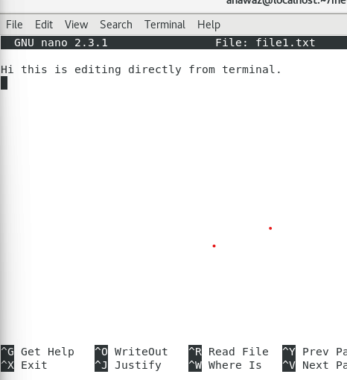

Solution 3.

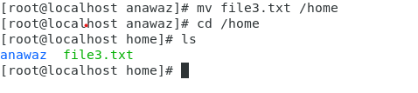

Above screen shot is for mv command .On executing **mv file2.txt /home** it moved the file from present directory to /home directory.

Solution 4.

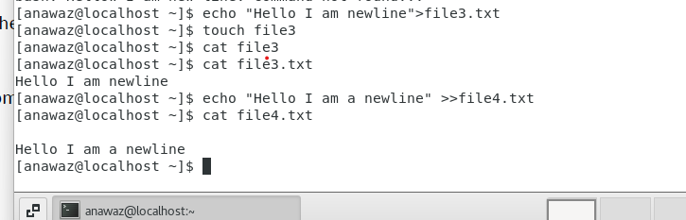

The difference between the **echo “Hello I am newline” > file3.txt and** do **echo “Hello I am newline” >> file3.txt**

The former insert the txt with any line gap but the latter will leave a line to insert a line.

Solution -5



Rm file1.txt will delete the file from the current directory.



Rmdir -r will delete the non empty directory.