Name : Aadil Mohamed Reg No : 22BCE2436

Course Title: Probability and Statistics Lab Course Code: BMAT 202P

Faculty: Parvez Alam

Digital Assignment-1

Question-1

Collect the data on marks of at least 60 students on your own. and analyse the followings.

1. Mean, Median & Mode
2. Range, variance, standard deviation, mean deviation, coefficient of variation and coefficient of quartile deviation

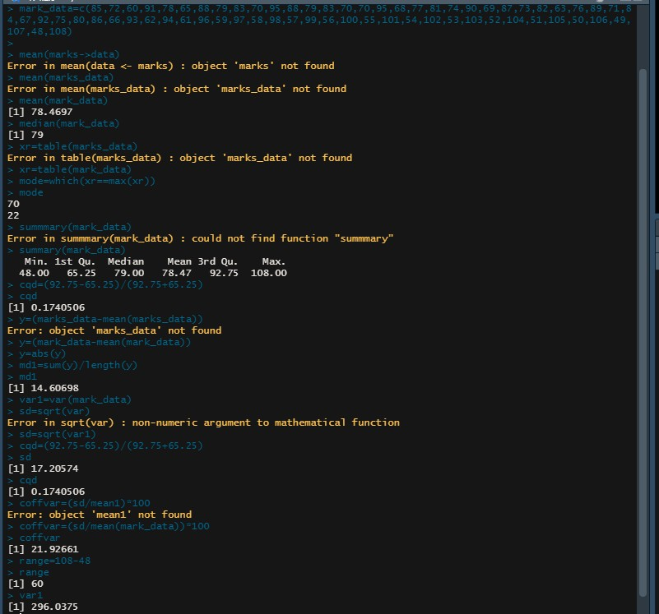

**Program Screenshot**

