Report of
AI-Based Personalized Academic Course Planner
Using Rule-Based Reasoning and Constraint Satisfaction
For
3CS111CC26
Artificial Intelligence
B.Tech. Semester V

Report Prepared By
Aadit Shah (24BAM005)
Ayush Tiwari (24BAM006)
School of Technology
Institute of Technology
Nirma University
Ahmedabad 382481
September 2026

Table of Contents
Section | Page
Abstract | 3
1. Introduction | 3
2. Problem Statement | 4
3. AI Concepts Covered | 4
3.1 Hybrid AI | 4
3.2 Rule-Based Reasoning | 4
3.3 Knowledge Representation | 5
3.4 Constraint Satisfaction Problem | 5
3.5 Backtracking, MRV and Forward Checking | 5
3.6 Preference-Based Ranking and Explainability | 6
4. System Architecture | 6
4.1 Overall Architecture | 6
4.2 Knowledge Base and Student Profile | 7
4.3 Eligibility Inference | 7
4.4 CSP Formulation and Constraints | 7
4.5 Solver Pipeline | 8
5. Python and Streamlit Implementation | 8
5.1 Project Structure | 8
5.2 Rule Engine | 9
5.3 CSP and Hard Constraints | 9
5.4 Solver Implementations | 10
5.5 Preference Evaluation and Explanations | 10
5.6 Streamlit Interface | 10
6. Testing and Validation | 11
7. Output and Results | 11
7.1 Eligibility Analysis | 11
7.2 CSP Formulation | 12
7.3 Solver Comparison | 12
7.4 Personalized Plans and Explanations | 13
7.5 No-Solution Scenarios | 13
8. Conclusion | 14
References | 14

Abstract
This report presents an AI-based personalized academic course planning system developed as an Innovative Assignment for the Artificial Intelligence course. The application uses a Hybrid AI approach that combines rule-based reasoning with a Constraint Satisfaction Problem (CSP). A JSON knowledge base stores course information such as semester, credits, prerequisites, course type, specialization and available time slots. A custom inference engine determines course eligibility from the student's current semester, completed courses and prerequisites. Eligible Semester-5 courses are then formulated as CSP variables whose domains contain their available time slots. Hard constraints enforce credit limits, blocked time slots and timetable conflict avoidance. Three manually implemented solvers—Basic Backtracking, Backtracking with Minimum Remaining Values (MRV), and MRV with Forward Checking—are compared using search metrics. Feasible plans are ranked using simple student preferences, and an explanation module describes eligibility decisions, plan validity and preference scores. The system is presented through a Streamlit interface that integrates reasoning, search, personalization and explanations in a single workflow.

1. Introduction
Academic course planning is a decision-making problem in which several conditions must be satisfied simultaneously. A student may need to complete prerequisite courses, remain within a credit limit, avoid timetable clashes, respect unavailable time slots and still prefer courses aligned with a particular specialization. A simple list of courses does not provide a systematic way to handle all of these requirements together.
This project models academic planning as a Hybrid AI problem. Rule-based reasoning is first used to determine which courses are eligible. The remaining Semester-5 choices are represented as a CSP and solved using search techniques. The resulting valid plans are then evaluated according to student preferences so that the application provides personalized rather than merely feasible schedules.
The implementation is intentionally compact and educational. It uses Python, JSON, Streamlit and the Python unittest framework, without machine-learning models, databases or external AI APIs.

2. Problem Statement
Design and implement a Python-based AI system that generates personalized Semester-5 academic course plans for a student while satisfying academic and timetable constraints.
The system must:
- Represent course and prerequisite knowledge in a structured knowledge base.
- Determine course eligibility using explicit reasoning rules.
- Formulate eligible Semester-5 courses as a Constraint Satisfaction Problem.
- Respect maximum credits, blocked time slots and timetable conflicts as hard constraints.
- Compare multiple CSP search strategies using measurable execution metrics.
- Rank feasible plans according to simple student preferences.
- Explain why courses are eligible or rejected and why generated plans are valid or preferred.

3. AI Concepts Covered

3.1 Hybrid AI
The project combines symbolic reasoning and search-based problem solving. The rule engine performs explicit logical checks, while the CSP solvers perform systematic search over possible course-slot assignments. Preference scoring is applied after feasibility is established.

3.2 Rule-Based Reasoning
Course eligibility is implemented through four ordered rules. The first applicable rule produces the eligibility decision and an explanation.
Rule | Condition | Result
R1 | Course is already completed | Ineligible
R2 | Course belongs to a different semester | Ineligible
R3 | One or more prerequisites are missing | Ineligible
R4 | Semester and prerequisite requirements are satisfied | Eligible

3.3 Knowledge Representation
The course knowledge base is stored in JSON and converted into Python Course objects. Each course contains a course ID, name, semester, credits, category, prerequisites, offered slots, course type and specialization. A separate StudentProfile object stores the student's semester, completed courses, maximum credits and preferences.

3.4 Constraint Satisfaction Problem
After eligibility filtering, each eligible course becomes a CSP variable. Its domain contains the available time slots. Elective courses additionally receive the value NOT_SELECTED, allowing the solver to represent an optional course explicitly.
Example:
AI301 → [MON-09, WED-11]
CMAI301 → [TUE-10, THU-10]
DL301 → [MON-09, THU-14]
OST301 → [TUE-10, FRI-10, NOT_SELECTED]

3.5 Backtracking, MRV and Forward Checking
Basic Backtracking assigns variables in their original order and recursively explores legal values. MRV improves variable selection by choosing the unassigned course with the smallest currently legal domain. Forward Checking further propagates the effect of each assignment by removing invalid values from future variables and stopping a branch when a future domain becomes empty.
Solver | Main idea
Basic Backtracking | Try values in normal variable order and backtrack when constraints fail.
Backtracking + MRV | Choose the most constrained unassigned variable first.
MRV + Forward Checking | Use MRV and prune future domains after each assignment.

3.6 Preference-Based Ranking and Explainability
Hard constraints determine whether a plan is valid. Preferences are applied only after feasible plans have been generated. A plan receives +10 when a selected course matches the preferred specialization and +5 when its assigned slot is one of the preferred slots. Plans are sorted in descending preference score. The explanation module reports the score contributions and summarizes why the plan satisfies the hard constraints.

4. System Architecture
The system follows a modular pipeline. The Streamlit interface collects the student profile, the knowledge base supplies course facts, the inference engine determines eligibility, the CSP module constructs variables and domains, the solver module searches for feasible assignments, and the evaluator and explanation modules process the resulting plans.
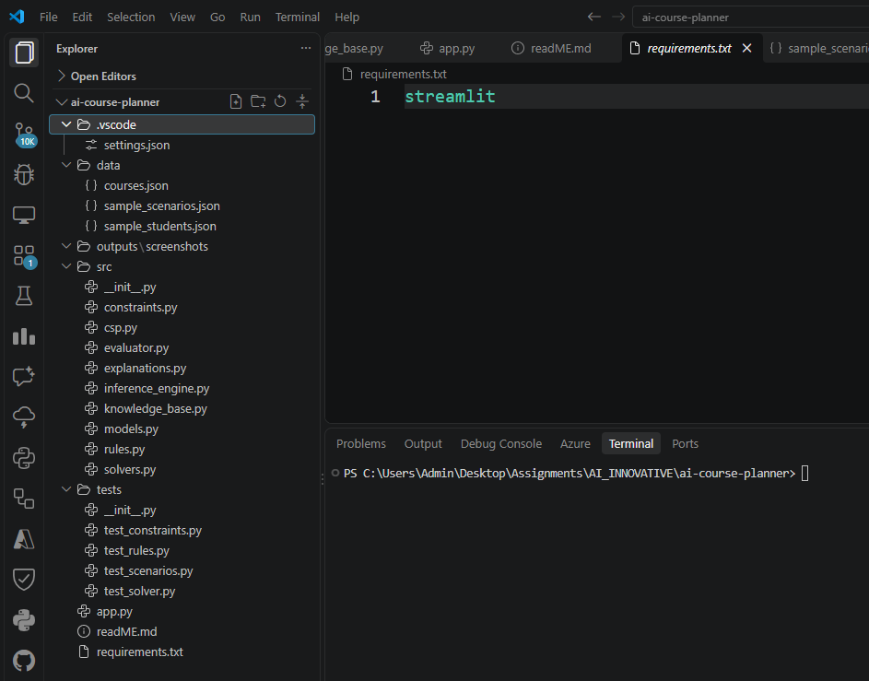
Overall System Architecture / Workflow
Figure 1: Overall workflow from student profile to eligibility reasoning, CSP search, preference ranking and explanations.

4.1 Overall Architecture
Module | Responsibility
app.py | Streamlit user interface and end-to-end application workflow.
models.py | Course and StudentProfile data structures.
knowledge_base.py | Loads JSON course and student information.
rules.py | Defines the four eligibility rules.
inference_engine.py | Applies rules to every course.
csp.py | Builds variables and domains for eligible courses.
constraints.py | Checks blocked slots, timetable conflicts and credit limits.
solvers.py | Implements Basic Backtracking, MRV and Forward Checking.
evaluator.py | Scores and ranks feasible plans.
explanations.py | Generates human-readable explanations.

4.2 Knowledge Base and Student Profile
The demonstration catalogue contains 30 subjects from Semester 1 through Semester 5. Earlier-semester subjects are primarily used as completed-course and prerequisite knowledge, while Semester 5 forms the main planning cycle.
Course ID | Course | Credits | Type | Specialization | Available Slots
AI301 | Artificial Intelligence | 4 | Mandatory | AI | MON-09, WED-11
CMAI301 | Computational Mathematics for AIML | 4 | Mandatory | Mathematics | TUE-10, THU-10
DL301 | Deep Learning | 4 | Mandatory | AI | MON-09, THU-14
OST301 | Open Source Technology | 4 | Elective | Software | TUE-10, FRI-10
DCN301 | Data Communication & Networking | 4 | Mandatory | Networks | THU-14, FRI-11
BDS301 | Big Data System | 4 | Mandatory | Data | WED-11, FRI-14

The prerequisite relationships in this demonstration are project-defined rules used to demonstrate AI reasoning; they are not presented as official university prerequisite regulations.

4.3 Eligibility Inference
For each course, the InferenceEngine applies the eligibility rules in order. The returned result contains the course ID, course name, status, rule ID and reason. The Streamlit interface displays the Semester-5 results in a readable table.

4.4 CSP Formulation and Constraints
Eligible courses become variables and their offered time slots become domains. For electives, NOT_SELECTED is added to the domain. The assignment is valid only when all hard constraints are satisfied.
Hard Constraint | Meaning
Blocked time slot | A selected course cannot be assigned to a slot blocked by the student.
Timetable conflict | Two selected courses cannot occupy the same time slot.
Maximum credits | The total credits of selected courses cannot exceed the student's limit.

4.5 Solver Pipeline
Eligible Courses
↓
CSP Variables + Domains
↓
┌───────────────┬──────────────────┬────────────────────────┐
│ Basic BT │ BT + MRV │ MRV + Forward Checking │
└───────────────┴──────────────────┴────────────────────────┘
↓
Feasible Plans
↓
Preference Scoring
↓
Ranked Plans + Explanations
Each solver records nodes explored, backtracks, execution time and solutions found. Forward Checking additionally records pruning events. The application compares the three approaches using the same CSP instance, making the search-strategy comparison meaningful.

5. Python and Streamlit Implementation

5.1 Project Structure
ai-course-planner/
├── app.py
├── requirements.txt
├── data/
│ ├── courses.json
│ ├── sample_students.json
│ └── sample_scenarios.json
├── src/
│ ├── models.py
│ ├── knowledge_base.py
│ ├── rules.py
│ ├── inference_engine.py
│ ├── csp.py
│ ├── constraints.py
│ ├── solvers.py
│ ├── evaluator.py
│ └── explanations.py
├── tests/
│ ├── test_rules.py
│ ├── test_constraints.py
│ ├── test_solver.py
│ └── test_scenarios.py
└── outputs/screenshots/

5.2 Rule Engine
The rule functions are kept independent so that each decision is easy to inspect and explain. InferenceEngine.evaluate_course() applies the ordered rule list to one course, while evaluate_all_courses() repeats the process for the complete knowledge base.
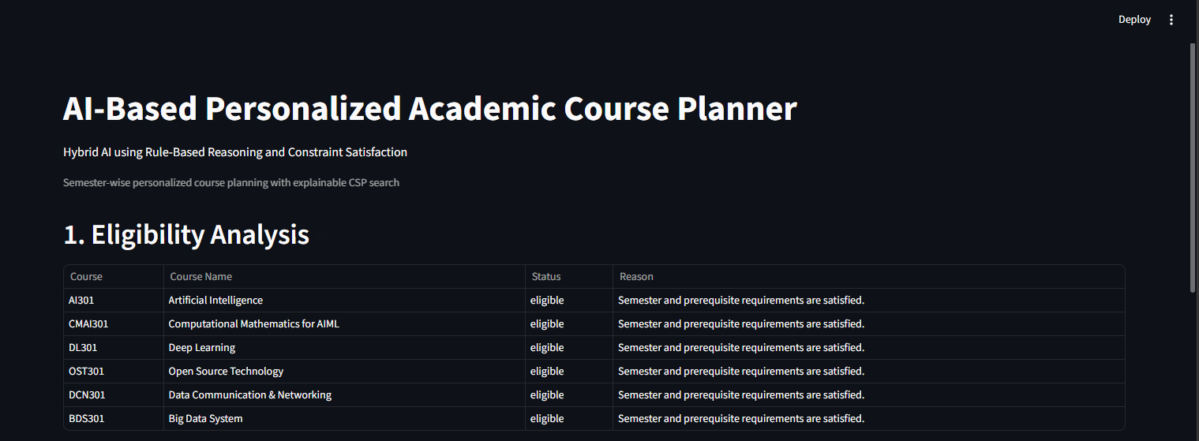
Eligibility Analysis
Figure 2: Streamlit eligibility table showing eligible/ineligible Semester-5 courses and the corresponding reasons.

5.3 CSP and Hard Constraints
The build_course_csp() function converts eligible courses into CSP variables and domains. The is_valid_assignment() function is shared by the solvers, ensuring that all solver variants use the same hard-constraint definition.
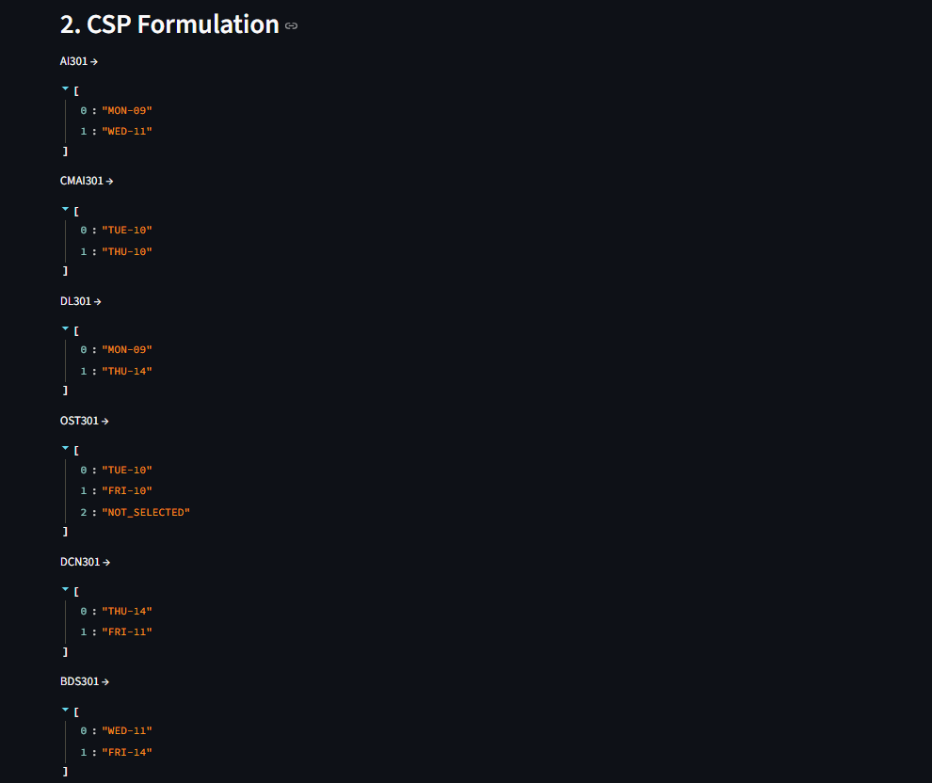
CSP Formulation
Figure 3: Streamlit CSP formulation showing each eligible course variable and its available domain values.

5.4 Solver Implementations
The three solvers are implemented manually rather than relying on a CSP library. Basic Backtracking chooses the first unassigned variable. MRV selects the variable with the fewest currently legal values. Forward Checking copies the current domains, removes values that are no longer valid and stops the branch when a future domain becomes empty.
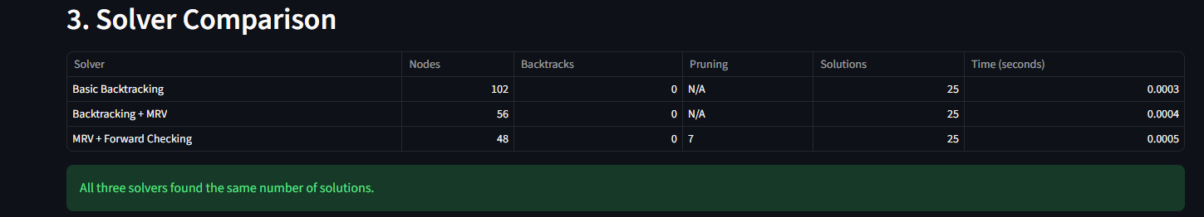
Solver Comparison
Figure 4: Streamlit solver comparison showing nodes explored, backtracks, pruning events, solutions and execution time.

5.5 Preference Evaluation and Explanations
The evaluator assigns a simple preference score after feasibility has already been established. This separation is important: preferences do not override hard constraints. The explanation functions then convert the computed information into short human-readable statements.

5.6 Streamlit Interface
The application provides sidebar inputs for student ID, current semester, completed courses, maximum credits, preferred specialization, preferred slots and blocked slots. After the Generate Academic Plan button is pressed, the interface displays the reasoning and search pipeline in four major sections: Eligibility Analysis, CSP Formulation, Solver Comparison and Personalized Academic Plans.
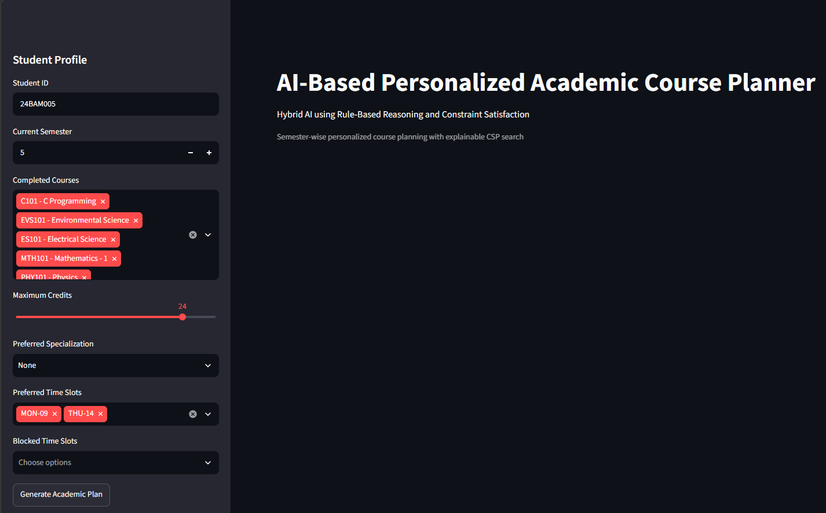
Main Streamlit Interface
Figure 5: Main Streamlit application showing student profile inputs and generated planning workflow.

6. Testing and Validation
The project includes a small unittest suite to validate the rule engine, hard constraints, solver consistency and predefined scenarios. The tests are separate from the main application and do not add any dependency to the planning workflow.
Test File | Coverage | Tests
test_rules.py | Eligibility and prerequisite reasoning | 2
test_constraints.py | Blocked slot, timetable conflict and credit limit | 3
test_solver.py | Solver consistency and Forward Checking metrics | 2
test_scenarios.py | Five predefined feasible/infeasible scenarios | 1
Total | Rules + constraints + solvers + scenarios | 8

The current implementation was executed with Python unittest discovery and all 8 tests passed. The test suite confirms that the three solvers return a consistent number of solutions for the normal scenario and that Forward Checking exposes pruning metrics.
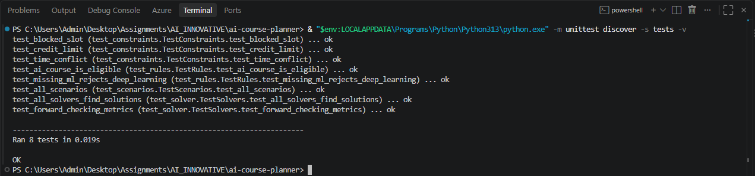
Unit Test Execution
Figure 6: Terminal output showing the unittest suite and the final 'Ran 8 tests ... OK' result.

Scenario Validation
Scenario | Purpose | Expected Outcome
S1 | Normal feasible Semester-5 profile | Feasible plans
S2 | Remove ML202 from completed courses | DL301 becomes ineligible
S3 | Maximum credits = 16 | No feasible plan
S4 | Block MON-09 and WED-11 | AI301 has no usable slot
S5 | Data specialization + FRI-14 preference | Feasible plans with altered ranking

7. Output and Results

7.1 Eligibility Analysis
For the default Semester-5 profile, all Semester-5 courses are eligible because the required earlier-semester courses are included in the completed-course set. When ML202 is removed from the completed courses, the rule engine marks DL301 as ineligible and reports ML202 as the missing prerequisite.
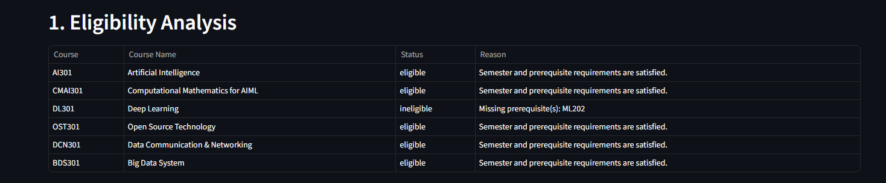
Eligibility Result
Figure 7: Eligibility analysis for the normal profile and/or missing-prerequisite scenario.

7.2 CSP Formulation
For the normal Semester-5 profile, the CSP contains six variables: AI301, CMAI301, DL301, OST301, DCN301 and BDS301. OST301 is the elective and therefore contains NOT_SELECTED as an additional domain value.
Variable | Domain
AI301 | MON-09, WED-11
CMAI301 | TUE-10, THU-10
DL301 | MON-09, THU-14
OST301 | TUE-10, FRI-10, NOT_SELECTED
DCN301 | THU-14, FRI-11
BDS301 | WED-11, FRI-14

7.3 Solver Comparison
A normal-profile execution produced 25 feasible plans with all three solvers. The number of explored nodes decreased as the search strategy became more informed. The exact execution time is machine-dependent and should be reported from the final screenshot/run used for submission.
Solver | Nodes Explored | Backtracks | Pruning | Solutions
Basic Backtracking | 102 | 0 | N/A | 25
Backtracking + MRV | 56 | 0 | N/A | 25
MRV + Forward Checking | 48 | 0 | 7 | 25

The result demonstrates the intended progression: MRV reduces the amount of search by selecting a more constrained variable, while Forward Checking additionally prunes values from future domains. All three methods preserve solution correctness for the tested scenario.

7.4 Personalized Plans and Explanations
After the feasible plans are generated, the evaluator assigns preference scores. A selected course matching the preferred specialization contributes 10 points, while a selected course assigned to a preferred time slot contributes 5 points. The highest-scoring plans are displayed first, with the top five plans shown by the interface.
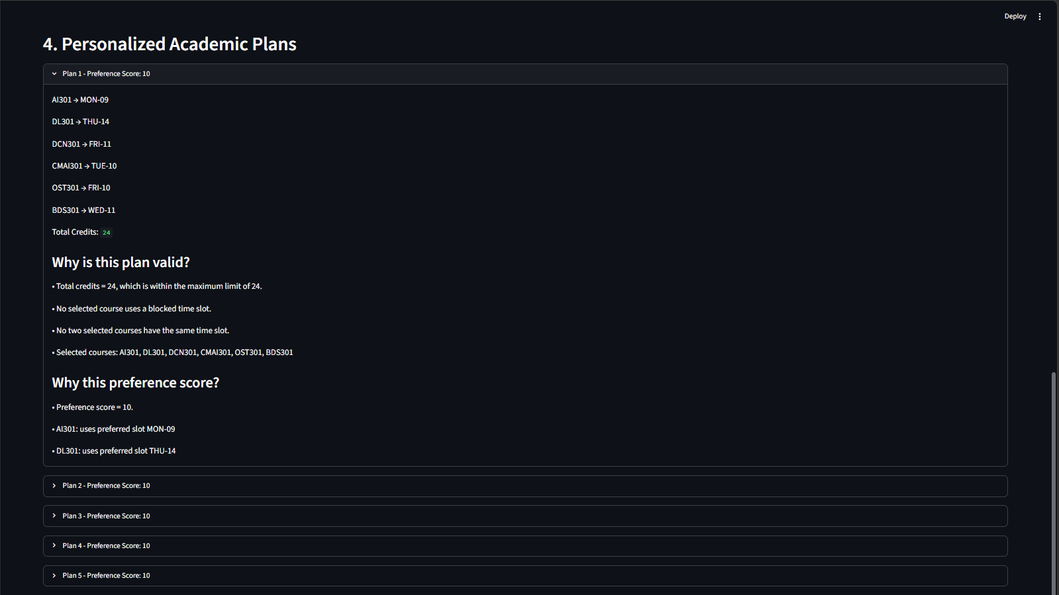
Personalized Academic Plans
Figure 8: Generated academic plans showing preference scores, selected course slots and total credits.
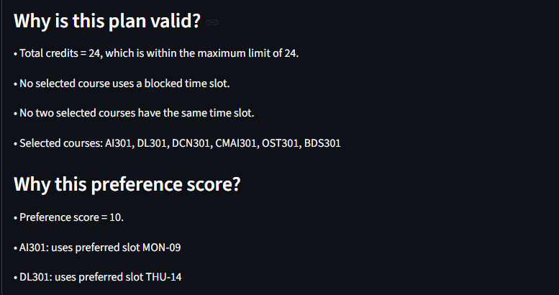
Plan Explanation
Figure 9: Explanation section showing why a plan is valid and why it received its preference score.

7.5 No-Solution Scenarios
The application also explains common infeasibility conditions. If the mandatory-course credit requirement already exceeds the student's maximum credit limit, the system reports that conflict. If a mandatory course has all of its available slots blocked, the system reports that the course cannot be scheduled. If neither specific explanation is detected, a general message states that no combination satisfies the current hard constraints.
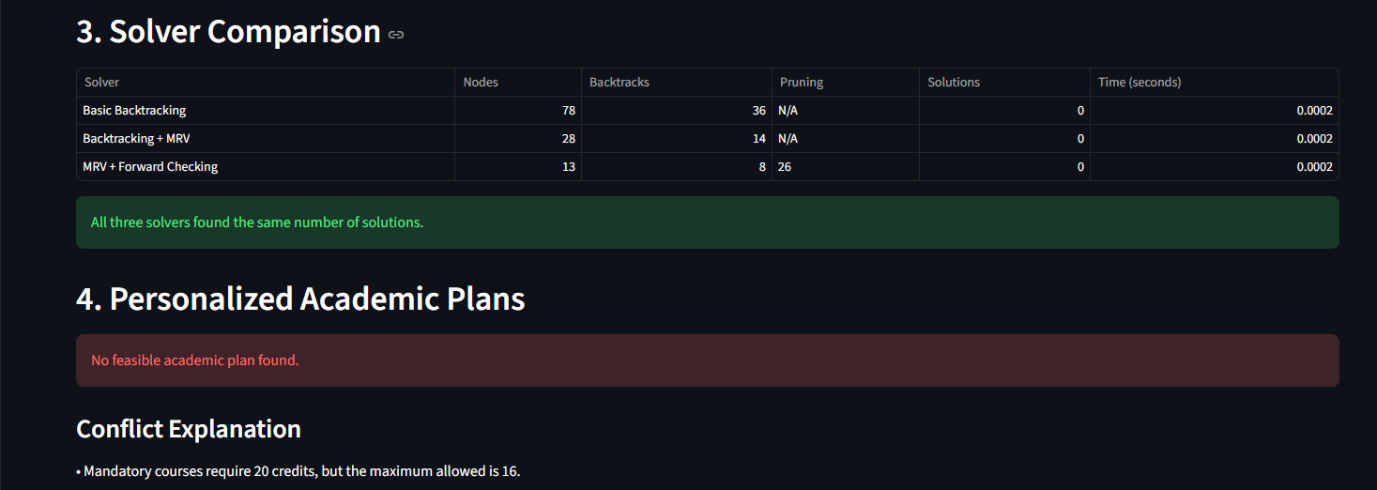
No-Solution Explanation
Figure 10: Example no-solution case showing the detected conflict and explanation.

8. Conclusion
The project successfully implements a compact Hybrid AI academic course planning system using rule-based reasoning and Constraint Satisfaction. The rule engine provides transparent eligibility decisions based on semester, completed courses and project-defined prerequisites. The CSP formulation converts course scheduling into a structured search problem with explicit domains and hard constraints.
The three manually implemented solvers demonstrate how heuristic selection and constraint propagation can improve search efficiency while maintaining solution correctness. MRV reduces the number of explored nodes compared with basic Backtracking in the tested scenario, while MRV with Forward Checking additionally records pruning events. The preference evaluator adds personalization after feasibility has been established, and the explanation module makes the resulting decisions easier to understand.
The implementation remains intentionally simple and modular for a Semester-5 Artificial Intelligence project. It demonstrates core symbolic AI and search concepts without introducing machine learning, databases or external AI services.

References
- Stuart Russell and Peter Norvig, Artificial Intelligence: A Modern Approach, 4th Edition, Pearson.
- Python Software Foundation, Python 3 Documentation.
- Streamlit Documentation, Streamlit Python Application Framework.
- Project knowledge base and source implementation: courses.json, rules.py, inference_engine.py, csp.py, constraints.py, solvers.py, evaluator.py and explanations.py.
- Project test suite: test_rules.py, test_constraints.py, test_solver.py and test_scenarios.py.

