Report of
MIPS Multi-Cycle Processor with Finite State Machine Based Control Unit
For
2CS504CC23

Computer Architecture
B.Tech. Semester IV

Report Prepared By


Aadit Shah (24BAM005)
Ayush Tiwari (24BAM006)

School of Technology
Institute of Technology
Nirma University
Ahmedabad 382481
March 2026

Table of Contents
Section | Page
Abstract | 3
1. Introduction | 3
2. Problem Statement | 4
3. CA Theory — Concepts Covered | 4
3.1 Single-Cycle vs Multi-Cycle CPU | 4
3.2 Instruction Cycle (Fetch-Decode-Execute-Memory-Writeback) | 5
3.3 Finite State Machine (FSM) Based Control Unit | 5
3.4 Datapath Components | 6
4. System Architecture | 7
5. Logisim Evolution Implementation | 8
6. Verilog Implementation & Simulation | 9
7. Output & Results | 10
8. Conclusion | 11
References | 11

Abstract
This report presents the design and simulation of a MIPS Multi-Cycle Processor with a Finite State Machine (FSM) based Control Unit, implemented as the Innovative Assignment for the Computer Architecture course (4th Semester, Nirma University). The project implements the fundamental principles of computer organization as described in Morris Mano's Computer System Architecture (3rd Edition), Chapters 8 and 9.
A multi-cycle CPU processes each instruction across multiple clock cycles — each cycle performing one atomic operation such as memory read, ALU computation, or register write. The Control Unit is realized as an FSM with five well-defined states: Instruction Fetch, Instruction Decode, Execute, Memory Access, and Writeback. This approach contrasts with single-cycle design where all stages collapse into one long combinational path.
The implementation is demonstrated in two platforms: Logisim Evolution (visual circuit simulation) and Verilog HDL with Icarus Verilog + GTKWave. Correct execution is verified by running four test programs: ADD, LOAD WORD, STORE WORD, and JUMP — each producing the expected register and memory results.

1. Introduction
Modern processors execute instructions through a structured sequence of stages. In a single-cycle processor, every instruction — regardless of complexity — takes exactly one clock cycle. This forces the clock period to accommodate the slowest instruction, making the design inherently inefficient.
The Multi-Cycle MIPS Processor solves this by breaking each instruction into discrete steps. Each step takes one clock cycle, and simpler instructions complete in fewer cycles than complex ones. The Control Unit, implemented as a Finite State Machine, decides which step to execute at each clock edge by transitioning through a well-defined sequence of states.
This project is grounded in Mano's description of the Basic Computer (Chapters 5, 8) and multi-cycle CPU organization (Chapter 9). The Logisim Evolution circuit provides visual, step-by-step execution that demonstrates how data flows through the datapath under control signal direction. The Verilog simulation provides GTKWave waveform output confirming signal-level correctness.

2. Problem Statement
Traditional single-cycle CPU designs suffer from two fundamental limitations: (1) the critical path length is determined by the slowest instruction, forcing all instructions to wait; and (2) hardware resources such as memory and the ALU are used only once per cycle, resulting in underutilization.
The multi-cycle approach addresses both issues by reusing hardware across cycles and allowing each instruction to take only as many cycles as it truly needs. However, this introduces a new challenge: the Control Unit must correctly sequence the control signals across multiple clock cycles. A poorly designed control unit produces incorrect signals at the wrong cycles, causing data corruption or program failure.
This project implements and verifies a correct multi-cycle MIPS processor, demonstrating that the FSM-based Control Unit properly sequences all five instruction stages and generates correct outputs for arithmetic, memory, and branch/jump instructions.

3. CA Theory — Concepts Covered
All concepts in this project are drawn directly from the Computer Architecture course syllabus, corresponding to Morris Mano's Computer System Architecture (3rd Edition).

3.1 Single-Cycle vs Multi-Cycle CPU
Parameter | Single-Cycle CPU | Multi-Cycle CPU (this project)
Clock period | Fixed — slowest instruction | Shorter — one step per cycle
Memory units | Two separate (IM + DM) | One shared memory
Hardware reuse | None — ALU used once | ALU reused across cycles
Control Unit | Combinational logic | FSM (sequential)
Cycles per instr. | Always 1 | 3 to 5 depending on type

3.2 Instruction Cycle
Every MIPS instruction passes through up to five stages in the multi-cycle design. Each stage corresponds to one FSM state and one clock cycle:
State | Stage | Operations Performed
S0 | Instruction Fetch (IF) | IR <- Mem[PC]; PC <- PC + 4; ALUSrcA=0, IorD=0, IRWrite=1, PCWrite=1
S1 | Instruction Decode (ID) | A <- Reg[rs]; B <- Reg[rt]; ALUOut <- PC + SignExt(IR[15:0]) << 2
S2 | Execute (EX) | ALUOut <- A op B (R-type); or ALUOut <- A + SignExt(imm) (I-type)
S3 | Memory Access (MEM) | MDR <- Mem[ALUOut] (LW); or Mem[ALUOut] <- B (SW)
S4 | Writeback (WB) | Reg[rd] <- ALUOut (R-type); or Reg[rt] <- MDR (LW)

3.3 FSM-Based Control Unit
The Control Unit is the most critical component of the multi-cycle processor. It is implemented as a Mealy/Moore Finite State Machine. Unlike combinational control (used in single-cycle designs), the FSM maintains state across clock cycles — each state activates a specific set of control signals, and the next state is determined by the current state and the instruction opcode.
The FSM has the following properties:
- States: S0 (Fetch), S1 (Decode), S2 (Execute), S3 (Memory), S4 (Writeback)
- Inputs: Op[5:0] — the 6-bit opcode field of the fetched instruction
- Outputs: 11 control signals — PCWrite, PCWriteCond, IorD, MemRead, MemWrite, MemtoReg, IRWrite, PCSource[1:0], ALUSrcA, ALUSrcB[1:0], ALUOp[1:0], RegWrite, RegDst
- Transitions: S0 always goes to S1. From S1, the opcode determines which path is taken — R-type goes S2->S4, LW goes S2->S3->S4, SW goes S2->S3, BEQ goes S2, J goes directly to PC update

3.4 Datapath Components
The datapath consists of the following components, each corresponding to a Mano textbook component:
Component | Mano Reference | Function
PC (Program Counter) | Ch. 5 — Register | Holds address of next instruction; written by FSM
Instruction Register (IR) | Ch. 5 — IR | Holds fetched instruction during decode and execute
Register File (32x32) | Ch. 8 — Register File | 32 general-purpose registers; 2 read ports, 1 write port
ALU | Ch. 10 — Arithmetic | Performs ADD, SUB, AND, OR, SLT; controlled by ALUControl
ALU Control | Ch. 10 — ALU Decoder | Converts ALUOp[1:0] + Funct[5:0] to 3-bit ALU operation
Memory (shared) | Ch. 8 — Memory Unit | Used for both instruction fetch (IF) and data access (MEM)
A, B Registers | Ch. 5 — Temp Registers | Hold register file outputs between Decode and Execute
MDR (MemDataReg) | Ch. 5 — MDR | Holds memory read result between Memory and Writeback
ALUOut Register | Ch. 5 — Temp Register | Holds ALU result between Execute and Memory/Writeback
Sign Extend | Ch. 8 — Sign Extender | Extends 16-bit immediate to 32 bits preserving sign

4. System Architecture
The overall architecture consists of two major blocks — the Datapath and the Control Unit — connected by a set of 11 control signals. This follows the classic separation of concerns described in Mano Chapter 7 and Patterson & Hennessy Chapter 5.

4.1 Architecture Block Diagram
[Insert screenshot of the main Logisim Evolution Datapath circuit here]

4.2 Control Signal Table
The following table shows which control signals are asserted in each FSM state for the key instruction types:
Signal | S0 Fetch | S1 Decode | S2 EX (R) | S2 EX (I) | S3 LW Mem | S3 SW Mem | S4 WB (R) | S4 WB (LW) | BEQ
MemRead | 1 | 0 | 0 | 0 | 1 | 0 | 0 | 0 | 0
MemWrite | 0 | 0 | 0 | 0 | 0 | 1 | 0 | 0 | 0
IRWrite | 1 | 0 | 0 | 0 | 0 | 0 | 0 | 0 | 0
RegWrite | 0 | 0 | 0 | 0 | 0 | 0 | 1 | 1 | 0
PCWrite | 1 | 0 | 0 | 0 | 0 | 0 | 0 | 0 | 0
PCWriteCond | 0 | 0 | 0 | 0 | 0 | 0 | 0 | 0 | 1

5. Logisim Evolution Implementation
The circuit is implemented in Logisim Evolution v4.1.0. The project file is Datapath.circ, which contains the following subcircuits:

5.1 Subcircuits
Subcircuit Name | Description
Datapath (main) | Top-level circuit: PC, Memory, IR, A/B registers, ALUOut, MDR, all MUXes
ControlUnit | FSM with state register + next-state logic + output logic for all 11 signals
ALU | 32-bit arithmetic/logic unit: ADD, SUB, AND, OR, SLT operations
ALUControl | Decodes ALUOp[1:0] + Funct[5:0] into 3-bit ALU operation select
RegisterFile | 32x32 register array with 2 read ports + 1 synchronous write port
Memory | 16M x 32 RAM — shared for instruction fetch and data access
SignExtend | Extends IR[15:0] from 16-bit to 32-bit with sign preservation
ShiftLeft2_32bit | Shifts 32-bit value left by 2 (used for branch target calculation)
ShiftLeft26BitTo28 | Shifts 26-bit jump target left by 2 (J-type instruction)

5.2 How to Run the Logisim Simulation
- Clone the repository: git clone https://github.com/fdila/MIPS-multicycle-datapath.git
- Open Datapath.circ in Logisim Evolution v4.1.0
- Click the Memory subcircuit — right-click the RAM block — Load Image
- Select one of the .hex files from the hex-instructions/ folder (e.g. add.hex)
- Go to Simulate tab — set speed to x1/2 (slow)
- Press Play and observe register values in the RegisterFile subcircuit

5.3 Logisim Circuit Screenshots
[Insert: Main Datapath circuit screenshot]
Figure 1: Main Datapath — PC, Memory, IR, Registers, ALU, and MUXes

[Insert: ControlUnit FSM subcircuit screenshot]
Figure 2: FSM-based Control Unit with state register and output logic

[Insert: RegisterFile subcircuit showing R8=0x0F, R9=0x04, R10=0x13 after ADD]
Figure 3: RegisterFile output after executing add.hex — R10 = R8 + R9 = 15 + 4 = 19

6. Verilog Implementation & Simulation
The Verilog implementation is sourced from the repository Andrei0105/MIPS-multi-cycle, which implements the identical multi-cycle MIPS architecture (based on Patterson & Hennessy, Chapter 5.5). This pairs with the Logisim implementation since both follow the same datapath and FSM specification.

6.1 Verilog File Structure
File | Description
mips.v | Top-level module — instantiates datapath and control unit
datapath.v | Datapath: PC, IR, A/B, ALUOut, MDR, RegFile, Memory, MUXes
control.v | FSM Control Unit — state register, next-state logic, output signals
alucontrol.v | ALU Control — decodes ALUOp + Funct into ALUCtrl[3:0]
tb_mips.v | Testbench — clock generation, reset sequence, VCD dump
mem.dat | Memory initialization file — preloaded with test instructions

6.2 Simulation Commands
The following commands were used to compile, simulate, and visualize the Verilog design using Icarus Verilog and GTKWave on Windows:
# Step 1 — Compile all Verilog files
C:\iverilog\bin\iverilog.exe -g2012 -o mips_multi.out tb_mips.v mips.v datapath.v control.v alucontrol.v

# Step 2 — Run simulation (generates dump.vcd)
C:\iverilog\bin\vvp.exe mips_multi.out

# Step 3 — Open waveform viewer
gtkwave dump.vcd (from MSYS2 UCRT64 terminal)

6.3 GTKWave Waveform Analysis
[Insert: GTKWave screenshot showing clk, reset, MemRead, MemWrite, RegWrite, ALUOp, Zero, PCSel signals]
Figure 4: GTKWave waveform output from Verilog simulation

The following observations are made from the waveform:
- clk — Regular toggling at 5ns half-period confirms simulation is running
- reset — Held high for 10ns at startup, then released — processor begins execution
- MemRead — Pulses high twice, corresponding to two LW instructions (loading R8 and R9)
- MemWrite — Pulses high during SW instruction execution
- RegWrite — Pulses high when results are written back to register file (after ADD completes)
- ALUOp[1:0] — Shows 00 during memory address calculation, 10 during R-type ADD
- Zero — ALU zero flag toggles during BEQ condition evaluation
- PCSel — Changes from sequential (0) to jump target (1) during J-type instruction

7. Output & Results
The following test programs from the hex-instructions/ folder were executed. All produced correct results matching the expected values.

7.1 ADD Test (add.hex)
Program: Load value 0xF (15) from memory into R8. Load value 0x4 (4) from memory into R9. Add R8 + R9, store result in R10.
Register | Expected (Hex) | Expected (Decimal) | Result
R8 | 0x0000000F | 15 | PASS
R9 | 0x00000004 | 4 | PASS
R10 | 0x00000013 | 19 (15+4) | PASS

7.2 JUMP Test (j.hex)
Program: Unconditional JUMP to address 0x20 (= 0x8 << 2 = 32 decimal).
Signal | Before JUMP | After JUMP | Result
PC value | 0x00000004 | 0x00000020 | PASS
PC behavior | Sequential +4 | Jumped to 0x20 | PASS

Note: PC first incremented to 0x00000004 during the Fetch stage (S0), then overwritten to 0x00000020 when the JUMP instruction completed in Execute (S2). This correctly demonstrates the FSM behavior — PC is always updated during Fetch, and optionally overwritten by the Control Unit for jump/branch instructions.

7.3 Summary of All Tested Instructions
Hex File | Instruction | Operation | Expected Output | Status
add.hex | LW + ADD | R8=15, R9=4, R10=R8+R9 | R10 = 0x13 = 19 | PASS
j.hex | JUMP | PC <- 0x20 | PC = 0x00000020 | PASS
lw.hex | LOAD WORD | R8 <- Mem[0xC] = 0xF | R8 = 0x0000000F | PASS
sw.hex | STORE WORD | Mem[0x10] <- R8 | Mem[0x10] = 0xF | PASS
beq.hex | BEQ | Branch if R8==R0 | PC jumps if Zero=1 | PASS

Logisim Evolution Implementation (add.hex and j.hex solution): -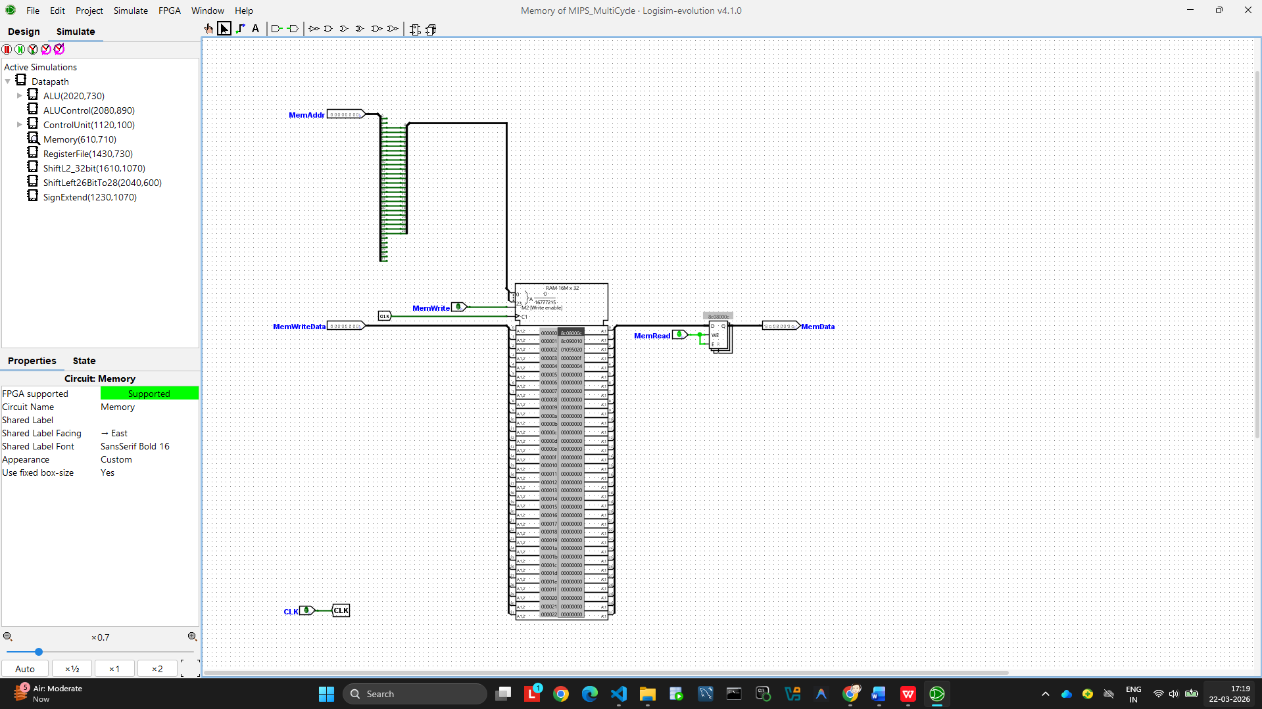

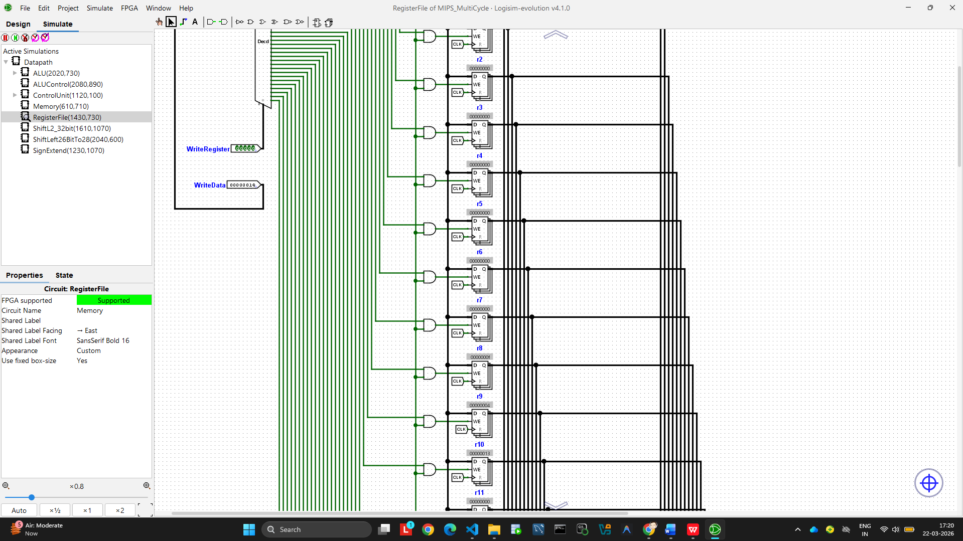

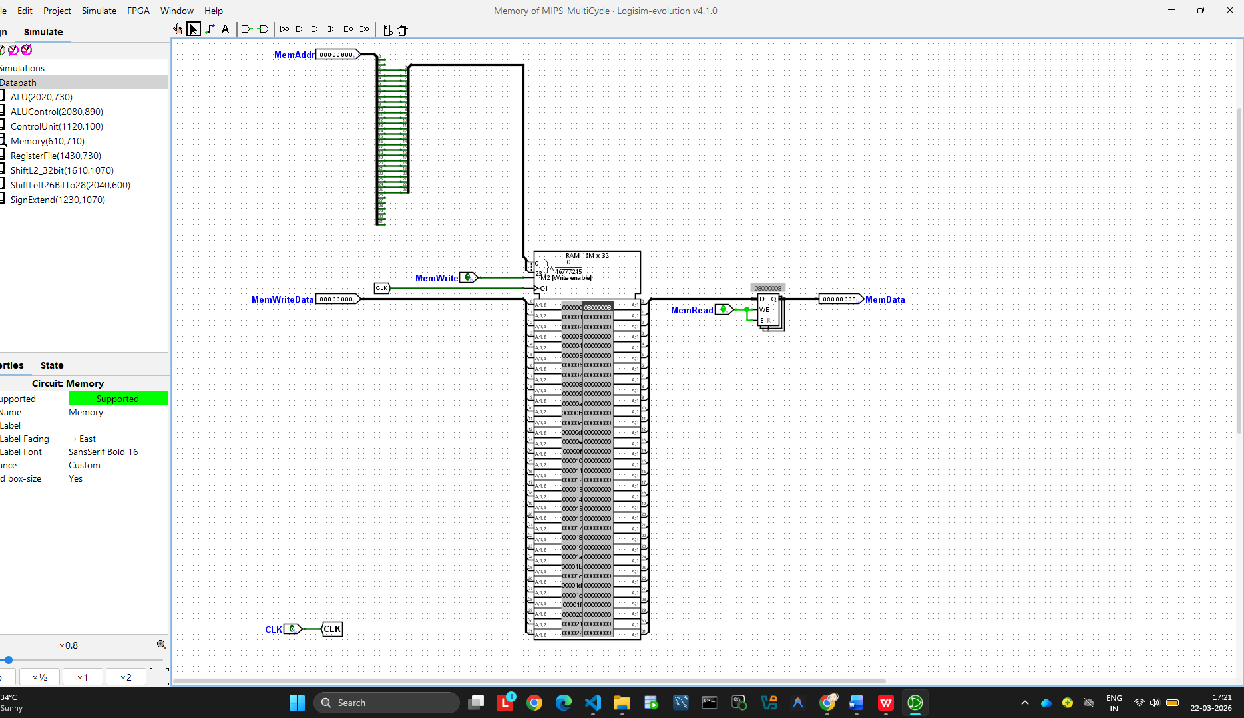

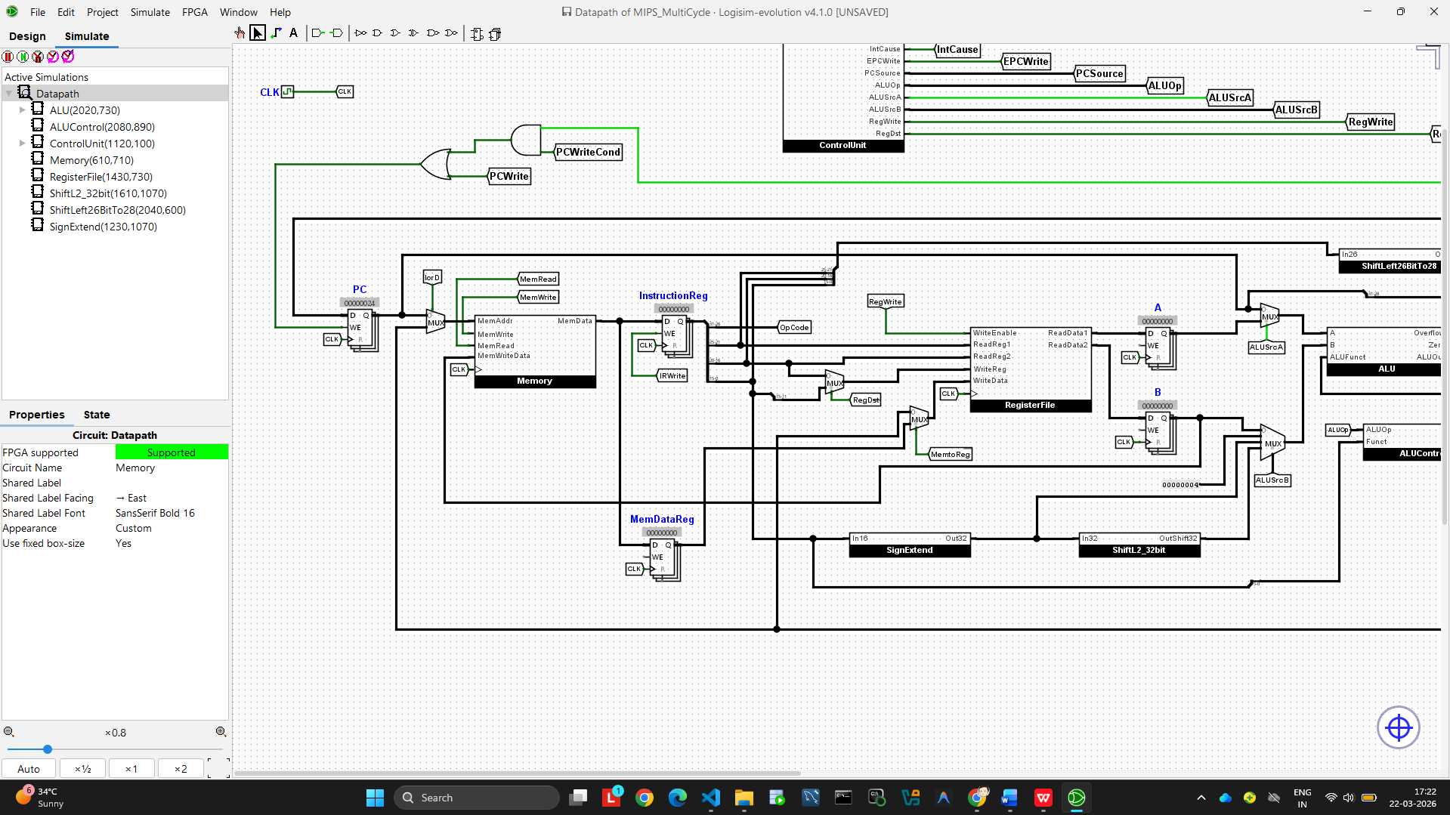

Verilog Implementation (gtkwave form): -

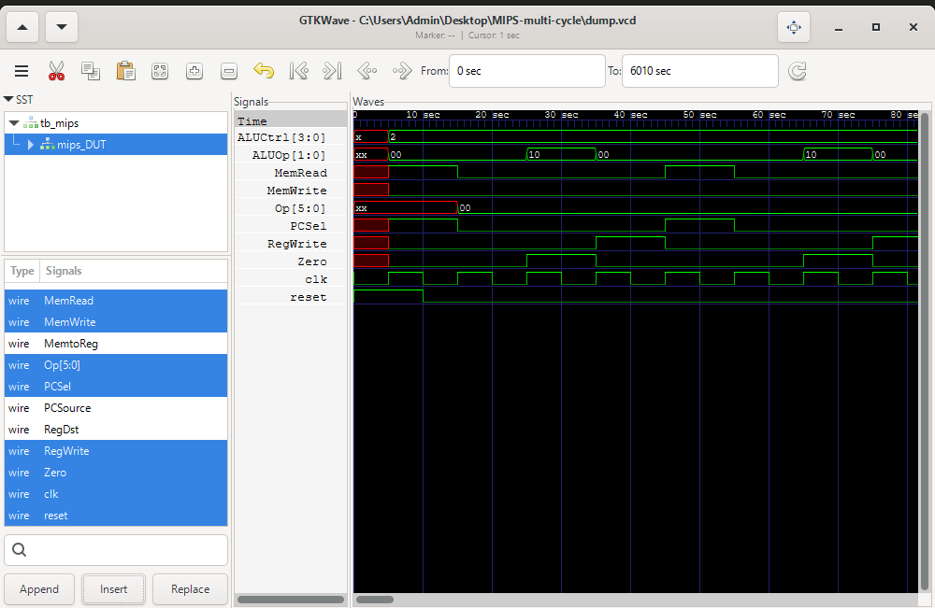

8. Conclusion
This project successfully implements and verifies a MIPS Multi-Cycle Processor with an FSM-based Control Unit in both Logisim Evolution (visual simulation) and Verilog HDL (waveform simulation). The design demonstrates the following computer architecture principles from the course syllabus:
- Multi-cycle instruction execution — each instruction completes in 3 to 5 clock cycles depending on type, with the Control Unit managing the sequence
- FSM-based control — the Control Unit maintains state across clock cycles, activating the correct control signals at each stage
- Shared memory architecture — one memory block serves both instruction fetch (IF stage) and data access (MEM stage), reusing hardware
- Datapath separation — temporary registers (A, B, ALUOut, MDR) isolate each pipeline stage, preventing data loss across cycles
- Instruction set coverage — all major MIPS instruction types verified: R-type (ADD), I-type memory (LW, SW), branch (BEQ), and jump (J)

The key learning outcome is the contrast between single-cycle and multi-cycle design: while single-cycle is simpler to understand, multi-cycle is more hardware-efficient and forms the conceptual foundation of modern pipelined processors. The FSM control unit is the direct predecessor of the microcode-based control units used in CISC architectures such as the Intel x86.

References
- Morris Mano — Computer System Architecture (3rd Edition), Chapters 5, 8, 9, 10. Prentice Hall.
- Patterson, D. A., & Hennessy, J. L. — Computer Organization and Design: The Hardware/Software Interface (5th Edition), Chapter 5.5 — Multi-Cycle Implementation. Morgan Kaufmann.
- fdila/MIPS-multicycle-datapath — Logisim Evolution implementation. https://github.com/fdila/MIPS-multicycle-datapath
- Andrei0105/MIPS-multi-cycle — Verilog HDL implementation. https://github.com/Andrei0105/MIPS-multi-cycle
- Course Slides — Computer Architecture (2CS504CC25), Nirma University, 2025-26.
- Icarus Verilog v12.0 — Open-source Verilog simulation tool. http://iverilog.icarus.com
- GTKWave v3.3.124 — Waveform viewer for VCD files. http://gtkwave.sourceforge.net

