**Implement program for time series data cleaning, loading**

**and handling time series data and preprocessing technique**

**AIM:**

To implement program for time series data cleaning, loading and handling time series data and preprocessing technique using jupyter notebook.

**ALGORITHM:**

1. Load the taxi dataset then clean and load the values

2. Preprocess the values such as variables in the dataset

3. Plot the graph and visualize the values

**CODE:**

**import** pandas **as** pd

**import** matplotlib.pyplot **as** plt

**from** statsmodels.tsa.holtwinters **import** ExponentialSmoothing

file_path **=** "Downloads/train.csv/taxi dataset.csv"

df **=** pd**.**read_csv(file_path)

print(df**.**head())

df['datetime'] **=** pd**.**to_datetime(df[['year', 'month', 'day']]) **+** pd**.**to_timedelta(df['hour_of_day'], unit**=**'h')

df **=** df**.**sort_values(by**=**'datetime')

df**.**set_index('datetime', inplace**=True**)

df_daily **=** df[['total_amount']]**.**resample('D')**.**sum()

model **=** ExponentialSmoothing(df_daily['total_amount'], trend**=**"add", seasonal**=**"add", seasonal_periods**=**7)

fit **=** model**.**fit()

forecast **=** fit**.**forecast(7)

plt**.**figure(figsize**=**(12, 6))

plt**.**plot(df_daily**.**index, df_daily['total_amount'], label**=**"Actual", color**=**'blue')

plt**.**plot(forecast**.**index, forecast, label**=**"Forecast", color**=**'red', linestyle**=**"dashed")

plt**.**xlabel("Date")

plt**.**ylabel("Total Fare Amount")

plt**.**title("Daily Taxi Fare Amount Forecasting")

plt**.**legend()

plt**.**grid()

plt**.**show()

**OUTPUT:**

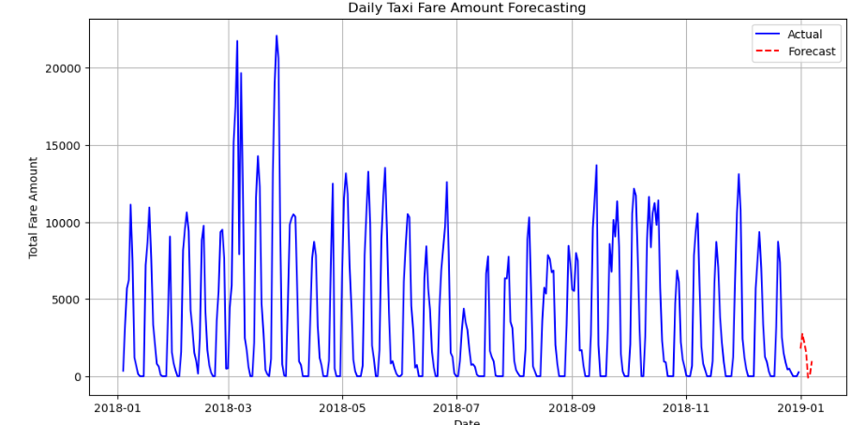

**RESULT:**

The program to execute the time series data cleaning, loading and handling time series data and preprocessing techniques completed successfully and the output is verified.