**Develop vector auto regression model for multivariate time series data forecasting**

**AIM:**

To Develop vector auto regression model for multivariate time series data forecasting

using jupyter notebook.

**ALGORITHM:**

1. Load the taxi dataset then clean and load the values

2. Aggregate multivariate time series data by time (e.g., daily sums).

Transform data to ensure stationarity (e.g., differencing).

Fit a VAR model and forecast future values using past observations.

3. Plot the graph and visualize the values

**CODE:**

import pandas as pd

from statsmodels.tsa.api import VAR

import matplotlib.pyplot as plt

# Load dataset

df = pd.read_csv("taxi dataset.csv")

# Create datetime index

df['datetime'] = pd.to_datetime(df[['year', 'month', 'day', 'hour_of_day']])

df.set_index('datetime', inplace=True)

# Resample data to daily level and aggregate

daily_data = df.resample('D').agg({

'trip_distance': 'sum',

'fare_amount': 'sum',

'tip_amount': 'sum',

'total_amount': 'sum'

})

# Drop missing values (if any)

daily_data.dropna(inplace=True)

# Check for stationarity and difference if needed

data_diff = daily_data.diff().dropna()

# Fit VAR model

model = VAR(data_diff)

results = model.fit(maxlags=15, ic='aic')

# Forecast next 7 days

forecast = results.forecast(data_diff.values[-results.k_ar:], steps=7)

forecast_df = pd.DataFrame(forecast, index=pd.date_range(start=daily_data.index[-1] + pd.Timedelta(days=1), periods=7),

columns=daily_data.columns)

print(forecast_df)

forecast_df.plot(title='7-Day Forecast')

plt.show()

**OUTPUT:**

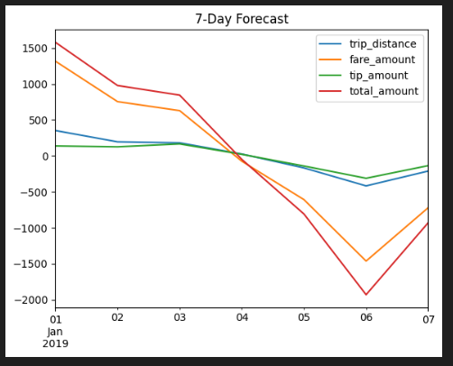

**RESULT:**

To Develop vector auto regression model for multivariate time series data forecasting completed successfully and the output is verified.