**Implement programs for estimating & eliminating trend in**

**time series data- aggregation, smoothing.**

**AIM:**

To implement program for estimating & eliminating trend in time series data- aggregation, smoothing technique using jupyter notebook.

**ALGORITHM:**

1. Load the taxi dataset then clean and load the values

2. Smooth daily trend by averaging and applying a 7-day rolling mean to the total amount over time.

3. Plot the graph and visualize the values

**CODE:**

# Import necessary libraries

import pandas as pd

import matplotlib.pyplot as plt

# Load the dataset

df = pd.read_csv("taxi dataset.csv")

# Create a datetime column from year, month, day, hour

df["datetime"] = pd.to_datetime(df[["year", "month", "day"]]) + pd.to_timedelta(df["hour_of_day"], unit='h')

# Set datetime as index

df.set_index("datetime", inplace=True)

# Aggregate total_amount by day (trend estimation)

daily_avg = df["total_amount"].resample("D").mean()

# Smooth the data using 7-day rolling average

smoothed = daily_avg.rolling(window=7, center=True).mean()

# Plotting the original and smoothed trends

plt.figure(figsize=(14, 6))

plt.plot(daily_avg, label="Daily Average Total Amount", alpha=0.6)

plt.plot(smoothed, label="7-Day Rolling Average (Smoothed)", linewidth=2, color='orange')

plt.title("Trend Estimation and Smoothing of Total Amount")

plt.xlabel("Date")

plt.ylabel("Total Amount ($)")

plt.legend()

plt.grid(True)

plt.tight_layout()

plt.show()

**OUTPUT:**

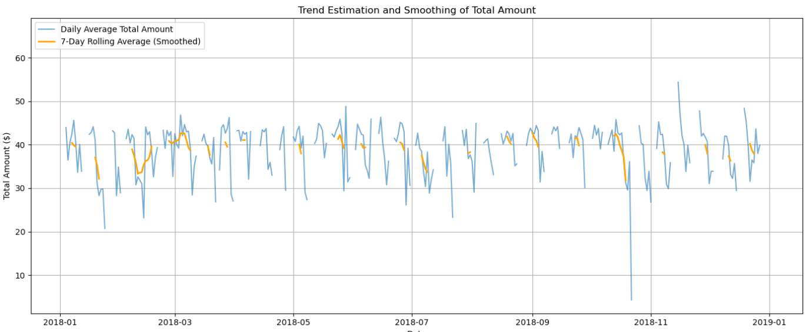

**RESULT:**

The program to execute the time series data cleaning, loading and handling time series data and preprocessing techniques completed successfully and the output is verified.