**Implement program for decomposing time series data**

**into trend and seasonality**

**AIM:**

To implement program for decomposing time series data into trend and seasonality

using jupyter notebook.

**ALGORITHM:**

1. Load the taxi dataset then clean and load the values

2. Decompose the time series into trend, seasonal, and residual components using a seasonal decomposition model.

3. Plot the graph and visualize the values

**CODE:**

import pandas as pd

import matplotlib.pyplot as plt

from statsmodels.tsa.seasonal import seasonal_decompose

# Load and prepare dataset

df = pd.read_csv("taxi dataset.csv")

df["datetime"] = pd.to_datetime(df[["year", "month", "day"]]) + pd.to_timedelta(df["hour_of_day"], unit='h')

df.set_index("datetime", inplace=True)

# Resample to daily average

daily_avg = df["total_amount"].resample("D").mean().dropna()

# Apply seasonal decomposition (multiplicative or additive)

result = seasonal_decompose(daily_avg, model="additive", period=7)

# Plot the components

result.plot()

plt.suptitle("Time Series Decomposition (Trend, Seasonality, Residuals)", fontsize=16)

plt.tight_layout()

plt.show()

**OUTPUT:**

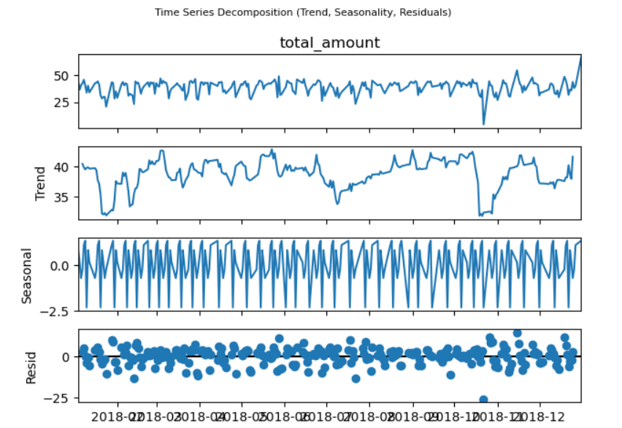

**RESULT:**

The program to execute program for decomposing time series data into trend and seasonality completed successfully and the output is verified.