Automated image analysis for evaluation of pork chop quality traits
Fatima Davelouis, Manuel Juarez, Sophie Zawadski and Arun Kommadath

Problem statement
Given images of pork loin carcasses, it takes a long time to manually measure the width and depth of the muscle region, as well as the fat depth. This process is also very tedious and strenuous on people’s eyes. We propose a method for automating this process using image analysis, basic geometry and a segmentation model.

Dataset:
The dataset came from a 2019 study of 209 images of pork loin carcasses. Figure 1 shows and example of a pork loin carcass. Images have dimensions 5184 x 3456 pixels.
All images show the carcass on a white tray, as well as 3 color palettes: one to the left of the pork loin, one above the pork loin and one below it. In addition, a ruler that consistently appears to the right of the pork loin carcass.
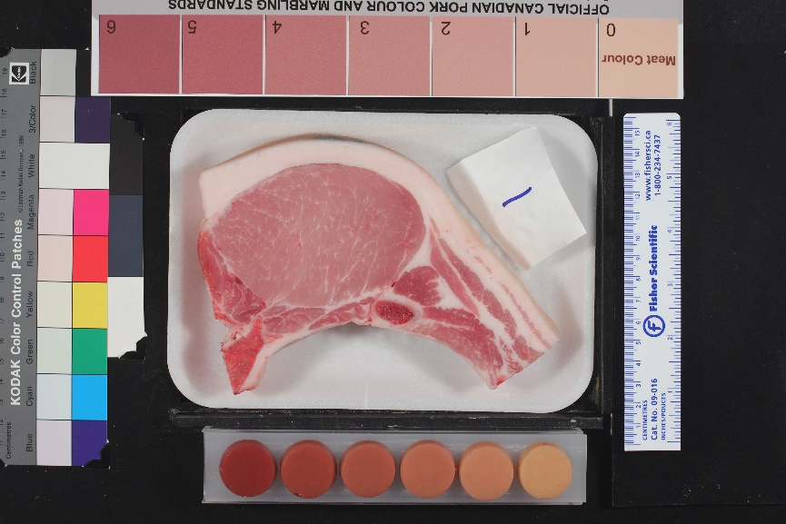
Figure 1. Pork loin carcass image. Loin ID 101.

Current techniques
There are 3 measurements that we aim to compute:
- Longissimus Dorsi (LD) muscle width.
- Longissimus Dorsi (LD) muscle depth.
- Upper fat depth.
To manually measure these dimensions, employees use some pre-defined heuristics:
- The desired muscle width is defined as the length of the longest line segment that extends horizontally across the LD muscle.
- The muscle depth is measured 7 cm from the midline of the carcass and perpendicular to the skin. This is the measurement site used in the Canadian grading system (CAN site), (Pomar et al., 2001);
- The fat depth: the portion of the vertical line segment defined in (b) that extends through the upper fatty tissue.
Currently, these measurements are first made on ImageJ or Fiji software.

Objectives of this study
Our goal is to automate and speed up the measurement process. Thus, we ask the following questions:
- Can we replicate these heuristics automatically or come up with different ones that result in similar measurements?
- How close can we come to the manual measurements?
This report presents a methodology to answer the above questions.

Methods
We employ deep learning techniques, image analysis and geometry. Images are ran sequentially, but the program can be adjusted to run in parallel.

Preprocess images

Image Rotation
Before running the program, we took a look at the images and saw that some were positioned sideways. More specifically, these images had been rotated by 90 degrees clockwise as shown in Figure 2.
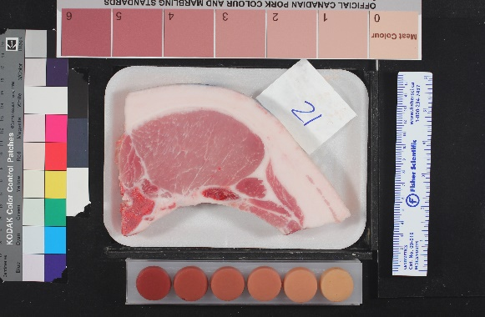
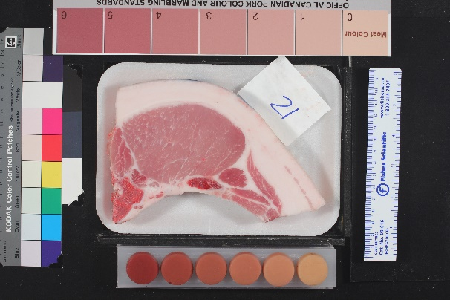
Figure 2. Left: original image as given in the dataset. Right: image after we correct for rotation. Pork loin ID: 121.
In order to fix this, we ran the script called fix_image_rotation.py. This script goes through each image and corrects the orientation of the images. As the script stands currently, it corrects images that have been rotated by multiples of 90 degrees. We used the Python PIL library to detect the angle of rotation, applied a correcting counter-rotation and saved the resulting image using the Python opencv library. This process maintains the same image width and height (in pixels) and even increases the DPI from 72 to 96 in each image. However, a lot of the image metadata is lost. We found that each original raw image had size ~5.13 MB to ~3.67 MB.

Labelled Data
We made sure that all 209 images have manual measurements saved to file. This will allow us to validate our automated measurements.

NN Inference using a pre-trained image segmentation model

Why image segmentation?
In computer vision, semantic segmentation is used to extract a region of interest from an image. We use a pretrained image segmentation model to extract the LD muscle region. This allows us to then measure the lean width and depth.
Usually, the region of interest is extracted and encoded as a binary mask, i.e., a 2D array of “0”s and “1”s where the location of the “1”s correspond to the region of interest in the image. The inputs to our segmentation process are 5184 x 3456 pixel images with 3 color channels (red, green, blue). The outputs are 5184 x 3456 binary masks of the LD muscle region.

U-net Segmentation Model:
We load and compile a neural-network (NN) architecture that was previously trained using very similar pork loin images for a segmentation task. In particular, such task focused on separating the muscle region from the rest of the image. The type of NN is called a U-Net, and it is commonly used in image segmentation (Ronneberger et al., 2015). More information about where the pretrained weights are stored and how they were obtained is found in the Appendix.
Details on how the U-net was pretrained:
- In order to train any U-net segmentation model, one requires (1) the original images and (2) the binary masks of the regions of interest (e.g., LD muscle). Usually, the binary masks are generated from .roi files.
- The U-Net we used was pretrained on very similar pork loin images that were compressed to 320 x 320 pixels.
- The output of the U-net is a 320 x 320 binary mask of the region of interest. The goal of training is to optimize the NN weights to make this output as close as possible to the given binary mask.
Procedure:
To obtain the binary mask, we follow the steps below:
- Crop the borders of the image to reduce image dimensions from 5184 x 3456 pixels to 3000 x 3000 pixels. Note that these borders are irrelevant to the segmentation task.
- Compress images to 400 x 400 pixels.
- Further compress images to 320 x 320 pixels.
- Run image in a forward pass of the U-net. The output of the U-net is a 4D array of size 1 x 320 x 320 x 1. This array contains floating-point numbers between 0 and 1; each number represents the probability of the entry in the array to be part of the LD muscle.
- Process the output to obtain a binary mask (i.e., a 2D array containing “1”s and “0”s), where a “1” points to entries that are in the LD muscle region, and “0” outside of it.
- Expand binary mask to 3000 x 3000 pixels, the same size as the cropped image in step #1.

Geometrical and Image Analysis for Muscle Width and Depth Measurements
- One way to measure the LD muscle width and depth is to take the muscle mask that was generated in the process above and draw a bounding box around it. Then, we can take the width and height of the box as the muscle width and depth, respectively.
  - Note, to generate the bounding-box, we locate the left-, right-, top- and bottom-most coordinate points on the muscle mask. These are show as the blue points in Figure 3b.
  - The function that computes the bounding-box is called boundingbox_line, and it is located in the fitted_lines_bbox.py file.
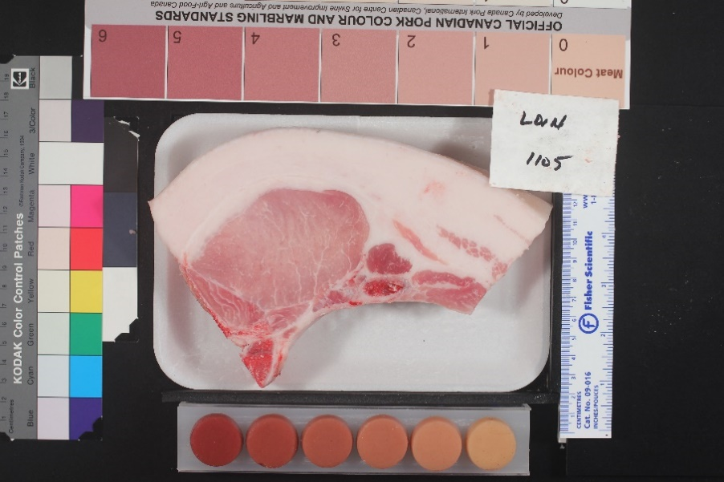
- The problem with this approach emerges when the loin carcass is tilted by a large angle as shown in Figure 3a. In this case, the bounding box will not be aligned with the tilt of the loin carcass and thus could result in inaccurate measurements. See Figure 3b for an example of the bounding box.
Figure 3a. Example of a pork loin carcass that was tilted on the tray. Loin ID: 1105.

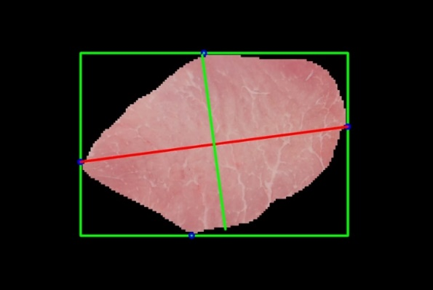
Figure 3b Segmented LD muscle with bounding box. Loin ID: 1105.

Correcting Inclination of Loin Carcass on the Tray
- To correct for the tilt, we first compute the angle of inclination of the LD muscle and apply a correcting rotation to the entire image. As a result, the carcass’ horizontal axis becomes aligned with the horizontal axis of the rotated image.
- Then, we draw a bounding-box around the segmented LD muscle. Figure 4 shows the same image and segmented LD muscle after applying the correction.

Extracting Muscle Measurements
- The length of the line segment that joins the left- and right-most coordinate points of the mask corresponds to the width of the LD muscle. Figure 4 (right) shows this horizontal line segment in red.
- To measure the depth of the muscle mask, we compute the line segment that is perpendicular to the segment described above and measure its length. Figure 4 (right) shows this line segment in green.
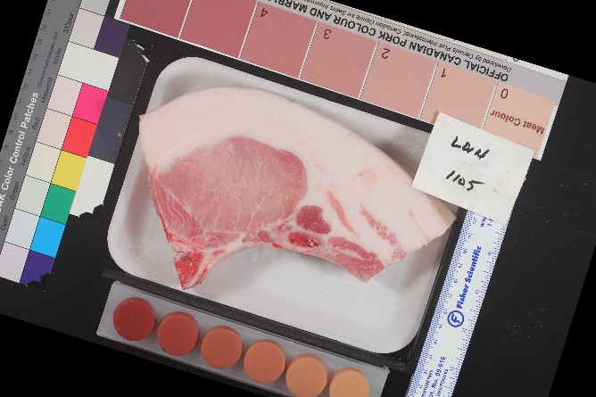
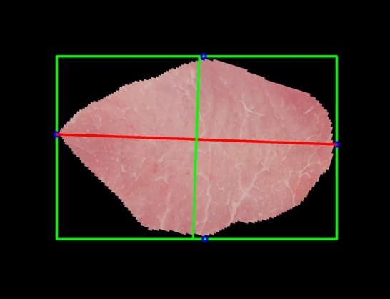
Figure 4 left: Loin 1105 after correcting for tilt angle; now the LD muscle is aligned with the horizontal axis of the image. Right: segmented LD muscle after correcting for tilt angle. Now the horizontal line segment of the LD muscle (red line) is more aligned with the horizontal axis of the bounding box.

Details on the calculation of the angle of inclination:
- In order to compute the tilt angle, we fit an ellipse onto the LD muscle mask using least-squares regression. Our least-squares regression program takes as input the contour points of the muscle mask and returns 4 values: the centre of the ellipse, the angle of ellipse tilt (with respect to the horizontal axis of the image), the semi-major axis and semi-minor axis. We apply a rotation to the image according to the computed angle with respect to the ellipse centre.

Geometrical and Image Analysis for Fat Depth Measurements
- Recall that the U-net we used so far had only been trained to segment the LD muscle. We therefore can not use it to segment the upper fatty tissue.
- Since we did not have .roi files of the upper fat region available, we were not able to generate the corresponding binary masks and train a second U-net that segments the upper fatty tissue.
  - Recall, in order to train the U-net, we must have both the original images and the binary masks of the regions of interest (which in this case, would be the upper fat region).
- Thus, instead of using image segmentation, we adopted a geometrical approach: we took the line segment traced to measure the muscle depth (green line in Figure 4 right) and extended it until we reached the upper boundary of the fat tissue. Then, we measured the length of the line segment that extends across the fat tissue.
- Since both the color of the fat and tray are white, it was challenging to automatically detect the upper fat boundary.
- Figure 5 shows a loin carcass with all 3 line segments drawn, as well as the muscle mask contour.

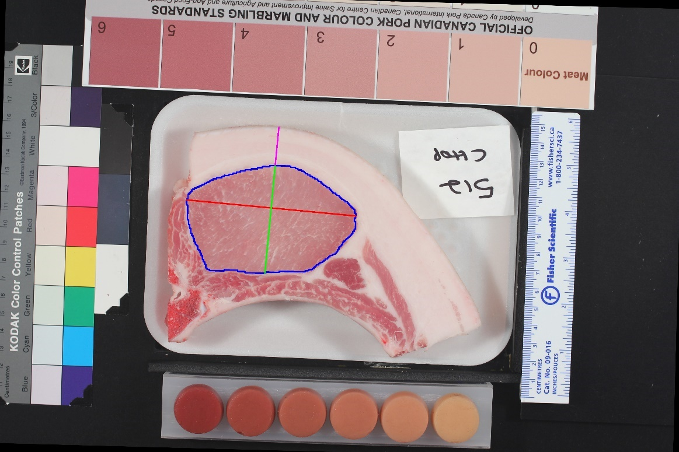
Figure 5. Line segments and contour of the LD muscle after correcting for tilt angle. The lengths of the magenta, green and red lines correspond to the fat depth, LD muscle depth and LD muscle width respectively. The LD muscle contour in blue was obtained from the muscle mask generated by the U-net segmentation model. Loin ID #512.

Post-processing
Once all 3 measurements are calculated, they are saved onto a csv file. All measurements are made in pixels. Finally, the pixel measurements are converted to metric units using the pre-calculated ratios provided by Sophie Zawadski.

Results

Muscle Width and Depth Measurements:
- Once the measurements were saved to file, we converted them to mm values and compared them to the manual baselines. Figure 6 and 7 show histogram plots of the LD muscle measurement deviations from manual baselines of depth and width respectively (deviations = automated – manual).
- Since most of the depth and width deviations are negative, this suggests that we underfit the manual measurements. In terms of muscle depth, automated measurements are approximately 0.8 to 2.5 mm shorter than manual baselines. On the other hand, we underfit the manual widths by 0.7 to 1.9 mm.
- We believe that the reason for this is due to the fact that our U-net was trained with compressed images (320 x 320 pixels). Thus, when the binary masks are blown back up to original size, there is some inaccuracy in the resulting boundaries of the muscle.
Figure 6. Differences between automated and manual muscle depth measurements.
Figure 7. Differences between automated and manual muscle width measurements.

Fat Depth Measurements
- When we generated the fat depth measurements, the main difficulty was to find the top boundary of the fat region: we observed that a portion of line segments across the fat tissue were very short and others very long. To prevent this, our implementation ignores measurements smaller than 100 pixels (7.25 mm) and those larger than 480 pixels (34.8 mm). With our current approach, we only generate measurements for 51% of images (amounts to 108 out of 209 pork loins).
- Figure 8 shows a histogram plot of the fat depth deviations from manual baselines (deviations = automated – manual).
- For the most part, the fat depth deviations are slightly negative, meaning that we underfit the manual fat measurements by differences in the range of -1.7 to 0.27 mm.

Figure 8. Differences between automated and manual measurements of the fat depth.

Correlation and Regression Analysis
We computed the Pearson correlation coefficient as well as the line of best fit between the automated vs. manual measurements. For the LD muscle width and depth, the correlation coefficient was 0.982 and 0.967 respectively. In terms the fat depth, the correlation coefficient amounted to 0.981.
Figures 9, 10 and 11 show the lines of best fit between the automated and manual measurements for muscle width, depth and fat depth, respectively.

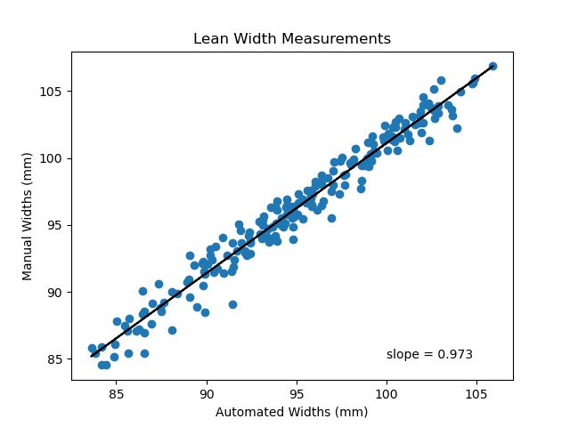
Figure 9. Line of best fit between automated and manual LD muscle widths. The slope of the line is 0.973.
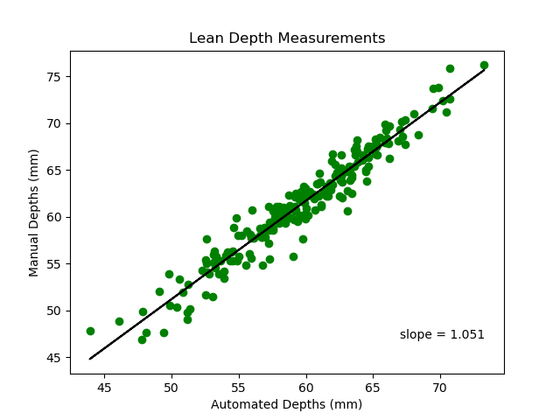
Figure 10. Line of best fit between automated and manual LD muscle depths. The slope of the line is 1.051.
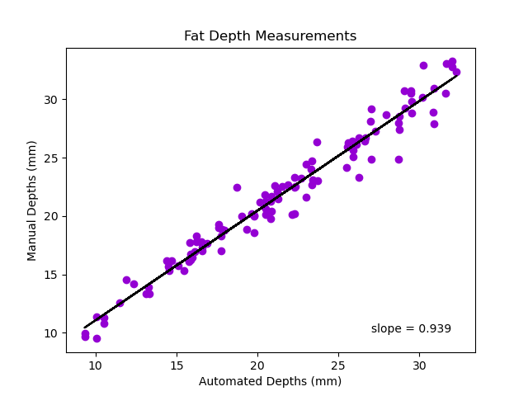
Figure 11. Line of best fit between automated and manual fat depths. The slope of the line is 0.939.

Future work, Limitations and Recommendations
There are a few avenues of future work. First, in order to avoid underestimating the manual measurements, retraining the U-net segmentation model with a larger image size could be useful. Of course, this would take up more computational resources.
Moreover, having .roi files of the upper fatty tissue is indispensable to generate binary masks and train a second U-net to segment the fat region. Then, we can use the second U-net to segment the fatty tissue in newer datasets of pork loin carcasses, and generate the respective masks. In this way, extending the line segment from the upper boundary of the muscle mask to the top of the fat mask would be straight-forward. Alternatively, refining the inductive biases used to detect the top of the fat region is an option, yet it might not be robust to new datasets.

Limitations and Potential Improvements
There are some limitations to our current methodology. For instance, in the preprocessing step, our implementation only handles images that were rotated by multiples of 90 degrees (see Figure 1). A potential improvement is to refine the code so that it handles any type of rotation. Another potential improvement involves parallelizing the program across the entire dataset, instead of running the images sequentially. Moreover, if memory allows, using full resolution images as the input to the U-net model would prevent the system from underfitting the LD muscle region.

Recommendations
In the future, replacing the white tray with a black or dark-coloured tray would facilitate finding the upper boundary of the fat region and in turn measuring the fat depth.
Additionally, ensuring that the loin LD muscle is aligned with the horizontal axis of the tray could also be helpful. If the latter is true, then we would not need to fit an ellipse to the LD muscle mask to extract the angle of inclination. Every time we do least-square fitting there is a bit of approximation error.

References
- Pomar,C., Rivest, J., Jean dit Bailleul, P., & Marcoux, M. (2001). Predicting loin-eye area from ultrasound and grading probe measurements of fat and muscle depths in pork carcasses. Canadian Journal of Animal Science. 81(4): 429-434. https://doi.org/10.4141/A00-081

- Ronneberger, O., Fischer, P., & Brox, T. (2015). U-net: Convolutional networks for biomedical image segmentation. In Medical Image Computing and Computer-Assisted Intervention–MICCAI 2015: 18th International Conference, Munich, Germany, October 5-9, 2015, Proceedings, Part III 18 (pp. 234-241). Springer International Publishing.

Appendix

Where can I find the code and neural-network weights?
All the scripts were written and tested in Python 3.8 and they are located in a directory called Loin-Segmentation. The weights of the pretrained NN are stored in a filed named FromOriginal_ToRoi_1Class_RandomSplit_best_model_saved_copy.h5. This file is stored in the subdirectory Loin-Segmentation/ models/semantic segmentation. The function get_model loads the weights onto the NN and compiles it; this function is located in the script model_functions.py.

How do I run the code?
To run the program, please take a look at the README.md file in the Loin-Segmentation directory.
TLDR: go to the file titled main_inference_sequential.py and scroll down to the main() function. In this function, you must update the variables folder to point to where your image data is stored and image_processing_folder to point to where you want the results to be stored.

What dependencies do I need to run the program?
The required packages are listed in the file called requirements.txt. The README.md file explains how to create and activate your virtual environment with micromamba or any other conda distribution.

What does the program generate?
Depending on which flags you select, the program will at minimum generate a csv file called measurements.csv. This file will record 4 columns: the image ID, LD muscle width, LD muscle depth and fat depth; all of these measurements are computed in pixels. To convert them to mm, we used the pixel-to-mm ratios obtained manually.
In addition, you may generate some quality-control data to see how the system segmented the LD muscle and traced the line segments to extract the measurements.
The user can specify the following flags and folder variables to store the desired quality control data:
- save_lines_to_roi : if set to True, the line segments across the width and depth of the LD muscle are converted to .roi files and saved to the directory path that is specified by the rois_folder variable.
- plot_bounding_box : if set to True, a bounding-box is drawn around the muscle mask and saved to the directory path that is specified by the image_processing_folder variable.
- plot_image_overlay : if set to True, the muscle mask is plotted over the original image, before any correction for the tilt angle is applied to the image. The resulting image is saved to the directory path that is specified by the overlayed_images_folder variable.
- plot_line_segments : if set to True, the line segments across the width and depth of the LD muscle are traced over the rotated image. In addition, the contour line around the muscle region is also drawn. If the line segment across the fat region is found, then it is also drawn. Figure 5 shows an example of an image saved to the directory path that is specified by the image_processing_folder variable.
- plot_rotated_images : if set to True, the rotated image (after correcting for the angle of inclination) is saved to the directory path that is specified by the rotated_img_folder variable.

