My Report Title Report for ABC2026-001ABC
Prepared for: collab_partner_org (partner@example.com)
Prepared by: your_name
April 9, 2026
- Table of contents

Analytics for the Australian Grains Industry
CU (AAGI-)
AAGI Program Report

My Report Title

Technical Report
Project code: ABC2026-001ABC
Authors: your_name
Prepared for: collab_partner_org (partner@example.com)
Prepared by: AAGI — your_name
Correspondence: <>
Date: April 2026

Executive summary
Concise summary of the work provided by AAGI and the primary findings.

Introduction
- Goals of the research project.
- Background, context and rationale.

Experimental / Trial Design
- Trial design and layout.
- Treatments, replicates, blocking, randomisation.
- Special considerations (small plots, glasshouse, genetics, breeding, OFE, bioinformatics).

Exploratory Data Analysis & Visualisation
- Interpretation of key plots.
- Rationale for visualization choices.

Methods
- Detailed procedures, software versions, pipeline commits.
- Input/output descriptions and pre-processing steps.

Analysis
- Statistical approaches and workflow.
- Model specifications and diagnostics.

Results and Discussion
- Main findings and implications.

Figure example
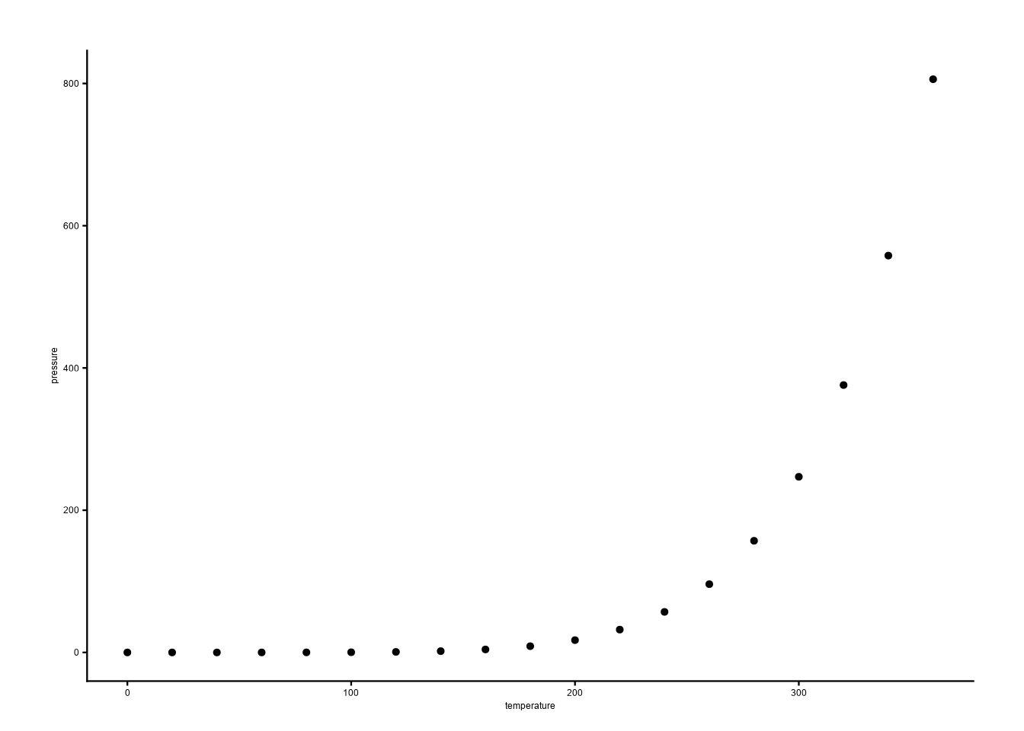
Figure 1: An example figure using {ggplot2}.

Table example
Table 1: An example table using {flextable}.
Ozone | Solar.R | Wind | Temp | Month | Day
41 | 190 | 7.4 | 67 | 5 | 1
36 | 118 | 8.0 | 72 | 5 | 2
12 | 149 | 12.6 | 74 | 5 | 3
18 | 313 | 11.5 | 62 | 5 | 4
 |  | 14.3 | 56 | 5 | 5
28 |  | 14.9 | 66 | 5 | 6

Metadata & Datasets (Optional)
- md5sums or checksums for inputs/outputs.
- Git commit hashes and tags.
- Output locations (FAIR Data) and DOIs.

Map (Optional)
Include maps or geospatial outputs if relevant.

References

Appendix (Optional)
Supplementary information, extended tables, code snippets.

