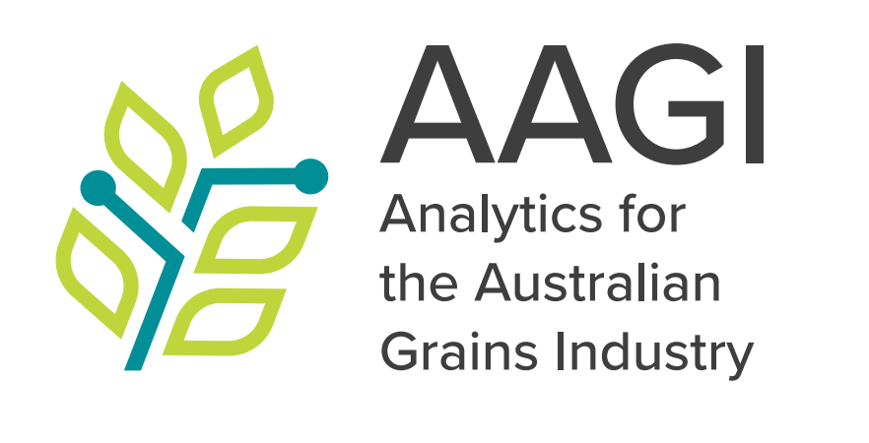

**AAGI Analytics for the Australian Grains Industry Report**

GRDC Investment Project XXXXXXX-XXX

Prepared by Author 1, Position 1

Author 2, Position 2

01/07/2024

# Executive summary

* 1. What was provided by AAGI and the main results.

# Introduction

* 1. Goals of the research project.
  2. Background, context and rationale behind the research.

# Experimental/Trial Design

* 1. Trial design type and layout.
  2. Treatments, number of replicates.
  3. Specific considerations for small plots, glasshouse, genetics, breeding trials, OFE projects, or bioinformatics.

# Exploratory Data Analysis and Data Visualization

* 1. Interpretation of plots and data.
  2. Rationale behind specific methods used.

# Methods

* 1. Detailed description of the procedures and methodologies used.
  2. Include versions/commits on developed pipelines, scripts, and input/output details if applicable.

# Analysis (if separate from Methods)

* 1. Approach taken for data analysis.

# Results and Discussion

* 1. Findings and their implications.

# Metadata and Datasets (Optional)

* 1. md5sums for input data and outputs (if applicable).
  2. Git commit numbers and tags.
  3. Location of outputs (FAIR Data).
  4. DOI for AAGI outputs

# Map (Location, Optional)

* 1. Include if relevant to the project.

# References (Optional)

* 1. Cited works and literature.

# Appendix (Optional)

* 1. Additional supporting information.